Name: _____________________________ Period: ______
AP Biology Starter Questions
Friday/Monday (3/8-11)
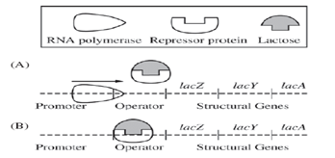
- Which of these shows the lac operon when lactose is NOT being utilized?

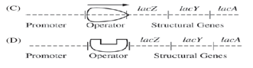

- Predict what would happen in the lac operon for each of these scenarios (hint – the lac operon is an inducible operon):
  - Lactose is present, glucose is scarce
  - A mutation in the operator so the repressor cannot bind
  - Lactose is absent
  - Glucose is present
  - The repressor has a mutation so that it always binds to the operator

Tuesday/Wednesday (3/12-13)
- The region of DNA that is often distant from the gene it is acting on yet it controls that gene’s regulation is called:
  - Promoter b. Enhancer c. Activator d. Repressor

- Homeotic genes are often referred to as “master genes”. Identify what homeotic genes do and why they get the title “master genes.”

- During mitotic cell division, each daughter cell receives an exact copy of the DNA from the parent cell. Explain two mechanisms how eukaryotes have exactly the same copy of DNA in each body (somatic) cell, yet different proteins can be expressed in the cells.

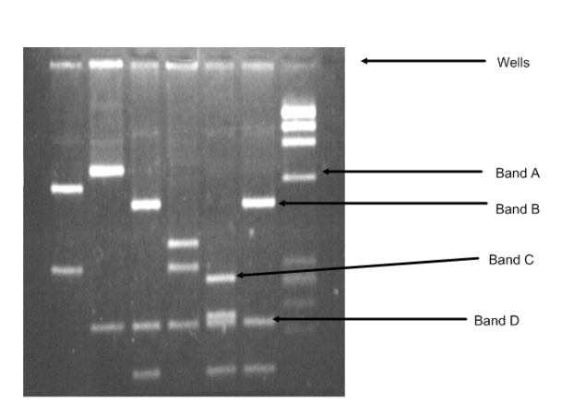
Thursday/Friday (3/14-15)
- What describes the fragments seen on the gel correctly?
  - Band A is more negatively charged than band B
  - There is more DNA at band D than B
  - Band C has never been cut by restriction enzymes
  - Band D is smaller than Band A

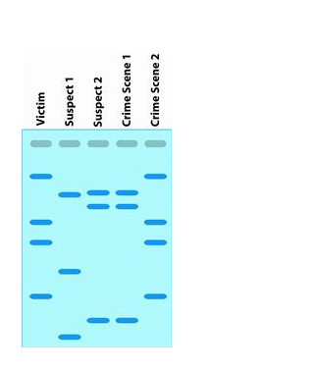
- Analyze the DNA fingerprinting evidence in gel 1 below.
-Who’s guilty (matches a crime scene)?

-Victim found where?

-Innocent bystander?

-Other possible uses of DNA fingerprinting?

- Analyze the gel # 2 below: Label the POSITIVE end of the gel.
  - Which allele has the smallest pieces of DNA? A, B, or C?
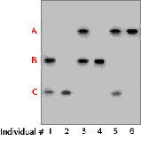
  - Which individual(s) are homozygous for the A allele?

Monday/Tuesday (3/18-19)
- Cloning eukaryotic genes into bacterial cells poses what problem?
  - Failure to express the correct protein because the bacteria cannot process introns
  - Rejection of the DNA due to the origin being from another species
  - Incorrect reading frame of the gene due to misplacement of the gene
  - Improper protein production since the codons in bacteria code for different amino acids

- Explain how PCR can amplify a certain segment of DNA. Name the components of the process that are necessary.

- What benefits would there be to using a cDNA library (DNA complementary to the mature mRNA which has already been processed and is used to make the polypeptide) instead of mapping the entire chromosome sequence when working on the Human Genome Project?

