Name: ____________________________________ Date: _______________________ Period: _______

Basics of Cell Signaling Worksheet
Modified from a POGIL activity created by Flinn Scientific

Part 1:
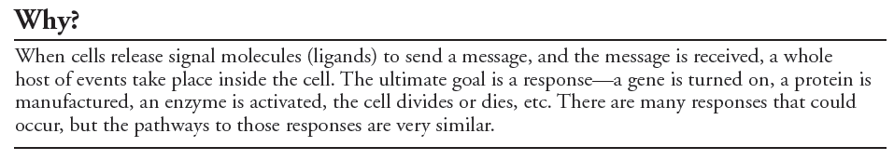
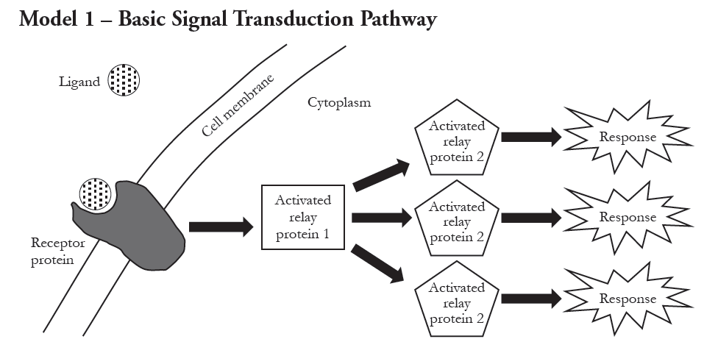
***Some of the activated relay proteins in the picture may be protein kinases. Notice that there are no second messenger molecules in this example of cell signaling.***

1. According to Model 1, does the signal transduction pathway occur inside or outside of a cell?

2. Compare the shape of the ligand in Model 1 to the shape of the receptor protein.

3. The three steps in the signal transduction pathway are listed below. Label the diagram above with the Roman numerals to indicate where on the diagram each step is taking place.
I. Reception
II. Transduction
III. Response

4. Amplification often occurs during the transduction step in the signal transduction pathway.
a. Define “amplification” as it is used in everyday language.

b. Explain how the signal in Model 1 was amplified.

5. List several possible responses that could occur due to a signal being received by a cell. (Hint: There are several listed in the Why? box.)

6. Once the response is achieved in a cell, what would need to occur to stop the response?

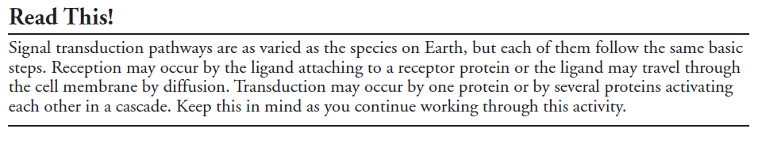
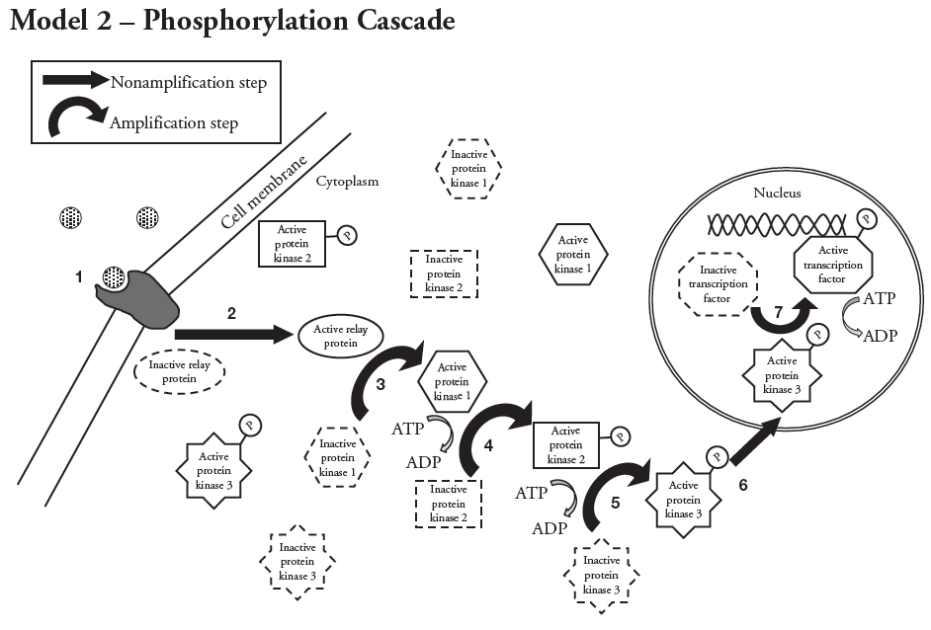
***Notice that there are no second messenger molecules in this example of cell signaling.***

7. Refer to Model 2. Describe the event that sets off a phosphorylation cascade inside of a cell.

8. Phosphorylation is a process that adds a phosphate group onto a protein to “activate” it—that is, to change its shape enough that it can function properly.
a. Which step(s) in the phosphorylation cascade illustrated in Model 2 include phosphorylation?

b. Where do the phosphate groups come from that are added to the proteins during phosphorylation?

9. According to Model 2, what class of enzymes performs phosphorylation?

10. Identify the steps in Model 2 that represent reception, transduction, and response for the phosphorylation pathway.
Reception Transduction Response

11. What is the cell’s response to the signal received in Model 2?

12. What advantage would there be to an organism if the signal transduction pathway had several amplification steps?

13. Describe what would occur in the cell if the activated protein kinase enzymes continued to be active for a long period of time.

14. What would need to occur in the cell to deactivate the protein kinase enzymes?

15. Protein phosphatases are enzymes that remove phosphate groups from proteins. Complete the illustration in Model 2 by adding at least two protein phosphatases (PP) to show how the cell is returned to inactive status.

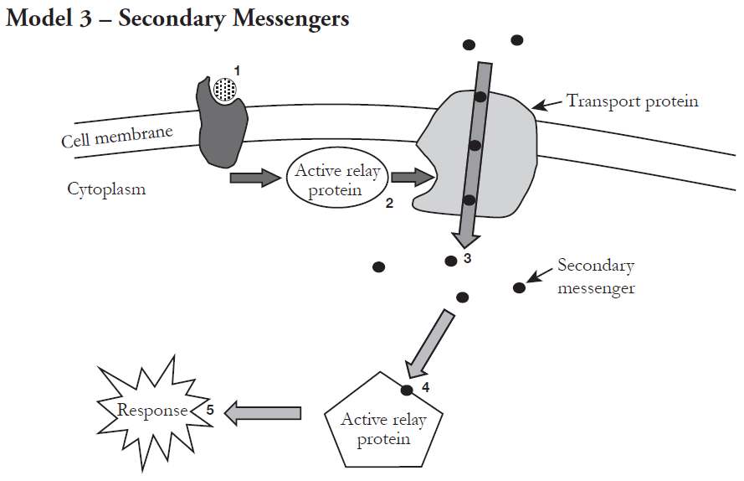

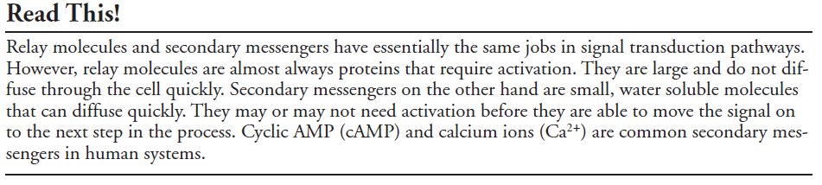

16. Consider the signal transduction pathway in Model 3. What event begins the process of producing a cellular response?

17. What activates or opens the transport protein channel that allows the secondary messengers to enter the cell?

18. Within an organism it is critical that signals between cells are very specific. For example, if
ligand A is meant to activate immune system cells to reproduce in response to an infection, it should not also cause other cells to grow as if they had received a growth hormone. When a ligand is released, what prevents all of the cells in the body from being affected?

Part 2:

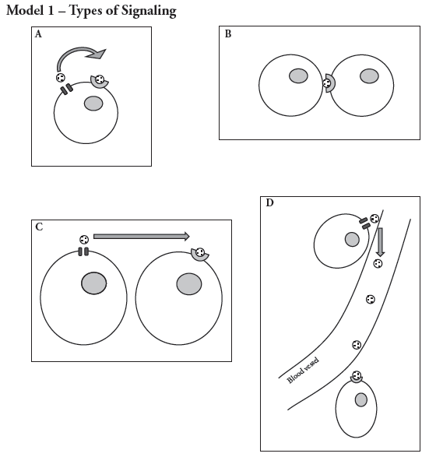
19. Consider the diagrams in Model 1 of four types of cellular communication. Match each of the
shapes below with a label at the right.
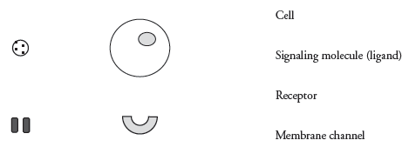
20. Describe how the shape of the ligand (signaling molecule) and the shape of the receptor are
related.

21. Which of the cellular communication methods in Model 1 appear to be for signaling between
cells that are in close proximity but not touching?

22. Which of the cellular communication methods in Model 1 appear to be for signaling between
cells in different parts of an organism (long-distance communication)?
23. In which of the cellular communication methods would a ligand (signaling molecule) need to
have the longest “life”? Explain your reasoning.

24. Use the four terms below to label the diagrams in Model 1. Word-part definitions are given to
help you determine the meanings of each term.

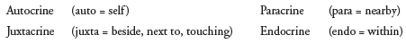
***Endocrine means that signals are sent WITHIN the body across LONG distances***

25. Consider each of the following cellular communication examples. Determine which type of signaling is occurring in each example (autocrine, juxtacrine, paracrine or endocrine), and then explain your reasoning.

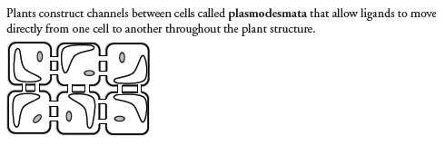

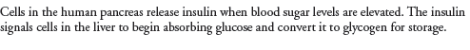

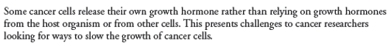

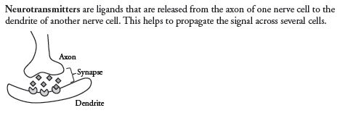

26. If a medical researcher wanted to prevent communication between cells in order to cure a disease
or prevent a malady, how might they achieve that? Propose two or more general methods that
could be used to stop a signal transmission from cell to cell.

