Name: ___________________________________

Biochemistry (Unit 2) Multiple Choice Questions

1. About 25 of the 92 natural elements are known to be essential to life. Which four of these 25 elements make up approximately 96% of living matter?
A) carbon, sodium, hydrogen, nitrogen
B) carbon, oxygen, phosphorus, hydrogen
C) oxygen, hydrogen, calcium, nitrogen
D) carbon, hydrogen, nitrogen, oxygen
E) carbon, oxygen, nitrogen, calcium

2. What results from an unequal sharing of electrons between atoms?
A) a nonpolar covalent bond
B) a polar covalent bond
C) an ionic bond
D) a hydrogen bond
E) a hydrophobic interaction

3. The slight negative charge at one end of one water molecule is attracted to the slight positive charge of another water molecule. What is this attraction called?
A) a covalent bond
B) a hydrogen bond
C) an ionic bond
D) a hydrophilic bond
E) a van der Waals interaction

4. Which of the following effects is produced by the high surface tension of water?
A) Lakes don't freeze solid in winter, despite low temperatures.
B) A water strider can walk across the surface of a small pond.
C) Organisms resist temperature changes, although they give off heat due to chemical reactions.
D) Evaporation of sweat from the skin helps to keep people from overheating.
E) Water flows upward from the roots to the leaves in plants.

5. One of the buffers that contribute to pH stability in human blood is carbonic acid (H2CO3). Carbonic acid is a weak acid that dissociates into a bicarbonate ion (HCO3-) and a hydrogen ion (H+). Thus,

H2CO3 ↔ HCO3- + H+

If the pH of the blood drops, one would expect
A) a decrease in the concentration of H2CO3 and an increase in the concentration of HCO3-.
B) the concentration of bicarbonate ion (HCO3-) to increase.
C) the HCO3- to act as a base and remove excess H+ with the formation of H2CO3.
D) the HCO3- to act as an acid and remove excess H+ with the formation of H2CO3.

6. Why are hydrocarbons insoluble in water?
A) The majority of their bonds are polar covalent carbon-to-hydrogen linkages.
B) The majority of their bonds are nonpolar covalent carbon-to-hydrogen linkages.
C) They are hydrophilic.
D) They exhibit considerable molecular complexity and diversity.
E) They are lighter than water.

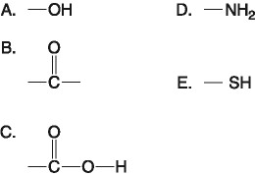
7. Which of the groups above is a basic functional group that can accept H+ and become positively charged?
A) A
B) B
C) C
D) D
E) E

8. Which functional group is not present in this molecule?

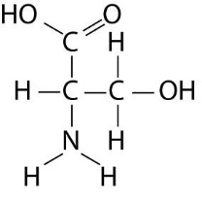
A) carboxyl
B) sulfhydryl
C) hydroxyl
D) amino

9. What is the chemical reaction mechanism by which cells make polymers from monomers?
A) phosphodiester linkages
B) hydrolysis
C) dehydration reactions
D) ionic bonding of monomers
E) the formation of disulfide bridges between monomers

10. Humans can digest starch but not cellulose because
A) the monomer of starch is glucose, while the monomer of cellulose is galactose.
B) humans have enzymes that can hydrolyze the β glycosidic linkages of starch but not the α glycosidic linkages of cellulose.
C) humans have enzymes that can hydrolyze the α glycosidic linkages of starch but not the β glycosidic linkages of cellulose.
D) humans harbor starch-digesting bacteria in the digestive tract.
E) the monomer of starch is glucose, while the monomer of cellulose is glucose with a nitrogen-containing group.

11. Which of the following statements concerning saturated fats is not true?
A) They are more common in animals than in plants.
B) They have multiple double bonds in the carbon chains of their fatty acids.
C) They generally solidify at room temperature.
D) They contain more hydrogen than unsaturated fats having the same number of carbon atoms.
E) They are one of several factors that contribute to atherosclerosis.

12. The tertiary structure of a protein is the
A) bonding together of several polypeptide chains by weak bonds.
B) order in which amino acids are joined in a polypeptide chain.
C) unique three-dimensional shape of the fully folded polypeptide.
D) organization of a polypeptide chain into an α helix or β pleated sheet.

13. Which of the following descriptions best fits the class of molecules known as nucleotides?
A) a nitrogenous base and a phosphate group
B) a nitrogenous base and a pentose sugar
C) a nitrogenous base, a phosphate group, and a pentose sugar
D) a phosphate group and an adenine or uracil
E) a pentose sugar and a purine or pyrimidine

14. Which of the following is (are) true for anabolic pathways?
A) They do not depend on enzymes.
B) They are usually highly spontaneous chemical reactions.
C) They consume energy to build up polymers from monomers.
D) They release energy as they degrade polymers to monomers.

15. According to the induced fit hypothesis of enzyme catalysis, which of the following is correct?
A) The binding of the substrate depends on the shape of the active site.
B) Some enzymes change their structure when activators bind to the enzyme.
C) A competitive inhibitor can outcompete the substrate for the active site.
D) The binding of the substrate changes the shape of the enzyme's active site.
E) The active site creates a microenvironment ideal for the reaction.

16. Increasing the substrate concentration in an enzymatic reaction could overcome which of the following?
A) denaturization of the enzyme
B) allosteric inhibition (i.e., noncompetitive inhibition)
C) competitive inhibition
D) saturation of the enzyme activity

17. Which of the following is true of enzymes?
A) Enzyme function is increased if the 3-D structure or conformation of an enzyme is altered.
B) Enzyme function is independent of physical and chemical environmental factors such as pH and temperature.
C) Enzymes increase the rate of chemical reaction by lowering activation energy barriers.
D) Enzymes increase the rate of chemical reaction by lowering the free energy change between reactants and products.

The following question is based on the reaction A + B ↔ C + D shown in the figure below.

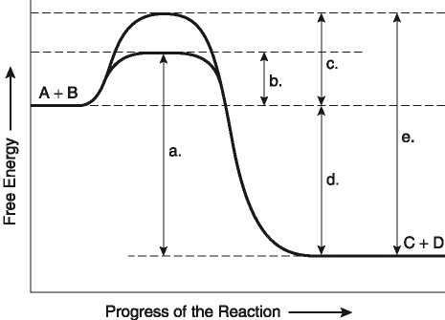
18. Which of the following terms best describes the forward reaction in Figure 8.1?
A) endergonic, ∆G > 0
B) exergonic, ∆G < 0
C) endergonic, ∆G < 0
D) exergonic, ∆G > 0

