Name: _____________________________________________ Date: ____________________________ Period: ______

AP Biology Exam Review: Biochemistry (Unit 2)

Helpful Videos and Animations:
- Bozeman Science: Biological Molecules
- Bozeman Science: Nucleic Acids
- Bozeman Science: Lipids
- Bozeman Science: Carbohydrates
- Bozeman Science: Proteins
- Bozeman Science: Polymers
- Bozeman Science: Coupled Reactions
- Bozeman Science: Enzymes

Unit Vocabulary:

-Ionic Bonds
-Covalent Bonds (polar covalent vs. nonpolar covalent)
-Hydrogen Bonds
-Chemical Reactions
-Reactants
-Products
-Polar Molecule
-Electronegative
-Hydrophilic
-Hydrophobic
-Universal Solvent
-Cohesion
-Surface Tension
-Adhesion
-Capillary Action
-Specific Heat / Heat Capacity
-Heat of Vaporization
-Evaporative Cooling
-pH Scale
-Acid
-Base
-Buffer
-Macromolecules / Organic Molecules
-Functional Groups (Hydroxyl, Carbonyl, Carboxyl, Amino, Sulfhydryl, Methyl, Phosphate)
-Monomers
-Polymers
-Dehydration Synthesis / Condensation Reaction
-Hydrolysis
-Carbohydrates
-Monosaccharides (ex: glucose, fructose, galactose, ribose, deoxyribose)
-Disaccharides (ex: sucrose, lactose, maltose)
-Polysaccharides (ex: starch, glycogen, cellulose, chitin)
-Lipids
-Glycerol
-Fatty Acids
-Fats / Triglycerides
-Phospholipids
-Steroids
-Unsaturated Fats vs. Saturated Fats
-Proteins
-Amino Acids (composed of a central carbon surrounded by an amino group, a carboxyl group, a hydrogen atom, and an R/variable group)
-Dipeptide
-Polypeptide
-Peptide Bonds
-N (amino) Terminus
-C (carboxyl) Terminus
-4 Levels of Protein Structure (Primary, Secondary, Tertiary, and Quaternary)
-Disulfide Bond / Disulfide Bridge (a type of bond found in protein tertiary structure)
-Nucleic Acid
-Nucleotide
-DNA (deoxyribonucleic acid)
-RNA (ribonucleic acid)
-Metabolism
-Catabolic Pathways / Catabolism
-Anabolic Pathways / Anabolism
-Exergonic Reaction
-Endergonic Reaction
-Catalyst (when a catalyst speeds up a reaction, it “catalyzes” the reaction)
-Enzyme
-Activation Energy / Free Energy of Activation
-Substrate
-Active Site
-Induced Fit
-Denature
-Saturated
-Competitive Inhibition
-Non-Competitive Inhibition (a type of allosteric regulation)
-Allosteric Regulation
-Allosteric Activators
-Feedback Regulation (includes feedback inhibition / negative feedback and positive feedback)
-Energy Coupling / Coupled Reactions
-ATP (adenosine triphosphate)
-ADP (adenosine diphosphate)
-Hydrolysis of ATP
-Phosphorylation of ADP
-Pi (inorganic phosphate… a single phosphate group)

Topic Outline: (Thank you to Megan Chirby!)

Unit 2, Part 1 Notes: Atomic and Molecular Structure
- Bonds: Ionic, Covalent (Polar vs. Nonpolar), Hydrogen ; know the relative strengths of each bond and where they are used in nature

Unit 2, Part 2 Notes: Properties of Water
- The Properties of Water (all come from water’s polarity and its ability to form hydrogen bonds ; understand how the structure of the water molecule is related to its function)
- Excellent solvent (know how water dissolves polar and ionic compounds we have water-based cellular fluids
- Cohesion and adhesion transpiration in plants
- Less dense as a solid prevents ponds and lakes from freezing solid
- High Heat Capacity / Specific Heat evaporative cooling (sweating) in animals ; moderates air temperatures near large bodies of water
- pH: acid-base/ 0-14, # of H+ ions determines scale; logarithmic- pH 3 = 10⁻³ = 1/1000 (concentrationof H+ ions)…blood- 7.4, stomach- 2, small intestine- 8; enzymes are specific to pH

Unit 2. Part 3 Notes: Macromolecules
- Reactions of Life
- Dehydration Synthesis (releases water ; used to create polymers connected by covalent bonds ; anabolic ; endergonic)
- Hydrolysis (uses water ; used to break polymers into monomers by breaking covalent bonds ; catabolic ; exergonic)
- Macromolecules
- Carbohydrates
- CHO 1:2:1 ratio
- Monomers = monosaccharides (know the basic structure and examples)
- Dimers = disaccharides (know the basic structure, how they form, and examples)
- Polymers = polysaccharides (know the basic structure, how they form, and the following examples – cellulose, starch, chitin, and glycogen)
- Lipids
- C, H, O (not a 1:2:1 ratio) *P only in phospholipids
- Basic structure (fatty acid chains and a polar region)
- Degree of saturation of fatty acid chains (# of H’s linked to carbons, which is inversely related to the number of hydrogen bonds) unsaturated fatty acid chains with kinks (liquid at room temperature) vs. saturated straight fatty acid chains (solid at room temperature)
- Phospholipids make up cell membranes (double layer) and are amphipathic- hydrophilic and hydrophobic
- Functions = cell membrane (phospholipids), energy storage (fats, oils), steroid hormones like testosterone and estrogen (variations on a cholesterol 5-ring lipid), insulation, myelin sheath of neurons
- Proteins
- C, H, O, N (may have other elements like S in R group)
- Monomers = amino acids (know the basic structure ; the 20 different amino acids only differ in their R groups)
- Parts of amino acid= carboxyl group (COOH) on one end, amino group on the other end (NH2), central carbon and variable R group (can be hydrophobic or hydrophilic) which determines chemical properties.
- Protein Folding- shape determines function; primary structure= amino acid chain; secondary= beta pleated sheet or alpha helix( hydrogen bonds between non-adjacent carboxyl and amino groups); tertiary=globular; folds in on itself (disulfide bridges, hydrogen bonds, hydrophobic interactions; ionic bonding between R groups); quartenary= more than one polypeptide.
- Many functions: enzymes (ex: amylase), structure (ex: keratin), transport (ex: hemoglobin), signaling (ex: oxytocin hormone), protein carriers in cell membrane, antibodies
- Nucleic Acids
- C,H,O,N, and P
- Monomers = nucleotides (know the basic structure ; made of nitrogenous bases, phosphate groups, and deoxyribose sugars)
- Polymers = DNA and RNA
- Nucleotide made up of sugar, phosphate and base
- DNA is double stranded, has deoxyribose, A, G, C, T
- RNA is single stranded, has ribose, A, G, C, U
- mRNA- copies genetic message; rRNA- attaches mRNA and makes up ribosomes (most common);tRNA- carries amino acids; DNA- carries genetic code
- Function: storage and transmission of genetic information

Unit 2, Part 4 Notes: Enzymes

- Enzymes
- Biological catalysts (made of protein) that speed up rate of chemical reactions by lowering activation energy required for reaction to occur
- Enzyme has active site (exposed R groups) where reaction occurs
- Enzymes can break down substance (catabolic reaction) or build up substances (anabolic)
- Enzyme/substrate complex is formed
- Substrate is what enzyme acts on
- Rate is determined by collisions between substrate and enzyme
- Ends in –ase, named after substrate often
- Enzyme is specific to substrate; the substrate must be complementary to the surface properties (shape and charge) of the active site (which is made up of R groups with specific chemistry, i.e. hydrophobic).
- Enzyme rate is affected by:
- pH (optimal for each enzyme),
- temperature (optimal for each enzyme but in general increased temp means increased collisions so rate goes up initially; too much heat can denature enzyme), enzyme concentration (more enzyme faster rate or vice versa)
- substrate concentration (more substrate = faster rate, until the point of enzyme saturation)
- Know the difference between an endergonic and exergonic reaction and be able to analyze their reaction curves ; be able to explain energy coupling and provide examples
- Inhibition-competitive inhibition (something competes for active site; can be overcome with more substrate)
- Non-competitive inhibition- attaches at allosteric site and changes shape of enzyme so it is not functional; can not be overcome with more substrate
- Coenzymes (organic; examples include NAD and vitamin B) and cofactors (inorganic; examples include zinc and magnesium) interact with enzymes to put them into the right structure to do work.

Lab Review

Note: We may or may not have done these labs in class. If not, please read over the information and be familiar with the basic set-up of the lab.

Enzyme Lab

Background Information | In this lab, you will determine how a particular factor (ex: pH, temperature, enzyme concentration, substrate concentration, etc.) affects the rate of an enzyme-catalyzed reaction.  A basic enzymatic and substrate reaction can be depicted as follows:  Enzyme + Substrate → Enzyme-Substrate Complex → Enzyme + Products + Δ G  For this investigation the specific reaction is as follows:  (Peroxidase + Hydrogen Peroxide → Complex → Peroxidase + Water + Oxygen)  2H2O2 → 2H2O + O2 (gas)  Peroxidase is an enzyme that breaks down peroxides, such as hydrogen peroxide, and is produced by most cells in their peroxisomes. Peroxide is a toxic byproduct of aerobic metabolism. Various factors — abiotic and biotic — could have a major influence on the efficiency of this reaction. In this lab, peroxidase from a turnip plant is used.  To determine the rate of an enzymatic reaction, a change in the amount of at least one specific substrate or product is measured over time. In a decomposition reaction of peroxide by peroxidase (as noted in the above formula), the easiest molecule to measure is oxygen gas, a final product. This can be done by measuring the actual volume of oxygen gas released or by using an indicator. In this experiment an indicator for oxygen will be used.  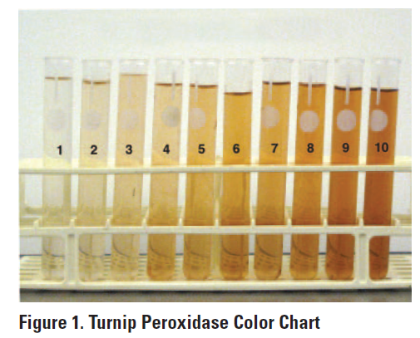  The compound guaiacol has a high affinity for oxygen, and in solution, it binds instantly with oxygen to form tetraguaiacol, which is brownish in color. The greater the amount of oxygen produced, the darker brown the solution will become. A color palette ranging from 1 to 10 (Figure 1) is sufficient to compare relative amounts of oxygen produced. A sample color palette for the peroxidase reaction is shown to the right.  Alternately, the color change can be recorded as a change in absorbency using a variety of available meters, such as a spectrophotometer or a probe system. Using a color palette is a relative way to compare a change and is therefore qualitative. To collect quantitative data, a spectrophotometer or probe system is required. (With a spectrophotometer, light is transmitted through the test tube sample, and the absorbance or transmittance of light through the sample is measured. The absorbance and transmittance of light through the sample vary with different sample colors.)
Hypothesis | If pH is the factor we are choosing as our independent variable…  If we vary the pH of a solution in which a peroxidase reaction is taking place, then the highest rate of reaction (i.e. the darkest color) will result at the optimum pH for the enzyme peroxidase. Above or below this optimum pH, the rate of reaction will be significantly decreased (i.e. the test tubes will remain light in color).
Methods | Basics: You will be combining a test tube containing the enzyme (peroxidase) and a solution of a particular pH with a test tube containing the substrate (hydrogen peroxide) and rating the color (see color palette at the top of the page) after 6 minutes to compare the rate of reaction at various pH values.  Independent Variable: pH of the enzyme solution  Dependent Variable: rate of reaction (measured based on the color change, which indicates the amount of product formed… in this case, oxygen gas is the product)  Control Group (group not exposed to the independent variable): N/A  Experimental Groups (groups exposed to varying degrees of the independent variable): the different pH levels  Constants (to make sure that any differences between the control group and experimental groups are due to the independent variable alone): amount of enzyme, amount of substrate, time passed before rating the color (6 minutes)  Repeated Trials: Need to have 3-5 trials at each pH level to ensure accuracy of data
Data Collection and Organization | If you are using the color rating method, you may organize your data in a chart similar to the one given to the right.  pH Color Rating at 6 Minutes  3  5  6  7  8  10  You may then graph the data in your chart using a scatter plot connected with a line titled “The Effect of pH on the Rate of Reaction in an Enzyme-Catalyzed Reaction.” pH will be on the x-axis and your color rating will be on the y-axis.
Data Analysis | The average color rating over several trials for each pH level will allow you to determine the optimal pH for peroxidase activity and either support or refute your hypotheses.

Practice “Thinking” Questions

- If the following molecules were to undergo a dehydration synthesis reaction, what molecules would result? Circle the parts of each amino acid that will interact and draw the resulting molecule.

- Identify which of the six main elements (CHNOPS) are found in each of the four macromolecules (carbohydrates, lipids, proteins, and nucleic acids).

- Describe the relationship between substrate concentration and reaction rate shown in the graph below and propose an explanation for it.

- DNA polymerase from T. aquaticus (Taq) is used in PCR (polymerase chain reaction). PCR is a technique where millions of copies of DNA can be made from one original copy. In this method, the target DNA molecule is subjected to temperatures over 95 °C to make the double-stranded DNA separate. The temperature is then lowered slightly to allow primers to anneal before the Taq polymerase catalyzes the reactions to incorporate new nucleotides into the complementary strands. The cycle is then repeated over and over until there are millions of copies of the target DNA.
- Predict why this bacterial polymerase is used instead of a human polymerase.

- What would happen if you used a human polymerase in a series of PCR reactions?

5.

Practice Short Response Questions

Water is important for all living organisms. The functions of water are directly related to its physical properties. Describe how the properties of water contribute to TWO of the following:
- Transpiration
- thermoregulation in endotherms
- plasma membrane structure

Practice Long Response Questions

1. 2008:1
The physical structure of a protein often reflects and affects its function.
a. Describe THREE types of chemical bonds/interactions found in proteins. For each type, describe the role in determining protein structure.
b. Discuss how the structure of a protein affects the function of TWO of the following.
- muscle contraction
- regulation of enzyme activity
- cell signaling
c. Abnormal hemoglobin is the identifying characteristic of sickle cell anemia. Explain the genetic basis of abnormal hemoglobin. Explain why the sickle cell allele is selected for in certain areas of the world.

2. Earth is carbon based. Our carbon basis allows for the formation of complex molecules. Pick three of the four groups of complex carbon based molecules (macromolecules) and for each:
a) For each group, discuss the structural components of the molecule group.
b) For each group, discuss two examples of molecules that belong to each of the groups that
you chose. Briefly describe their function.
c) All of these groups of molecules are created from monomers joining to form polymers. Explain the process that joins these molecules

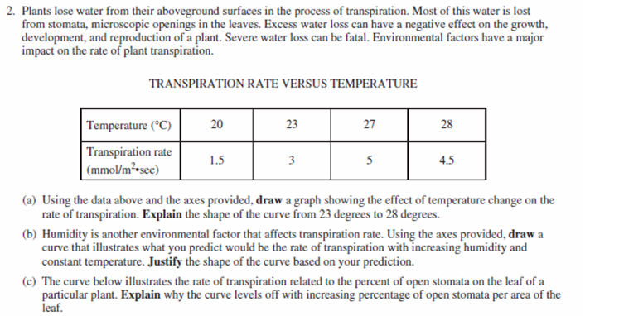
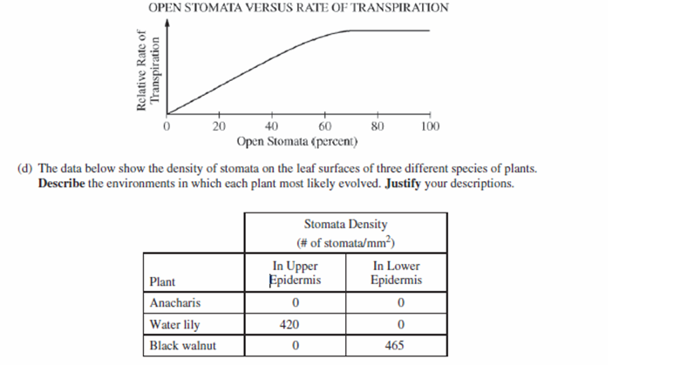
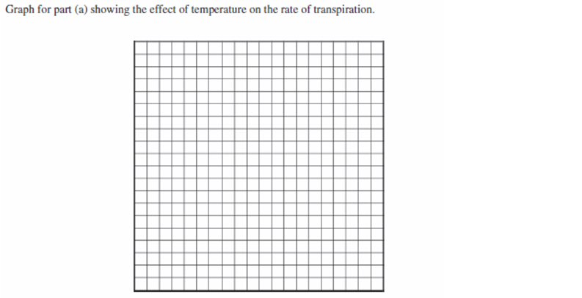
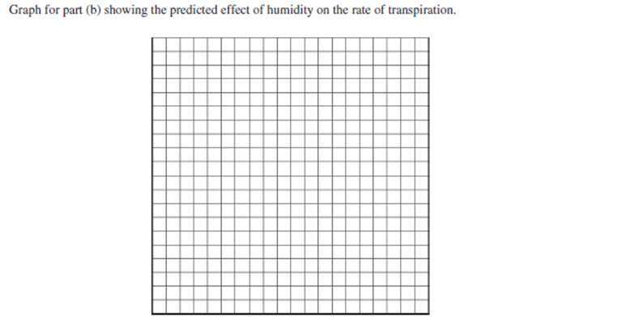

Practice Calculations Questions

Rate
Why use this formula?
Use the rate formula to determine how quickly a particular process is occurring over a given period of time.

Formula

1.
Additional Information from the Formula Sheet
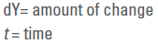

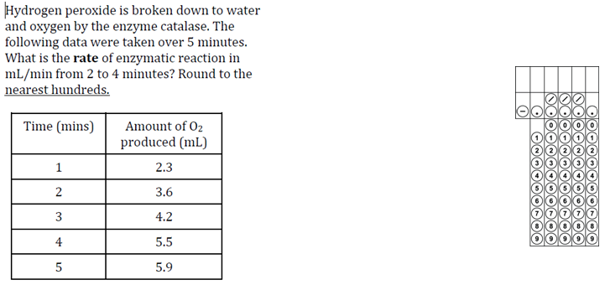

Gibbs Free Energy (We did not learn about this in class, and I do not think it will be on the AP Biology Exam, but it is on the AP Biology Formula sheet, so I have included some practice)

Why use this formula?
Calculating the change in free energy enables you to determine whether the reaction is endergonic / anabolic (+ΔG, products have a higher free energy than reactants) or exergonic / catabolic (-ΔG, products have a lower free energy than reactants).

Helpful Videos
Bozeman Biology – Gibbs Free Energy
https://www.youtube.com/watch?v=DPjMPeU5OeM

Formula Additional Information from the Formula Sheet
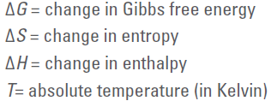

Practice problem on next page.
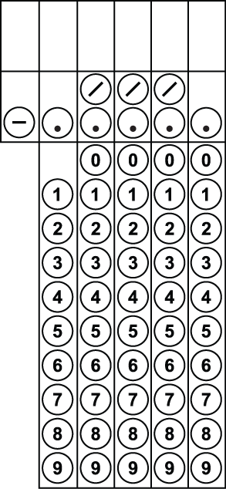
2. An experiment determined that when a protein unfolds to its denatured (D) state from the original folded (F) state, the change in Enthalpy is ΔH = H(D) – H(F) = 46,000 joules/mol. Also the change in Entropy is ΔS = S(D) – S(F) = 178 joules/mol. At a temperature of 20⁰C, calculate the change in Free Energy ΔG, in j/mol, when the protein unfolds from its folded state.

pH
Why use this formula?
Use the hydrogen ion concentration of a solution to determine the pH or vice versa.

Formula

3. What is the pH of a solution with a hydrogen ion concentration of 1.0 x 10⁻⁸? Express your answer as a whole number.

4. According to the Acid Rain Monitoring Project at the University of Mass, the pH measured at King Phillip Brook on April 10, 2012, was near 5, which the pH measured at Robbins Pond on that same date was near 9. Determine to the nearest + number how many times greater the hydrogen ion concentration was at King Phillip Brook.

