Name: ___________________________________ Date: __________________________ Period: __________
Biology Up Close
AP Biology, 2018-2019

When observed up close, even the most ordinary objects can look beautiful, other-worldly, and sometimes even disturbing. Throughout the year, you’ve gotten a much “closer” look at biology. You’ve become experts in the details of life—studying the processes that sustain life and the delicate balance that exists between living organisms and the environment. You’ve gotten up close in the books, and now it’s time to get up close in real life.

Task: You will be allowed some time outside the classroom to find an everyday object or organism that can be related to one (or several) of the concepts learned in AP Biology this year. Capture an artistic close-up of this object. This photo should give a new perspective. It is ok if the viewer may not be able to tell what it is from the angle / zoom you’ve chosen. Examples of these close-ups are given below.
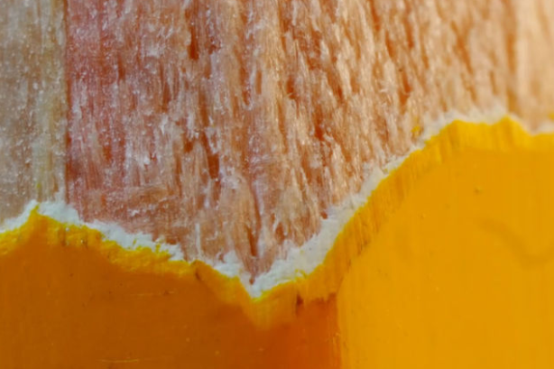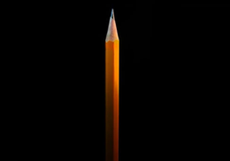

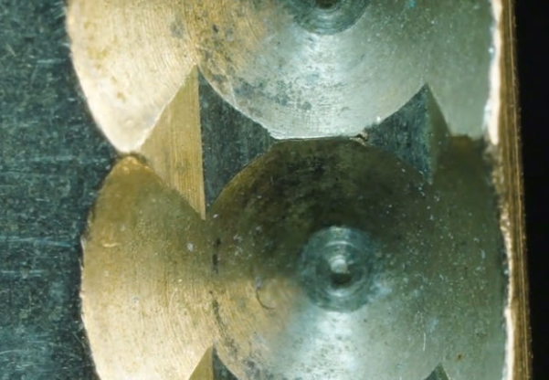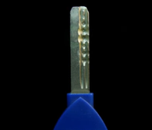

Your subject can be either biotic or abiotic, but MUST be related to a concept studied this year in AP Biology. Once you capture the close-up image, don’t forget to take a picture of the item as a whole.

After taking your photograph, write a paragraph about the item and how it relates to biology (8-10 sentences total). For example, you might take a picture of a bee pollinating a flower, and write about ecology, evolution, and/or reproduction (Remember, you can write about more than one biological concept). If you were to take a close-up of a person’s insulin pump, you could write about cell signaling and how negative feedback systems work, using insulin and glucagon as a specific example.

Once you’ve completed the task, email both pictures and the paragraph to jenseno@pwcs.edu (don’t send through Remind).
Grading Rubric
Category | Requirement | Points Possible
Photo | Both photos (close-up and of the whole object) were submitted via email. | / 1
 | The close-up photo shows creativity and effort. | / 1
Paragraph | Overarching concept (or concepts) is clearly stated. | / 1
 | The finished paragraph is 8-10 sentences | / 1
 | The concept is specifically related to the image. This means that the image could be considered an example of the concept you chose to talk about. | / 2
 | The paragraph goes into detail about the concept(s) and shows an AP level of understanding. | / 2
 | Vocabulary words are defined within the paragraph. | / 1
 | The paragraph is free of spelling and grammar errors. | / 1

Total: ________ / 10
Brainstorming:

