Name:_______________________________________ Date:__________________ Period: __________
Video Notes: Bozeman Science-Photosynthesis http://www.bozemanscience.com/photosynthesis/

Photosynthesis
- Name two organisms, other than plants, that carry out photosynthesis.

Chloroplasts
- Draw a typical plant cell as seen under the microscope. Be sure to include (and label) the following: cell wall, cell membrane, cytoplasm, chloroplasts.

- Label the chloroplast in the picture below:
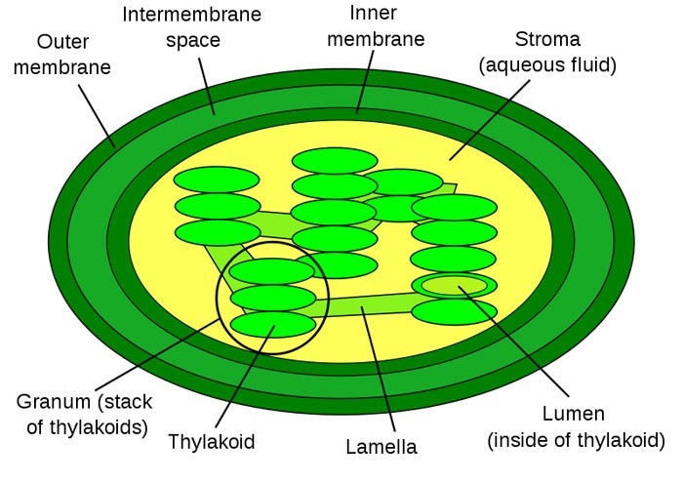

Describe the following parts of the chloroplast (make sure to include where the light reactions and the Calvin cycle occur):
  - Thylakoid membrane:
  - Granum:
  - Stroma:
Chromatography
- What is chromatography used for?

- Draw the chromatography for a leaf.

- What do each of the bands represent?

- What does chromatography tell us about plant pigments?

- What color(s) do plants absorb the most?

- What color(s) do plants absorb the least?

Photosynthesis
- Write out the equation for photosynthesis:

- What are the reactants of photosynthesis?

- How does the plant get the reactants it needs for photosynthesis?

- What are the products of photosynthesis?

- How are these products used?

- Who are plants carrying out photosynthesis for?

Light Reactions
- Where do the light reactions occur?
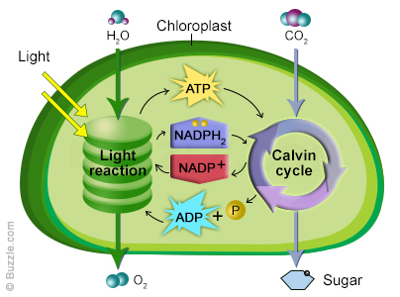
- Reactants | Products

Calvin Cycle
- Where does the Calvin Cycle take place?

Reactants | Products

- What are photosystems?
- The splitting of water in the light reactions produces ________________________.
- As protons move through _________ ___________________, ATP is made.
- The electrons in NADPH come from ______________________________________.
- The main enzyme of the Calvin cycle is ____________________________________.
- The Calvin cycle produces ______________________which can be assembled into glucose, maltose, etc.
- Fixing carbon means making it ____________________________________________
- What happens to the Calvin cycle if you don’t have ATP, NADPH, or CO_{2?}
____________________________________________________________________________________________________________
- What is photorespiration? ________________________________________________
________________________________________________________________________
- Almost all plants are called ________________________________________ plants.
- How do CAM plants deal with the problem of photorespiration? ______________
________________________________________________________________________
- How do C4 plants deal with the problem of photorespiration? ________________
________________________________________________________________________

