Name: ______________________________________

Cell Division and Molecular Genetics (Unit 6) Multiple Choice Questions

- Which of the following organisms does NOT reproduce cells by mitosis and cytokinesis?
  - Cow
  - Bacterium
  - Mushroom
  - Cockroach
  - Banana tree

- During which phase(s) of mitosis do we find coiled chromosomes composed of two chromatids?
  - From interphase through anaphase
  - From G1 of interphase through metaphase
  - From prophase through telophase
  - From anaphase through telophase
  - From prophase through metaphase

- If mammalian cells receive a go-ahead signal at the G1 checkpoint, they will:
  - Move directly into telophase.
  - Complete the cycle and divide.
  - Exit the cycle and switch to a nondividing state.
  - Show a drop in MPF concentration.
  - Complete cytokinesis and form new cell walls.

- How do the daughter cells at the end of mitosis and cytokinesis compare with their parent cell when it was in G1 of the cell cycle?
  - The daughter cells have half the amount of cytoplasm and half the amount of DNA.
  - The daughter cells have half the number of chromosomes and half the amount of DNA.
  - The daughter cells have the same number of chromosomes and half amount of DNA.
  - The daughter cells have the same number of chromosomes and the same amount of DNA.
  - The daughter cells have the same number of chromosomes and twice the amount of DNA.

- Proteins that are involved in the regulation of the cell cycle, and that show fluctuations in concentration during the cell cycle, are called:
  - ATPases.
  - Kinetochores.
  - Centrioles.
  - Proton pumps.
  - Cyclins.

- The restoration of the diploid chromosome number after halving in meiosis is due to:
  - Synapsis.
  - Fertilization.
  - Mitosis.
  - DNA replication.
  - Chiasmata.

- The statement that is NOT true for meiosis is:
- Diploid cells produce haploid cells that are specialized for sexual reproduction.
- Crossing over takes place during prophase I.
- Haploid cells produce diploid cells that become egg or sperm.
- Meiosis is a form of cell division.
- Meiosis occurs only in the reproductive tissues.

- Meiosis II is similar to mitosis because:
- Sister chromatids separate.
- Homologous chromosomes separate.
- DNA replication precedes the division.
- They both take the same amount of time.
- Haploid cells are produced.

- Homologous chromosomes line up in pairs in:
- Metaphase of mitosis.
- Metaphase I.
- Metaphase II.
- Interphase.
- Prophase of mitosis.

- Which of the following statements is FALSE?
  - DNA uses the sugar deoxyribose.
  - DNA uses the nitrogenous base uracil.
  - DNA is a nucleic acid.
  - One DNA molecule can include four types of nucleotides in its structure.
  - DNA molecules have a sugar-phosphate backbone.
11. In his transformation experiments, what did Griffith observe?
A) Mutant mice were resistant to bacterial infections.
B) Mixing a heat-killed pathogenic strain of bacteria with a living nonpathogenic strain can convert some of the living cells into the pathogenic form.
C) Mixing a heat-killed nonpathogenic strain of bacteria with a living pathogenic strain makes the pathogenic strain nonpathogenic.
D) Infecting mice with nonpathogenic strains of bacteria makes them resistant to pathogenic strains.
E) Mice infected with a pathogenic strain of bacteria can spread the infection to other mice.

12. In trying to determine whether DNA or protein is the genetic material, Hershey and Chase made use of which of the following facts?
A) DNA contains sulfur, whereas protein does not.
B) DNA contains phosphorus, whereas protein does not.
C) DNA contains nitrogen, whereas protein does not.
D) DNA contains purines, whereas protein includes pyrimidines.
E) RNA includes ribose, whereas DNA includes deoxyribose sugars.

- When one DNA molecule is copied to make two DNA molecules, the new DNA contains:
- 25% of the parent DNA.
- 50% of the parent DNA.
- 75% of the parent DNA.
- 100% of the parent DNA.
- None of the parent DNA.

14. A biochemist isolates, purifies, and combines in a test tube a variety of molecules needed for DNA replication. When she adds some DNA to the mixture, replication occurs, but each DNA molecule consists of a normal strand paired with numerous segments of DNA a few hundred nucleotides long. What has she probably left out of the mixture?
A) DNA polymerase
B) DNA ligase
C) nucleotides
D) Okazaki fragments
E) primase

- We would expect that a 15- nucleotide sequence will direct the production of a polypeptide that consists of:
- 2 amino acids.
- 3 amino acids.
- 5 amino acids.
- 7 amino acids.
- 15 amino acids.

- Which one of the following does NOT happen to eukaryotic RNA?
- Introns are added to the RNA.
- Exons are spliced together.
- A small cap of extra nucleotides is added to one end of the RNA.
- A long tail of extra nucleotides is added to the other end of the RNA.
- The completed RNA molecule is exported out of the nucleus.

- The transfer of genetic information from DNA to RNA is called:
- Translation.
- Transcription.
- Initiation.
- Elongation.
- Promotion.

#18 and 19 on the back.

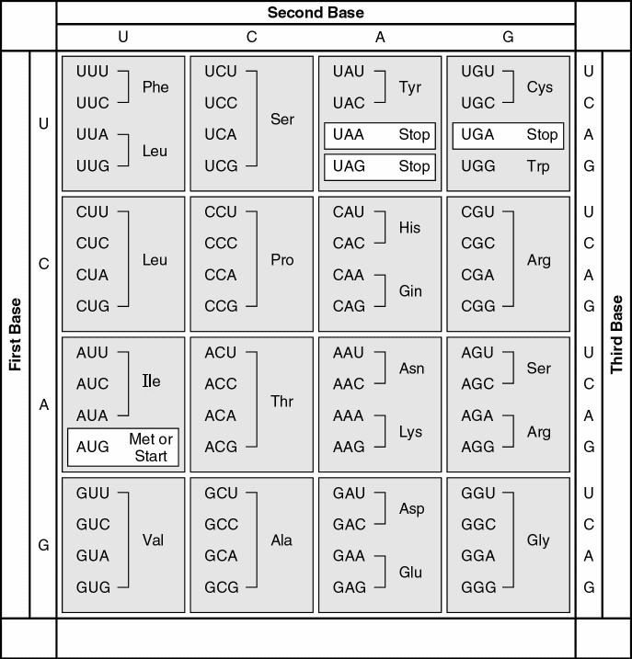
18. A peptide has the sequence NH2-phe-pro-lys-gly-phe-pro-COOH. Which of the following sequences in the coding strand of the DNA could code for this peptide?
A) 3' UUU-CCC-AAA-GGG-UUU-CCC
B) 3' AUG-AAA-GGG-TTT-CCC-AAA-GGG
C) 5' TTT-CCC-AAA-GGG-TTT-CCC
D) 5' GGG-AAA-TTT-AAA-CCC-ACT-GGG
E) 5' ACT-TAC-CAT-AAA-CAT-TAC-UGA

Use this representation to answer the following question.

DNA template strand 5' ____________________________ 3'
DNA complementary strand 3' ____________________________ 5'

19. Given the locally unwound double strand above, in which direction does the RNA polymerase move?
A) 3' → 5' along the template strand
B) 5' → 3' along the template strand
C) 3' → 5' along the complementary strand
D) 5' → 3' along the complementary strand
E) 5' → 3' along the double-stranded DNA

