Name: _______________________________________

Cell Energy (Unit 3) Multiple Choice Questions

1. The final electron acceptor in cellular respiration is
A. NADP+
B. NAD+
C. oxygen
D. ATP

2. Autotrophic organisms that are able to capture free energy from simple inorganic molecules are termed
A. hydrolytic
B. chemosynthetic
C. photosynthetic
D. ectothermic

3. Glycolysis occurs in the _____________ of the ____________.
A. stroma; mitochondria
B. cytoplasm; mitochondria
C. cytoplasm; cell
D. matrix; cell

4. In glycolysis, glucose is split into two molecules of ____________, which are then transported with the help of ATP into the ____________.
A. pyruvate; mitochondria
B. ATP; mitochondria
C. ADP & inorganic phosphate; cell
D. pyruvate; cytoplasm

5. Where do photosystem I and II reactions occur in the chloroplasts?
A. thylakoid membranes
B. outer membrane
C. lumen
D. cytoplasm

6. As excited electrons move along photosystem II electron transport chain, their energy is used to create a difference in charges across the thylakoid membrane. The difference in charges will drive the phosphorylation of ADP through a process known as
A. glycolysis
B. oxidation
C. reduction
D. chemiosmosis

7. Fermentation produces organic molecules, and occurs
A. in the absence of oxygen
B. in the presence of oxygen
C. during the electron transport chain
D. in the mitochondria

8. When a H is bonded to NADP+ in photosynthesis, NADP+ becomes ____________ to ________.
A. reduced; NADPH
B. oxidized; NADPH
C. reduced; NADPH+
D. oxidized; NADPH+

9. The synthesis of ATP and NADPH provides the energy to power what photosynthetic reaction?
A. Krebs cycle
B. Calvin Cycle
C. electron transport chain
D. photosystem I and II

10. The fixation of carbon dioxide takes place in __________ and results in the synthesis of ________________.
A. glycolysis; pyruvate
B. the thylakoid space; ATP
C. the matrix; carbohydrates
D. the stroma; carbohydrates

11. Electrons that are removed in a series of chemical reactions in the matrix are carried by NADH and FADH2 to
A. to the Calvin cycle
B. to the Kreb's cycle
C. to the cytoplasm
D. the electron transport chain

12. In prokaryotes, the creation of the proton gradient established during respiration occurs
A. across the inner mitochondrial membrane
B. in the matrix
C. in the stroma
D. across the plasma membrane

13. In humans, the mitochondria found in type I muscle fibers have inner membranes with a surface area approximately five times the area of the outer membrane. A high school student has a rare genetic disorder in which the mitochondria in her muscle cells have inner membranes with a surface area less than three times the area of the outer membrane.
Which of the following would be a potential consequence of this disorder?
A. the student's muscle cells would be able to produce more ATP per unit time via oxidative phosphorylation than most other people's muscle cells
B. the student's muscle cells would be able to produce less ATP per unit time via oxidative phosphorylation than most other people's muscle cells
C. the student's muscle cells would be able to produce more ATP per unit time via substrate level phosphorylation than most other people's muscle cells
D. the student's muscle cells would be more permeable to glucose than most other people's muscle cells

14. The following leaf disk experiment was designed to study the rate of photosynthesis:
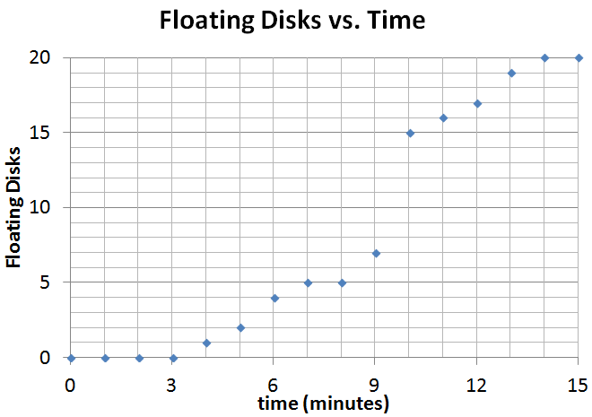
Twenty 5 mm diameter disks were ‘punched’ out of spinach leaves and placed into plastic syringe. A small volume of 0.2% sodium bicarbonate solution was drawn into the syringe and a vacuum was created to saturate the leaf’s air spaces with the solution. After all of the disks have sunk in the syringe, they were transferred into a clear plastic cup filled with bicarbonate solution. They were then placed under a light source and a timer was started. At the end of each minute, the number of floating disks were recorded.
From the graph to the right, what is the ET50 (estimated time for 50% of the disks to float)?
A. 5.0 minutes C. 9.5 minutes
B. 6.5 minutes D. 15 minutes

15. For the experiment described in #14, what is the purpose of the sodium bicarbonate?
A. It buffers the solution the disks are placed in for the correct pH and ion concentration.
B. It negates the reaction of aerobic respiration, which can alter the amount of oxygen formed.
C. If you used distilled water, the cells of each disk would burst, due to the large influx of water.
D. It supplies the carbon needed for the reaction of photosynthesis to proceed.
16. Photosynthesis may be studied in a number of ways. For this protocol, a dye-reduction technique will be used. This dye-reduction investigation tests the hypothesis that light and chloroplasts are required for the light reactions to occur. A compound, DPIP (2,6-dichlorophenol-indophenol), will be substituted so that when a reduction reaction has occurred, the DPIP changes from blue to colorless. In this experiment, chloroplasts are extracted from spinach leaves and incubated with DPIP in the presence of light. As the DPIP is reduced and becomes colorless, the resultant increase in light transmittance (at 605 nm, the Amax of ‘blue’ DPIP) is measured over a period of time using a spectrophotometer.
Which molecule does DPIP replace in the light reactions of photosynthesis? (In other words, what is the final electron acceptor at the end of the light reactions?)
A. chlorophyll
B. ATP
C. water
D. NADP+

17. For the experiment described in #16, one experimental trial will contain chloroplasts that have been boiled for 5 mintues before the DPIP was added. Which of the following plots best shows this trial as compared to the control group?
A
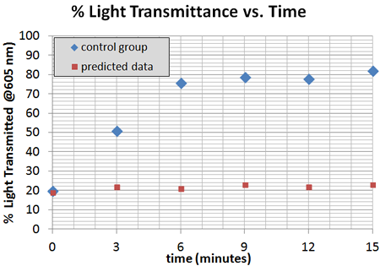
B
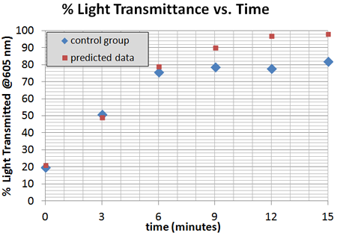
C
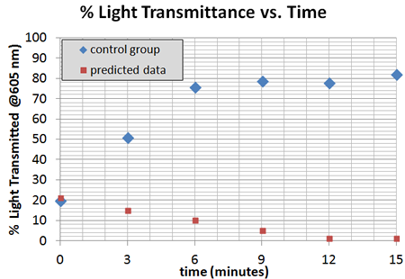
D (on next page)
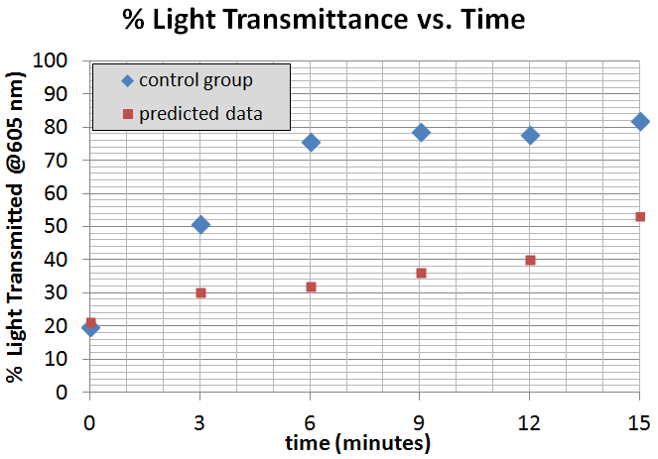

18. To measure the rate of organismal respiration, a 10 mL microrespirometer was constructed. These measure relative volume as oxygen is consumed by respiring organisms. However, as oxygen gas is consumed during aerobic respiration, it is replaced by CO2 gas at a ratio of one molecule of CO2 for each molecule of O2. However, in the following protocol, the CO2 produced is removed by a small piece of cotton treated with potassium hydroxide (KOH).
KOH reacts with CO2 to form the solid potassium carbonate (K2CO3). 5 mL of germinating pea seeds were placed in one setup, while a control microrespirometer was filled with 5 mL of glass beads in another. Over the course of 20 minutes, changes in the volume were measured by following the distance of a red soap bubble placed on the end of a 40 uL capillary tube at time = 0.

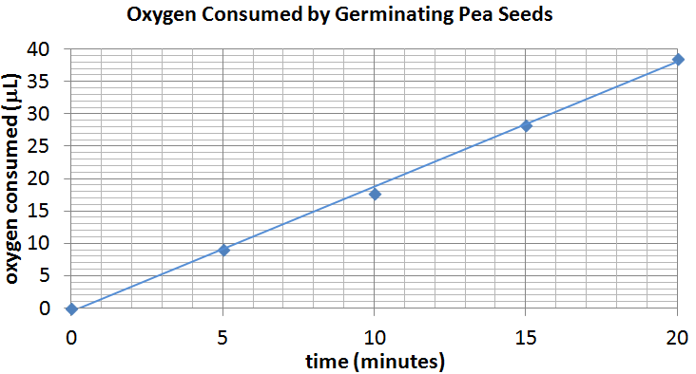

What is the rate of oxygen consumption (in microliters per minute) based on this data?
A. 1.9
B. 19
C. 3.8
D. 38

