Name: _____________________________________________ Date: ____________________________ Period: ______

**AP Biology Exam Review: Cell Energy – Cell Energy (Unit 3)**

**Helpful Videos and Animations:**

1. [Bozeman Science: Photosynthesis and Respiration](http://www.youtube.com/watch?v=0IJMRsTcwcg&feature=BFa&list=PLFCE4D99C4124A27A)
2. [Bozeman Science: Photosynthesis](http://www.youtube.com/watch?v=g78utcLQrJ4&feature=relmfu)
3. [Bozeman Science: Cellular Respiration](http://www.youtube.com/watch?v=Gh2P5CmCC0M&feature=relmfu)

**Unit Vocabulary:**

-ATP (adenosine triphosphate)

-ADP (adenosine diphosphate)

-Hydrolysis of ATP

-Phosphorylation of ADP

-Pi (inorganic phosphate… a single phosphate group)

-Mitochondrion (outer membrane, intermembrane space, inner membrane, cristae, matrix)

-Oxidation-Reduction Reaction / Redox Reaction (remember OIL RIG… Oxidation Is Loss, Reduction Is Gain)

-Electrons

-Oxidized

-Reduced

-Glycolysis

-Glucose

-Pyruvate

-NAD+ / NADH

-Acetyl CoA

-Carbon Dioxide / CO2

-Krebs Cycle / Citric Acid Cycle

-FAD / FADH2

-Electron Transport Chain

-Membrane Protein Pumps / Electron Carrier Proteins

-Oxygen Gas / O2

-Final Electron Acceptor

-Hydrogen Ions / Protons / H+

-Concentration Gradient / Electrochemical Gradient

-Proton Motive Force

-ATP Synthase

-Chemiosmosis

-Oxidative Phosphorylation vs. Substrate-Level Phosphorylation

-Anaerobic Respiration / Fermentation

-Alcoholic Fermentation / Ethanol Fermentation / Ethyl Alcohol Fermentation

-Ethanol / Ethyl Alcohol

-Lactic Acid Fermentation

-Lactic Acid / Lactate

-Stomata (singular Stoma)

-Guard Cells

-Chloroplast (outer membrane, inner membrane, stroma, thylakoid, thylakoid space / lumen, granum)

-Light Reactions / Light-Dependent Reactions

-Thylakoid Membrane

-Chlorophyll

-Accessory Pigments

-Photosystems (II and I)

-Primary Electron Acceptor / PEA

-NADP+ / NADPH

-Noncyclic Photophosphorylation / Noncyclic Phosphorylation / Noncyclic Electron Flow

-Cyclic Photophosphorylation / Cyclic Phosphorylation / Cyclic Electron Flow

-Calvin Cycle / Dark Reactions / Light-Independent Reactions

-Carbon Fixation

-RuBP / Ribulose Bisphosphate

-Rubisco / RuBP Carboxylase

-PGAL / G3P / Glyceraldehyde-3-Phosphate

-Photorespiration

-C3 Plants

-C4 Plants / C4 Photosynthesis

-Mesophyll Cells

-Bundle Sheath Cells

-CAM Plants / CAM Photosynthesis

-Malic Acid

-Autotrophs (Photosynthetic Autotrophs / Photoautotrophs vs. Chemosynthetic Autotrophs / Chemoautotrophs)

-Photosynthesis /

-Chemosynthesis / Chemoautotrophy

-Heterotrophs

**Topic Outline:**

***Unit 3 Notes, Part 1: Cell Respiration***

1. Cellular Respiration

* Explain the difference between aerobic cellular respiration and anaerobic cellular respiration (aka fermentation)
* Write the full balanced chemical equation for cellular respiration
* Cell Respiration = Exergonic
* A Series of Redox Reactions: Oxidation (loss of electrons / energy) ; reduction (gain of electrons / energy)
* Gycolysis

1. In cytosol
2. Glucose 🡪2 Pyruvate (electrons and H+ taken from glucose to reduce 2 NAD+ 🡪 2NADH ; 2 net ATP gained)

* Oxidation of Pyruvate

1. Transport protein moves pyruvate from cytosol to matrix of mitochondrion
2. 2 Pyruvate 🡪 2 Acetyl CoA (an enzyme removes CO2, takes away electrons to reduce NAD+ 🡪 NADH, and adds coenzyme A)

* Citric Acid Cycle

1. 2 turns of the cycle (1 per acetyl CoA) 🡪 one molecule of glucose is fully oxidized to CO2
2. A series of oxidation / reduction reactions produces 🡪 2CO2, 3NADH, 1FADH2 (another electron / hydrogen carrier) and 1 ATP per turn of the cycle (Total = X2)

* Electron Transport Chain + Chemiosmosis

1. ETC 🡪 NADH and FADH2 “dump” electrons off to the inner mitochondrial membrane’s electron transport chain proteins use energy from electrons passed between them to “pump” H+ across the inner mitochondrial membrane into the intermembrane space

The final electron acceptor is O2 🡪 H2O

1. Chemiosmosis 🡪 H+ flow back down their gradient (proton motive force) through a channel in ATP synthase into the matrix🡪 ATP synthase turns and creates ATP from ADP and Pi

Chemiosmosis is an energy-coupling mechanism that uses energy stored in the form of an H+ gradient across a membrane to drive cellular work (creation of ATP by ATP synthase)

This method of making ATP is known as oxidative phosphorylation (ADP is phosphorylated and oxygen is necessary to keep the electrons flowing)

Oxidative phosphorylation accounts for 26-28 of the 30-32 total ATP created during cellular respiration

* Fermentation / Anaerobic Respiration (creating ATP without oxygen)

1. An expansion of glycolysis (the Kreb’s / Citric Acid Cycle and Electron Transport Chain are not used)
2. Glycolysis 🡪 2 ATP
3. Reactions that regenerate NAD+ to act as an electron acceptor for electrons released during the breakdown of glucose to pyruvate

2 Types of Fermentation = alcohol fermentation and lactic acid fermentation

Alcohol Fermentation 🡪 pyruvate is converted to ethanol, releasing CO2 and regenerating NAD+ from NADH

Lactic Acid Fermentation 🡪 pyruvate is reduced by NADH (NAD+ is formed in the process), and lactate is formed as a waste product

1. Facultative anaerobes can use aerobic respiration if oxygen is present but can switch to fermentation under anaerobic conditions ; obligate anaerobes cannot survive in the presence of oxygen

***Unit 3 Notes, Part 2: Photosynthesis and Part 3: Exceptions to Normal Photosynthesis and Comparing Photosynthesis and Cellular Respiration***

1. Photosynthesis

* Know the difference between autotrophs and heterotrophs
* Know the structure of a chloroplast and the location of cells with high concentrations of chloroplasts (mesophyll tissue of leaf) ; Be able to identify the following structures within a chloroplast – stroma, thylakoid,granum, thylakoid space
* Know the location of stomata on a leaf’s surface (bottom surface) and their function in transpiration and gas exchange (How do stomata open and close?)
* Know the full balanced chemical equation for photosynthesis
* Summary of the two steps in photosynthesis: Light Reactions and Calvin Cycle

1. Light Reactions (in thylakoid membrane)

-Light is absorbed by chlorophyll and drives the transfer of electrons from water to NADP+ 🡪 NADPH

-Water is split when electrons are removed, and O2 is released from the stomata

-ATP is generated, using chemiosmosis to power the addition of a phosphate group to ADP 🡪 ATP in a process called photophosphorylation

-Vocabulary: photons, pigments, chlorophyll, carotenoids / accessory pigments, absorption spectrum of a pigment, action spectrum for photosynthesis, photosystems (I and II), reaction centers, primary electron acceptor

-Key Skills: Explain the difference between linear (noncyclic) electron flow and cyclic electron flow

1. Calvin Cycle

-electrons and H+ from NADPH and energy from ATP are used to reduce CO2 into organic molecules (Glyceraldehyde-3 Phosphate / G3P… the precursor molecule to glucose) in a process called carbon fixation

-Vocabulary: ribulose bisphosphate (RuBP), rubisco, glyceraldehydes 3-phosphate (G3P)

-Key Skills: Describe the role of the rubisco enzyme in carbon fixation

* Understand how C4 and CAM plants fix carbon in hot, arid climates where stomata must remain closed at times ; know the difference between spatial and temporal separation (Remember, normal plants = C3 plants)

Vocabulary: photorespiration, bundle-sheath cells, mesophyll cells

**Lab Review**

***Note: We may or may not have done these labs in class. If not, please read over the information and be familiar with the basic set-up of the lab.***

***Cellular Respiration Lab***

|  |  |
| --- | --- |
| Background Information | In this lab, you will use a device called a respirometer to measure the use of oxygen gas during cellular respiration in germinating (i.e. sprouting / growing) peas vs. non-germinating (i.e. dormant / not growing).  A respirometer can be used to measure changes in gas volume. During cellular respiration, two gases are changing in volume.  Oxygen gas is being consumed by the respiring cells and carbon dioxide gas is diffusing out of the cells.  The respirometer, therefore, has to be able to deal with two simultaneously changing gas volumes.  This is accomplished by introducing potassium hydroxide into the device.  KOH absorbs carbon dioxide, following this equation  CO2 + 2KOH --> K2CO3 + H2O  http://biologycorner.com/resources/cell_respiration_pipetsPotassium carbonate ( K2CO3 ) is a solid precipitate.  Any CO2 produced is immediately converted from a gas to a solid and is therefore no longer governed by gas laws.  This allows the respirometer to measure only one variable, the consumption of oxygen gas by living cells.  Two sets of three respirometers will be assembled during this lab exercise.  Each set will be incubated at a different temperature.  One respirometer will contain germinated seeds, one will contain a mix of nongerminating seeds and plastic beads, and a third will contain only plastic beads.  water bathThe purpose of the beads is to ensure that each respirometer is uniform in volume.  The respirometers will also contain a layer of cotton that has been saturated with KOH so that carbon dioxide will be absorbed.  The respirometers will be submerged in a pan of water; water will flow from an area of high pressure to an area of low pressure.  As oxygen is used up by the respiring seeds, the gas pressure inside the respirometer will decrease and the water will flow into the pipet down its pressure gradient.  http://biologycorner.com/resources/cellular_respiration_read.gif  You will be able to measure the position of the water entering the respirometer using the measurements on the side of the respirometer (see below). |
| Hypothesis | If we measure the rate of cellular respiration in germinating vs. non-germinating peas, then the germinating peas will have a higher rate of cellular respiration.  If we measure the rate of cellular respiration in peas at room temperature vs. cold temperatures, then the peas at room temperature will have a higher rate of cellular respiration. |
| Methods | Basics: You will have 6 different respirometers set-up under the following conditions.   |  |  |  | | --- | --- | --- | | **#** | **Contents of the Respirometer** | **Temperature** | | 1 | Germinating Peas | Room Temperature | | 2 | Non-Germinating Peas | Room Temperature | | 3 | Glass Beads | Room Temperature | | 4 | Germinating Peas | Cold | | 5 | Non-Germinating Peas | Cold | | 6 | Glass Beads | Cold |   **Independent Variable**: There are actually two independent variables in this experiment—germinating vs non-germinating peas and room temperature vs. cold.  **Dependent Variable:** Rate of cellular respiration (measured by the rate of oxygen consumption)  **Control Group** (group not exposed to the independent variable): Respirometers 3 and 6 (contain glass beads, which should not go through cellular respiration)  **Experimental Groups** (groups exposed to varying degrees of the independent variable): Respirometers 1, 2, 4, and 5.  **Constants** (to make sure that any differences between the control group and experimental groups are due to the independent variable alone): volume of peas and/or glass beads in the respirometer, amount of cotton and KOH, etc.  **Repeated** **Trials**: Need to have 3-5 trials for each respirometer set-up (#1-6) to ensure accuracy of data |
| Data Collection and Organization | You will record your data in a chart similar to the one given below… |
| Data Analysis | http://biologycorner.com/APbiology/images/corn_resp_graph.gifYou will compare the mean changes in volume after twenty minutes across 3-5 trials in each of the six respirometers to either support or refute your hypothesis.  You can also construct a scatter plot with connecting lines like the one shown to the right to visualize differences in the rate of respiration for the six different respirometer conditions. (Note: They used corn instead of peas, but you get the idea!) This graph will also allow you to see if there are any changes in the rate of respiration across the twenty minutes within each treatment group. |

***Photosynthesis Lab***

|  |  |
| --- | --- |
| Background Information | In this lab, you will measure the rate of photosynthesis of spinach leaf disks in the presence of a carbon source (ex: carbon dioxide) and in the absence of a carbon source. |
| Hypothesis | If the leaf disks are provided with a carbon source, then they will undergo photosynthesis, produce oxygen, and float.  If the leaf disks are NOT provided with a carbon source, then they will not undergo photosynthesis, produce oxygen, and float. |
| Methods | Basics:  You will prepare a bicarbonate solution using baking soda and water. Then, you will cut 10 leaf disks of uniform size for two treatments—one with bicarbonate solution and one with distilled water (i.e. no carbon source).  You will then remove any existing air between the leaf disks cells by infiltrating the leaf disks with whatever solution they will be later submerged in (either bicarbonate solution or distilled water). You will infiltrate the leaf disks with solution by placing a small amount of solution along with the leaf disks into a plastic syringe and creating a vacuum (see picture to the right)  Once the air has been removed from the leaf disks for the two treatment groups, place about 150 mL of each solution into two beakers. Submerge the corresponding leaf disks in the solution. (They should sink to the bottom of the solution, since all air has been removed from the spaces between the leaf disk cells and replaced with solution.) Place both beakers (with submerged leaf disks) under a lamp. As the leaf disks go through photosynthesis in the bicarbonate solution (but not in the distilled water solution because there is no carbon source), they will produce oxygen gas as a product, which will cause them to float. Record the total number of leaf disks floating every minute until all 10 leaf disks in the beaker are floating.  ***Note: You could also use this set-up to test the effect of different bicarbonate concentrations, different light intensities, different light wavelengths, etc. on the rate of photosynthesis***  **Independent Variable**: presence or absence of a carbon source (i.e. bicarbonate solution)  **Dependent Variable**: Rate of photosynthesis (measured as ET50. See “Data Analysis” below for a definition of ET50 ).  **Control Group** (group not exposed to the independent variable): leaf disks submerged in distilled water  **Experimental Groups** (groups exposed to varying degrees of the independent variable): leaf disks submerged in bicarbonate solution  **Constants** (to make sure that any differences between the control group and experimental groups are due to the independent variable alone): same amount of solution in the beaker, same amount and size of leaf disks, same light, etc.  **Repeated Trials**: Need to have 3-5 trials (with 10 leaf disks in each trial) for the two treatments (distilled water and bicarbonate solution) to ensure accuracy of data |
| Data Collection and Organization | You will record your data in a chart like the one given to the right…   |  |  |  | | --- | --- | --- | | **Time (in minutes)** | **Total # of Leaf Disks Floating in the Bicarbonate Solution** | **Total # of Leaf Disks Floating in the Distilled Water** | | 1 |  |  | | 2 |  |  | | 3 |  |  | | 4 |  |  | | 5 |  |  | | 6 |  |  | | 7 |  |  | | 8 |  |  | | 9 |  |  | | 10 |  |  |     You will then graph your data using a scatter plot connected with a line like the one given to the right… |
| Data Analysis | The blue lines in the graph given above represent the ET50 , the time at which 50% of the leaf disks are floating (in this case, 5 leaf disks). A high ET50 (i.e. a long time for the leaf disks to float) corresponds to a low rate of photosynthesis. A low ET50 (i.e. a short time for the leaf disks to float) corresponds to a high rate of photosynthesis.  You will determine the average ET50 over 3-5 trials for each of the treatment groups (bicarbonate solution vs. distilled water). This will allow you to support or refute your hypotheses. (Note: The leaf disks in the distilled water may never float because they should not undergo photosynthesis. Their ET50, therefore, is an infinite amount of time! If leaf disks do float in the distilled water, it is probably because not all the air was successfully removed from the spaces between the leaf cells by the syringe.) |

**Practice “Thinking” Questions**

1. The figure below outlines the process of cellular respiration. Glucose and oxygen are both reactants in this process.
2. Describe the journey of a single carbon atom from glucose in cellular respiration
3. Describe the journey of a single hydrogen atom from glucose in cellular respiration

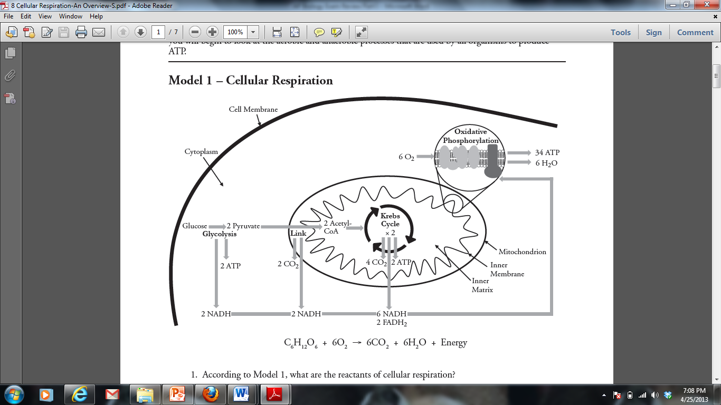

1. Describe the function of the oxygen molecules in cellular respiration
2. The figure below outlines the process of photosynthesis. Carbon dioxide and water are both reactants in this process.
3. Describe the journey of a single hydrogen atom from water in photosynthesis.
4. Describe the journey of a single oxygen atom from water in photosynthesis.
5. Describe the journey of a carbon dioxide molecule in photosynthesis.

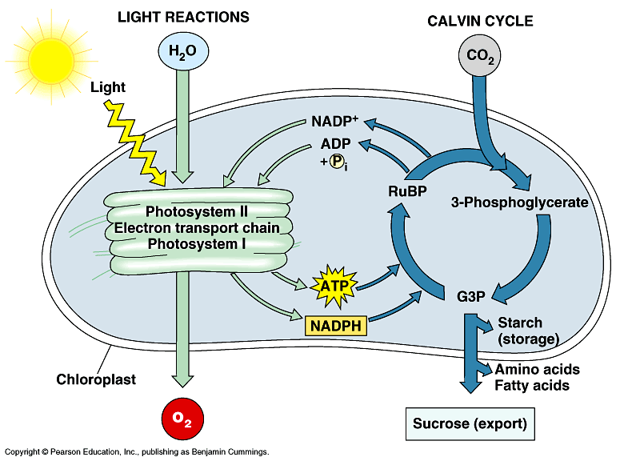

1. 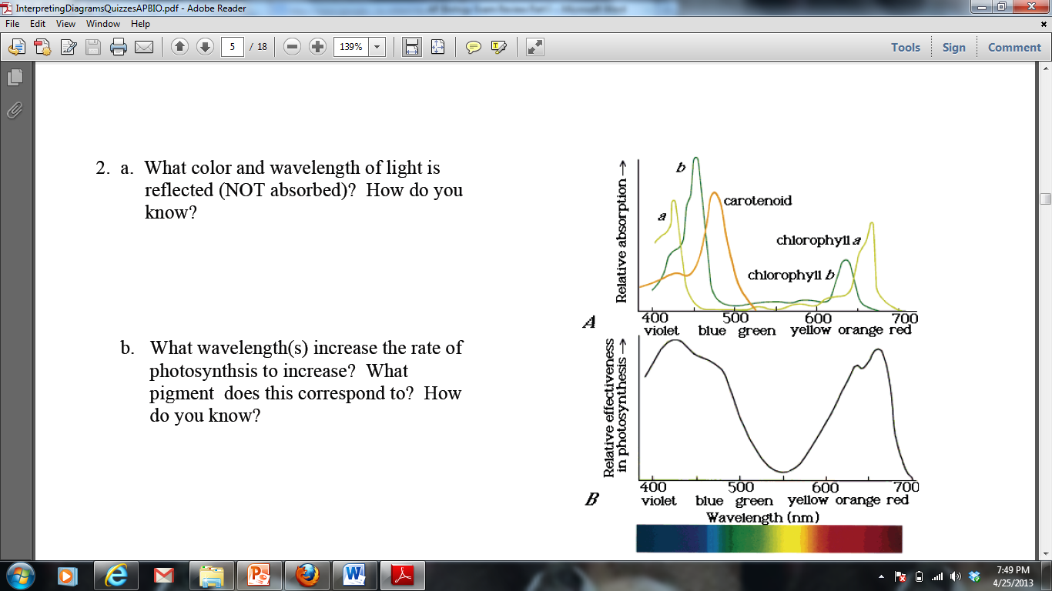The figures to the right display the absorption range for several different pigments found in plants (top) and the rate of photosynthesis at varying conditions of wavelength in one plant species (bottom):
2. What color and wavelength of light is reflected by the plant species tested? How do you know?
3. What wavelength(s) increase the rate of photosynthesis in the plant species tested? What pigment does this correspond to? How do you know?

**Practice Short Response Questions**

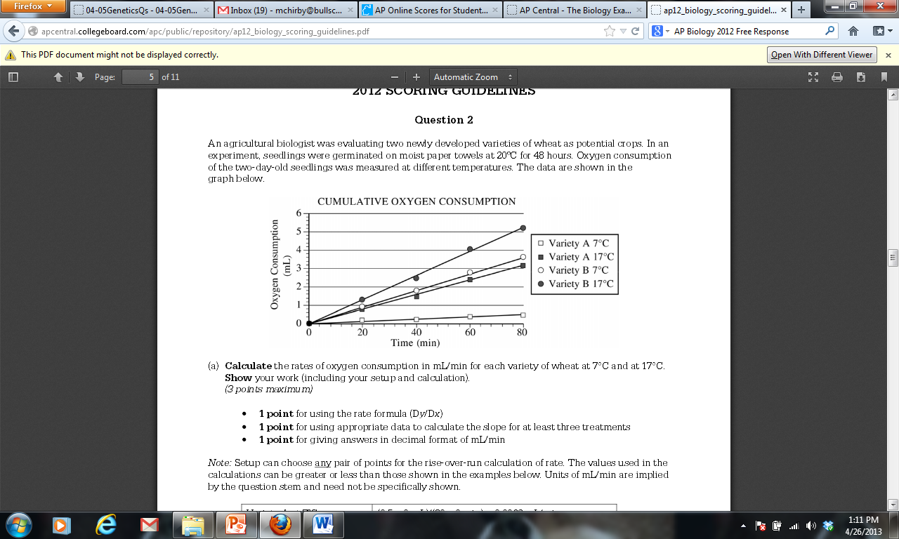

In a second experiment, Variety A seedlings at 17oC were treated with a chemical that prevents NADH from being oxidized to NAD+. **Predict** the most likely effect of the chemical on metabolism and oxygen consumption of the treated seedlings. **Explain** your prediction.

**Practice Long Response Questions**

A controlled experiment was conducted to analyze the effects of darkness and boiling on photosynthetic rate of incubated chloroplast suspension. The dye reduction technique was used. Each chloroplast suspension was mixed with DPIP, an electron acceptor that changes from blue to clear when it is reduced. Each sample was placed in individually in a spectrophotometer and the percent transmittance was recorded. *(Hint: The percent transmittance is higher through clear liquid than blue liquid!)* The three samples used were prepared as follows:

* Sample 1 – chloroplast suspension + DPIP
* Sample 2 – chloroplast suspension surrounded by foil wrap to provide a dark environment + DPIP
* Sample 3 – chloroplast suspension that has been boiled + DPIP

|  |  |  |  |
| --- | --- | --- | --- |
| Time (min) | Light, unboiled  % Transmittance  Sample 1 | Dark, Unboiled  % Transmittance  Sample 2 | Light, Boiled  % Transmittance  Sample 3 |
| 0 | 28.8 | 29.2 | 28.8 |
| 5 | 48.7 | 30.1 | 29.2 |
| 10 | 57.8 | 31.2 | 29.4 |
| 15 | 62.5 | 32.4 | 28.7 |
| 20 | 66.7 | 31.8 | 28.5 |

1. **Construct** and **label** a graph showing the results of the three samples
2. **Identify** and **explain** the control **OR** controls for this experiment
3. The differences in the curves of the graphed data indicate that there were differences in the number of electrons produced in the three samples during the experiment. **Discuss** how electrons are generated in photosynthesis and why the three samples gave different transmittance results.

|  |  |  |  |  |  |  |  |  |  |  |  |  |  |  |  |  |  |  |  |
| --- | --- | --- | --- | --- | --- | --- | --- | --- | --- | --- | --- | --- | --- | --- | --- | --- | --- | --- | --- |
|  |  |  |  |  |  |  |  |  |  |  |  |  |  |  |  |  |  |  |  |
|  |  |  |  |  |  |  |  |  |  |  |  |  |  |  |  |  |  |  |  |
|  |  |  |  |  |  |  |  |  |  |  |  |  |  |  |  |  |  |  |  |
|  |  |  |  |  |  |  |  |  |  |  |  |  |  |  |  |  |  |  |  |
|  |  |  |  |  |  |  |  |  |  |  |  |  |  |  |  |  |  |  |  |
|  |  |  |  |  |  |  |  |  |  |  |  |  |  |  |  |  |  |  |  |
|  |  |  |  |  |  |  |  |  |  |  |  |  |  |  |  |  |  |  |  |
|  |  |  |  |  |  |  |  |  |  |  |  |  |  |  |  |  |  |  |  |
|  |  |  |  |  |  |  |  |  |  |  |  |  |  |  |  |  |  |  |  |
|  |  |  |  |  |  |  |  |  |  |  |  |  |  |  |  |  |  |  |  |
|  |  |  |  |  |  |  |  |  |  |  |  |  |  |  |  |  |  |  |  |
|  |  |  |  |  |  |  |  |  |  |  |  |  |  |  |  |  |  |  |  |
|  |  |  |  |  |  |  |  |  |  |  |  |  |  |  |  |  |  |  |  |
|  |  |  |  |  |  |  |  |  |  |  |  |  |  |  |  |  |  |  |  |

**Practice Calculations Questions**

**Q10  (We did not learn about this formula in class. I do not think it will be on the AP Biology Exam, but it is on the AP Biology Formula Sheet, so I have included some practice problems.)**

***Why use this formula?***

The Q10 value represents the factor by which the rate of a reaction increases for every 10-degree rise in the temperature.

***Helpful Videos***

Bozeman Biology – Q10 – The Temperature Coefficient:

<https://www.youtube.com/watch?v=UQWWSmGM0yQ>

***Formula***

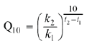

***Additional Information from the Formula Sheet***

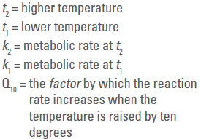

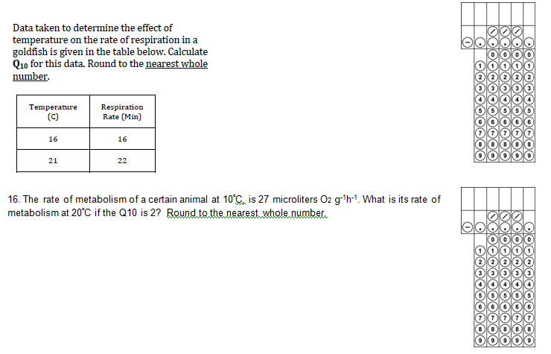

**Primary Productivity (We did not learn about this formula in class. I do not think it will be on the AP Biology Exam, but it is on the AP Biology Formula Sheet, so I have included some practice problems.)**

***Why use this formula?***

The primary productivity formula can be used to determine the mass of carbon fixed to glucose during photosynthesis based on measurements of the amount of oxygen gas produced.

***Formula***

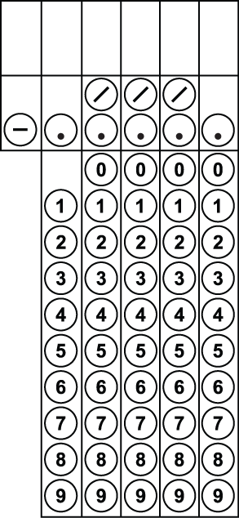

A scientist recorded the amount of dissolved oxygen produced by elodea, an underwater plant, as 52 mg O2/L. How much carbon (in mg/L) was fixed by this plant? Round your answer to the nearest tenth.

An elodea plant fixed 1.5 mg carbon / L. How much dissolved oxygen (in mg / L) was produced by this plant?