Name: _________________________________ Unit 3 Topic 3
Period: _______ Page: ______
Cell Membrane Coloring & Application
Composition of the Cell Membrane & Functions:
The cell membrane is also called the _______________ membrane and is made of a phospholipid _____________. The phospholipids have a hydrophilic (water attracting) ____________ and two hydrophobic (water repelling) ______________. SKETCH AND LABEL a phospholipid coloring the heads red and the tails blue.
PHOSPHOLIPID:

Another type of lipid in the cell membrane is __________________ that strengthens. Embedded in the phospholipid bilayer are proteins that aid in diffusion and in cell recognition. Proteins called ________________ proteins go all the way through the bilayer and recognize and assist medium to large and polar molecules passing through the membrane. Some of the membrane proteins have ______________________ attached to help cells in recognize each other and certain molecules; these molecules are called glycoproteins.
List the functions of each of the following macromolecules in the cell membrane:
a. | Carbohydrate:_______________________________________________________________________
b. | Protein:_____________________________________________________________________________
c. | Lipid:_______________________________________________________________________________
Correctly color code and identify the name for each part of the cell membrane.
Letter | Name/Color | Letter | Name/Color
_____ | Phospholipid bilayer (no color) | _____ | Phosphate heads (yellow)
_____ | Protein (pink) | _____ | Cholesterol (blue)
_____ | Fatty acid tails (orange) | _____ | Glycoprotein (Carbohydrate) (green)

Match the cell membrane structure or its function with the correct letter from the diagram above.
Letter | Structure/Function
_____ | Attracts water
_____ | Helps maintain strength of membrane
_____ | Involved in cell-to-cell recognition
_____ | Repels water
_____ | Make up the bilayer
_____ | Help transport certain materials across the cell membrane
Osmosis and Tonicity
- Define osmosis. _____________________________________
- In which direction does water move across membranes, up or down the concentration gradient? ________________
- Define these 3 terms:
a. isotonic- | _____________________________________
b. hypertonic | _____________________________________
c. hypotonic | _____________________________________

Use arrows to show the direction of water movement into or out of each cell. Color and label the cell in an isotonic environment light blue, the hypotonic environment yellow, and the hypertonic environment light green.
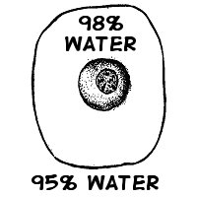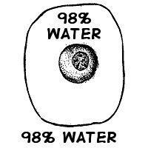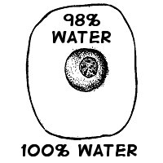

Match the description or picture with the osmotic condition:
A. Isotonic | _____ solution with a lower solute concentration
 | _____ solution in which the solute concentration is the same
B. Hypertonic | _____ condition plant cells require
 | _____ condition that animal cells require
C. Hypotonic | _____ red blood cell bursts (cytolysis)
 | _____ plant cell loses turgor pressure (Plasmolysis)
 | _____ solution with a higher solute concentration
 | _____ plant cell with good turgor pressure
 | _____ solution with a high water concentration

Label the tonicity for each solution (isotonic, hypotonic, or hypertonic):

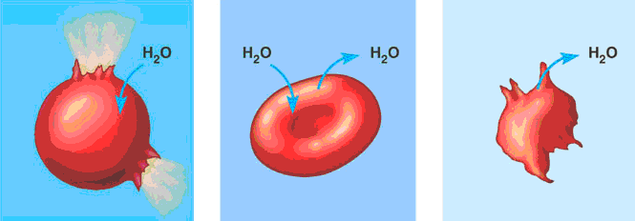
____________ ____________ ____________

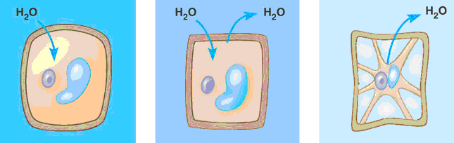
____________ ____________ ___________
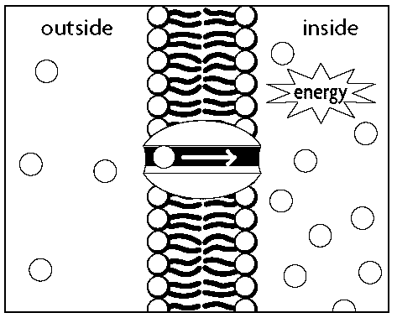
Transport Requiring Energy
- What type of transport is represented by the picture to the right? _______________________
- In which direction (concentration gradient), is the movement occurring? _________________
Color the internal environment of the cell yellow. Color and Label the transport proteins red and the substance being moved blue.

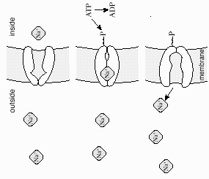
One type of active transport is called the ________________ pump which helps muscle cells contract. This pump uses ___________ to move ions ________ the concentration gradient.
The protein that is used to pump the ions through is called a ____________ protein and it changes its shape to move the ions across the cell membrane. Label and color the carrier proteins red and the ions green.

