Name: ____________________________ Unit 3 Topic 2

Period: ______ Page: _____

**Parts of the Cell: Coloring & Labeling**

***Part A: Animal Cell***

Label the following parts of the animal cell pictured below: ***Cell membrane, nuclear membrane, nucleoplasm, nucleolus, cytoskeleton, cytoplasm, smooth ER, rough ER, ribosomes, mitochondria, lysosomes, golgi apparatus.*** After labeling the parts, color-code them (ex: if you color one mitochondria orange, color the rest of the mitochondria orange as well).

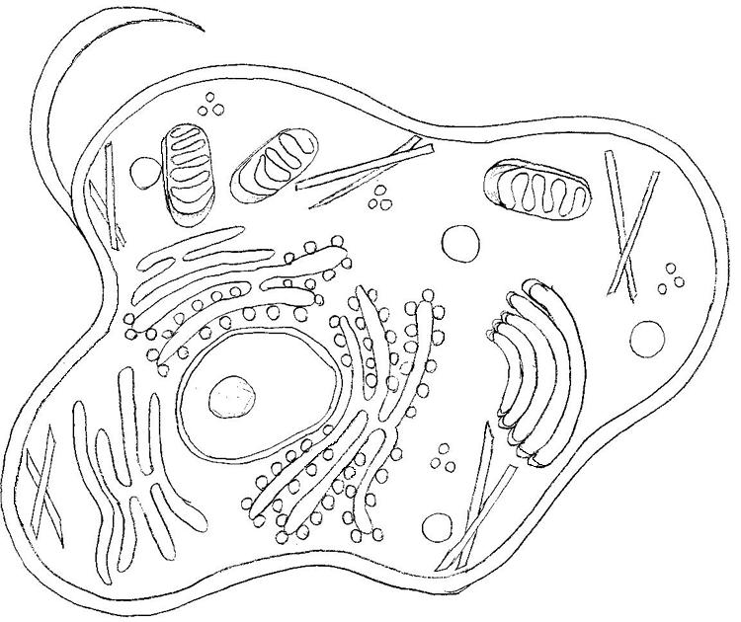

***Part B: Plant Cell***

Label the organelles in the plant cell pictured below: ***Cell wall, chloroplasts, central vacuole, AND all other parts that are also found in the animal cell pictured above!.*** After labeling the parts, color-code them using the colors already used above (ex: if you colored the above mitochondria orange, color the mitochondria here orange as well).

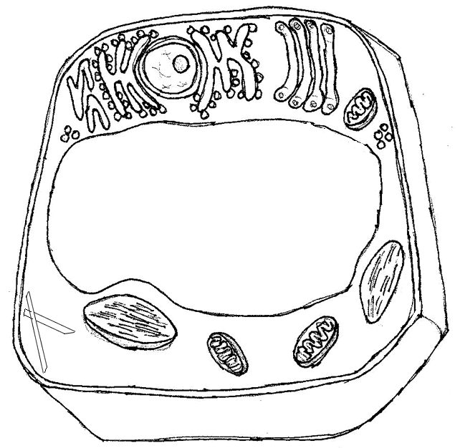

***Part C: Bacterial Cell***

In the space below, draw a general bacterial cell. You will then label and color-code these cellular components as well. You must include the following components: **cell wall, cell membrane, DNA (nucleoid region), ribosomes, cytoplasm, flagella**.

***Part D: Comparing and Contrasting***

In the following space, complete **two** Venn Diagrams: one for comparing/contrasting prokaryotic and eukaryotic cells, the second for comparing/contrasting plan and animal cells.

BOTH

Eukaryotic Cells

Prokaryotic Cells

Animals

Plants

BOTH

***Part E: Functions***

Complete the following table, using your notes to help you.

|  |  |  |
| --- | --- | --- |
| **Structure** | **Function** | **Found in? (pro, eu, all, plant, animal)** |
| **Cell Wall** |  |  |
| **Cell Membrane** |  |  |
| **Cytoplasm** |  |  |
| **Ribosome** |  |  |
| **DNA** |  |  |
| **Nucleus** |  |  |
| **Nucleolus** |  |  |
| **Cytoskeleton** |  |  |
| **Golgi Body** |  |  |
| **Mitochondria** |  |  |
| **Centrioles** |  |  |
| **Lysosomes** |  |  |
| **Vacuole** |  |  |
| **Chloroplast** |  |  |
| **Endoplasmic Reticulum (both)** |  |  |