Name: ___________________________________

Cell Signaling (Unit 5) Multiple Choice Questions

Observe the diagram below.
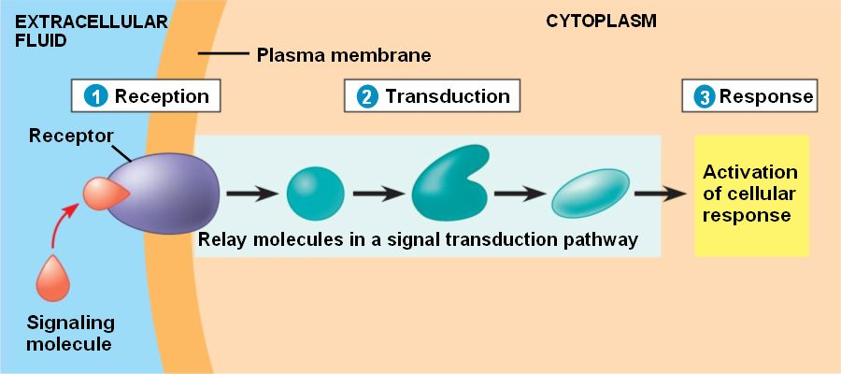
1. Identify a type of molecule that would be involved in the first step.
A. G-protein
B. cyclic AMP (cAMP)
C. transcription factors
D. Calcium ions (Ca 2+)

2. Identify a type of molecule that is involved in the second step.
A. G-protein linked receptors
B. Transcription factors
C. secondary messengers like cAMP
D. ion-gated channels

3. Identify a potential cellular response in step 3.
A. Secondary messengers
B. Increased transcription
C. G-protein linked receptors
D. ion-gated channels

4. Does this diagram represent a protein or steroid ligand?
A. This is a steroid ligand, since the molecule attaches to a receptor on the outside of the cell lmembrane.
B. This is a protein ligand, since the molecule attaches to a receptor on the outside of the cell membrane.
C. This is a steroid, since the shape is of a hydrocarbon ring, which is common in hydrophobic molecules.
D. This is a protein, since the molecule is hydrophilic and can cross the phospholipid bilayer easily.

5. Bacteria are single celled prokaryotes. When large numbers of bacteria populate a certain area, they secrete chemicals that signal cooperative behavior. For example, a biofilm is a group of cooperatively working bacteria, where different bacteria in different locations perform different functions. This example of cell signaling can best be described as:
A. quorum sensing
B. altruistic
C. competitive exclusion
D. signal transduction pathways

6. Pheromones are air-born chemicals that are sensed through olfaction. In deer, females release a sexually attractive pheromone during mating season that is sensed by male deer. Why do only certain cells in the male deer receive pheromone signals, while the pheromones are exposed to all cells in the male deer?
A. All cells contain the intra- and extra-cellular receptors necessary to stimulate a signal transduction pathway.
B. Only certain cells in the male (particularly cells involved in the sex response) have receptors that bind to the female deer pheromone.
C. Temporal isolation causes the receptors to only be active during mating season to maximize cell energy efficiency.
D. Cell reception is different than organ processing of chemical signals.

7. Animals rely heavily on this mechanism to reduce, or dampen, a stimulus which then returns the body to set point.
A. Homeostasis
B. Negative feedback
C. Positive feedback
D. Circadian rhythm

8. During menstruation, childbirth and lactation, females rely on this control mechanism to amplify the stimulus until it is complete.
A. Negative feedback
B. Homeostasis
C. Positive feedback
D. Regulator
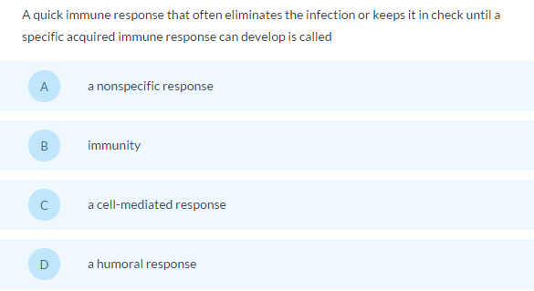
9.

10.
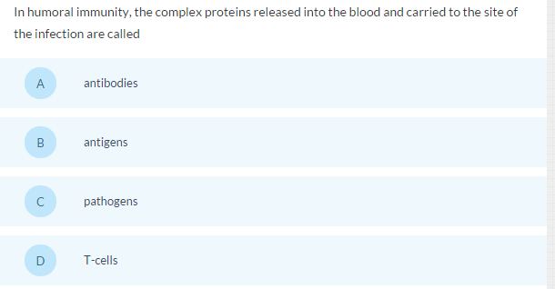
11.
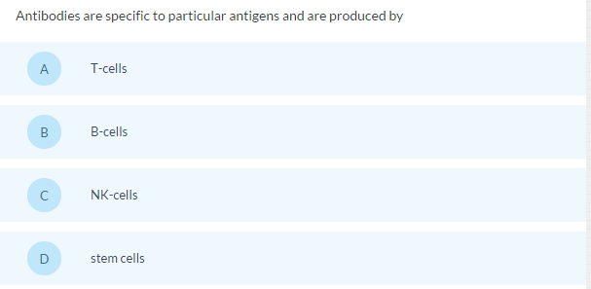

12.
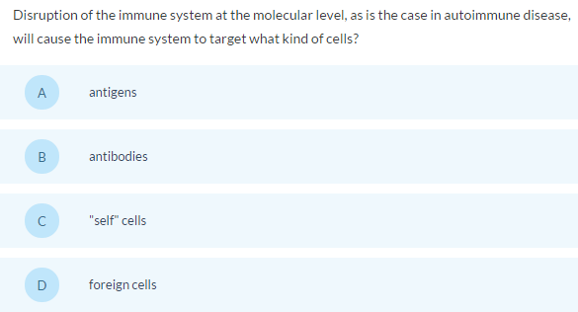

13.
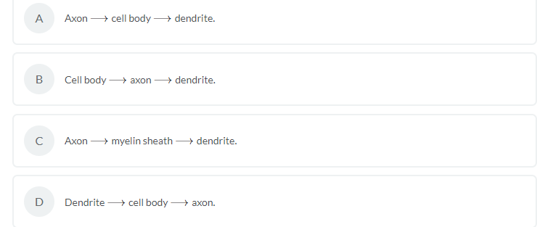
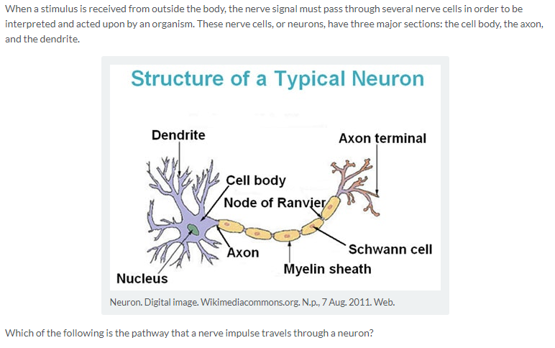

Choose from answer choices to the right.
14.
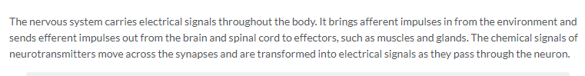
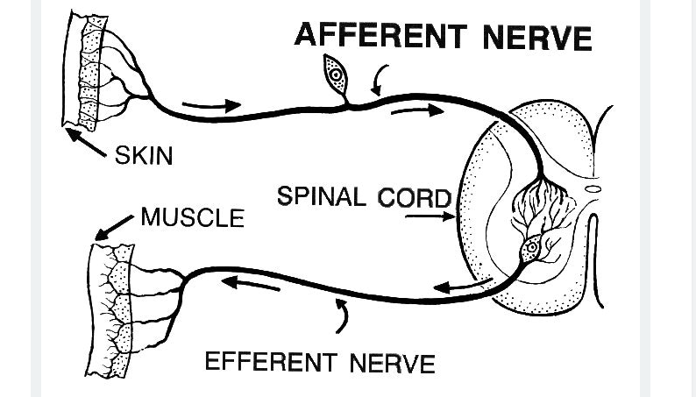
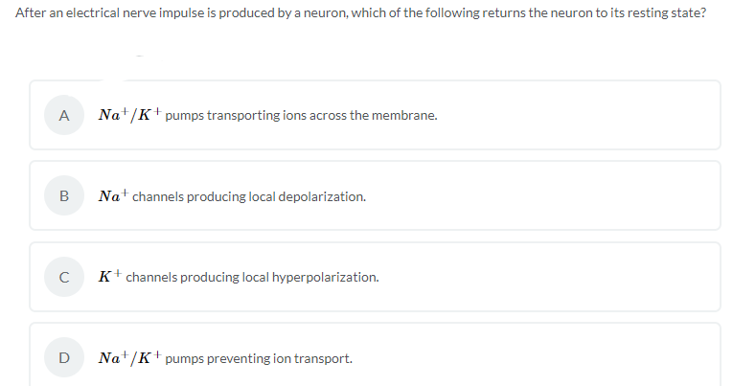

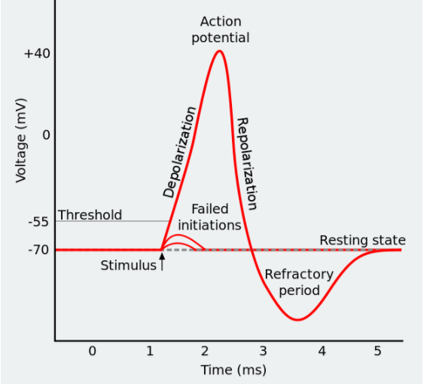
15.

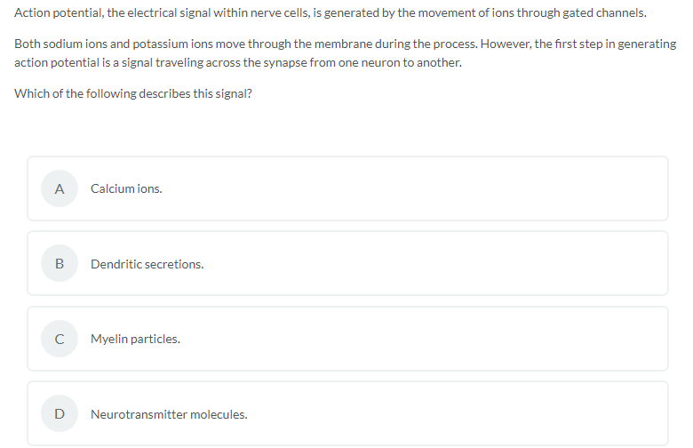

16.
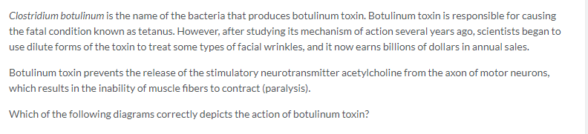
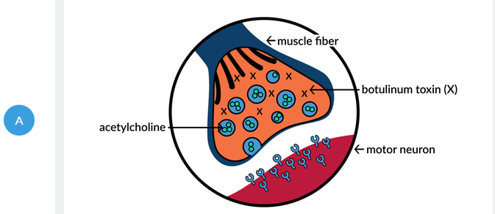
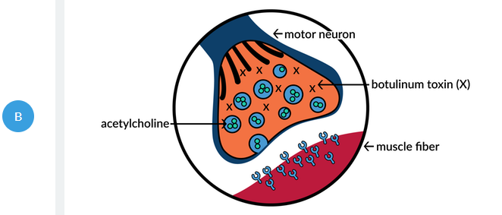

C and D choices are on next page.
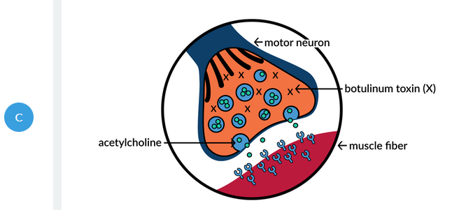
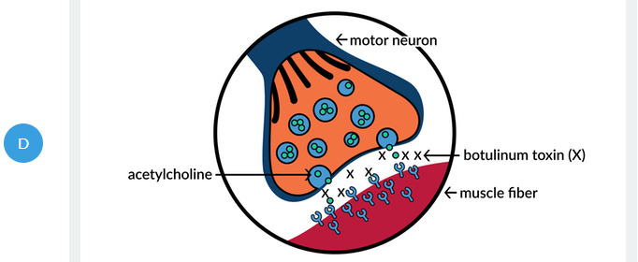

17.
