Name: ______________________________________

Cell Structure and Transport (Unit 4) Multiple Choice Questions

1. Which of the following best describes what happens when the cell has a small surface to volume ratio?
A. the cell will have difficulty taking nutrients into the cell, but will have difficulty eliminating wastes
B. the cell will be able to easily take in and eliminate nutrients and waste materials
C. the cell will have difficulty in taking in and eliminating nutrients and waste materials
D. the cell will be able to readily take in materials, but have difficulty in eliminating waste

2. If a large surface area is needed for an actively metabolizing cell, why are cells limited in size?
A. because larger cells have a larger surface to volume ratio
B. because larger cells have a smaller surface to volume ratio
C. because smaller cells have a larger surface to volume ratio
D. because smaller cells have a smaller surface to volume ratio

3. There are a number of transport proteins that span across the cell membrane. These proteins will transport molecules across the cell membranes through a process known as
A. endocytosis B. osmosis
C. facilitated diffusion D. receptor-mediated endocytosis

4. In a plant, structure, support and protection of the cells is provided by the
- cell membrane B. keratin
- cell wall D. chitin

5. If a cell lives in a hypotonic environment, this means
A. there are less solutes inside the cell
B. there is an equal amount of solutes inside as outside the cell
C. there is more solute outside the cell
D. there is less solute outside the cell

6. A number of membrane-enclosed vesicles fuse with the plasma membrane and secrete their contents into the extracellular fluid. As the various components are secreted the membrane is restored. This process is referred to as
A. pinocytosis B. phagocytosis
C. endocytosis D. exocytosis

7. Cell membranes are found surrounding
A. mitochondria, chloroplast, and endoplasmic reticulum
B. nucleus, nucleolus, ribosomes
C. chromatin, chromosomes, and microtubules
D. mitochondria, chloroplast, ribosomes, Golgi apparatus

8. The cell membrane is described as a "fluid mosaic model". The term "mosaic" refers to
A. the collection of proteins, cholesterol and other molecules floating in the cell membrane
B. the collection of phospholipids making up the cell membrane
C. the cholesterol in the cell membrane
D. glycolipids and glycoproteins held to the cell membrane by Van der Waals bonds

9. Passive transport across the cell membrane occurs without energy. Examples of passive transport include
A. endocytosis, receptor-mediated endocytosis, exocytosis B. endocytosis, exocytosis
C. diffusion, osmosis, facilitate diffusion D. diffusion, receptor-mediated diffusion, osmosis

10. When a red blood cell (RBC) is placed in distilled water, the RBC is ____________ to water. This will cause the RBC to _______________.
A. hypertonic; swell B. hypertonic; shrivel
C. hypotonic; swell D. hypotonic; shrivel

11. A cell that is bound by a plasma membrane and contains ribosomes, cytoplasm, nucleus, mitochondria, and Golgi would be characterized as a(n)
A. prokaryote B. eukaryote
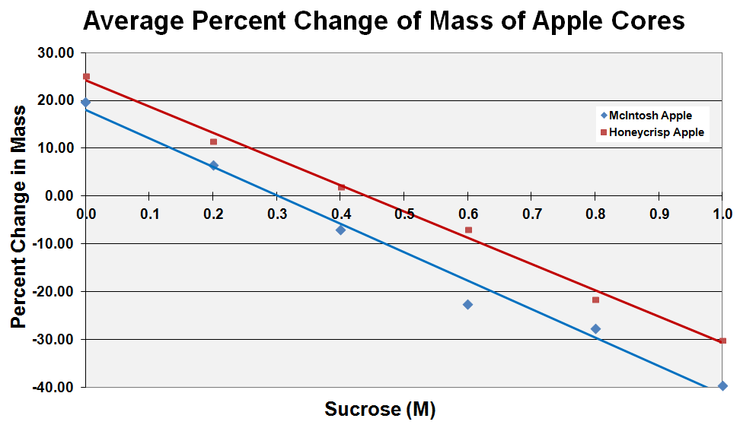
C. fungi D. archaebacteria

12. Predict the result of the following protocol. Potato cores with an osmolarity of 0.5 M are placed in a 1.0 M solution of sucrose water overnight.
A. The potato cores will gain mass.
B. The potato cores will lose mass.
C. The potato cores will neither gain nor loss mass.
D. You cannot determine the outcome.

13. To determine which apple variety, McIntosh or Honeycrisp has a higher osmolarity, 24 uniform apple cores were made from each type. Three of each variety were initially massed and placed in beakers filled with 100 mL of the respective solutions of sucrose: 0.0 M, 0.2 M. 0.4 M, 0.6 M, 0.8 M, and 1.0 M. They were left overnight and massed again the following day. The graph to the right shows the percent change in mass of the cylinders in each solution of sucrose.
How would you describe the intracellular osmotic potential of the Honeycrisp apple compared to the McIntosh apple?
- isotonic
- hypertonic
- hypotonic
- equilibrium

14. Using the data from #13, what is the osmolarity of the McIntosh and Honeycrisp apple variety, respectively?
A. 0.30 M and 0.44 M
B. 0.40 M and 0.40 M
C. 0.44 M and 0.30 M
D. Not enough information provided to make that determination

15. Three rectangular blocks of agar have the following dimensions (length, width, and height in cm): A - 3 x 4 x 1; B - 3 x 2 x 2; C - 6 x 2 x 1. These were treated with a 0.1 M NaOH solution and phenolphthalein, turning them pink. Which of the following would you predict to turn completely clear first when placed in a slightly acid solution?
A. Block A
B. Block B
C. Block C
D. All three will turn clear at the same time.

16. Which structure is the site of the synthesis of proteins that may be exported from the cell?
A) rough ER
B) lysosomes
C) plasmodesmata
D) Golgi vesicles
E) free cytoplasmic ribosomes

