Name: _____________________________________________ Date: ____________________________ Period: ______

**AP Biology Exam Review: Cell Structure and Transport (Unit 4)**

**Helpful Videos and Animations:**

1. Bozeman Science: Cell Membranes
2. Bozeman Science: Transport Across Cell Membranes
3. Bozeman Science: Compartmentalization
4. Bozeman Science: Cellular Organelles

**Unit Vocabulary:**

-Cytosol / Cytoplasm

-Organelles

-Prokaryotic vs. Eukaryotic Cell

-Surface Area: Volume Ratio

-Microvilli

-Nucleus (includes the nuclear membrane / envelope, nuclear pores, chromatin or chromosomes, nucleolus)

-Ribosomes

-Endomembrane System

-Rough ER

-Smooth ER

-Golgi Body / Complex / Apparatus

-Vesicles

-Lysosomes

-Vacuoles

-Mitochondria

-Chloroplasts

-Endosymbiotic Theory / Endosymbiosis

-Cytoskeleton

-Cilia

-Flagella

-Microtubules

-Cell Wall

-Plasmodesmata

-Extracellular Matrix / ECM (composed of glycoproteins like collagen)

-Intercellular Junctions (tight junctions, desmosomes, and gap junctions)

-Membrane-Bound Organelles

-Plasma Membrane / Cell Membrane

-Fluid Mosaic Model

-Phospholipids (heads vs. tails)

-Phospholipid Bilayer

-Cholesterol

-Integral Membrane Proteins / Transmembrane Proteins

-Peripheral Membrane Proteins

-Glycoprotein

-Glycolipid

-Simple Diffusion

-Concentration Gradient

-Passive Transport

-Equilibrium

-Facilitated Diffusion

-Channel Proteins vs. Carrier Proteins

-Osmosis

-Solute vs. Solvent

-Hypotonic vs. Hypertonic vs. Isotonic Solutions

-Lysis

-Turgid

-Flaccid

-Plasmolyzed

-Contractile Vacuole

-Active Transport

-Protein Pumps

-Cotransport

-Symport / Symporter vs. Antiport / Antiporter

-Endocytosis (includes phagocytosis, pinocytosis, and receptor-mediated endocytosis)

-Exocytosis

-Vesicle

-Water Potential

-Solute Potential / Osmotic Potential

-Pressure Potential

-Ionization Constant

**Topic Outline:**

***Unit 4, Part 1 Notes: Cell Structure and Function***

1. The Difference between Prokaryotic and Eukaryotic Cells (organelles present, size, organization of DNA, etc.)
2. Structures and Functions of Eukaryotic Organelles (make sure you understand how the structure and molecular composition of each cell part gives it its unique functions)

* Nucleus (with nuclear membrane, nuclear pores, nucleolus, and chromatin)
* Ribosomes (free vs. bound… what kinds of proteins does each type create?)
* Endoplasmic Reticulum (smooth vs. rough)
* Golgi Apparatus
* Vacuoles (compare plant vs. animal vacuoles)
* Mitochondria
* Chloroplasts
* Cytoskeleton
* Centrosomes + Centrioles
* Cilia and Flagella
* Extracellular Matrix
* Intercellular Junctions: three types in animal cells (tight junctions, desmosomes, and gap junctions) ; one type in plant cells (plasmodesmata)

1. Identify which organelles are found in plant vs. animal cells and identify each in an image
2. Describe the function of the endomembrane system in protein synthesis and secretion (be able to list / sequence all structures and processes involved)
3. Be able to describe how eukaryotic cells and the mitochondria / chloroplasts within them arose by endosymbiosis

***Unit 4, Part 2 Notes: Cell Membrane and Transport***

1. Structure of the Cell Membrane (understand the fluid mosaic model and identify the structure and function of molecules found within it – phospholipids, integral proteins, peripheral proteins, glycolipids, and glycoproteins)
2. Semi/Selective Permeability – which molecules can move through the phospholipid bilayer and which molecules must move with the help of a transport protein?
3. Passive Transport vs. Active Transport – up vs. down concentration gradient, use of energy?
4. Types of Passive Transport

* Simple Diffusion
* Facilitated Diffusion using channel or carrier proteins (what is the difference between these two types transport proteins?)
* Osmosis (hypertonic, hypotonic, isotonic) – be able to predict the movement of water across a semi-permeable membrane based on solute OR water concentration (Hint: you must know how to analyze a “U-tube” problem)

Associated Vocabulary: lysis (animal cells), flaccid (plant cell), plasmolyzed (plant cell), turgid / turgo pressure (plant cell)

1. Types of Active Transport

* Protein pumps (know how the sodium (Na+) / potassium (K+) pump works!)
* Co-transport
* Bulk Transport: Exocytosis vs. Endocytosis (3 Types: phagocytosis, pinocytosis, and receptor-mediated endocytosis)

1. Importance of having a large membrane surface area 🡪 efficient transport of materials into and out of the cell (Note: this is why cells of the small intestine—an organ used for absorption—have many membrane folds called microvilli)
2. Be able to perform cell surface area to volume ratio calculations to compare the efficiency of membrane transport in cells of various shapes and sizes

***Unit 4, Part 3 Notes: Water Potential***

1. I do not have a topic outline for this notes packet.

**Lab Review**

***Diffusion and Osmosis – Potato Core Experiment***

|  |  |
| --- | --- |
| Background Information | Potato cells contain water and sucrose, so we can measure the rate of osmosis by placing potato cores (small cylinders from the interior of a potato) into solutions of varying sucrose concentrations and measuring the mass change that occurs in the potato cells as water enters or exists the potato cells to move into or out of the external solution. |
| Hypothesis | If potato cores are placed in hypotonic sucrose solutions (i.e. the solution has a higher water and lower solute concentration than the potato cells), then the potato cells will experience a positive mass change (i.e. they will gain mass due to water entering the potato cells).  If potato cores are placed in isotonic sucrose solutions (i.e. the solution has the same water and solute concentration as the potato cells), then the potato cells will experience little to no mass change (i.e. there will be no net gain or loss of water from the potato cells).  If potato cores are placed in hypertonic sucrose solutions (i.e. the solution has a lower water and higher solution concentration than the potato cells), then the potato cells will experience a negative mass change (i.e. they will lose mass due to water leaving the potato cells). |
| Methods | Basics: Place potato cores of the same size into sucrose solutions of varying concentrations (ex: 0 Molar, 0.2 M, 0.4 M, 0.6 M, 0.8 M, and 1.0 M)  **Independent Variable**: The sucrose concentration of the external solution  **Dependent Variable**: Mass change in the potato core due to water movement into or out of the potato core  **Control Group** (group not exposed to the independent variable): 0 Molar solution (distilled water, no sucrose), water should definitely enter the potato  **Experimental Groups** (groups exposed to varying degrees of the independent variable): 0.2 M, 0.4 M, 0.6 M, 0.8 M, and 1.0 M sucrose solutions  **Constants** (to make sure that any differences between the control group and experimental groups are due to the independent variable alone): type of potato, size of potato core, amount of solution  **Repeated Trials**: 3-5 potato cores per solution to ensure accuracy of data |
| Data Collection and Organization | You will determine the mass of the potato cores before and after soaking in the solutions for an extended period of time (30 minutes – 1 hour)  You will record your data in a chart similar to the one shown below. In this data table you will calculate percent change in mass so that you will be able to directly compare the mass change for the potato cores in all the solutions. The formula for percent change in mass is given below…  % Change in Mass = [(final mass-initial mass) / initial mass] x 100    http://www2.sluh.org/bioweb/apbio/labs/apl01masspercentchangegraph.pngYou will then graph the percent change in mass corresponding to the potato cores in each sucrose solution. You will use a scatter plot and connect the points to determine where the line crosses the x-axis (i.e. the point where there is 0% change in mass). |
| Data Analysis | According to the data in the graph given at the bottom of the previous page, there is a 0% change in mass in the potato cores at a sucrose solution concentration of approximately 0.3 M. With a 0% mass change, there is no net water movement into or out of the potato cells, so the sucrose solution must be isotonic to the potato cells (i.e. having the same water and solute concentrations as the potato cells). Therefore, the sucrose concentration of the potato cells is approximately 0.3 M. |

***Diffusion and Osmosis – Dialysis Tubing Lab***

|  |  |
| --- | --- |
| Background Information | Osmosis occurs when different concentrations of water are separated by a differentially permeable membrane. One example of a differentially permeable membrane within a living cell is the plasma membrane. This experiment demonstrates osmosis by using dialysis membrane, a differentially permeable cellulose sheet that permits the passage of water but obstructs passage of large molecules (ex: sucrose). If you could examine the membrane with a scanning electron microscope, you would see that it is porous. Thus molecules larger than the pores cannot pass through the membrane. (courtesy of Boston University)  In this lab, you will place dialysis bags containing solutions of varying sucrose concentrations into external solutions (in beakers) of varying sucrose concentrations. You will take the mass of the bag before and after placing it in the external solution for 30 minutes and determine the mass change. If the mass change is positive, water moved into the bag. If the mass change is negative, water moved out of the bag. |
| Hypothesis | If dialysis bags are placed in hypotonic sucrose solutions (i.e. the external solution has a higher water and lower solute concentration than the solution inside the dialysis bag), then the dialysis bags will experience a positive mass change (i.e. they will gain mass due to water entering the dialysis bags).  If dialysis bags are placed in isotonic sucrose solutions (i.e. the external solution has the same water and solute concentration as solution inside the dialysis bag), then the dialysis bags will experience little to no mass change (i.e. there will be no net gain or loss of water from the dialysis bags).  If dialysis bags are placed in hypertonic sucrose solutions (i.e. the external solution has a lower water and higher solute concentration than the solution inside the dialysis bag), then the dialysis bags will experience a negative mass change (i.e. they will lose mass due to water leaving the dialysis bags). |
| Methods | Basics: The chart given below summarizes the sucrose concentrations of the solutions inside and outside the dialysis bags for the four different treatment groups.   |  |  |  | | --- | --- | --- | | **Beaker #** | **Solution Inside Bag** | **Solution Outside Bag (in beaker)** | | 1 | Distilled Water | Distilled Water | | 2 | 15% Sucrose Solution | Distilled Water | | 3 | 30% Sucrose Solution | Distilled Water | | 4 | Distilled Water | 30% Sucrose Solution |     **Independent Variable**: Sucrose concentration of the solutions inside and outside of the bag  **Dependent Variable**: Mass change of the bag (due to the movement of water into or out of the bag  **Control Group** (group not exposed to the independent variable): Beaker #1 because we do not expect a mass change in this bag  **Experimental Groups** (groups exposed to varying degrees of the independent variable): Beakers #2-4  Constants (to make sure that any differences between the control group and experimental groups are due to the independent variable alone): type of dialysis tubing, volume of solution inside the bag and in the beaker, time bags spend in the external solution, etc.  **Repeated Trials**: Need to have a large sample size (i.e. 3-5 trials per treatment group) to ensure accuracy of data |
| Data Collection and Organization | You will determine the mass of the bags before and after they have been placed in the external solution and osmosis has taken place. You will organize your data in a chart like the one given below.   |  |  |  |  |  | | --- | --- | --- | --- | --- | | # | Bag/Beaker Contents | Bag Mass (g)  0 Min | Bag Mass (g)  30 Min | Mass change from 0-30 mins (g) | | 1 | Distilled water/  Distilled water |  |  |  | | 2 | 15% Sucrose/  Distilled water |  |  |  | | 3 | 30% Sucrose/Distilled water |  |  |  | | 4 | Distilled water/  30% Sucrose |  |  |  | |
| Data Analysis | The average mass changes over several trials for each of the treatment groups will allow you to support or refute your hypotheses. |

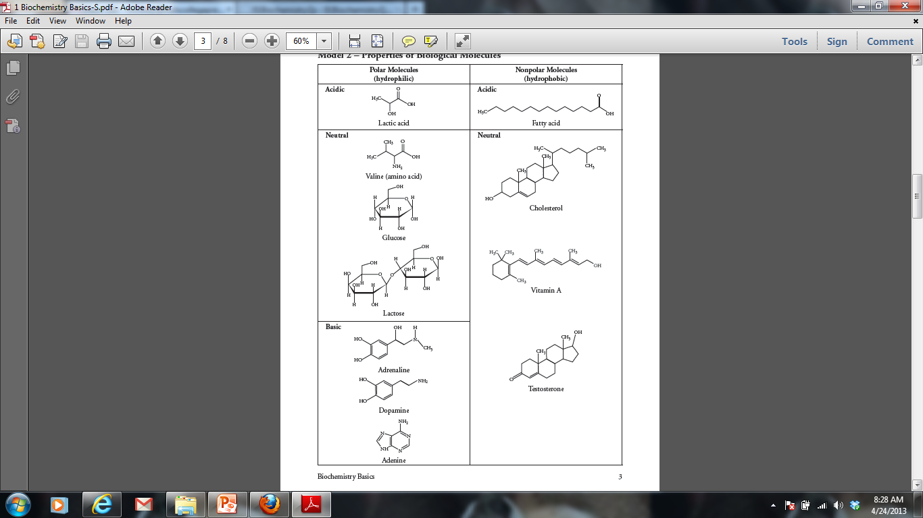**Practice “Thinking” Questions**

1. For each molecule shown to the right, answer the following, providing justifications for each:
2. Is it polar or nonpolar?
3. Is it hydrophobic or hydrophilic?
4. In order to be transferred into a cell, would the molecule require a protein channel?

‘

1. Biological systems rely heavily on the properties of water movement. Excretion, digestion, and blood pressure are just a few examples of situations where water balance is important. Suppose you have a semi-permeable membrane that ONLY water can pass. On one side of the membrane you have 0.1 M CaCl2. On the other side of the membrane, you have 0.1 M Glucose. CaCl2 ionizes in water to produce 3 ions. Glucose does not ionize in water.

|  |  |
| --- | --- |
| 0.1 M CaCl2 | 0.1 M Glucose |

1. Calculate the water potential for each side of the membrane. Assume room temperature (25 degrees Celsius or 298 Kelvin)
2. Describe which way water will move and explain your answer.

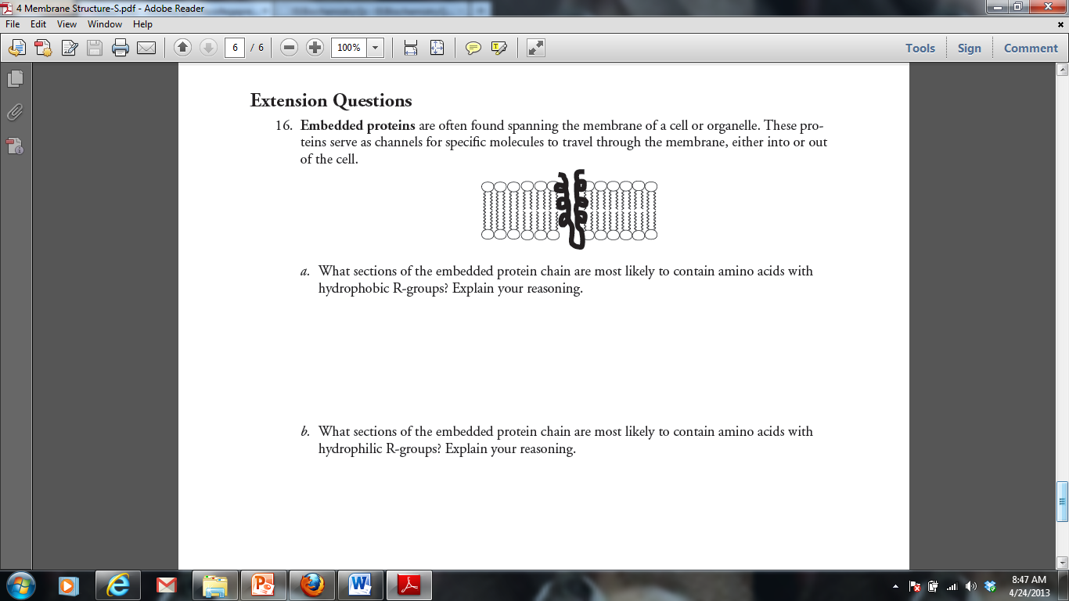

4. Tay-Sachs disease is a human genetic abnormality that results in cells accumulating and becoming clogged with very large and complex lipids. Which cellular organelle must be involved in this condition?

**Practice Short Response Questions**

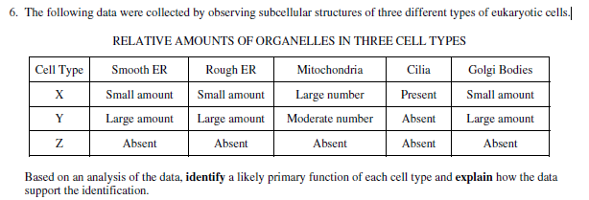

**Practice Long Response Questions**

A laboratory assistant prepared solution of 0.8 *M*, 0.6 *M*, 0.4 *M*, and 0.2 *M* sucrose, but forgot to label them. After realizing the error, the assistant randomly labeled the flasks containing these four unknown solutions as flask A, flask B, flask C, and flask D.

**Design** an experiment, based on the principles of diffusion and osmosis, that the assistant could use to determine which of the flasks contains each of the four unknown solutions. **Include** in your answer

(a) a description of how you would set up and perform the experiment

(b) the results you would expect from your experiments

(c) an explanation of those results

**Practice Calculations Questions**

***Surface Area and Volume***

***Why use this formula?***

Biologists compare the surface area to volume ratio of cells of various shapes and sizes because this ratio is an indicator of the efficiency of transport across the cell membrane.

***Formula Additional Information from the Formula Sheet***

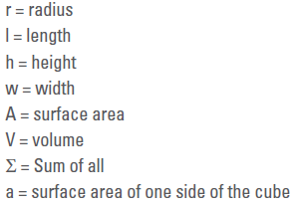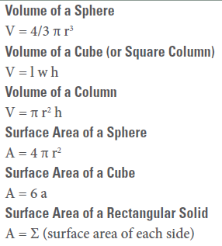

1. 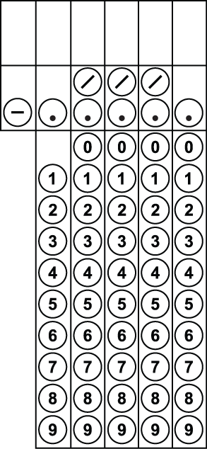What is the SA/V for this cell? Round your answer to the nearest hundredth.





2. Four blocks of pink phenolphthalein agar are placed in a vinegar solution. Which block would the vinegar solution penetrate most thoroughly into after ten minutes? Determine the surface area to volume ratio for this block, and round your answer to the nearest hundredth.

* + 1. Block 1: 2 cm x 4 cm x 4 cm
    2. Block 2: 2 cm x 8 cm x 4 cm
    3. Block 3: 1 cm x 8 cm x 8 cm
    4. 1 cm x 1 cm x 64 cm

3. For the problem above, which block would have the greatest volume of pink phenolphthalein (untouched by the vinegar) remaining at the end of ten minutes? Determine the surface area to volume ratio for this block, and round your answer to the nearest hundredth.

**Water Potential and Solute Potential**

***Why use this formula?***

The water potential and solute potential calculations help determine the direction of water movement (from a high water potential to a low / more negative water potential).

***Helpful Videos***

Bozeman Biology – Water Potential

<https://www.youtube.com/watch?v=nDZud2g1RVY>

***Formula Additional Information from the Formula Sheet***

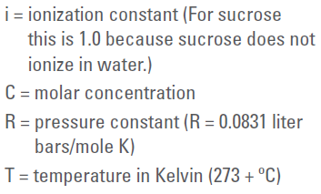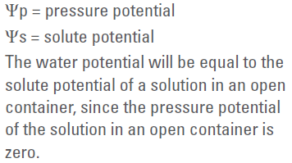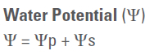

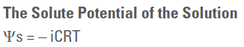



4. 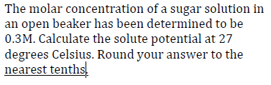



5. Scientists are trying to determine under what conditions a plant can survive. They collect the following data and would like to know the water potential of the plant cell. The solute potential is -0.6 MPa and the pressure potential is -1.0 MPa. What is the water potential? Round your answer to the nearest tenth.