Name: _______________________________________

Classical Genetics (Unit 9) Multiple Choice Questions

1. Having a widow’s peak is dominant to having a straight hairline. What is the probability that a mother heterozygous for the widow’s peak gene and a father with a straight hairline would have children with the same phenotype as their father?
A. 0
B. 0.25
C. 0.5
D. 1

2. Which of the following cell processes best accounts for Mendel's Law of Segregation?
A. crossing over
B. mitosis
C. translation
D. Meiosis

3. Green pea seeds are recessive to yellow pea seeds. If two heterozygous pea plants produced 1000 offspring, approximately how many of them would be expected to be yellow?
A. 1000
B. 750
C. 500
D. 250

4. In guinea pigs, short coat is dominant to long. If a breeder wants to ensure that the short-haired guinea pig he has is homozygous for the hair length trait and could not afford genetic testing, which plan would be the best possible choice to give him this information?
A. Breed the animal with one that is homozygous for short hair and watch for long hair offspring
B. Breed the animal with one that is heterozygous for short hair and watch for long hair offspring
C. Breed the animal with one that is heterozygous for short hair and watch for short hair offspring
D. Breed the animal with one that is homozygous for long hair and watch for long hair offspring

5. In mice, black fur is dominant to white, and long fur is dominant to short. What is the probability that a white mouse that is homozygous for long fur and a mouse heterozygous for both traits can have an offspring with short white fur?
A. 0
B. 0.25
C. 0.5
D. 0.75

6. In the cross AaBBcc x aaBbCc, what is the probability of an offspring that is aaBbcc?
A. 1/2
B. 1/4
C. 1/8
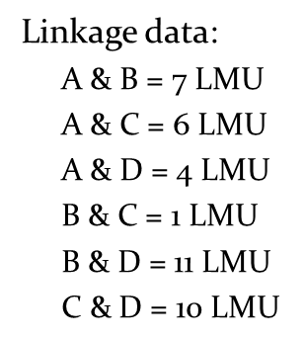
D. 1/16

7. Experimental linkage mapping has established the distances between four genes, as shown. Which of these choices best reflects the order of the genes on the chromosome? (Note: LMU stands for Linkage Map Units)
A. ADCB
B. BACD
C. DACB
D. CDAB

8. A new species of plant was discovered, and it is found that the stems occur in both a hairless (H) and hairy (h) variety. To investigate the inheritance patterns of stem hair, a researcher crossed a hairless plant with a hairy one. The result was 13 hairy plants and 11 hairless plants. Based on this information, what must be the genotypes of the parents?
A. HH x Hh
B. Hh x Hh
C. Hh x hh
D. HH x hh

9. A new species of plant was discovered, and it is found that the stems occur in both a hairless (H) and hairy (h) variety. In addition tall stems (T) and short stems (t) were evident. To investigate the inheritance patterns of stem hair, a researcher found that a cross produced all hairless stems in the F1 generation with half of the plants expressing the tall phenotype and the other half expressing the short. What could be the genotypes of the parental cross?
A. The parents were heterozygous for both traits.
B. One parent was homozygous dominant for the hairless trait, and heterozygous tall and the other parent was homozygous hairy and heterozygous tall.
C. One parent was homozygous hairless and heterozygous tall and the other parent was heterozygous hairless and short.
D. One parent was short and hairy and the other plant was heterozygous tall and hairy.

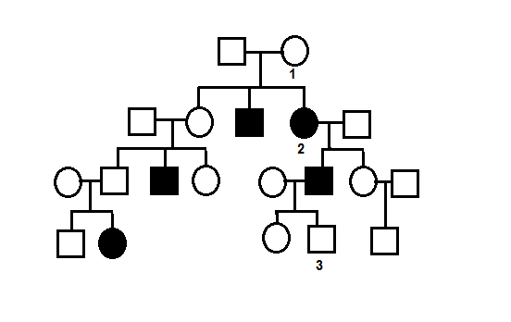
10. Using the pedigree in the image, what type of inheritance pattern is most likely?
A. Autosomal dominant
B. Autosomal recessive
C. Sex-linked dominant
D. Sex-linked recessive

11. Using the pedigree in the image (which shows an autosomal recessive trait), what is the likelihood that if female number 1 and her partner have another child it will show the recessive trait?
A. 0.25
B. 0.5
C. 0.75
D. 1

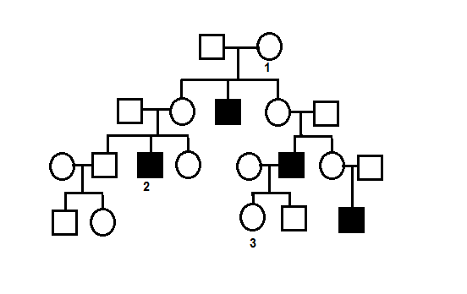
12. The pedigree to the right tracks the inheritance of colorblindness, a sex-linked recessive condition. If male number two has a child with a woman who is not colorblind, but whose father was, what is the chance that they will have a daughter who will be a carrier for the trait out of all the children born?
A. 0
B. 0.25
C. 0.5
D. 1

13. A test cross resulted in the data shown. What type of inheritance pattern best explains these results?
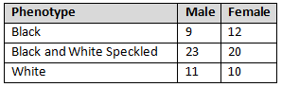
A. Sex linkage
B. Simple dominance
C. Incomplete dominance
D. Codominance

14. John and his father both have color blindness, a sex-linked trait. John has a sister, Kathy, who shares the same parents. Their mother is not color blind. What percent chance is there that Kathy is color blind out of the daughters born?
A. 0
B. 0.25
C. 0.5
D. 1

15. In birds, males carry two identical sex chromosomes (ZZ) and females carry two different sex chromosomes (ZW). A gene in parakeets called cinnamon is sex-linked recessive on the Z chromosome. If a cinnamon male is crossed with a normal female, what percentage of the offspring will be cinnamon?
A. All of the males only
B. All of the females only
C. All of the offspring
D. None of the offspring

16. Sickle cell anemia is caused by the mutation of a single base pair in the gene for hemoglobin. This mutation results in hemoglobin molecules that form long chains in low-oxygen settings and stretch the blood cells into their characteristic sickled shape. What would the result be if a different base pair in the sickle cell hemoglobin gene were to become mutated?
A. The effects of sickle cell would be increased
B. The effects of sickle cell would be reduced
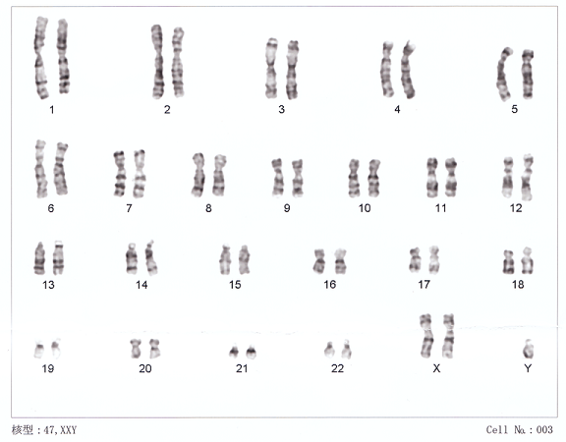
C. The new mutation would increase resistance to malaria
D. It is impossible to predict what the effect would be without knowing more about the mutation

17. This image shows the chromosomes of a person. Which term best describe this image?
A. Monosomy
B. Trisomy
C. Aneuploidy
D. Tetraploidy

18. Which of these terms is most relevant to the karyotype shown at the bottom of the previous page?
A. Translocation
B. Point mutation
C. Nondisjunction
D. Inversion

19. Which of the following statements best describes the person whose chromosomes are shown in the karyotype at the bottom of the previous page?
A. Female with no immediately identifiable disorders
B. Male with no immediately identifiable disorders
C. Female with a disorder
D. Male with a disorder

20. Sickle cell anemia is caused by the mutation of a single base pair in the gene for hemoglobin. This mutation results in hemoglobin molecules that form long chains in low-oxygen settings and stretch the blood cells into their characteristic sickled shape. Malarial parasites are less able to enter cells that are affected by the sickle mutation.
How would this affect the likely phenotypic distribution of this allele?
A. The allele would be more common in areas with high malarial activity
B. The allele would be less common in areas with high malarial activity
C. The allele would be more common in areas with low malarial activity
D. The allele distribution would be dependent on random assortment during meiosis and unaffected by environment

