Name: _____________________________________________ Date: ____________________________ Period: ______

AP Biology Exam Review: Classical Genetics (Unit 9)

Helpful Videos and Animations:
- Bozeman Biology: Mendelian Genetics
- Bozeman Biology: Chromosomal Genetics
- Bozeman Biology: A Beginner's Guide To Punnett Squares
- Bozeman Biology: Probability in Genetics - Multiplication and Addition Rules
- Bozeman Biology: Linked Genes
- Bozeman Biology: The Genetics of Blood Types
- Andrew Douch: Pedigree Analysis 1
- Andrew Douch: Pedigree Analysis 2

Unit Vocabulary

-DNA (deoxyribonucleic acid)
-Inherited Trait
-Chromosomes
-Homologous Chromosomes
-Gene
-Allele (dominant vs. recessive)
-Genotype (homozygous dominant vs. homozygous recessive vs. heterozygous)
-Phenotype
-Fertilization
-Zygote
-Punnett Square
-Purebred (another term for homozygous)
-Hybrid (another term for heterozygous)
-Gregor Mendel
-Pea Plant Generations: P, F1, F2
-Multiplication Rule of Probabilities
-Addition Rule of Probabilities
-Incomplete Dominance / Blending Inheritance
-Codominance
-Sex-Linked Traits (X-linked traits vs. Y-linked traits)
-X-Linked Recessive Traits
-X-Linked Dominant Traits
-Monohybrid Cross
-Dihybrid Cross
-Multiple Alleles (the pattern of inheritance seen in blood type genetics)
-Pleiotropy
-Polygenic Inheritance
-Multifactorial Traits (controlled by DNA AND the environment)
-Non-nuclear Inheritance (controlled by DNA NOT found in the nucleus, ex: mitochondrial DNA)
-Pedigree
-Autosomal Recessive Trait
-Carrier
-Autosomal Dominant Trait
-Mendel’s Law of Dominance
-Mendel’s Law of Segregation
-Mendel’s Law of Independent Assortment
-Nondisjunction
-Aneuploidy (ex: trisomy or monosomy)
-Polyploidy
-Linked Genes
-Unlinked Genes
-Recombination Frequencies
-Linkage Maps
-Map Units
-Gene Loci (singular = locus)

Topic Outline: (Thank you to Megan Chirby and Amy Litz!)

Unit 9, Part 1 Notes: The Basics of Mendelian Genetics

- Mendel’s experiments
- Pea plants with distinct dominant vs. recessive traits
- Know what happens in the P F1 F2 generations
- Basic Genetics Vocabulary
- Gene vs. allele
- Homozygous vs. heterozygous
- Genotype vs. Phenotype
- Monohybrid Cross vs. Dihybrid Cross
- Testcross
- Setting up / analyzing genetic crosses with Punnett squares
- Know how to set up monohybrid and dihybrid crosses given information regarding parent genotypes and phenotypes and analyze offspring genotype / phenotype ratios
- Understand the rules of probability in Punnett Square analysis:
- Rule of Multiplication: when calculating the probability that two or more independent events will occur together in a specific combination, multiply the probabilities of each of the two events
For example, the probability of a coin landing face up two times in two flips is ½ X ½ = ¼
In genetics, if you cross two organisms with the genotypes AABbCc and AaBbCc, the probability of an offspring having the genotype AaBbcc is ½ X ½ X ¼ = 1/16
- Rule of Addition: when calculating the probability that any of two or more mutually exclusive events will occur, you need to add together their individual probabilities. For example, if you are tossing a die, what is the probability that it will land on either the side with four spots or the side with five spots? (1/6 + 1/6 = 1/3)
- Non-Mendelian Patterns of Inheritance
- Explain how sex-linkage is different from autosomal patterns of inheritance and be able to set up a sex-linked Punnett square
- Codominance and Incomplete Dominance (be able to complete Punnett squares for these two patterns of inheritance)

Unit 9, Part 2 Notes: Human Genetics

- Non-Mendelian Patterns of Inheritance (continued)
- Multiple Alleles (blood type Punnett squares! Use the alleles i, I^{A}, and I^{B})
- Pleiotropy
- Polygenic Inheritance
- Nonnuclear inheritance (traits determined by DNA in mitochondria or chloroplasts, not DNA in the nucleus)
- Traits influenced by the environment (ex: human height)
- Analyzing a pedigree of a human inherited condition
- Be able to describe the methods of fetal testing for inherited genetic conditions (amniocentesis and chorionic villi sampling)
- Be able to determine the type of inheritance shown in a pedigree (autosomal dominant, autosomal recessive, sex-linked dominant, and sex-linked recessive) Here are a couple hints:
- If there are significantly more males with a condition than females, the trait is sex-linked (be able to explain why sex-linked recessive conditions are found more often in males)
- With an autosomal trait, if a child has a trait but the parents don’t, the trait is recessive (both parents are carriers)

Unit 9, Part 3 Notes: Chromosomal Genetics

- Mendel’s Laws
- Law of Dominance
- Law of Segregation (and explain how disorders caused by nondisjunction – ex. Trisomy 21 / Down Syndrome – are related to this law ; be able to define aneuploidy, monosomy, and trisomy)
- Law of Independent Assortment
- Linked Genes (found on the same chromosome and inherited together during cell division)
- Crossing over between homologous chromosomes during Prophase I of meiosis may separate linked genes onto different chromosomes. The frequency of recombination of linked genes due to crossing over increases if two genes are farther apart on the chromosome
- We can create a linkage map shown the location of genes on a chromosome. The distance between genes is measured in map units. 1 map unit = 1% recombination frequency those genes are close together!

Practice Long Response Questions

In fruit flies, the phenotype for eye color is determined by a certain locus. E indicates the
dominant allele and e indicates the recessive allele. The cross between a male wild-type fruit fly
and a female white-eyed fruit fly produced the following offspring.

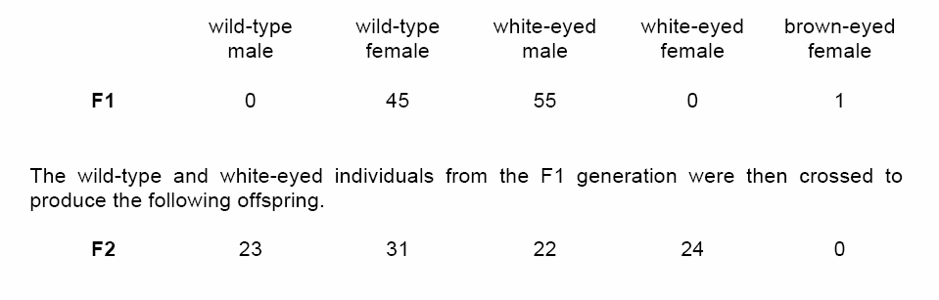
a. Determine the genotypes of the original parents (P generation) and explain your reasoning. You may use Punnett squares to enhance your description, but the results from the Punnett squares must be discussed in your answer.
b. Use a Chi-squared test on the F2 generation data to analyze your prediction of the parental genotypes. Show all your work and explain the importance of your final answer.
c. The brown-eyed female in the F1 generation resulted from a mutational change. Explain what a mutation is, and discuss two types of mutations that might have produced the brown-eyed female in the F1 generation.

Practice Calculations Questions

