Name: ___________________________________

Ecology (Unit 10) Multiple Choice Questions

In 1975, volunteers from a birding organization begin monitoring the populations of Cardinalis cardinalis and Molothrus ater in a certain forest. Molothrus ater, also know as the Brown-headed Cow Bird, is a species that lays its eggs in the nests of other birds. The volunteers collect data for ten years. The following graph shows their data.

1. The results shown in the graph above best support which of the following statements?
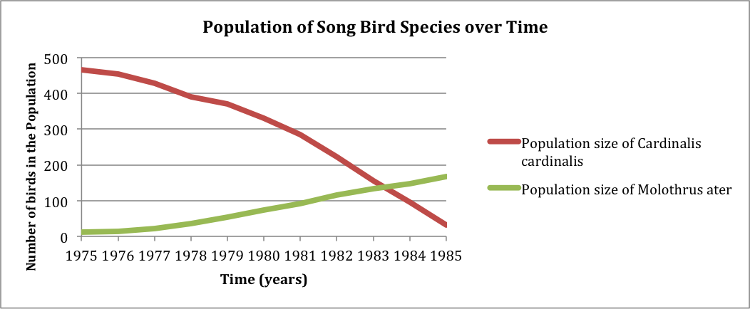
- the species C. cardinalis and M. ater share a mutualistic relationship
- the ability of M. ater to reproduce is reduced in the presence of C. cardinalis
- C. cardinalis is a predator of M. ater
- the ability of C. cardinalis to reproduce is reduced in the presence of M. ater

2. Assuming a linear food chain contains 1,534 kg of primary producer biomass, approximately how many kg of biomass can be supported at the level of secondary consumer?
- 1,000 kg
- 100 kg
- 10 kg
- 1 kg

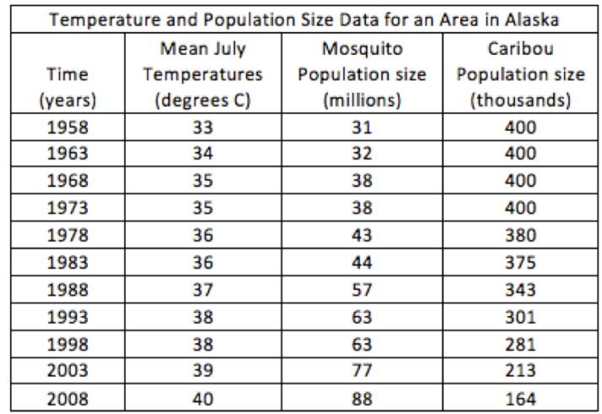
3. In a hypothetical situation, scientists studying the impacts of climate hypothesize that warmer temperatures in the arctic tundra should cause an increase in the population sizes of insects and herbivores. They chart changes in the average temperatures for the month of July over a period of fifty years, as well as the annual population sizes of a certain insect species and a certain herbivorous species. Their data is shown in the graph below:

Based on the data collected, scientists can logically conclude that warmer temperatures
- positively impact herbivorous species in the arctic tundra
- negatively impact insect species in the arctic tundra
- have differing impacts on different species in the arctic tundra
- have no significant impact on any species in the arctic tundra

4. Suppose that a population of bacteria capable of reproducing every 20 minutes is cultured from a single individual under laboratory conditions in which unlimited resources are provided and the mortality rate is zero. In two hours, the total size of the bacteria population should be
- 8 organisms
- 6 organisms
- 32 organisms
- 64 organisms

5. A city reports a problem with Norwegian rats (Rattus norvegicus). A population ecologist is hired to study the situation. She determines that the current population of rats in the city is 4,000 individuals and has an annual birth rate of 0.03. A city-wide trapping program has increased the annual death rate to 0.01.
Given this information, the population ecologist reports that in one year, the rat population will be
- 4160
- 4120
- 4080
- 4040

6. In Arizona, a species of plant called the Mistletoe sometimes can be found growing on the branches of Mesquite trees. The Mistletoe plants have modified roots that grow around the branches of the Mesquite trees and invade the vascular tissue to the tree. There, the root cells of the mistletoe plants absorb some of the water and nutrients flowing through the xylem and phloem of the Mesquite tree. Mesquite trees with Mistletoe plants have been observed to grow more slowly and produce fewer seeds than trees without Mistletoe plants.
Based on this information, which of the following best describes the relationship between these two species of plants?
- Predator-prey B. Mutualism
C. Commensalism D. Parasitism

7. Below is a graph that shows the size of two populations of organisms--voles and garter snakes. Voles are small predatory rodents that are active year round. Garter snakes prey upon the voles.
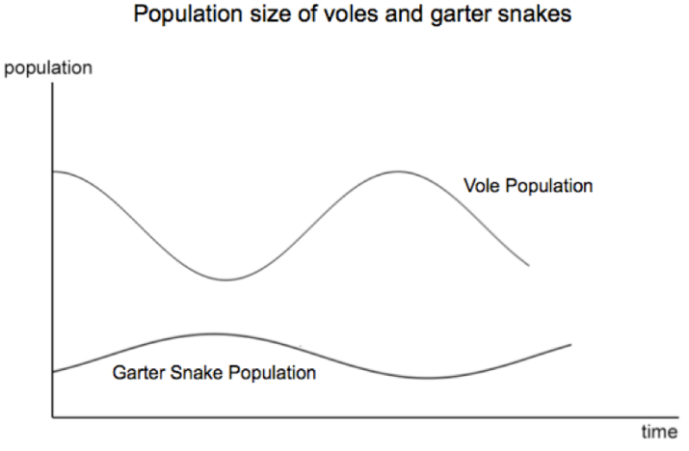
Which of the following best explains the data represented in the graph?

- As the population of voles decreases, garter snakes diversify their food sources which reduces competition and leads to an increase in population size
- As the population of garter snakes increases, they collectively eat more voles which causes a decrease in the vole population
- Because voles carry a disease that is fatal to garter snakes, when the population of voles decreases the population of garter snakes increases
- The population size of the voles increases and decreases independently of the population size of the garter snakes

8. Voters in a particular town in Massachusetts pass a law that bans the hunting of beavers. Additionally, under the new law beaver dams and lodges may not be removed or tampered with by people. Wildlife biologists track species diversity and distribution over the next ten years following the passage of the law. They conclude that beavers act as a keystone species in the area.
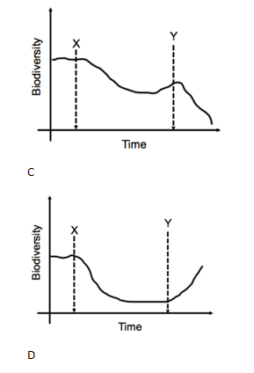
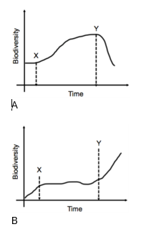
Which of the following graphs most accurately represents what might be seen if voters repeal the law and beavers are once again hunted and their dams and lodges removed? Point X shows the enactment of the law. Point Y shows the repeal of the law.

9. Organisms may thermoregulate their body temperatures either internally or through external sources. Birds and mammals are known as_____________, while amphibians, reptiles, and most invertebrates are known as_______________.
- ectotherms, endotherms
- endotherms, ectotherms
- homeotherms, poikilotherms
- thermoregulators, homeotherms

10. All living matter is dependent upon a diversity of organic molecules. Considering the following answers, which one has the most complete and correct list of elements that make up the organic molecules of all living matter?
- carbon, oxygen, hydrogen, sulfur, phosphorus, water
- carbon, oxygen, hydrogen, nitrogen
- carbon, oxygen, hydrogen, nitrogen, phosphorus, iron
- carbon, oxygen, hydrogen, nitrogen, phosphorus, sulfur

11. What type of organism is indicated by letter A in the diagram?
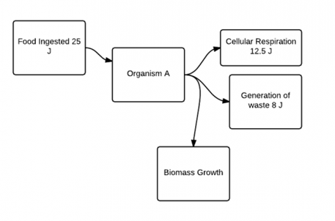
- autotroph
- producer
- heterotroph
- plant

12. Calculate the total amount of energy used by organism A to grow new cells (i.e. biomass growth).
- 25 J
- 12.5 J
- 8
- 4.5 J

13. What percent of energy is used by organism A in generation of ATP?
- 0.5
- 0
- 0.18
- 0.32

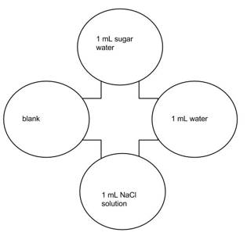
14. Fruit flies (Drosophila melanogaster) are attracted to odors found in rotting fruit. A culture of fruit flies is placed in a choice chamber with a rotten apple on one side, and a fresh apple on the other side. Identify an appropriate control group for this experiment. Note: This question is asking for a control group, not a constant.
- Maintaining the same mass of apples on either side, so there is only one independent variable tested in the experiment.
- Maintaining the same volume of apples on either side, so there is only one independent variable tested in the experiment.
- Run the experiment without apples in either side of the choice chamber, to ensure that the flies are not attracted to one side of the chamber.
- Maintaining the same temperature in both sides of the chamber, since temperature increases fruit fly activities and can affect the results.

15. Fruit flies (Drosophila melanogaster) are attracted to odors found in rotting fruit. A culture of fruit flies is placed in a choice chamber with the following choices: 1 mL of water, 1mL of sugar water, 1mL of salt water, and a control with no liquid added, as seen in the image to the right. After ten minutes, the location of the fruit flies was recorded. How many degrees of freedom are present in this experiment?
- 4 B. 3
C. 2 D. 1

16. We know that plants bend toward light because
(A) the sun stimulates equal cell expansion on both sides of the stem.
(B) cell expansion is greater on the dark side of the stem.
(C) cell expansion is greater on the light side of the stem
(D) auxin is inactive on the dark side of the stem.

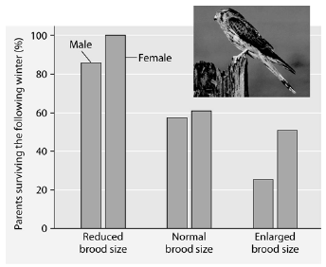
17. Plants often use changes in day length (photoperiod) to trigger events such as dormancy and flowering. There are two types of plants based on their photoperiod requirements to induce flowering. These two types of plants are called short-day plants and long-day plants. A long-day plant will flower
(A) in the late fall.
(B) when the night is shorter than a critical value.
(C) only under artificial light in the summer.
(D) during short days with proper fertilization.

Researchers in the Netherlands studied the effects of parental care given in European kestrels over five years. The researchers transferred chicks among nests to produce reduced broods (three or four chicks), normal broods (five or six chicks), and enlarged broods (seven or eight chicks). They then measured the percentage of male and female parent birds that survived the following winter. (Both males and females provide care for chicks.)

18. Which of the following is a conclusion that can be drawn from this graph?
a. | Female survivability is more negatively affected by larger brood size than is male survivability.
b. | Male survivability decreased by 50% between reduced and enlarged brood treatments.
c. | Both males and females had increases in daily hunting with the enlarged brood size.
d. | There appears to be a negative correlation between brood enlargements and parental survival.
e. | Chicks in reduced brood treatment received more food, weight gain, and reduced mortality.

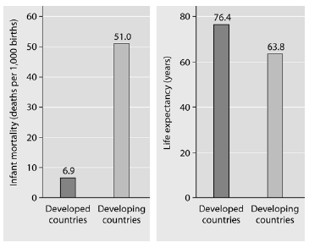

19. What is a logical conclusion that can be drawn from the graphs above?
a. | Developed countries have lower infant mortality rates and lower life expectancy than developing countries.
b. | Developed countries have higher infant mortality rates and lower life expectancy than developing countries.
c. | Developed countries have lower infant mortality rates and higher life expectancy than developing countries.
d. | Developed countries have higher infant mortality rates and higher life expectancy than developing countries.

20. Elephants are not the most dominant species in African grasslands, yet they influence community structure. The grasslands contain scattered woody plants, but they are kept in check by the uprooting activities of the elephants. Take away the elephants, and the grasslands convert to forests or to shrublands. The newly growing forests support fewer species than the previous grasslands. Which of the following describes why elephants are the keystone species in this scenario?
a. | Essentially all of the other species depend on the presence of the elephants to maintain the community.
b. | Grazing animals depend upon the elephants to convert forests to grassland.
c. | Elephants prevent drought in African grasslands.
d. | Elephants are the biggest herbivore in this community.
e. | Elephants help other populations survive by keeping out many of the large African predators.

21. Food chains are sometimes short because
a. | only a single species of herbivore feeds on each plant species.
b. | local extinction of a species causes extinction of the other species in its food chain.
c. | most of the energy in a trophic level is lost as it passes to the next higher level.
d. | predator species tend to be less diverse and less abundant than prey species.
e. | most producers are inedible.
22. If the figure below represents a terrestrial food web, the combined biomass of C + D would probably be
a. | greater than the biomass of A.
b. | less than the biomass of H.
c. | greater than the biomass of B.
d. | less than the biomass of A + B.
e. | 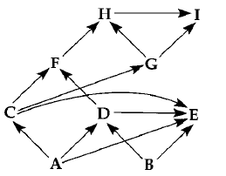  less than the biomass of E.

