Name: _____________________________________________ Date: ____________________________ Period: ______

AP Biology Exam Review: Ecology (Unit 10)

Helpful Videos and Animations:
- Bozeman Science: Ecosystems
- Bozeman Science: Ecosystem Changes
- Bozeman Science: Ecological Succession
- Bozeman Science: Populations
- Bozeman Science: Cooperative Interactions
- Bozeman Science: Communities
- Bozeman Science: Environmental Matter Exchange
- Bozeman Science: Response to External Environments
- Bozeman Science: Organ Systems
- Bozeman Science: Mechanisms of Timing and Control
- Bozeman Science: Homeostatic Disruptions
- Bozeman Science: Behavior & Natural Selection

Unit Vocabulary:

-Exponential Growth
-Logistic Growth
-Carrying Capacity
-Survivorship Curves (Type I / k-selected, Type II, Type III / r-selected)
-Limiting Factors (density-dependent vs. density-independent)
-Biotic
-Abiotic
-Ecological Niche (fundamental niche vs. realized niche)
-Trophic Level
-Food Chain vs. Food Web
-Producer / Autotroph
-Consumer / Heterotroph (primary, secondary, tertiary, and quaternary consumers)
-Decomposers / Detritivores
-Trophic Efficiency
-Pyramid of Energy / Pyramid of Production
-Pyramid of Biomass
-Pyramid of Numbers
-Primary Production
-Gross Primary Production (GPP)
-Net Primary Production (NPP)
-Secondary Production
-Species Diversity
-Species Richness
-Relative Abundance
-Symbiosis (Mutualism, Commensalism, Parasitism, Predation, Competition)
-Intraspecific Competition vs. Interspecific Competition
-Competitive Exclusion Principle
-Resource Partitioning
-Dominant Species
-Keystone Species
-Organism, Population, Community, Ecosystem, Biosphere
-Ecological Succession (Primary Succession vs. Secondary Succession)
-Pioneer Species
-Climax Community
-First Law of Thermodynamics / The Principle of Conservation of Energy
-Second Law of Thermodynamics
-Endothermy
-Ectothermy
-Invasive Species
-Biogeochemical Cycles
-Reservoir
-Assimilation
-Release
-Carbon Cycle (Photosynthesis, Cellular Respiration, Decomposition, Combustion)
-Water Cycle (the only process we focused on was Transpiration)
-Nitrogen Cycle (Nitrogen Fixation, Nitrification, Denitrification, Ammonification)
-Phosphorus and Sulfur Cycles (the only process we focused on was weathering)
-Cells, Tissues, Organs, Organ Systems
-Phototropism
-Auxin
-Photoperiodism (Short Day / Long Night Plants vs. Long Day / Short Night Plants)
-Innate Behaviors (ex: Fixed Action Pattern)
-Learned Behaviors (ex: Imprinting)

Topic Outline: (Thank you to Megan Chirby and Amy Litz!)

Unit 10, Part 1 & 3 Notes: Population and Community Ecology

- Populations
- Population Growth
- density dependent limiting factors (competition for resources, parasites & diseases, waste products, stress, predation)
- density independent limiting factors (climate = temperature & rainfall, natural disaster)
- exponential growth (J-shaped, unlimited) vs. logistic growth curve (S-shaped, limited)
- carrying capacity = maximum population supported by habitat
- Using age structure to study human populations
- Population ability to respond to changes in the environment is affected by genetic diversity. Species and populations with little genetic diversity are at risk for extinction.
- Communication within populations
- Cooperative behavior (ex: predator warnings)
- Behaviors to enhance reproductive success (ex: territory marking)
- Different types of behaviors and reasons for behaviors: Animals use visual, audible, tactile, electrical and chemical signals to indicate dominance, find food, establish territory and ensure reproductive success. (ex: bee dances)
- Communities
- Niche (fundamental vs. realized)
- Be able to analyze food chains and food webs / identify trophic levels
- Location of decomposers on a food chain
- Primary productivity (gross vs. net) and secondary productivity
- Trophic Efficiency: energy pyramids vs. pyramids of biomass vs. pyramids of numbers
- The importance of species diversity in a community (determined by species richness and relative abundance)
- Types of symbiosis: mutualism, commensalism, predation, parasitism, competition
- The effect of removing a dominant or keystone species

Unit 10, Part 2 Notes: Timing and Coordination

- Physiology basics
- Organization in multicellular organisms: cell tissue organ organ system organism
- Cooperation between organs (ex: stomach and small intestine)
- Cooperation between organ systems (ex: respiratory system and circulatory system; nervous and muscular system; root system, shoot system, and leaves in plants)
- Using physiology to respond to the environment
- Phototropism in plants
- Photoperiodism in plants
- Maintaining body temperature in humans
- Fruiting body formation in myxobacteria
- Using behavior to respond to the environment
- Innate behaviors (ex: fixed action patterns) vs. learned behaviors (ex: imprinting)
- Some behaviors are partially innate and partially learned (ex: migration patterns in black cap birds)
- Cooperative behaviors within or between populations can enhance the survival likelihood in the population (ex: the interactions between plants and their insect pollinators)

Unit 10, Part 4 Notes: Ecosystem Ecology & Biogeochemical Cycles

- Ecosystems
- Levels of ecology: population, community, ecosystem, biosphere
- Abiotic vs. biotic factors
- Effect of human activities on ecosystems (ex: invasive species)
- Effect of geological / meteorological events on ecosystems (ex: meteor causing extinction of dinosaurs)
- Free Energy
- Reproduction and rearing of offspring require free energy beyond that used for maintenance and growth. Different organisms use various reproductive strategies in response to energy availability.
- There is a relationship between metabolic rate per unit body mass and the size of multicellular organisms — generally, the smaller the organism, the higher the metabolic rate.
- Excess acquired free energy versus required free energy expenditure results in energy storage or growth.
- Insufficient acquired free energy versus required free energy expenditure results in loss of mass and, ultimately, the death of an organism.

- Molecules and atoms from the environment are necessary to build new molecules
- C,H,N,O,P, and S are the most common elements in living organisms
- Carbon (know where it is found in the four macromolecules and how it cycles between the environment and living organisms via the Carbon Cycle)
- Nitrogen (know where it is found in proteins and nucleic acids and how it cycles between the environment and living organisms via the Nitrogen Cycle)
- Phosphorus (know where it is found in lipids and nucleic acids and how it cycles between he environment and living organisms via the Phosphorus Cycle)
- Know where/how carbon, hydrogen, nitrogen, oxygen, phosphorus, and sulfur are used in the macromolecules

Lab Review

Note: We may or may not have done these labs in class. If not, please read over the information and be familiar with the basic set-up of the lab.

Transpiration Lab
Background Information | 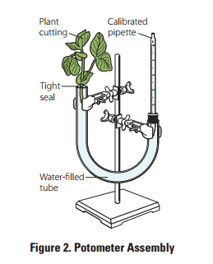  Transpiration is the process by which water evaporates out of small holes on the underside of leaves called stomata and enters the air as a gas (i.e. water vapor).  You can choose to measure the effects of various environmental variables (ex: temperature, humidity, etc.) on the rate of transpiration in plants.  Let’s say we chose to decrease the humidity (concentration of water vapor in the air) by using a small fan or a dehumidifying device pointed towards the plant. If this decreases the concentration of water vapor in the air, water should be more drawn to move down its concentration gradient from a high concentration in the leaf cells through the stomata to a low concentration in the air. Thus, decreasing the humidity should increase the rate of transpiration.  We can measure the rate of transpiration in the plant by constructing what is called a potometer (see image to the right). In a potometer, a plant is placed in a section of plastic tubing containing water. The plastic tubing is connected to a pipette with measurement markings. The pipette will also contain water up to a particular marking. Water should be able to flow from the pipette into the plastic tubing and into the roots of the plant. Once inside the plant, water will flow up the stem, into the leaves, and into the air through transpiration.  We can measure the rate of transpiration by recording the level of water in the pipette when the plant has just been placed in the potometer and again after a period of time. The difference between the water levels represents the amount of water lost to the air through transpiration over that time (i.e. the rate of transpiration).
Hypothesis | If plants are exposed to a dehumidifier, then their rate of transpiration will increase.
Methods | Basics: Construct two potometers. Expose one potometer to the dehumidifying device, and leave the other potometer under normal conditions for a period of time.  Independent Variable: The dehumidifier  Dependent Variable: Rate of transpiration (measured by the change in water level in the pipette component of the potometer)  Control Group (group not exposed to the independent variable): plant in the potometer that is not exposed to the dehumidifier  Experimental Groups (groups exposed to varying degrees of the independent variable): plant in the potometer that is exposed to the humidifier  Constants (to make sure that any differences between the control group and experimental groups are due to the independent variable alone): type of plant, sunlight, temperature, etc.  Repeated Trials: Need to conduct 3-5 trials per treatment group to ensure accuracy of data
Data Collection and Organization | You will record your data in a chart similar to the one given below…  Potometer Conditions Initial Water Level (mL) Final Water Level after 24 hours (mL) Change in Water Level over 24 hours (i.e. the amount of water transpired, in mL)  Humidifier present  No humidifier
Data Analysis | You will compare the mean changes in volume after 24 hours across 3-5 trials in both treatment groups to either support or refute your hypothesis.

Animal Behavior Lab

Background Information | 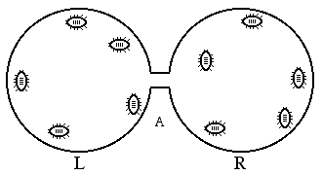  In this lab, you will be investigating the environmental preferences (wet or dry) of mealworms. You will create a “choice chamber” where one side of the petri dish contains wet filter paper and the other side contains dry filter paper (see image to the right). You will place 5 mealworms on each side of the chamber at the start of the experiment and record the number of mealworms on each side of the chamber every minute for 20 minutes.  Worms normally live in moist environments, so we might predict that worms will prefer the wet filter paper over the dry filter paper.
Hypothesis | If worms are given a choice between wet and dry filter paper, then more worms will choose the wet filter paper.
Methods | Basics: See background information section  Independent Variable: Wet vs. dry filter paper  Dependent Variable: Movement of the worms to either side of the choice chamber  Control Group (group not exposed to the independent variable): N/A  Experimental Groups (groups exposed to varying degrees of the independent variable): the worms in the choice chamber  Constants (to make sure that any differences between the control group and experimental groups are due to the independent variable alone): type of filter paper, size of filter paper, size of petri dishes in the choice chamber, temperature on each side of the choice chamber, light on each side of the choice chamber, etc.  Repeated Trials: There are 10 trials (i.e. worms) per choice chamber, but we will need to collect class data to compile all the trials and ensure accuracy of the data
Data Collection and Organization | Time (in minutes) # of Worms on Wet Side # of Worms on Dry Side  1  2  3  4  5  6  7  8  9  10  Mean (Average)  You will record your data in a chart similar to the one given below  The teacher will collect all class averages and determine the sum of these averages.
Data Analysis | You will run a Chi Square test on the class sums to either reject or fail to reject (i.e. support) the following null hypothesis: “There is no statistically significant difference between the number of worms on the wet side vs. the dry side of the choice chamber.”

Note: One lab from our ecology unit that is not included in this review is the Energy Dynamics Dry Lab. Please look over your lab packet as review.

Practice “Thinking” Questions

- Invasive species are species that are introduced into an environment but are not naturally found in that environment. One example of an invasive species is the American gray squirrel, introduced into Britain at the end of the 18th century. Until 1876 the only native squirrel in Britain was the European red squirrel, which was found in deciduous and coniferous forests. By 1940 the gray squirrel had displaced the red squirrel across most of the British Isles, and by 1984 the red squirrel was only found in isolated coniferous woodland areas. After its initial introduction, the gray squirrel population increased rapidly; however, in recent years population sizes within specific environments have become stable.
- Explain why the newly-introduced gray squirrel initially showed rapid population growth and why the native red squirrel showed a population decline.

- Why has the population size of the gray squirrel become stable in recent years?

- The first age structure graph below for country X shows the percent of the population in each age group for the year 2000. The remaining three graphs are projections of how the age structure of country X will change. From these age structure diagrams construct a graph of population size vs. time for 2000-2080 and justify your prediction.

- The graphs below display the growth rate for two species of bacteria when grown separately and together.
- The population growth of which bacteria is more affected by growing conditions? Explain how you know.

- Using the information provided in the graphs, make a prediction as to why the bacteria identified in part a is more affected by growing conditions than the other bacteria.

- Interdependence in nature is illustrated by the transfer of energy through trophic levels. The diagram below depicts the transfer of energy in a food web of an Arctic lake located in Alaska.
- Identify an organism from each of the 5 trophic levels (producer, primary consumer, secondary consumer, teritiary consumer and decomposer) and explain how energy is obtained at each level.

- Describe the efficiency of energy transfer between trophic levels of this food web.

- Explain how the amount of energy available at each trophic level affects the size of each population.

- If all of the Sculpin in this ecosystem were removed, predict how it would impact the following and explain each prediction:
- The population of lake trout
- The population of snails
- The population of algae
- The amount of oxygen produced in the ecosystem
- The amount of light energy absorbed by the ecosystem

Practice Short Response Questions (answer to the right!!!)

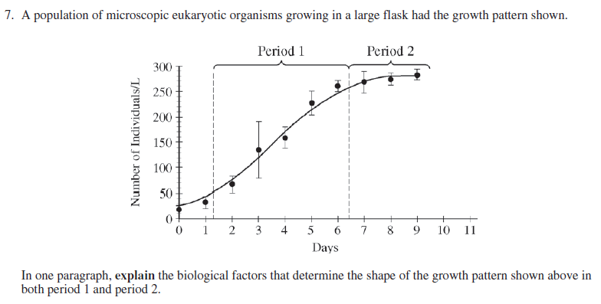

Practice Long Response Question

Practice Calculations Questions

Chi Square

Why use this formula?
Use the Chi square formula to determine if there is a statistically significant difference between expected results (hypothesized results) and observed results (actually experimental data).

Helpful Videos
Bozeman Science—Chi-squared Test:
https://www.youtube.com/watch?v=WXPBoFDqNVk

Formula Additional Information from the Formula Sheet
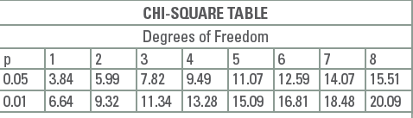
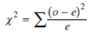
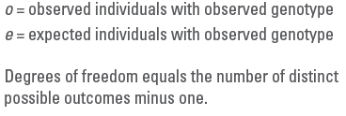

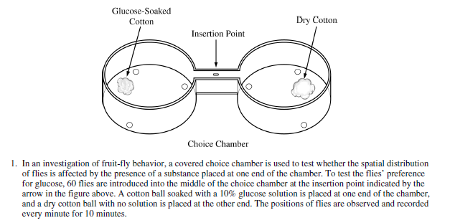
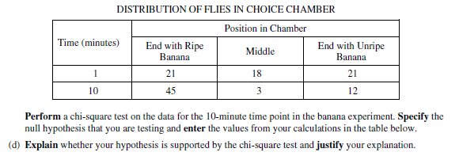

(CHI-SQUARE ON NEXT PAGE)
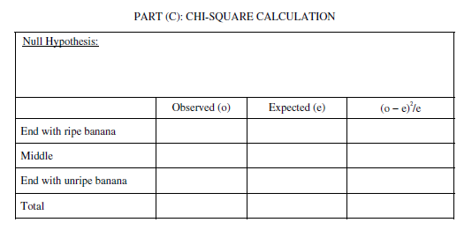

PART D ANSWER:

Rate

Why use this formula?
Use the rate formula to determine how quickly a particular process is occurring over a given period of time.

Formula

Additional Information from the Formula Sheet
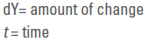

2.
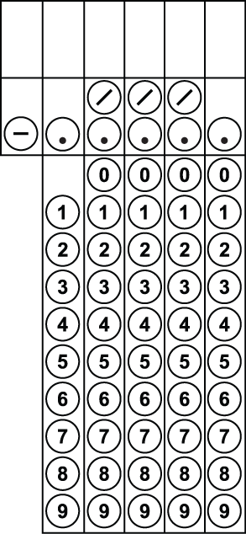
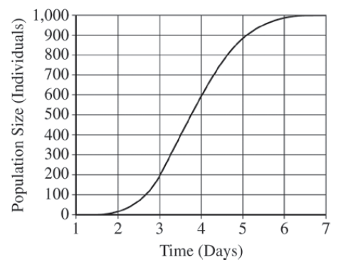
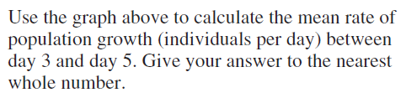
Population Growth

Why use this formula?
The population growth equations enable you to determine the rate of growth for population based on several factors including birth rate, death rate, carrying capacity (for logistic growth), etc.

Helpful Videos
Bozeman Science – Exponential Growth
https://www.youtube.com/watch?v=c6pcRR5Uy6w
Bozeman Science – Logistic Growth
https://www.youtube.com/watch?v=rXlyYFXyfIM

Formula Additional Information from the Formula Sheet
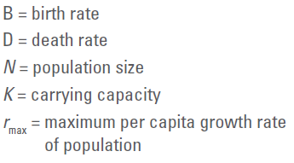
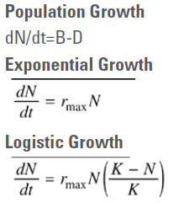

3. A hypothetical population has a carrying capacity of 1,500 individuals and rmax is 1.0. What is the population growth rate for a population with a size of 1,600 individuals? Round your answer to the nearest hundredth. What is happening to this population?

4. (Note: For the question below, your answer should be expressed as ___.___ millions of people.)
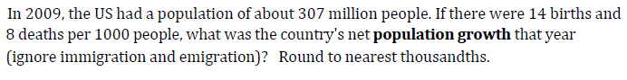

5. There are 2,000 mice living in a field. If 1,000 mice are born each month and 200 mice die each month, what is the per capita growth rate of mice over a month? Round your answer to the nearest tenth.

