Name: __________________________________________________ Date: _______________________ Period: ______

**Unit 1 (Evolution) Review Packet**

AP Biology, 2018-2019

**Topic #1: Evolution Basics and Types of Selection**

1. Centuries ago, the human appendix may have been used to digest raw meat that had not been cleaned properly. Now, the human appendix has lost its ability to function. Explain why this has occurred, using the term “natural selection” in your response.

2. Lynx (i.e. large cats) have evolved strong sprinting muscles to catch hares (i.e. rabbits). How might the hares evolve in response to this change in the lynx? (this is an example of coevolution)

3. Suppose there was a fossilized canine species that possessed traits of ancient wolves and modern domestic dogs. What would this fossil be called, and how does it provide evidence for evolution?

4. Why do scientists look at DNA or amino acid (i.e. the building blocks of proteins) sequences when investigating the evolutionary relationship between two species?

5. Suppose a population of daisies ranges in height from short to tall. Over time, the environment becomes much windier and the tall flowers blow over and die. How will the population evolve over the next few generations? Use the terms natural selection, fitness, survival, and reproduction in your response.

6. Let’s say a population of elephants has trunks ranging in length from short to medium-length to long. Describe a change in the environment that may result in disruptive selection, and describe the changes that would occur in the trunk length frequencies in the population over time.

7. Let’s say a population of elephants has trunks ranging in length from short to medium-length to long. Describe a change in the environment that may result in stabilizing selection, and describe the changes that would occur in the trunk length frequencies in the population over time.

8. Let’s say a population of elephants has trunks ranging in length from short to medium-length to long. Describe a change in the environment that may result in directional selection, and describe the changes that would occur in the trunk length frequencies in the population over time.

9. Explain how sexual dimorphism is caused by sexual selection. Provide an example in a population of animals. (Note: Your example can be imaginary or real!)

10. Male elk use their antlers to spar with one another in order to compete for females. Over time, the average male elk antler length has increased. However, at a certain length, long antlers make elk more likely to be caught and killed by wolves. Explain how sexual selection and the survival component of natural selection have balanced one another in the evolution of elk antler length.

**Topic #2: Genetic Variation and Hardy-Weinberg Equilibrium**

11. Why is sexual reproduction more beneficial than asexual reproduction when it comes to genetic variation and ensuring the survival of a species? Remember, sexual reproduction involves two parents and results in offspring that are not identical to one another or the parents. Asexual reproduction involves one parent and results in offspring that are identical to one another and the parent.

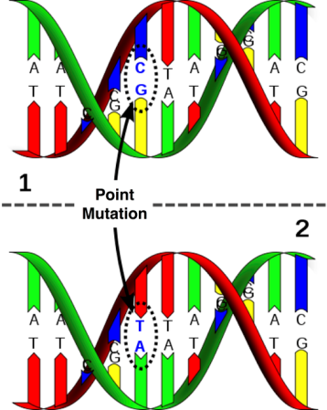12. What process is shown in the picture to the right? When does this occur, and does it increase or decrease genetic variation in a population?

13. What process is shown in the picture to the right? When does this occur, and does it increase or decrease genetic variation in a population?

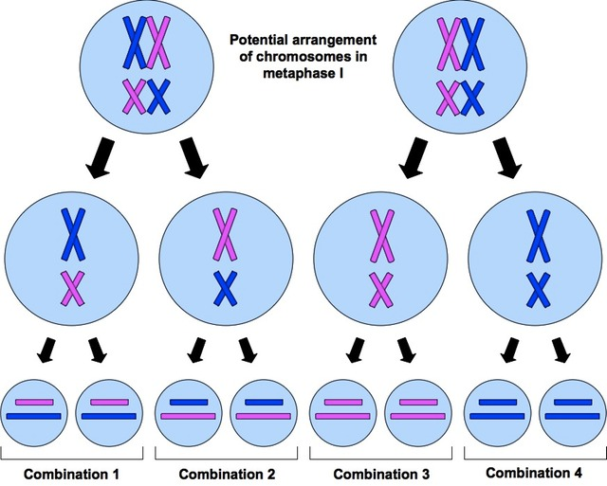

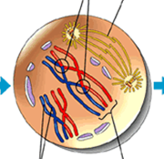14. What process is shown in the picture to the right? When does this occur, and does it increase or decrease genetic variation in a population?

15. What happens during fertilization? Why do we consider fertilization to be “random” in humans? What does the term “random” indicate? Does this process increase or decrease genetic variation in humans?

16. List and describe each of the five conditions that a population must meet to be in Hardy-Weinberg Equilibrium (i.e. a population that is not evolving with no changes in allele frequencies across generation). *Hint: These five conditions are the opposite of the five factors that can cause evolution.*

17. In Drosophila (fruit fly), the allele for normal wing length is dominant over the allele for short wings. In a population of 1000 individuals, 360 show the recessive phenotype. How many individuals would you expect to be homozygous dominant for the trait if the population is in Hardy Weinberg Equilibrium?

18. The allele for a widow's peak (hairline) is dominant over the allele for a straight hairline. In a population of 500 individuals, 9% show the recessive phenotype. How many individuals would you expect to be heterozygous for the trait if the population is in Hardy Weinberg Equilibrium?

19. The ability to taste PTC is due to a single dominate allele "T". You sampled 215 individuals in biology, and determined that 150 could detect the bitter taste of PTC and 65 could not. Determine the frequency of the dominant allele in this sample of students if the sample is in Hardy Weinberg Equilibrium.

**Topic #3: Macroevolution and the History of Life**

20. Describe the difference between prezygotic and postzygotic barriers to reproduction between two populations.

21. Provide an example of a prezygotic barrier.

22. Provide an example of a postzygotic barrier.

23. Two populations of protists were raised on two different food sources—glucose (Population #1) and lactose (Population #2). Each population adapted to its food source. When members of the two populations were put in the same petri dish, scientists recorded the number of successful matings within and between members of the two populations.

|  |  |  |  |
| --- | --- | --- | --- |
|  | Female | | |
| Male |  | Population 1 | Population 2 |
| Population 1 | 26 | 11 |
| Population 2 | 9 | 30 |

Are the populations two different species? How do you know?

24. If two populations of giraffe can mate and produce living offspring but the offspring are sterile (i.e. infertile or unable to reproduce), are the two populations members of the same species? Why or why not?

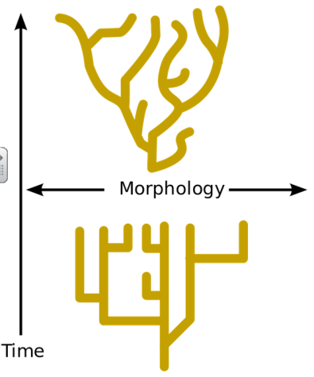

25. Identify the model for the rate of evolution—gradualism vs. punctuated equilibrium—shown by each graph to the right. Explain your choices.

26. Several populations of the same ancestral species of river turtle spread out to different rivers and adapted to each new environment. Over time, the members of the different population became unable to mate successfully with one another. Is this an example of divergent evolution, convergent evolution, or coevolution? Explain your answer.

27. Lizards and salamanders are not closely related. Lizards descend from ancestral reptiles, and salamanders descend from ancestral amphibians. Because they live in similar environments, however they have adapted similar body forms (ex: four limbs and a tail). Is this an example of divergent evolution, convergent evolution, or coevolution? Explain your answer.

28. The old world swallowtail (Papilio machaon) caterpillar lives on the fringed rue (Ruta chalepensis) plant. The rue produces oils that repel plant-eating insects. The old world swallowtail caterpillar developed resistance to these poisonous substances. Is this an example of divergent evolution, convergent evolution, or coevolution? Explain your answer.

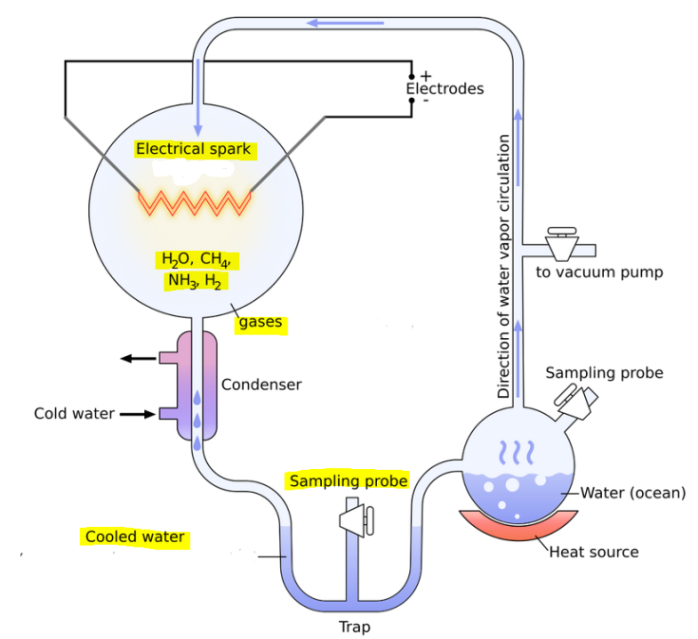

29. The image to the right shows Miller and Urey’s apparatus for their origin of life experiment.

A) What did the gases in the large round chamber represent?

B) What did the electrical spark represent?

C) What did Miller and Urey find using the sampling probe in the cooled water at the bottom of the apparatus? What conclusion did they draw from their results?

30. Which molecule—DNA or RNA—have scientists concluded was the first molecule of inheritance? How did they conclude this?

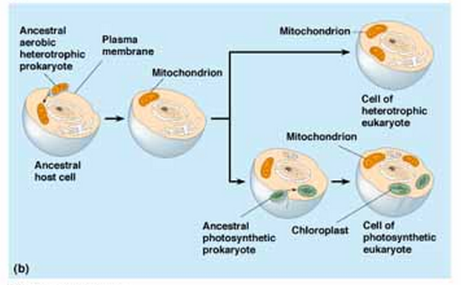

31. What process is shown in the picture to the right? How does this relate to the origin of eukaryotic cells? Which cell part—chloroplast or mitochondrion—appears to have evolved first, and how do you know?

32. What are two features of mitochondria and chloroplasts that suggest they were once free-living prokaryotic cells?

33. Identify 3-5 major steps in the history of life that led from the synthesis of the first simple organic molecules (ex: amino acids) to the origin of the first multicellular organisms with cells specialized for particular functions?

**Topic #4: Classification and Biodiversity**

34. On the phylogenetic tree shown to the right, what happened to species V?



35. On the phylogenetic tree shown to the right, among species X,Y, and Z, which two species share the most recent common ancestor? How do you know?

36. Describe three traits found in the universal common ancestor of the three domains of life—Archaea, Bacteria, and Eukarya. (Note: These traits are also found in current members of the three domains of life.)

37. Use the table of shared morphological characteristics for the four species—*Spermocyon, Castropsis, Pseudofelis, and Neomysticena*—to create a cladogram in the space below showing the evolutionary relationships for these four species. Your cladogram should include “tick marks” to represent the traits.

|  |  |  |  |  |
| --- | --- | --- | --- | --- |
| Character | *Spermocyon* | *Castropsis* | *Pseudofelis* | *Neomysticena* |
| 3 toes on hindfeet | X | X |  | X |
| Naked tail (hairless) | X | X | X | X |
| Incisors greatly enlarged |  | X |  | X |
| Hair tufts protrude from ears |  |  |  | X |

**Statistics: Error Bar Graphing**

38. What is the formula we use to calculate our range for a 95% Confidence Interval?

39. Use the following data to make an error bar graph, with the error bars representing the 95% confidence interval.

|  |  |  |
| --- | --- | --- |
| Average Number of Sodium Ions That Can Enter A Nerve Cell | | |
|  | Normal Nerve Cell | Nerve Cell Treated with Poison |
| Mean ($\overline{x}$) | 38 | 19 |
| Standard Error (SE) | 2.1 | 1.3 |

40. Do the errors bars overlap? What does that mean? What

does it mean if the opposite happens?

**Calculations: Hardy-Weinberg Equilibrium**

41. What the mathematical terms that represent each of the following:

a. homozygous recessive genotype

b. heterozygous genotype

c. recessive allele

d. homozygous dominant genotype

e. dominant phenotype (all individuals that “look” dominant)

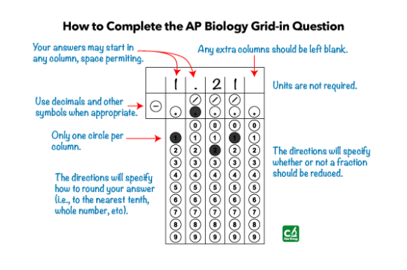 f. recessive phenotype (all organisms that “look” recessive)

g. dominant allele

42. What do you need to do to give your answer as:

a. frequency

b. percent

c. number of individuals (“How many organisms…”)

43. See Topic #4 for practice problems.