Evolution (Unit 9) Multiple Choice Questions

1. A pair of American Robins (Turdis migratorius) successfully rear five young. Two of the offspring are males that live to be the same age before they die.
What data would be most relevant in determining which of the male offspring was more fit?
A. Determine the weight of both birds when they died. The bird that weighed more was more fit
B. Determine the total mass of food ingested by both birds over the course of their lives. Whichever bird consumed more food was more fit
C. Determine the size of the territory established by each bird before they died. Whichever bird had the larger territory was more fit
D. Determine the number of offspring each bird produced over the course of their lives. Whichever bird produced the most offspring was more fit

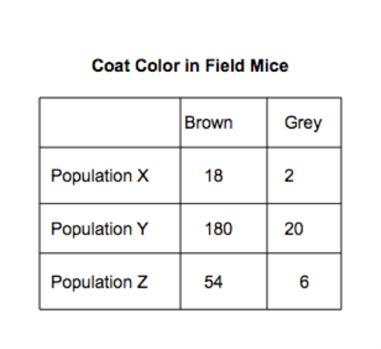
2. A scientist is studying coat color in three different populations of field mice. Brown coat color is dominant to grey coat color.
To the right is a data table showing the number of brown and grey mice in each of the three populations:

Which population is most likely to be subject to the bottleneck effect?
A. Population X
B. Population Y
C. Population Z
D. It is impossible to tell from the information given

3. Which of the following is a condition that must be met for a population or an allele to be in Hardy-Weinberg equilibrium?
A. The population in question must be small
B. Organisms must be free to migrate into or out of the population
C. New mutations must be introduced to the gene pool at a consistent and unfluctuating rate
D. Organisms in the population must express no mating preferences

4. On a college campus, health services began using methicillin to treat S. aureus bacterial infections in its athletes. Within six months of starting this effective treatment method, 85% of all new infections were caused by methicillin-resistant S. aureus organisms.
Which of the following best explains this phenomenon?
A. Some drug-resistant bacteria were present at the beginning of the new treatment program, and the addition of the drug methicillin changed the environment so that natural selection increased their frequency
B. S. aureus altered the structure of the protein targeted by methicillin in response to the drug's presence
C. A student on the campus must have contracted a methicillin-resistant strain of S. aureus during an away game at another college
D. S. aureus is unaffected by vaccines

5. Which of the following pieces of evidence most strongly supports the idea that all life on Earth evolved from a single ancient common ancestor?
A. All life requires a constant input of energy from its environment
B. All organisms use the same molecules (DNA and RNA) to function and reproduce
C. All organisms reproduce
D. All organisms experience evolution

6. Which of the following statements concerning genetic variation is most accurate?
A. The process of natural selection directly creates genetic variation
B. Changes in the environment of a population stimulate mutation and genetic change in that population
C. Genetic variation must first be present in a population before natural selection can act upon organisms in that population
D. The higher the average heterozygosity in a population, the less genetic variation in the gene pool

7. In the wild, female Red Winged Blackbirds (Agelaius phoeniceus) lay egg clutches that vary in size from just two eggs per clutch to seven eggs per clutch. Clutch size is a genetic trait, so a single female will lay clutches of a set size throughout her reproductive life.

Prior to a seven-year-long drought, a population ecologist surveys a breeding population of birds in a two mile radius and determines the average number of eggs per clutch laid by females in that population to be five.

The ecologist surveys the same breeding population of birds at the end of the drought and finds the average number of eggs per clutch laid by females in that population to be two.

Three years later, during which time the area receives normal amounts of precipitation, the average clutch size in the population of breeding females has returned to five. Which of the following best explains these observations?

A. Directional selection shifted to favor females who laid fewer eggs during the drought, and then shifted again after the drought to favor females who laid more eggs
B. By the end of the seven-year-long drought all of the females who laid fewer eggs starved to death, leaving behind the females who laid more eggs
C. By the end of the seven-year-long drought all the males who preferred females who laid fewer eggs starved to death, leaving only the males who preferred females who laid more eggs
D. Female birds that laid more eggs starved to death during the drought, leaving only females who laid fewer eggs. When the drought ended, new niches were available which causes the remaining females to experience adaptive radiation

8. In the year 2230, ten married (heterosexual) pairs of space colonists settle an uninhabited planet. They and their children randomly mate for several generations. All of the original colonists could roll their tongues, and four were heterozygous for the trait.
Why is it unlikely for Hardy-Weinberg equilibrium to maintain initial allele frequencies for tongue rolling that existed in the original colonists' population?
A. Random mutations are more likely to occur in the environment of a new planet
B. Inbreeding would occur, which has the same effect on a population as emigration
C. Tongue rolling is an important survival trait that is likely to be selected for the environment of the new planet
D. The population is so small that random chance will artificially alter the allele frequencies from generation to generation.

9. In a certain species of chameleon lizard, there is variability in size. Chameleons use their tongues, which they extend forward to catch their preferred food--butterflies. Larger chameleons have longer tongues. Smaller chameleons, with shorter tongues, must get significantly closer to butterflies in order to catch them than the larger chameleons. Surprised that the numbers of smaller chameleons and larger chameleons are about equal in a particular population, a herpetologist catches and examines the physiology of large and small chameleons.

She discovers that the tips of the shorter tongues of the smaller chameleons are coated with an extremely sticky mucus. The tongues of the larger chameleons have no such mucus.
Which of the following is the most logical conclusion that can be drawn from this observation?
A. The larger and smaller chameleons are actually different species and they hunt different species of butterflies to avoid competition
B. Even though they must get closer to their prey to catch them, the smaller chameleons can move much faster than the larger chameleons
C. The sticky mucus increases the fitness of the smaller chameleons more than the shorter tongue length decreases their fitness and so they are able to survive
D. The smaller chameleons are less likely to be seen by the butterflies and so have a higher fitness than the larger chameleons

10. DNA sequences in many chimpanzee genes show a greater degree in similarity to comparable genes in mountain gorillas than in savannah baboons.
Which of the following offers the most likely explanation for this observation?
A. convergent evolution led to the observed genetic similarities between chimpanzees and gorillas
B. chimpanzees and gorillas share a more recent common ancestor than do chimpanzees and baboons
C. gorillas evolved from chimpanzees, not from baboons
D. baboons evolved from chimpanzees, not from gorillas
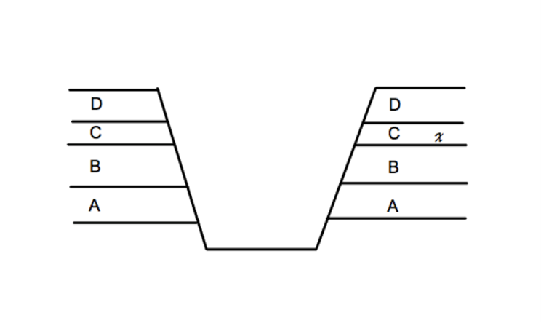
11. The image above shows where a team of paleontologists have dug down into the earth through several layers of sedimentary rock labeled A through D.

If "x" shows where the scientists found fossils of two closely related species of dinosaur, in which layer should they expect to find fossils from their most recent common ancestor?
A. A
B. B
C. C
D. D

12. There are multiple color phenotypes in a hypothetical population of flies living in a New England forest, matching the various colors of the bark of the trees on which they live and hide from predators.

The graphs below show four possible changes to the population of flies after air pollution from a coal-burning power plant darkens the bark of the trees in the forest.

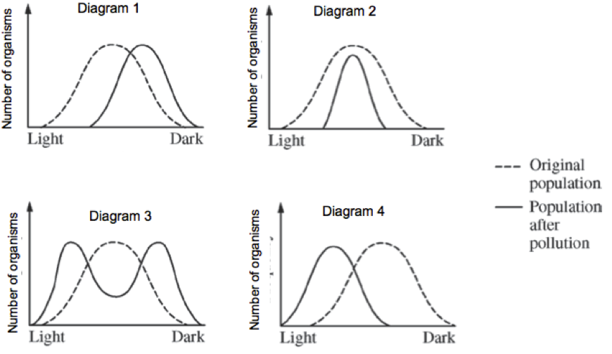
Which of the following provides the most probable change in the coloration of the fly population in response to the effects of the air pollution along with a correct explanation for the change?
A. The coloration range shift shown in diagram 4. The darker flies became easier for predators to find
B. The coloration range shift shown in diagram 2. Predators no longer recognized the lighter colored flies as a food source, and the darker colored flies were better able to camouflage themselves against the darker colored bark
C. The coloration range shift shown in diagram 3. Predators could find both the lighter and darker colored beetles more easily
D. The coloration range shift shown in diagram 1. Predators were able to find the lighter colored beetles more easily than the darker colored beetles

13. During a conversation at the dinner table, a high school student tells his mother that: "at first all giraffes had short necks because they all ate leaves close to the ground, but when all those leaves were gone some giraffes started being born with long necks".

Which statement would be most helpful in correcting the student's misconception?
A. Phenotypic variations occur through random mutations which are then selected for or against
B. The phenotype for neck length changed in giraffes so that the species did not go extinct
C. Short-necked giraffes developed long necks in response to increased competition for food
D. When the environment changed, the struggle to exist created new mutations in the gene pool and natural selection acted on them

14. Scientists have collected data showing that the metabolic process of glycolysis is present in the cells of organisms from all three domains of life (Archaea, Bacteria, and Eukarya).
This data best supports which of the following hypotheses?
A. The existence of glycolysis in the cells of organisms from all three domains suggests that convergent evolution has occurred
B. In all three of the domains, organisms produce ATP exclusively through the process of anaerobic respiration
C. The use of glycolysis as an energy releasing process in the cells of organisms from all three domains suggests a common ancestor for all forms of life.
D. In the cells of organisms from all three domains, glycolysis occurs in the intermembrane space of the mitochondria

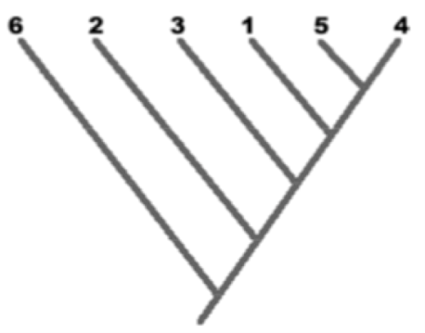

15. Examine the cladogram above. Which two organisms are most closely related?
A. 1 and 4
B. 3 and 4
C. 4 and 5
D. 2 and 4

16. When new islands are formed as a result of sudden and violent volcanic eruptions, such as when the Hawaiian Islands formed, which of the following features and resulting phenomenon should be observed?
A. Overcrowding which would lead to organisms migrating to nearby land masses
B. Mass extinctions which would lead to a bottleneck effect
C. Adaptive radiation which would lead to the founder effect
D. Many new and empty ecological niches which would lead to adaptive radiation

17. A wide river has separated two populations of jack rabbits for many generations. A severe drought related to ongoing climate change causes the river to dry up for a brief period of time.
When the river begins to flow again, its course changes so that the two populations of rabbits are now on the same side of the river.
Which of the following scenarios is NOT possible in this situation?
A. Rabbits from the two populations breed but they produce sterile offspring
B. Rabbits from the two populations breed and produce fertile offspring
C. Rabbits from the two populations do not attempt to breed with each other
D. Rabbits from the two populations breed and produce inferior offspring, but when the inferior offspring breed with each other, they produce superior offspring

18. Which of the following properties of ribozymes supports the idea that RNA was the first genetic material to develop on Earth?
A. Ribozymes have enzymatic properties that can speed up other chemical reactions
B. Ribozymes are capable of self replicating
C. Ribozymes can experience mutations that render them non-functional under certain environmental conditions
D. In laboratory experiments, RNA nucleotides form far more often than do DNA nucleotides

19. Which of the following statements provides the best supporting evidence for the idea that all organisms on Earth share a common ancestral origin of life?
A. All cells on Earth can be infected by viruses, which can use either DNA or RNA as their genetic material
B. All cells on Earth synthesize protein polypeptides from different combinations of the same 20 amino acid monomers
C. All cells on Earth require an aqueous internal environment in which to run various metabolic chemical reactions
D. All cells on Earth are capable of growing physically larger and reproducing

20. In certain African countries, 4% of the newborn babies have sickle cell anemia - which is caused by a recessive version of the hemoglobin gene.
Out of a random population of 10,000 newborn babies, how many would you expect to be homozygous for the normal, dominant hemoglobin genotype assuming Hardy-Weinberg equilibrium?
A. 400
B. 3200
C. 6400
D. 9600

21. In humans, the allele for the hair pattern called "widow's peak" is dominant over the allele for not having a "widow's peak". In a population of 1,000 individuals, 490 do NOT have a "widow's peak".
What are the homozyogous dominant, heterozygous, and homozygous recessive genotypic frequencies, respectively?
A. 0.09, 0.42, 0.49
B. 0.09, 0.49, 0.42
C. 0.49, 0.42, 0.09
D. 0.42, 0.49, 0.09

22. One way to classify humans is by their blood type. There are over two dozen ways to group blood types. One of them is by the presence of the D antigen on the surface of blood cells. If an individual expresses the D antigen, they are referred to as Rh positive. This is controlled by an autosomal dominant allele. In a given town, 16% of the population is considered Rh negative.
If this town's high school has 2,000 students, how many would you expect to have the homozygous dominant genotype?
A. 320
B. 720
C. 960
D. 1680

23. In humans, the allele for the hair pattern called "widow's peak" is dominant over the allele for not having a "widow's peak". In a population of 1,000 individuals, 490 do NOT have a "widow's peak".
What are the dominant and recessive allelic frequencies, respectively?
A. 0.51, 0.49
B. 0.49, 0.51
C. 0.7, 0.3
D. 0.3, 0.7

