Name: ___________________________

**Gene Regulation and Biotechnology (Unit 8) Multiple Choice Questions**

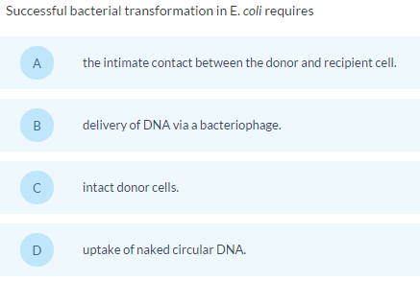

**1**

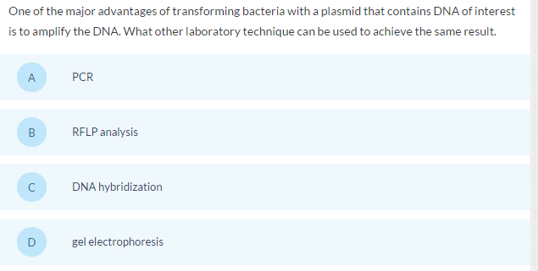

**2**

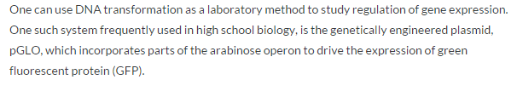

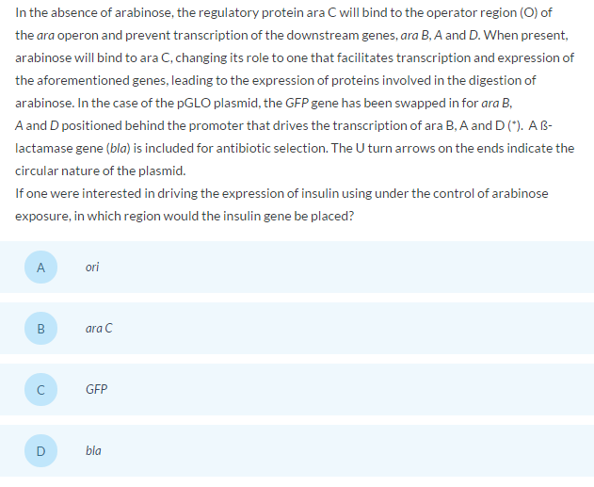

**3**

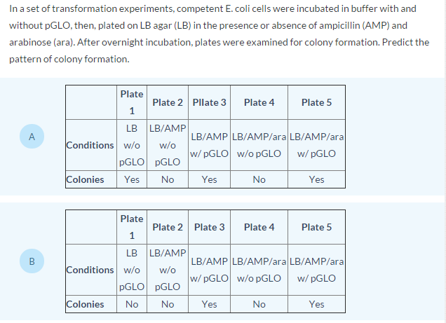 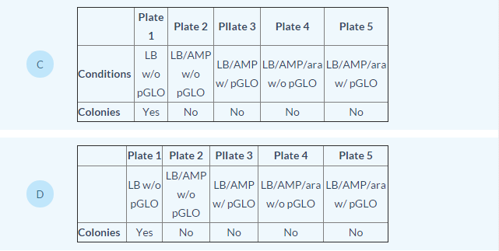

**4**

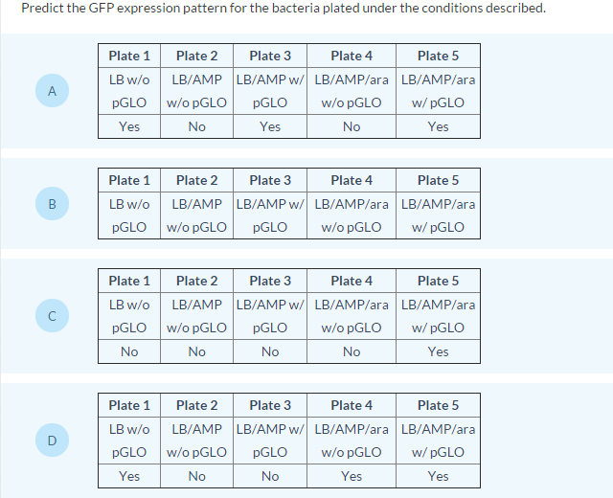

**5**

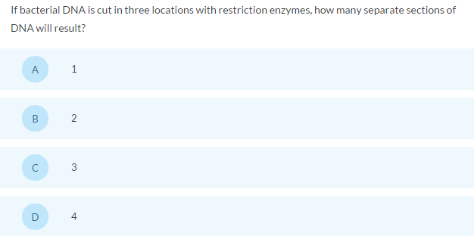

**66**

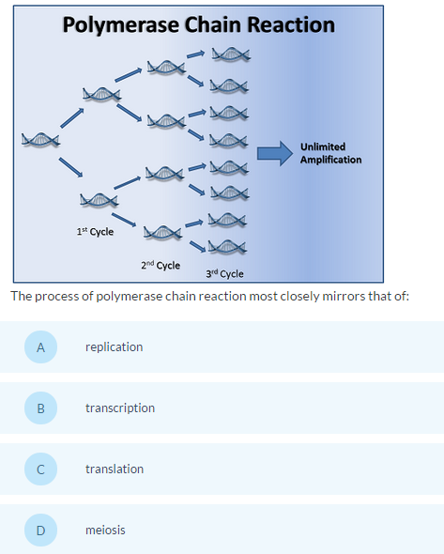

**76**

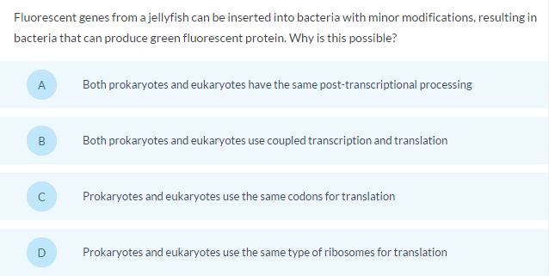

**86**

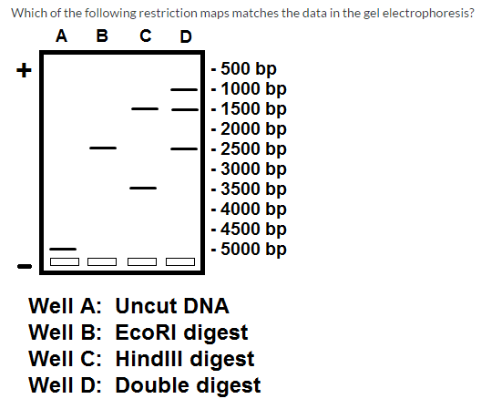

**96**

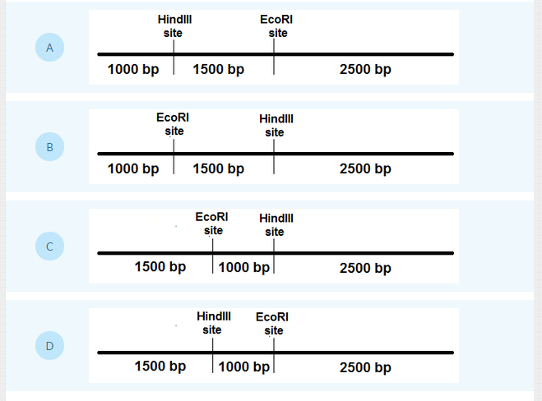

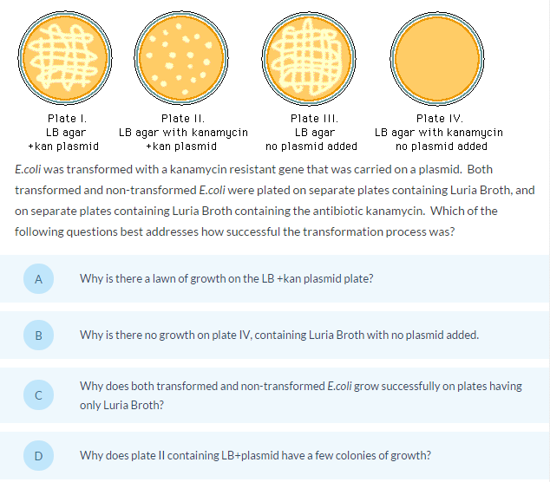

**10**

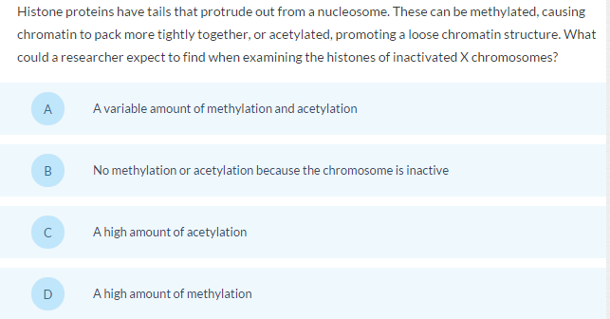

**11**

***Note: looser chromatin structure makes it easier to transcribe the DNA into mRNA because the RNA polymerase can more easily access the DNA***

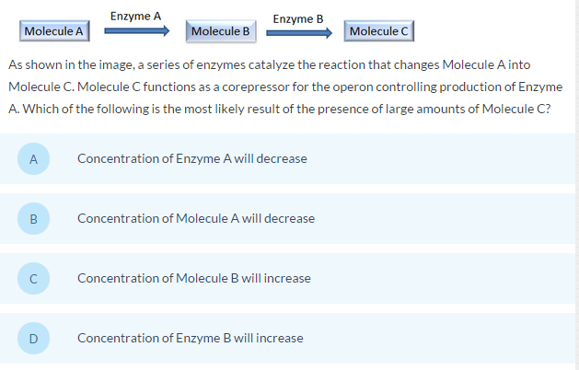

**123**

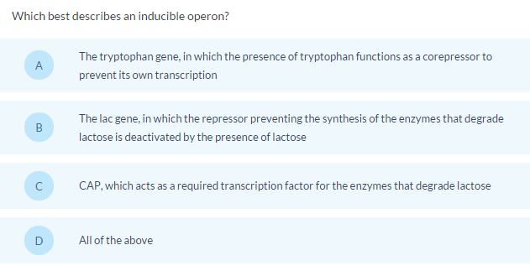

**13s3**

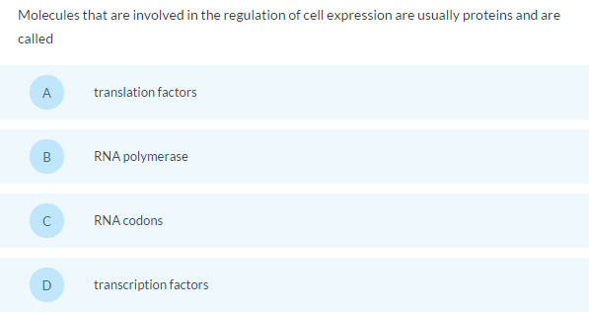

**143**

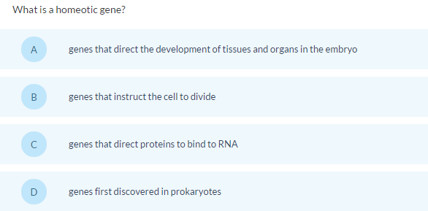

**153**

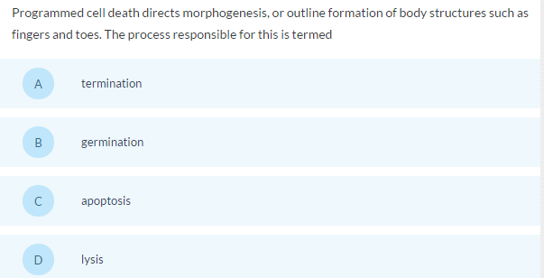

**163**

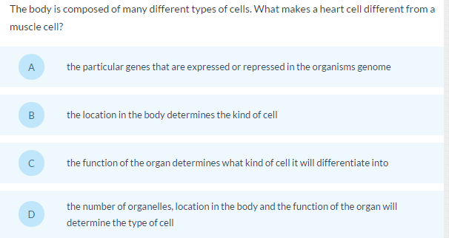

**173**

18. Which is primarily responsible for the rapid evolution of HIV?

A. Ease of transmission from person to person

B. Human use of antibiotics

C. Attack by immune cells

D. Lack of proofreading when making a DNA copy of RNA using reverse transcriptase