Name: _____________________________________________ Date: ____________________________ Period: ______

AP Biology Exam Review: Gene Regulation and Biotechnology (Unit 8)

Helpful Videos and Animations:
- McGraw-Hill Animation: Mechanism of Viral Infection (Lytic)
- McGraw-Hill Animation: Lytic vs. Lysogenic Cycle of Viral Infection
- Sumanas Animation: Life Cycle of HIV, a Retrovirus
- McGraw-Hill Animation: Bacterial Transduction Using a Temperate Phage
- Bozeman Science: Mechanisms of Genetic Variation in Prokaryotic vs. Eukaryotic Cells
- Sumanas Animation: Trp Operon (Repressible Operon)
- Sumanas Animation: Lac Operon (Inducible Operon)
- Bozeman Science: Gene Regulation in Prokaryotic vs. Eukaryotic Cells
- Sumanas Animation: Gel Electrophoresis
- McGraw-Hill Animation: Restriction Enzymes (AKA Restriction Endonucleases)
- McGraw-Hill Animation: Restriction Fragment Length Polymorphisms
- Sumanas Animation: Polymerase Chain Reaction (PCR)
- Cold Spring Harbor Lab Animation: Bacterial Transformation

Unit Vocabulary:

-Virus / Phage
-Capsid (protein shell / coat)
-Bacteriophage
-Lytic Cycle
-Lysis (of host cell)
-Lysogenic Cycle
-Prophage / Provirus
-Retrovirus
-Reverse Transcriptase
-cDNA / complementary DNA
-Bacterial Chromosome (circular, not linear like in eukaryotic cells)
-Bacterial Plasmids
-Transformation
-Transduction
-Conjugation
-Sex Pili (singular pilus)
-Gene Expression (which genes are “turned on” / transcribed into mRNA and then translated into protein)
-Gene Regulation (how organisms control which genes are “turned on”)
-Prokaryotic / Bacterial Operon (operator, promoter, genes of the operon, regulatory gene, repressor molecule)
-RNA Polymerase
-Repressible Operon (ex: Tryptophan / Trp Operon)
-Corepressor
-Inducible Operon (ex: Lactose / Lac Operon)
-Inducer
-DNA Methylation
-Histone Acetylation
-Transcription Factor (stimulatory vs. inhibitory)
-Enhancer-Binding Protein / Activator
-Enhancer Sequences
-Alternative splicing of introns
-RNA Interference (RNAi) using either microRNA molecules (miRNA) or small interfering RNA molecules (siRNA)
-Pattern Formation
-Morphogenesis
-Cell Differentiation / Specialization
-Cytoplasmic Determinants (ex: bicoid and caudal)
-Homeotic Genes / Hox Genes
-Apoptosis
-Embryonic Induction
-Gel Electrophoresis
-DNA Fingerprint
-Restriction Enzymes / Restriction Endonucleases
-Restriction Site
-Restriction Fragments
-Restriction Fragment Length Polymorphisms (RFLPs)
-Wells
-Agarose Gel
-DNA “bands”
-Sticky Ends
-Ligase / DNA Ligase
-Recombinant DNA
-Gene Cloning
-Polymerase Chain Reaction (PCR)
-Denature (separate DNA strands)
-Primers
-Anneal
-Taq Polymerase
-Bacterial Transformation
-Bacterial Lawns
-Bacterial Colonies
-Bacterial or Viral Vectors
-Transgenic Organisms (contain DNA from two or more species)
-Genetically-Modified Organisms / GMO’s (have had their DNA purposefully altered in some way by humans, are usually transgenic organisms… ex: a tomato plant that has been given the slug-resistance gene from another plant species)

Topic Outline: (Thank you to Megan Chirby and Amy Litz!)

Unit 7, Part 3 Notes: Viral and Bacterial Genetics

- Viruses
Replication
- Viruses inject DNA or RNA into host cell
- Viruses have highly efficient replicative capabilities that allow for rapid evolution
- Viruses replicate via the lytic cycle, allowing one virus to produce many progeny simultaneously
- Virus replication allows for mutations to occur through usual host pathways.
- RNA viruses lack replication error-checking mechanisms, and thus have higher rates of mutation.
- Related viruses can combine/recombine information if they infect the same host cell.
- Some viruses are able to integrate into the host DNA and establish a latent (lysogenic) infection
- HIV is a well-studied system where the rapid evolution of a virus within the host contributes to the pathogenicity of viral infection.
- Genetic information in retroviruses is a special case and has an alternate flow of information: from RNA to DNA, made possible by reverse transcriptase, an enzyme that copies the viral RNA genome into DNA. This DNA integrates into the host genome and becomes transcribed and translated for the assembly of new viral progeny.
- Bacterial Reproduction and Genetic Recombination
- Transformation
- Transduction
- Conjugation
- Transposition

Unit 8, Part 1 Notes: Gene Regulation and Development

- Prokaryotic Gene Regulation
- Bacteria are prokaryotic with a single circular chromosome
- Bacteria express all the genes needed for a product (more than one gene at a time)
- Organization includes the promoter region of DNA, operator, and structural genes
- Trp operon = repressible; anabolic pathway; used to make enzymes that help make tryptophan if none is present
- Repressor is naturally INACTIVE so it will make tryptophan
- Repressor only becomes ACTIVE when trp (called corepressor) is in excess and binds to repressor changing its shape
- Lac operon-catabolic pathway; inducible; used to make enzyme to break down lactose when it is available
- Repressor is naturally ACTIVE so it will block gene transcription unless lactose (allolactose- called inducer) binds and makes repressor INACTIVE

- Eukaryotic Gene Regulation
- Enhancers- Areas on genome that are non-coding that are located at a distance from a promoter. Transcription factors / activators can bind to these areas and cause transcription of certain genes. (turns on)
- MRNA Degradation by RNA interference- mRNA has a life span in the cytoplasm (can last a few hours to a week). (turns off)
- RNA processing (intron splicing, poly a tail, gtp cap) (turn on and alter expression)
- Histone Acetylation (turn on)
- DNA methylation (turn off)
- Translation Repressors (turn off)
- Posttranslational modifications- folding, cleaving, etc. (alter expression)

- The Steps of Embryonic Development
- Pattern Formation
- Cytoplasmic Determinants
- Homeotic Genes
- Morphogenesis
- Apoptosis
- Cell Differentiation
- Embryonic Induction
- Transcription Factors (Stimulatory or Inhibitory)

Unit 8, Part 2 Notes: Biotechnology

- Creation of Recombinant DNA and Bacterial Transformation
- Toolkit includes plasmid (piece of round DNA from bacteria/yeast) or other vector such as viruses; restriction enzymes; host cell (usually bacteria like E. coli)
- Restriction enzymes cut genes at restriction sites to make blunt or sticky ends
- Cut gene of interest (g.o.i.) with same enzyme to get same ends
- Use ligase to seal gene of interest into the plasmid
- Insert vector into host
- Used to clone and make copies or to produce a foreign protein such as HGH or insulin

- Polymerase Chain Reaction (PCR)
- Used to make large amounts of clones of DNA without using a host; heat which opens ; use a primer to mark the place in the sequence where Taq polymerase begins replication; cool; repeat

- Gel Electrophoresis
Used to look at unique pattern created by fragments of DNA; cut DNA using enzyme; load into a gel; turn on electricity; DNA runs from negative to positive; larger chunks move less; unique for each person if testing variable areas of DNA (ex: RFLP’s); can be used for protein or mRNA too

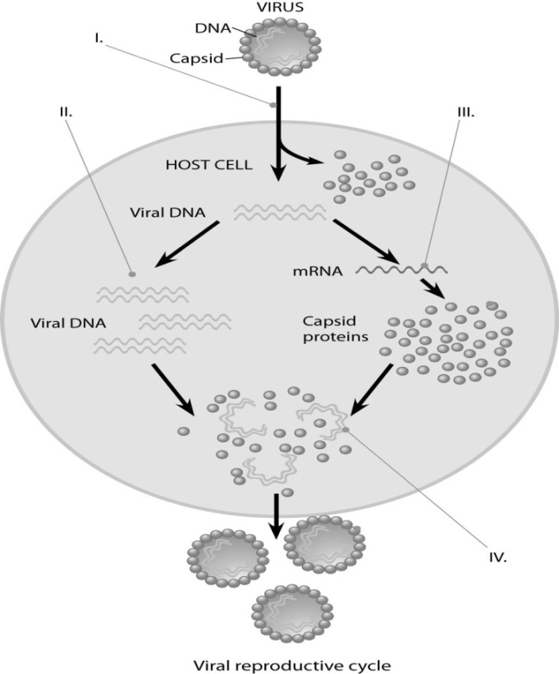

Practice “Thinking” Questions

- Describe the processes occurring at each of the numbered positions (I, II, III, and IV) in the diagram to the right.

- In a molecular biology laboratory, a student obtained competent E. coli cells and used a common transformation procedure to induce the uptake of plasmid DNA with a gene for resistance to the antibiotic kanamycin. The results below were obtained.
- What is the purpose of Plate IV?

- Explain the growth you see and the type of bacteria (transformed vs. non-transformed or both) that would be on Plate 1.

- Explain the growth you see and the type of bacteria (transformed vs. non-transformed or both) that would be on Plate II.

- If the student repeated the experiment, but the heat shock was unsuccessful and the plasmid was unable to be transformed, for which plates would growth be expected? Explain your answer.

- The restriction enzyme EcoRI cleaves double-stranded DNA at the sequence 5'-GAATTC-3' and the restriction enzyme HindIII cleaves at 5'-AAGCTT-3'. A 20 kb circular plasmid is digested with each enzyme individually and then in combination, and the resulting fragment sizes are determined by means of electrophoresis. The results are as follows:
Make a diagram of the circular molecule and indicate the relative positions of the EcoRI and HindIII restriction sites. (Hint: place one EcoRI site at '12 o'clock' and position the remainder relative to this site.)

Practice Short Response

1. Describe how recombinant DNA technology can be used to accomplish the following…
A. The creation of human insulin protein to treat diabetes.
B. The creation of golden rice, which is a transgenic plant (meaning it contains DNA from two different organisms) that has been given the gene for beta carotene (vitamin A) production using a bacterial vector.

