Name: ___________________________________________ Unit 2 Topic 3
Period: ______ Page: ______
Unit 2: Topic 3 Identifying the Macromolecules Worksheet

Tips for Identifying Pictures of Macromolecules:

Carbohydrates
- Pictures of carbohydrate monomers (monosaccharides) have one ring of carbon atoms (looks like a pentagon or hexagon) with oxygen atoms and hydrogen atoms branching off the ring.
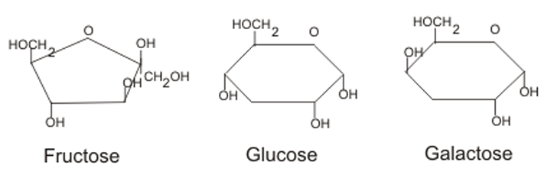
- Pictures of carbohydrate polymers (polysaccharides) have several rings of carbon atoms joined together by bonds.

Lipids
- Pictures of lipid polymers (fats) have a glycerol molecule (three carbon atoms joined in a chain with oxygen and hydrogen atoms branching off) linked to one or more fatty acid molecules (long chains of carbon and hydrogen atoms)
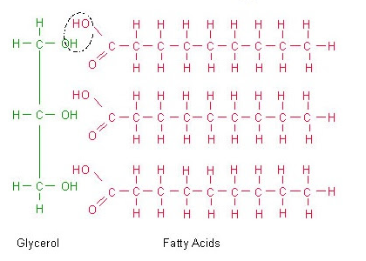
Nucleic Acids
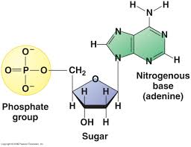
- Pictures of nucleic acid monomers (nucleotides) have a phosphate group (with a phosphorus atom surrounded by four oxygen atoms, PO₄²⁻), a 5-carbon sugar (looks like a pentagon), and a nitrogenous base (looks like one or two rings containing nitrogen atoms

- Pictures of the nucleic acid polymer DNA have a double helix structure (a winding staircase) that is composed of two chains of nucleotides. Pictures of the nucleic acid polymer RNA show a single chain of nucleotides.When “untwisted” the DNA molecule looks like a ladder. The phosphate groups and 5-carbon sugars of each nucleotide are located in the sides of the ladder, and the nitrogen bases form the middle “rungs” of the ladder.
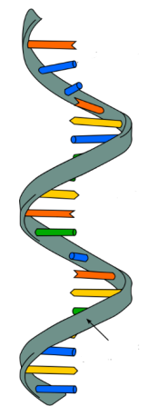
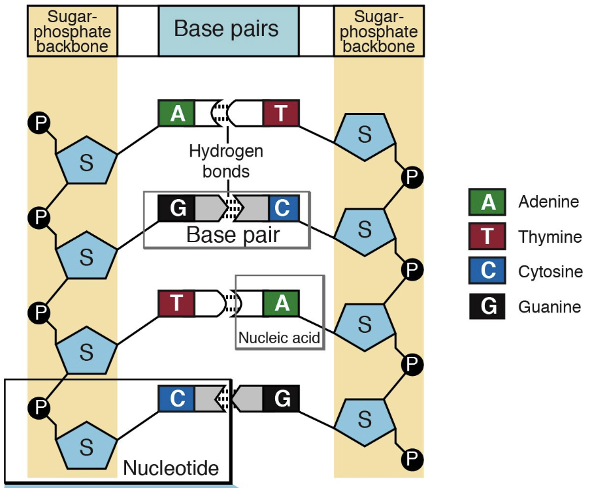
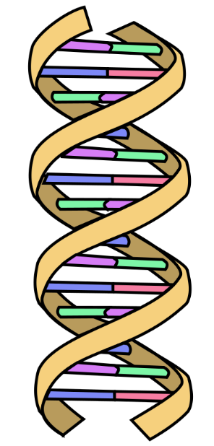

Proteins
- Pictures of protein monomers (amino acids) have a central carbon atom bonded to four things: a single hydrogen atom, an amino group (contains nitrogen and hydrogen atoms), a carboxyl group (contains a carbon atom that is double-bonded to an oxygen atom), and an R group (changes for each of the 20 different amino acids)
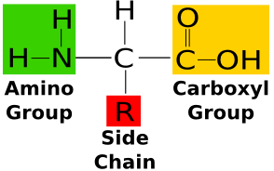
- Pictures of protein polymers (polypeptide) show a chain of amino acids, with the amino group of one amino acid bonded to the carboxyl group of the next amino acid in the chain.

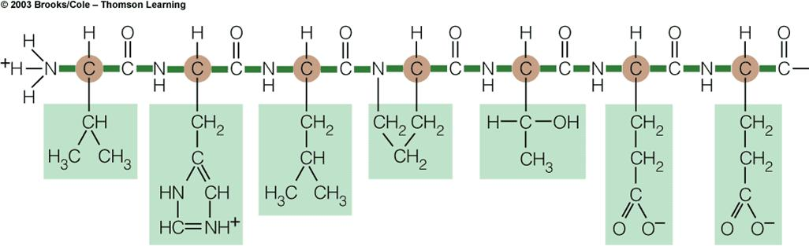
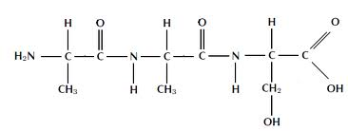
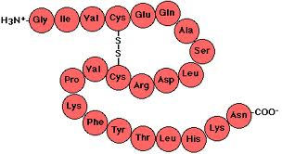

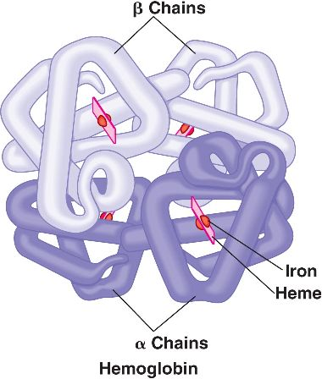

- Pictures of a “full protein” may show multiple polypeptide chains folded around one another.

Directions: Place a check mark in the column of each kind of macromolecule that has each characteristic. Some may need more than one check

Characteristics | Carbohydrate | Lipid | Protein | Nucleic Acid
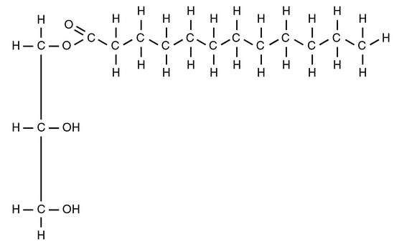
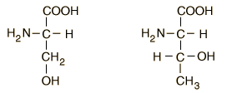
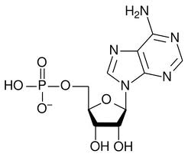
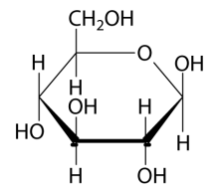
Enzymes (molecules that speed up chemical reactions) are an example of this type of macromolecule
Includes fats and oils

Polymers formed from amino acids
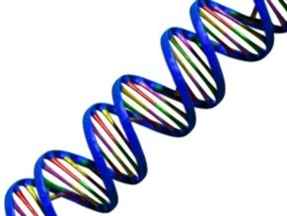
Always contains carbon and hydrogen
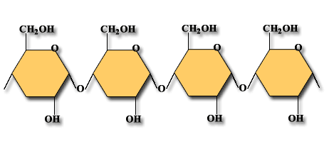
DNA and RNA are examples of this type of macromolecule |  |  |  | `
Table sugar (sucrose) is an example of this type of macromolecule
Characteristics | Carbohydrate | Lipid | Protein | Nucleic Acid
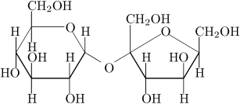

Stores genetic information

Is a polymer
Controls cellular activities
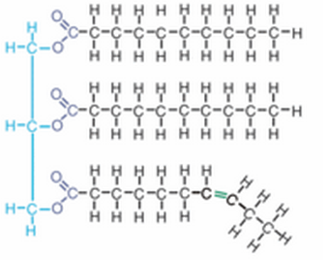
The polymer of this macromolecule is called a polypeptide
Is made of nucleotides

Is an organic compound
Includes starches
Made up of monomers

Is an organic compound

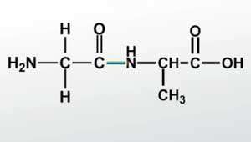
Formed by dehydration synthesis
Its monomers usually end in “ose”
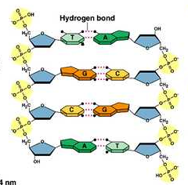
Breaks apart by hydrolysis

Important for defense, structure, storage, and transport

