Name: _________________________________ Unit 5 Cell Division
Period: _______ Page: _______
Language Targets for Unit 5, Topics 1-3
[[Language Target for Topic 1: I can identify the parts of a chromosome given a diagram; I can use images to describe how DNA coils up before cell division and verbally explain the purpose; I can discuss the impact of surface area to volume ratios]]
- Draw and label a chromosome with two sister chromatids; centromere; long arm (x2); short arm (x2); telomere

- Explain HOW and WHY DNA coils up prior to cell division (use pictures to help explain if necessary):

- Surface area to volume ratios: Most of this has been completed using our in-class POGIL, but take a moment to write what size cells are most efficient: ________________________
  - What do we mean when we say these cells are most efficient? _____________________________________________________________________________________ _____________________________________________________________________________________
  - How does DNA overload relate to this? _____________________________________________________________________________________ _____________________________________________________________________________________
  - Why can eukaryotic cells be larger than prokaryotic cells? _____________________________________________________________________________________ _____________________________________________________________________________________

[[Language Target for Topic 2: I can diagram the cell cycle, identifying key structural components while describing the events within; I can diagram the four stages of mitosis; I can create a Venn Diagram to explain the difference between plant and animal cell division; I can differentiate between prokaryotic and eukaryotic cell division.]]
- Place the appropriate component of the cell cycle in each sliver of the following image. Draw or describe what happens at each point (use the space to the right of the image, if needed).
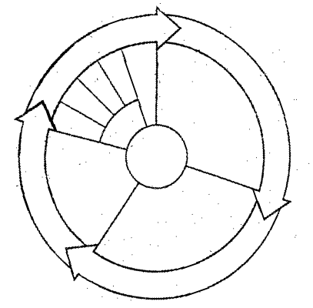

- Complete the following table comparing plant and animal cell division:
 | PLANT CELLS | ANIMAL CELLS
Centrioles used?
Cleavage furrow forms?
Cell plate forms?

- Complete the following table comparing prokaryotic and eukaryotic cell division:
 | PROKARYOTIC CELLS | EUKARYOTIC CELLS
Involves dividing the nucleus?
Produces identical daughter cells?
Uses binary fission?
Uses mitosis?
Produces two organisms?
Involves PMAT (pro, meta, ana…)?
Requires duplicating DNA?

[[Language Target for Topic 3: I can create a Venn Diagram to compare and contrast sexual and asexual reproduction; I can diagram the stages of Meiosis I and provide written descriptions for each stage; I can diagram the stages of Meiosis II and provide written descriptions for each stage; I can explain how meiosis creates egg and sperm cells; I can locate an abnormality on a karyotype and explain how nondisjunction caused it.]]
1. Complete the following table comparing sexual and asexual reproduction:
 | Asexual Reproduction | Sexual Reproduction
Number of parents

Genetic info compared to  the parents | Same Different | Same Different
Complexity of organism that uses this method | Simple Complex | Simple Complex
Example of an organism
that uses this method
Provide an advantage for asexual reproduction: _____________________________________
Provide an advantage for sexual reproduction: _____________________________________
Provide a disadvantage for asexual reproduction: _____________________________________
Provide a disadvantage for sexual reproduction: _____________________________________
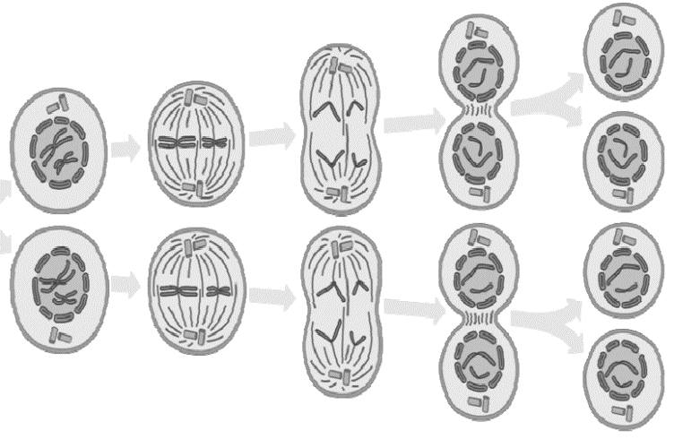
2. Label each stage of meiosis in the following diagrams:

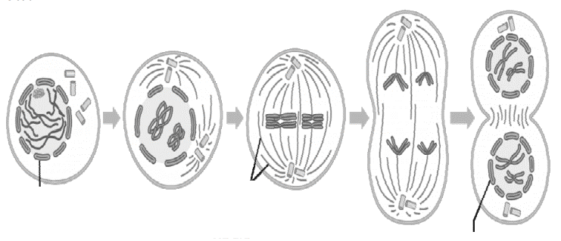

3. Why must egg and sperm cells be haploid?

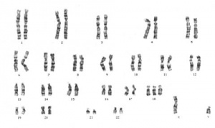
4. Analyze the following karyotype:
Sex of individual: _____________________
Normal/Trisomy/Monosomy: ________________________
If tri- or monosomy, on which chromosome? ____________

