Name:__________________________________________Date:_________________Period:_______________
Mendelian Genetics Sickle Cell Anemia Analysis
INTRODUCTION
Hemoglobin is a protein found in red blood cells (RBCs) that transports oxygen throughout the body. The hemoglobin protein consists of four polypeptide chains: two alpha chains and two beta chains. Sickle cell disease (also called sickle cell anemia) is caused by a genetic mutation in the DNA sequence that codes for the beta chain of the hemoglobin protein. The mutation causes an amino acid substitution, replacing glutamic acid with valine. Due to this change in amino acid sequence, the hemoglobin tends to precipitate (or clump together) within the RBC after releasing its oxygen. This clumping causes the RBC to assume an abnormal “sickled” shape.
Individuals who are homozygous for the normal hemoglobin allele (HBA) receive a normal hemoglobin allele from each parent and are designated AA. People who are homozygous for normal hemoglobin do not have any sickled RBCs. Individuals who receive one normal hemoglobin allele from one parent and one mutant hemoglobin, or sickle cell allele, from the other parent are heterozygous and are said to have sickle cell trait. Their genotype is AS. Heterozygous individuals produce both normal and mutant hemoglobin proteins, thus it displays a codominance pattern. These individuals do not have sickle cell disease, and most of their RBCs are normal. However, due to having one copy of the sickle cell allele, these individuals do manifest some sickling of their RBCs in low-oxygen environments. People with sickle cell disease are homozygous for the sickle cell allele (SS genotype); they have received one copy of the mutant hemoglobin allele from each parent. The resulting abnormal, sickle-shaped RBCs in these people block blood flow in blood vessels, causing pain, serious infections, and organ damage.
MENDELIAN GENETICS AND PROBABILITY
- If two people with sickle cell trait have children, what is the chance that a child will have normal RBCs in both high-and low-oxygen environments? What is the chance that a child will have sickle cell disease? Write the possible genotypes in the Punnett square.

  - Normal RBCs in high- and low-oxygen environments ____________
  - Sickle cell disease ____________

  - What is the chance that a child will carry the HbS gene but not have sickle cell disease?

  - What are the chances that these parents will have three children who are homozygous for normal RBCs? (Show your work.)

  - What are the chances that these parents will have two children with sickle cell trait and one with sickle cell disease? (Show your work.)

- A woman with sickle cell disease has children with a man who has sickle cell trait. Answer the following questions.
  - What are the genotypes of the parents?

  - What is the genetic makeup of the gametes the mother can produce?

  - What is the genetic makeup of the gametes the father can produce?

  - In the Punnett square, show all the possible genotypes of their children. Then summarize the genotype and phenotype ratios of the possible offspring to the right.

  - What are the chances that any one of this couple’s children will have sickle cell disease?

  - If this couple moves to the lowlands of East Africa and has children, which of their children would be more likely to survive? Explain your answer.

- In humans, blood type is a result of multiple alleles: I^{A}, I^{B}, and i. A few simple rules of blood type genetics are that
- I^{A} is dominant over i,
- I^{B} is dominant over i, and
- I^{A}I^{B} are codominant.

  - Two parents who are heterozygous for type A blood and have sickle cell trait have children. Answer the following questions:

  - What is the genotype of the parents?

  - What are the genetic makeups of all the possible gametes they can produce?

  - Complete the dihybrid Punnett square to determine the frequency of the different phenotypes in the offspring and list them to the right. (Note: Consider blood type and normal versus mutant hemoglobin in the various phenotypes.)

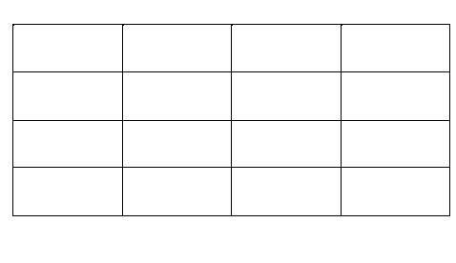

PEDIGREES
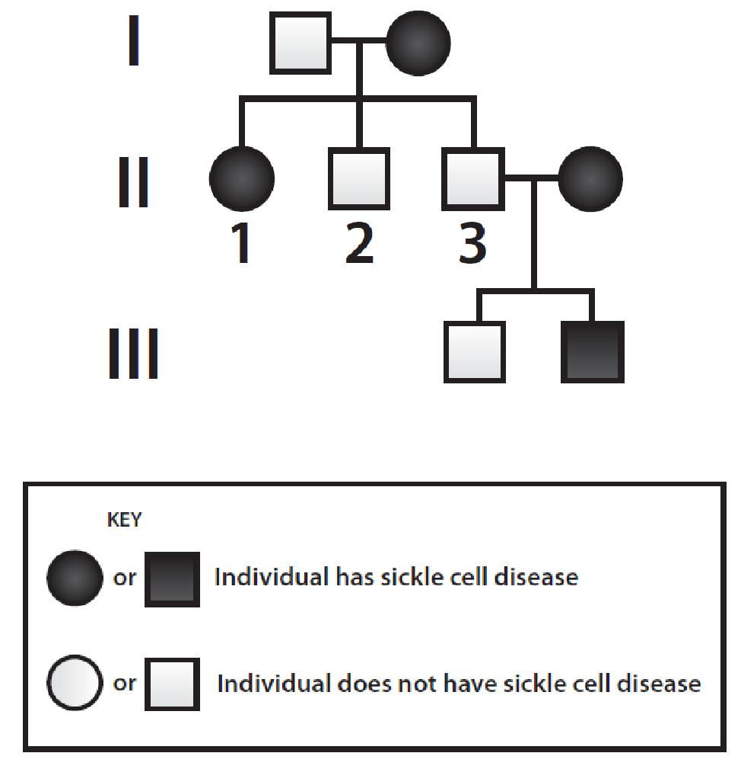
- The following pedigree traces sickle cell disease through three generations of a family. Use the pedigree to answer the following questions.

  - What is the genotype of the father in the first generation?

  - What is the genotype of the daughter in the second generation?

  - What is the genotype of individual 3 in the second generation? How do you know?

  - If the couple in the second generation has another child, what are the chances the child will have the following?
    - Sickle cell disease __________
    - Sickle cell trait __________
    - Completely normal hemoglobin __________

  - If the entire family moves to the lowlands of East Africa, four of the five males in the pedigree will have two genetic advantages over the other individuals in the family. Explain the two advantages.

- The following pedigree traces sickle cell disease through four generations of a family living in New York City. Use the pedigree to answer the following questions.
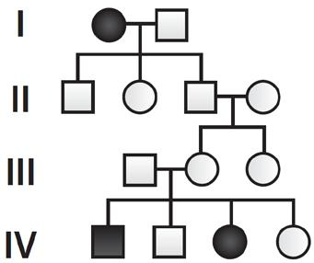

  - What is the genotype of the mother in the first generation?

  - What are the possible genotypes of the father in the first generation?

  - What can you say about the genotype of all the children of the couple in the first generation? Explain your answer.

  - Regarding the answer to the previous question, based on where the family resides, why would this genotype be considered a disadvantage?

  - What are the genotypes of the parents in the third generation? Explain how you know.
    - Mother _________
    - Father _________

  - What is the possible genotype or genotypes of the mother in the second generation?

  - If the couple in the third generation has another child, what are the child's chances of the following?
    - Having sickle cell disease __________
    - Having sickle cell trait __________
    - Being homozygous for normal RBCs __________
    - Being resistant to malaria and not having sickle cell disease __________

CHI-SQUARE STATISTICS
- Multiple couples living in a small village in the eastern African lowlands, all of whom are heterozygous for the Sickle Cell allele, have 500 children among them. Of these children, 139 are homozygous for the normal allele, 279 are heterozygous for the allele, and 82 suffer from sickle cell disease. Are these data statistically significant? Explain using a chi-square statistical analysis test.
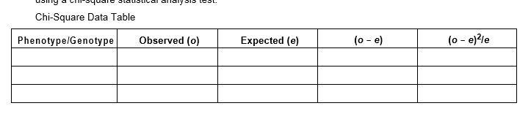
  - What is the chi-square value (χ2)? __________

  - Calculate the degrees of freedom (df). __________

  - Use the degrees of freedom and a p-value of .05 to determine the critical value._________

  - Based on your critical value, do you reject or fail to reject a null hypothesis?

  - What does that mean in the context of this activity?

