Name: ________________________________________________________ Date: __________________ Period: _____
Unit 3 Lab: Light Microscope Investigation Lab
Pre-Lab (Part 1): Parts of the Microscope Directions: Use your brain and the information you gathered from drawing the microscope to complete the following chart. Note: functions do not need to be written in full sentences.
Part | Function
Eyepiece
Body Tube
Revolving Nosepiece
Low-Power Objective
High-Power Objective
Stage
Stage Clips
Diaphragm
Course Adjustment
Fine Adjustment
Light Source/Illuminator
Base
Arm

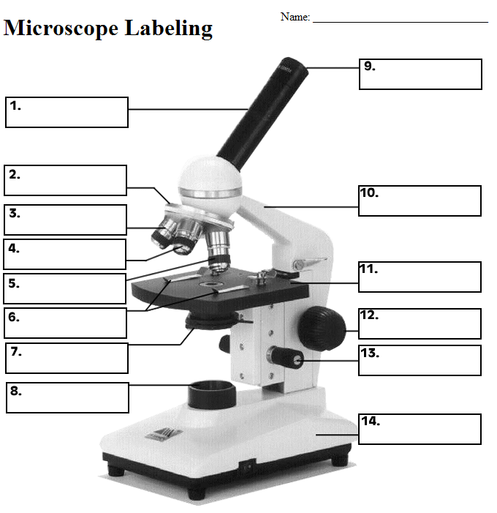
Microscope Labeling: Label the parts of the microscope. Note: #4 is the Scanning Objective, and #3 is the Low-Power Objective.

Pre-Lab (Part 2): How to Use the Microscope Directions: Read through the Notes provided and answer the pre-lab questions below in full sentences.
- How do you find the magnification of your specimen?

- What is the total magnification if the ocular lens is 10X, and the objective lens is 40X?

- Which objective lens should you start with when viewing your specimen? Why do you think this is?

- Which adjustment knob (course or fine) should you use when using the high-power objective lens?

- What should you do if the specimen is too light or too dark?

- What information should you include when labeling your drawings of specimens viewed through the microscope?

Lab Procedures
Part 1: Field of View
At each magnification, look through the eyepiece and determine the “diameter of the field of view” by placing a ruler on the stage underneath the objective lens. Fill in the diameters IN MILLIMETERS in the table below. Note: each black mark you see represents 1 mm.
Total Magnification | Diameter (in mm)
40X (Using Scanning Objective)
100X (Using Low-Power Objective)
400X (Using High-Power Objective)
Part 2: The Letter E
Place the slide of the "letter e" on the stage so that the letter is over the hole and is right side up. Use the scanning objective to view the letter and use the coarse knob to focus. Repeat on the low power objective. Finally, switch to high power. Remember at this point, you should only use the FINE adjustment knob.
Draw the "e" as it appears at each magnification. Drawings should be drawn to scale and you should note the orientation of the e in the viewing field (is it upside down or right side up?) Be sure to take your time when drawing – it should be very accurate! Note: Points will be taken off if drawing is messy or not accurate!
SCANNING | LOW
Have your partner push the slide to the left while you view it through the lens. Which direction does the E appear to move? __________________
Have your partner push the slide up while you view it through the lens. Which direction does the E appear to move?___________________
Part 3: Prepared Slides
- Obtain FOUR different prepared slides.
- View each slide under the microscope (at whichever magnification you choose) and draw a picture.
- For each picture, identify the name of the specimen and the magnification. When finding the magnification, make sure to MULTIPLY the ocular X objective.
- Under each picture, record THREE observations about what you see in the microscope. You CAN bullet your observations!

Specimen Name: ___________________ Specimen Name: _________________
Magnification: ______________________ Magnification: ___________________
Observations: Observations:

Specimen Name: ___________________ Specimen Name: _________________
Magnification: ______________________ Magnification: ___________________
Observations: Observations:

Post-Lab Review: Determine whether each of the following statements is TRUE or FALSE. Write the FULL WORD (trueor false) in the space to the left of each statement. If the statement is False, correct the statement to a true statement.
__________ On high power, you should use the coarse adjustment knob.
__________ The diaphragm determines how much light shines on the specimen.
__________ The low power objective has a greater magnification than the scanning objective.
__________ The fine focus knob visibly moves the stage up and down.
__________ Images viewed in the microscope will appear upside down.
__________ The type of microscope you are using is a scanning microscope.
__________ For viewing, microscope slides should be placed on the objective.
__________ In order to switch from low to high power, you must rotate the revolving nosepiece.
__________ The total magnification of a microscope is determined by adding the ocular lens to the objective lens

