Name: _________________________________________ Date: ________________________________ Period: ______

Unit 5 Notes, Part 4: The Immune System
AP Biology

Your annotations must be at least one full page (front and back) to receive a stamp!!!

Why do organisms need an immune system?
- Protection from external pathogens (ex: bacteria, viruses, fungi, and parasitic protists)
- Enter the body through the following routes: digestive system, respiratory system, urogenital system, or a break in the skin)
- Travel through the body using the following transport systems: circulatory system and lymphatic system
- Protection from internal attack by abnormal human body cells (ex: cancer cells)

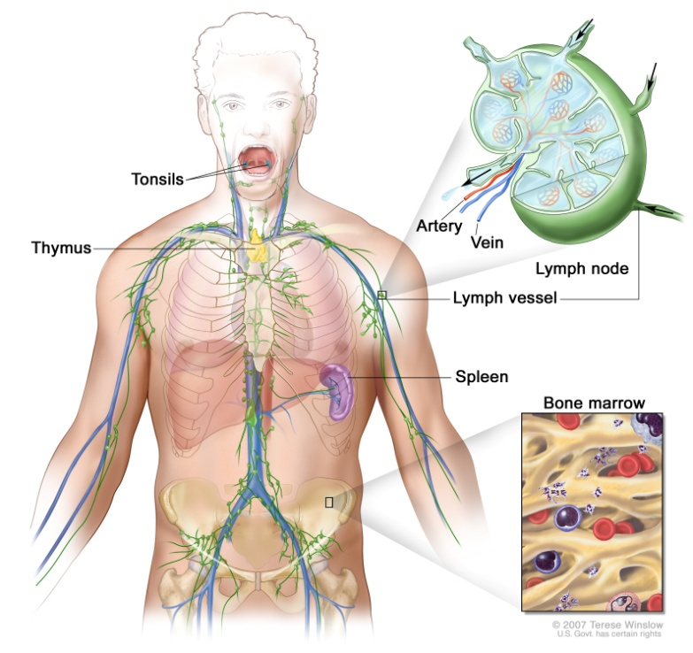
What organs and tissues are considered part of the human immune system?
- Lymph vessels = tubes that run parallel to the circulatory vessels (arteries and veins) and serve as a blood filtration system to remove foreign particles
- Lymph nodes = oval shaped organs in the armpits, neck, etc. that are connected to lymph vessels ; they collect foreign particles and store B and T lymphocyte cells
- Spleen = stores blood cells ; removes clumped pathogens coated with antibodies from the blood stream
- Adenoids (aka tonsils) = trap pathogens
- Bone Marrow = stem cells within the bone marrow differentiate into blood cells ; location where the B lymphocytes (aka B cells) mature
- Thymus = organ in the neck that is used to create and promote maturation of T lymphocytes (aka T cells)

What defenses are most organisms born with?
- Plants and all animals have nonspecific (aka innate/natural) immune responses that they are born with ; these responses attack any pathogen that tries to invade the body in the same way
- Example in Plants: Hypersensitivity response (cells that come in direct contact with the pathogen undergo apoptosis and signal other nearby cells to improve defenses in their cell walls)
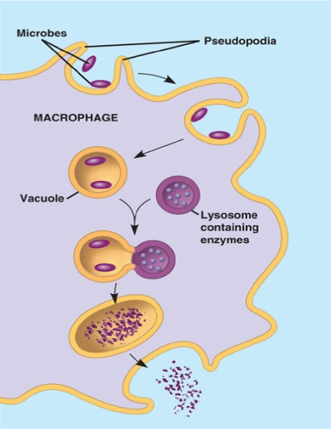
- Examples in Humans:
- First Line of Defense: External Barriers
- Physical Barriers: Skin; mucous membranes in the eyes, nose, anus, etc ; cilia lining the respiratory tract (sweep out pathogens)
- Chemical Barriers: Sweat (pH 3-5), tears + saliva (contain an enzyme called lysozyme that digests bacterial cell walls), stomach acid (hydrochloric acid is at pH 2)
- Second Line of Defense: Internal Barriers
- Leukocytes (phagocytic white blood cells that “swallow” any foreign particle)
Ex: Macrophages

- The Inflammatory Response:
-cells release histamine (causes dilation / widening of blood vessels)
-increased blood supply to the injury causes redness, warmth, and swelling
-blood brings leukocytes to the area to “swallow” and digest pathogens
-Fever = widespread inflammatory response; higher body temperature interferes with bacterial and viral activity
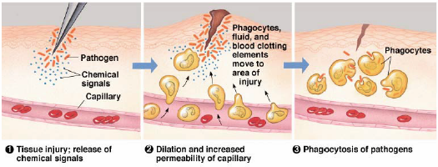

What defenses do organisms develop throughout their lifespan?
- Vertebrates have specific (aka acquired) immune responses that they develop over time in response to encounters with specific pathogens
- Example in Humans:
- A specific type of macrophage called an antigen –presenting cell (aka APC), which is part of the innate immune system, swallows an antigen released by a pathogen, chops it up, and presents it on its cell surface
(Antigen = a molecule (usually a protein or carbohydrate) found on the surface of a pathogen or released by a pathogen that triggers the production of specific immunity molecules called antibodies)
- The APC binds with a helper T cell, which initiates the specific immune response
- Helper T cells trigger the differentiation of several types of lymphocytes (specific types of leukocytes, or white blood cells)
- B lymphocytes (aka B cells) – come in two forms, plasma B cells and memory B cells
-plasma B cells actively make antibodies to bind to the antigen presented by the original APC
-Antibodies = Y shaped proteins with tips that bind specifically to a particular antigen and cause clumping of multiple antigens; this clumping signals a macrophage to swallow the clump and digest it
-memory B cells are made to prevent an infection by the same pathogen years later; they can be converted quickly into plasma B cells
-B cells are part of Humoral Immunity (regulates destruction of “naked” pathogens in the body fluids – blood, saliva, tears, etc.—that have not yet infected a body cell)

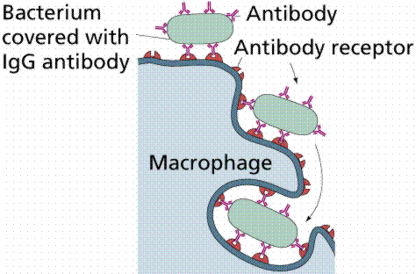
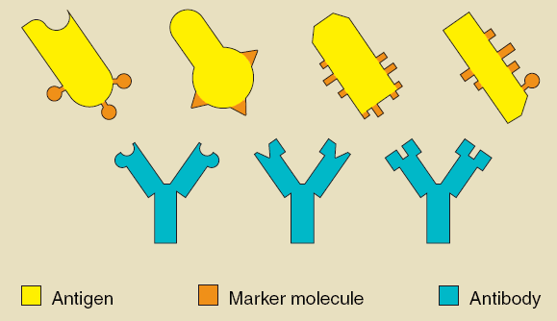

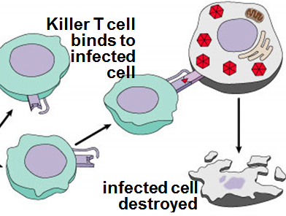
- T lymphocytes (aka T cells, cytotoxic T cells, or killer T cells) – come in two forms, active cytotoxic T cells or memory cytotoxic T cells
-active cytotoxic T cells bind to the antigens displayed on infected body cells and release perforins (protein molecules) to break open the infected cell’s membrane (i.e. cell lysis) and induce cell death
-memory cytotoxic T cells are made to prevent an infection by the same pathogen years later ; they can be converted quickly into active cytotoxic T cells
-Cytotoxic T cells are part of Cell-Mediated Immunity (regulates destruction of body cells that have been infected by a particular pathogen)

Summary Diagram of the Human Specific Immune Response (i.e. Humoral & Cell-Mediated Immune Responses)

(Note: There is also a summary diagram of both the human non-specific AND specific immune responses, which is on the last page of this packet).

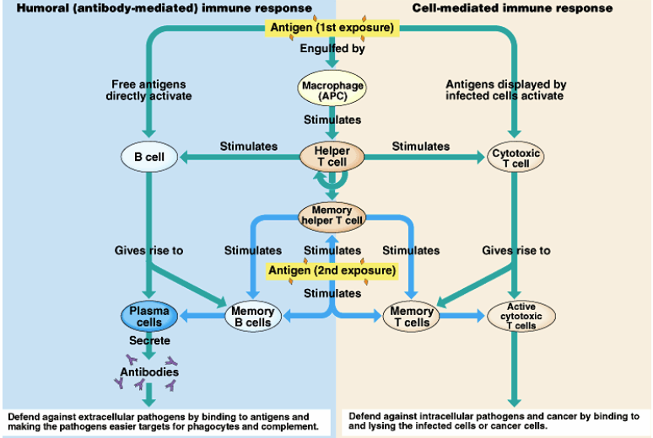

Why can’t humans “catch” the same infection twice?
- Memory B and cytotoxic T cells can quickly develop into plasma B cells and active cytotoxic T cells to rapidly eradicate a pathogen recognized by the body
- This is called the secondary immune response. Below is a question released on the 2013 AP Biology practice test that relates to the secondary immune response.

An individual’s humoral response to a particular antigen differs depending on whether or not the individual has been previously exposed to that antigen. Which of the following graphs properly represents the humoral immune response when an individual is exposed to the same antigen more than once?
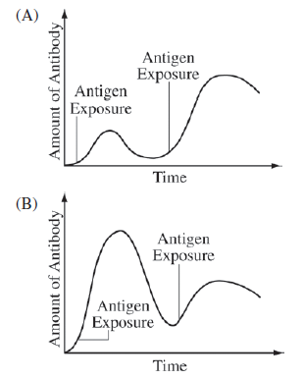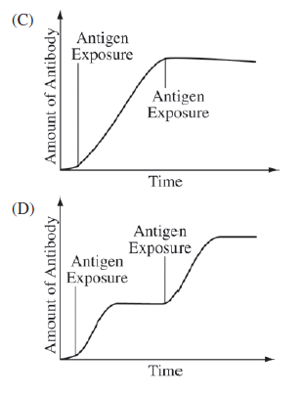
The correct answer is “A.” Read through the information below, which will help you to understand why “A” is the correct answer.

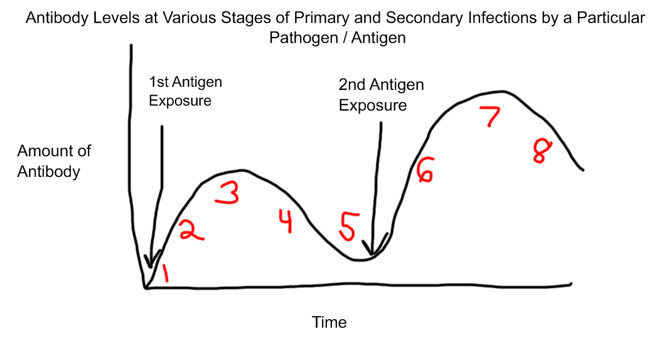
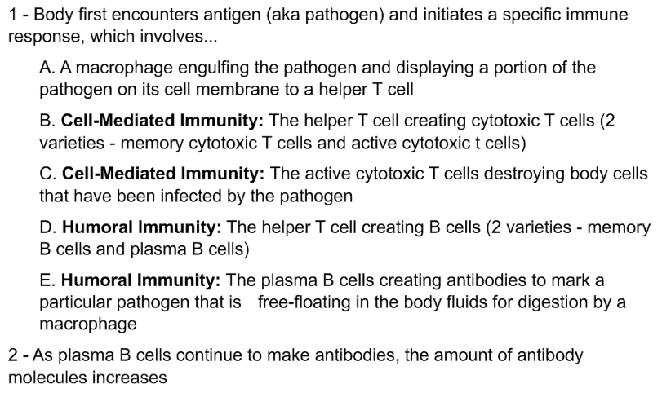
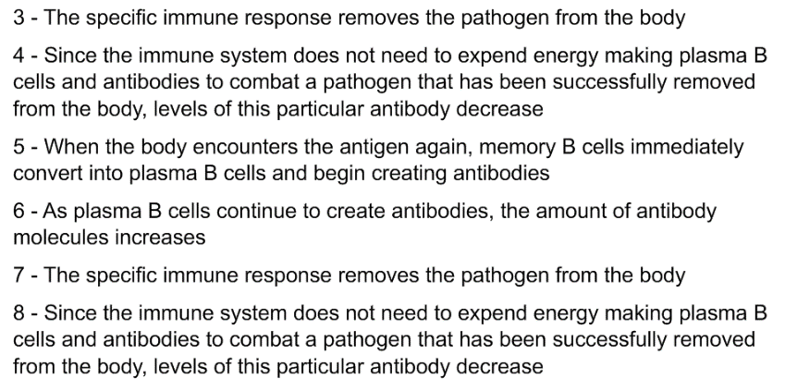

What is the difference between passive and active immunity?
- Active immunity involves an individual making his/her own antibodies, which are long-lasting
-Natural = antibodies produced by B cells in response to infection by a particular pathogen
-Artificial = antibodies produced by B cells in response to a vaccine (weakened / killed antigen)
- Passive immunity involves antibodies being transferred from another organism, which are short-lasting
-Natural = mothers pass antibodies to their fetus via the placenta and newborn via breast milk
-Artificial = antibodies produced by a mouse in response to a pathogen can be injected into human tissue to protect against the same pathogen

What are autoimmune diseases?
- Autoimmune diseases occur when the T cells and B cells fail to recognize the body cells as “self cells” and attack them as they would a pathogen
- Ex: Type 1 diabetes, lupus, multiple sclerosis, rheumatoid arthritis, psoriasis

Why is HIV so harmful to the human body?
- HIV = human immunodeficiency virus
- The HIV virus attacks the body’s Helper T cells, so that the body cannot create new cytotoxic T cells or B cells to fight against other, unrelated infections (ex: pneumonia, tuberculosis)
- When the Helper T cell count drops below 200 cells per cubic millimeter of blood, a patient has AIDS (acquired immunodeficiency syndrome); normally, a healthy individual’s T cell count ranges from 500 to 1800 cells per cubic millimeter of blood
- So in other words, HIV is the virus that causes the condition AIDS
- People who have AIDS typically pass away due to their inability to fight off other infections. Many of these infections, however, can be treated successfully with medications like antibiotics or antivirals.

Notes Questions

- Why is a secondary immune response often faster than a primary immune response? What types of immune cells / molecules are involved in a secondary immune response?

- How are helper T cells “activated?” Why are helper T cells considered the “connection” between innate / nonspecific immunity and aquired / specific immunity?

- Is the human body’s ability to distinguish its own cells from foreign cells (ex: bacterial pathogens) part of the nonspecific or specific immune response?

- Why is it safe for kids who have had chicken pox in the past to spend time with kids who currently have chicken pox?

- Compare and contrast the humoral and cell-mediated immune pathways.

- How are BOTH the humoral and cell-mediated immune pathways initiated (i.e. triggered)?

- Provide an example of an external and internal barrier in the innate immune system.

