Name: _____________________________________________ Date: __________________________ Period: ________

**Unit 5 Notes, Part 2: The Nervous System**

AP Biology

1. **How do multicellular organisms send signals between cells?**

Below are some examples of signaling methods used in multicellular organisms.

1. Plant and animal cells can communicate quickly when they are physically connected to each other (ex: plant cell communication through plasmodesmata)
2. Many animals use their nervous systems to transmit signals quickly over short distances
3. Many animals use their endocrine systems to release hormones from glands into the bloodstream to travel long distances to multiple target cells / tissues / organs. This is a slow method of cell signaling but it can produce many effects in the body.
4. **What is the basic unit of the nervous system?**
5. Nerve cells (aka **neurons**) are the basic unit of the nervous system.
6. Nerve cells contain

* projections called **dendrites** that receive signals
* a **cell body** that houses most of the organelles and the nucleus of the cell. The cell body may also be called the **soma**
* a long **axon** that transmits an electrical signal called an **action potential** down the length of the cell. The portion of the axon that connects to the cell body is called the **axon hillock**. This is where the action potential begins.
* **axon terminals** that release chemical signal molecules called **neurotransmitters** to travel to other nerve cells or muscle cells

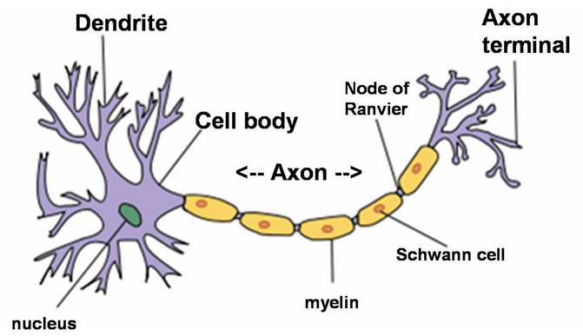

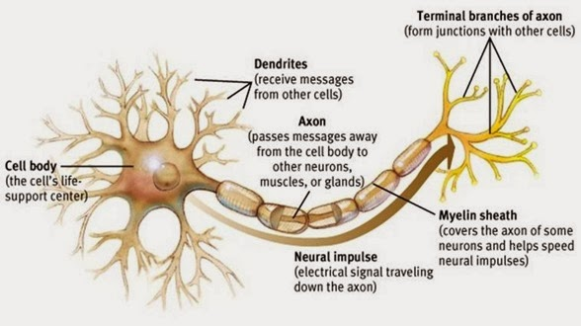

1. Along the length of the axon are **Schwann cells** made of a fatty insulating material called **myelin sheath**. The naked spaces between Schwann cells on the axon are called the **Nodes of Ranvier**. The Schwann cells increase the speed of the nerve signal because the signal jumps from one Node of Ranvier to the next in a process called **saltatory conduction.**

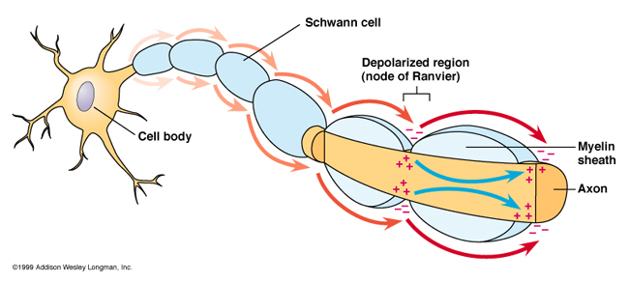

1. If one neuron is sending a signal to another neuron, the neuron that sends the signal is called the **pre-synaptic neuron**. The neuron that receives the signal is called the **post-synaptic neuron**. The space between the neurons is called the **synapse** or **synaptic cleft**. The pre-synaptic neuron releases neurotransmitters from its axon terminals. These neurotransmitters diffuse across the synapse and bind to receptors on the dendrites of the post-synaptic neuron.

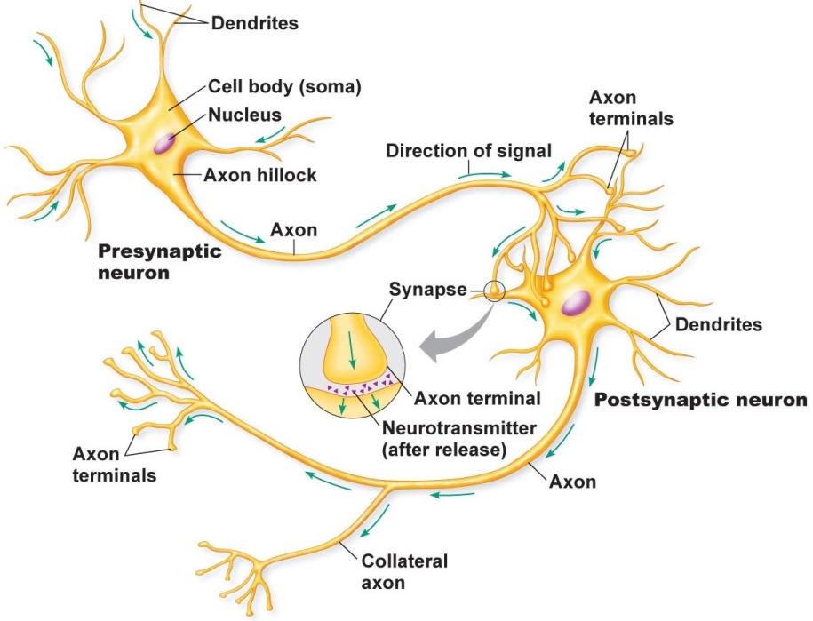 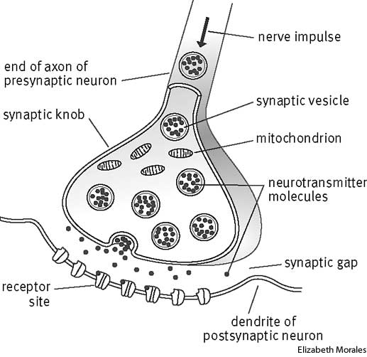

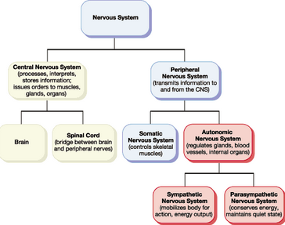**C. What are the major divisions of the nervous system?**

1. The nervous system is made of two main divisions: the **Central Nervous System (CNS**) and **Peripheral Nervous System (PNS)**
2. The CNS consists of the brain and spinal cord. All neurons in this division of the nervous system are a type of neuron called an **interneuron.**
3. The PNS contains all nerve cells outside the brain and spinal cord. All neurons in this division of the nervous system are either **sensory neurons** or **motor neurons.**
4. The CNS and PNS are further broken down according to the diagram to the right.

**D. What are the types of neurons?**

1. **Sensory neurons** send information gathered from sensory receptor cells (which is sometimes the sensory neuron itself) to the CNS. Sensory receptor cells receive information about touch, taste, sound, sight, smell, temperature, and pain. (Note: Some sensory neurons do not need a separate sensory receptor cell because their dendrites can detect environmental changes directly.)
2. **Motor neurons** send information from the CNS to direct muscle movement.
3. **Interneurons** in the brain and/or spinal cord integrate information from sensory neurons or other interneurons to coordinate a response (ex: by stimulating a motor neuron).
4. These three types of neurons are pictured below.

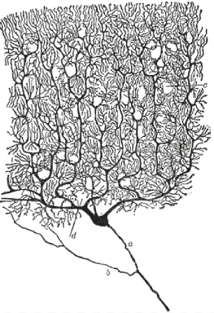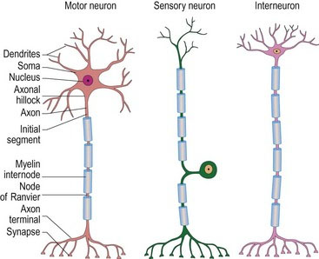

1. Interneurons often have highly branched dendrites to receive signals from many other neurons at once and integrate these signals. (See image to the right)

**E. How do the different types of neurons work together to sense and respond to environmental stimuli?**

1. 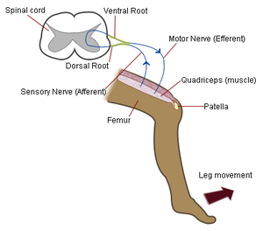Some sensory / motor neurons participate in a **reflex arc** that “bypasses” the brain. For example, the knee jerk reflex occurs when you get hit just below your knee cap. (*Note: Doctors typically check this reflex as part of a normal physical with a small mallet.)*

* First, the mallet hits your leg, triggering a sensory neuron.
* The sensory neuron carries the signal to the **dorsal root of the spinal cord** (dorsal meaning facing the back side of your body).
* The sensory neuron sends the signal to a motor neuron, which leaves the spinal cord through the **ventral root** (ventral meaning facing the front side of your body).
* The motor neuron sends the signal to your quadriceps muscle along the top of your thigh, which contracts / shortens and causes your foot to swing forward / up.

1. The reflex arc discussed above is **monosynaptic**, meaning there are no interneurons involved, so there is a single synapse between the sensory neuron and motor neuron. Some reflex arcs are **polysynaptic**, meaning they do involve one or more interneurons in the spinal cord (but not the brain). Mr. Jensen will help you label the polysynaptic reflex arcs below.

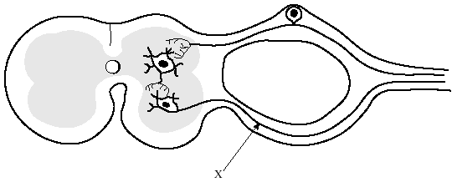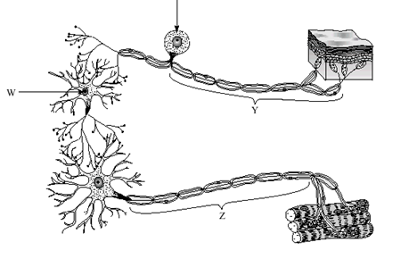**Polysynaptic Reflex Arcs/Loops**

Spinal Cord

Dorsal Root

Ventral Root

1. Most responses to the environment, however, are not reflexes. Most of the time, signals follow the steps below.

Sensory receptor cell 🡪 sensory neuron 🡪 interneuron in spinal cord 🡪 interneurons in brain 🡪 interneuron in spinal cord 🡪 motor neuron 🡪 muscle cell

**F. How is a signal transmitted from one end of a neuron to the other?**

1. Nerve signaling involves the use of **ion channels** located in the nerve cell membrane. There are several types of ion channels that are found in nerve cells.

* Ion channels that are always open and allow the diffusion of ions into or out of the cell at all times. These may be called “**leaky channels**.”
* **Ligand-gated ion channels** that are normally closed by a gate but open in response to a **ligand** (signal molecule) binding to a receptor on the channel.
* **Voltage-gated ion channels** that are normally closed by a gate but open in response to a change in electrical charge.

1. Nerve signals are a result of electrical currents that run down the length of a neuron.
2. Normally, the neuron is in a resting state. The resting state is described below. A labeled image of a resting-state neuron is also given below.

* There is a higher concentration of **potassium ions (K+)** inside the cytoplasm than outside the cell and a higher concentration of **sodium ions (Na+)** outside the cell than inside the cytoplasm.
* The **sodium / potassium pump** constantly pumps Na+ out of the cell and K+ into the cell.

*(Note: the Na+ / K+ pump moves 3 Na+ out for every 2 K+ it brings in)*

* The membrane of the neuron is not permeable to sodium ions (Na+), but it is permeable to potassium ions (K+). K+ ions tend to flow through **leaky K+ channels** from the inside to the outside of the cell by diffusion. (They move out of the cell down their concentration gradient because there is a higher concentration of K+ inside the cell due to the sodium/potassium pump.)
* The cytoplasm has an overall **negative charge** compared to the extracellular solution for several reasons…

1. The sodium/potassium pump moves more Na+ out of the cell than it moves K+ into the cell
2. K+ exits the cell through the leaky K+ channels
3. There are large negatively-charged proteins inside the neuron’s cytoplasm.

* There is an electrical charge difference between the cytoplasm and outside the cell of -70 mV (milliVolts). Because this is the normal charge of a nerve cell, we call -70 mV the **resting potential** of the cell. Draw and label the resting state of a neuron in the image below.

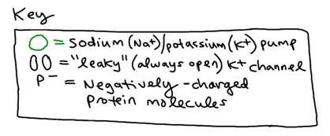**Resting State of a Neuron**

*\*The inside of the neuron normally has a charge of -70 mV compared to the outside of the neuron. We call -70 mV the “resting potential” of the neuron.\**

outside charge:

inside charge:

outside

outside

axon (cytoplasm)



1. Initially, scientists measured the resting potential of a nerve cell using a **microelectrode** placed inside the cell, a **reference microelectrode** placed outside the cell, and a **voltmeter (voltage meter).**

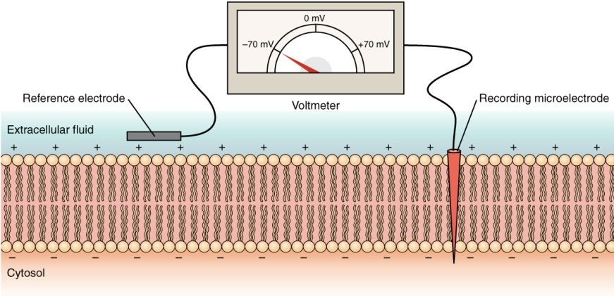

1. A nerve cell is not always at resting potential, however. An **action potential** occurs when a neuron sends information down its axon, away from the cell body. Neuroscientists may use other terms, such as a "**spike**" or an “**electrical impulse"** for the action potential. They might, therefore, state that “action potentials propagate (send) impulses along neurons.” The action potential is an explosion of electrical activity that is created by a depolarizing current. This means that some event (a stimulus) causes the resting potential to move toward 0 mV (more positive).
2. When the depolarization reaches **-55 mV** a neuron will fire an action potential. This voltage is known as the **threshold** or **threshold potential.** If the neuron does not reach this critical threshold level, then no action potential will fire. Also, when the threshold level is reached, an action potential of a fixed size will always fire. In other words, for any given neuron, the size **(amplitude)** of the action potential is always the same. Therefore, the neuron either does not reach the threshold or a full action potential is fired - this is the **"All or None" principle**.

*(Note: Neurons CAN increase the frequency of action potentials to transmit a more powerful signal)*

1. The steps of an action potential are summarized in the chart on the next page along with images I have drawn of each step. You may want to download the Powerpoint we viewed in class to see the color-coding. I’ve included a key directly below as well. There are also additional images given for each step that came from good old Google.

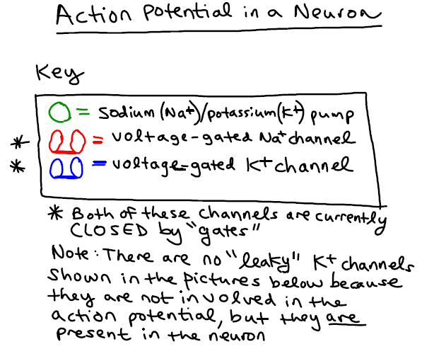

|  |  |
| --- | --- |
| **Stage Name** | **Description** |
| **1. Threshold** | Some stimulus causes the inside of the cell to depolarize to -55 mV (become a little more positive). Once a cell reaches this voltage, it will begin an action potential. |
| **2. Depolarization** | **Voltage-gated Na+ channels** open and allow Na+ to diffuse into the cell, causing the membrane to depolarize to 0 mV and gain an increasingly positive voltage to about +30 mV. (They are called voltage-gated channels because they are gated until the environment is just the right voltage: -55 mV, which can only be done if some positively charged ions are let into the cell).  The depolarization stage is what is commonly referred to as the **action potential** itself. ‘ |
| **3. Repolarization** | **Voltage gated K+ channels** also open in response to the membrane reaching -55 mV, but they open more slowly than Na+ channels. Once they open, the K+ channels allow K+ to diffuse out of the cell, lowering the cell’s voltage back to its resting potential (-70 mV).  During this stage, voltage-gated Na+ channels also close so that no more positive charge can enter the cell. |
| **4. Hyperpolarization** (aka **Undershoot**) | Because K+ channels take a long time to close, they let out some excess K+ and cause the membrane potential to dip below its resting state to about -80 mV. |
| **5. Resting Phase** | Eventually the membrane returns to its resting state by the action of **the sodium-potassium pump (Na+ / K+ pump)**, which pumps 3 Na + out and 2 K+ in using energy from ATP. Just to be clear, the resting state refers to the fact that the neuron is not firing an action potential. The cell is still working as all cells do (cellular respiration, protein synthesis, cell membrane transport, etc). |

1. The graph below tracks the membrane voltage and opening/closing of voltage-gated ion channels throughout the phases of an action potential. Label where is step listed above happens on the graph.

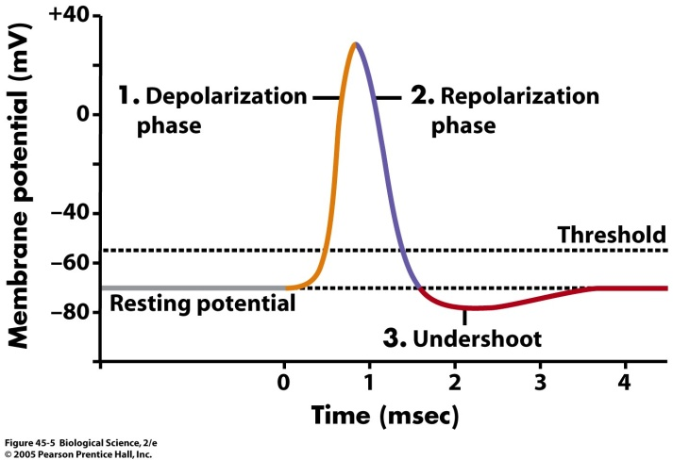

**\***

**\****A stimulus causes an influx of positive (+) charge that brings the membrane potential to threshold (-5 mv)*

1. Once a portion of the axon has depolarized, positive charge from the influx of Na+ causes voltage-gated Na+ channels further down the axon to open. This results in a wave of depolarization moving down the axon.
2. Because it takes a while for the Na+ channels at the beginning of the axon to be able to open again, the nerve signal cannot move “backwards.” The period of time it takes for the Na+ channels to reset so that another action potential can be sent down the axon is called the **refractory period**.

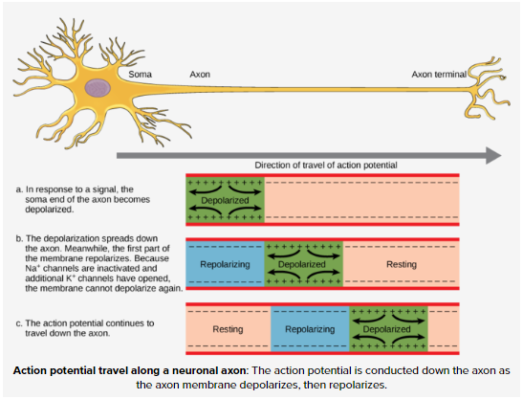

**G. How is a signal sent from one neuron to another?**

1. The space between two neurons is called the **synaptic cleft** or **synapse.**
2. The neuron before the synapse that sends the signal is called the **presynaptic neuron.**
3. The neuron after the synapse that receives the signal is called the **postsynaptic neuron.**
4. A list of steps involved in the passage of a signal across the synapse from a presynaptic neuron to a postsynaptic neuron is given on the next page.
   * The **axon terminal** of the pre-synaptic neuron receives an action potential signal. The depolarization in the axon terminal causes **voltage-gated calcium (Ca2+) channels** to open and allow **calcium ions** **(Ca2+)** to enter the axon terminal.

* The influx of calcium causes synaptic **vesicles** carrying signal molecules called **neurotransmitters** to fuse with the axon terminal membrane and release neurotransmitters in the synaptic cleft.
* Neurotransmitter molecules diffuse across the synaptic cleft and bind to **ligand-gated ion channels** on the post-synaptic (dendrite) membrane. *(Note: Ligand-gated ion channels open in response to the binding of a signal molecule / ligand.)*
  + The ligand-gated ion channels open and allow ions to enter the cell.

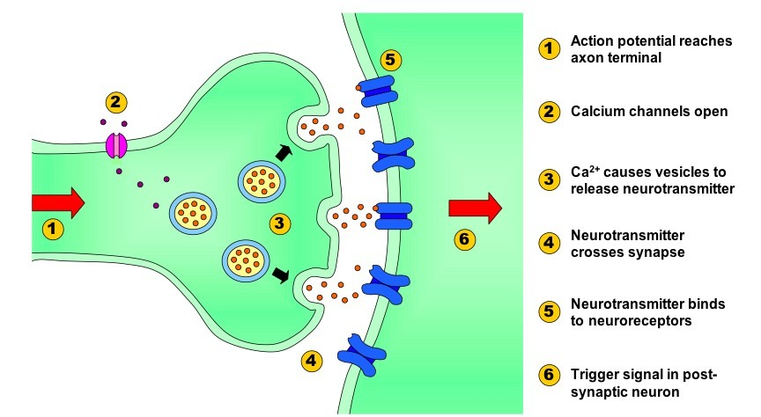



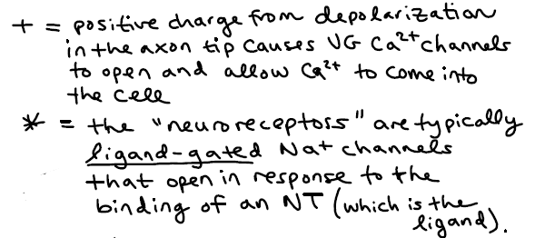



1. Depending on which type of neurotransmitter is used, the signal sent across the synapse could be **excitatory** or **inhibitory.**
2. Excitatory neurotransmitters cause the membrane potential to depolarize (move from -70 mV closer to 0 mV) by opening ligand-gated ion channels that allow positive charge into the cell. This is called an **excitatory post-synaptic potential (EPSP)**. For example, the neurotransmitter **glutamate** is often considered an excitatory neurotransmitter because it typically binds to ligand-gated Na+ channels that allow Na+ to enter the postsynaptic cell.
3. 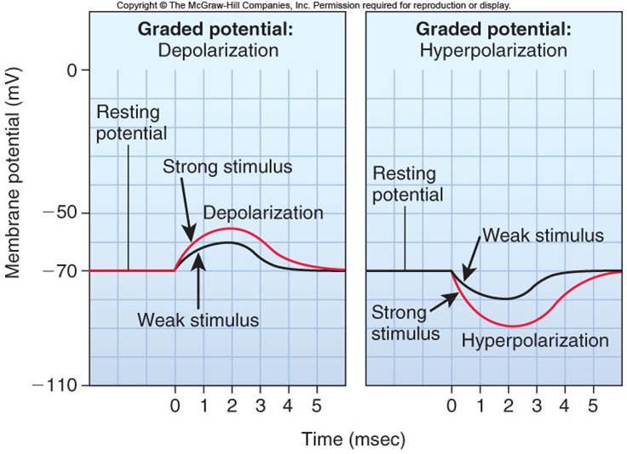Inhibitory neurotransmitters cause the membrane potential to hyperpolarize (become lower than -70 mV, the resting potential of the neuron) by opening ligand-gated ion channels that allow negative charge into the cell or allow positive charge out of the cell. This is called an **inhibitory post-synaptic potential (IPSP).** The neurotransmitter **GABA** is often considered an inhibitory neurotransmitter because it typically binds to ligand-gated Cl- channels that allow Cl- to enter the post-synaptic cell.

\**Post-Synaptic Potential is also known as Graded Potential (as in the graphs above).*

* + One release of excitatory neurotransmitters from a pre-synaptic neuron may depolarize the post-synaptic neuron’s dendrites and cell body all the way to threshold potential (-55 mV). At this point, an action potential will begin at the axon hillock. Oftentimes, however, multiple pre-synaptic inputs are required to bring the cell to threshold potential.

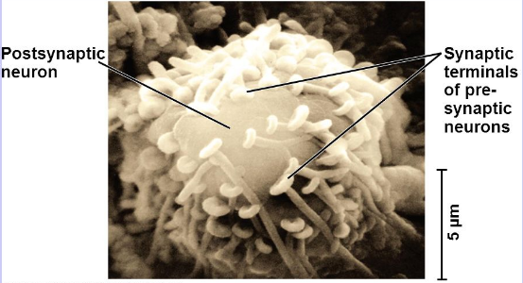

* + Synaptic transmission ends when the neurotransmitter diffuses out of the synaptic cleft, is reabsorbed by the pre-synaptic cell, or is degraded by enzymes in the synaptic cleft. When the neurotransmitter is reabsorbed by the pre-synaptic cell, this is called **reuptake.**

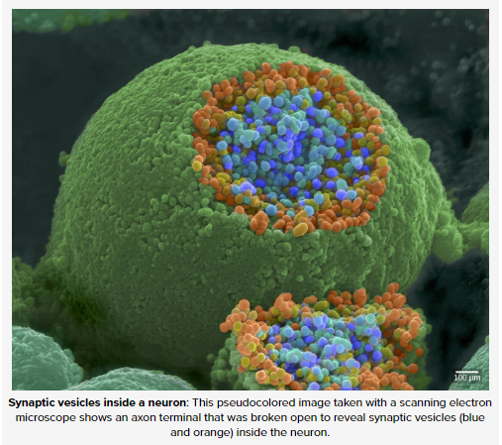 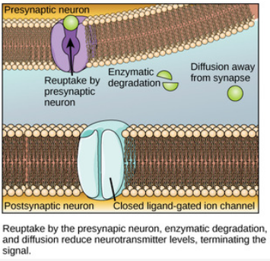

* Remember, multiple pre-synaptic inputs may be required to bring the post-synaptic cell to threshold potential. This is especially true if there are both excitatory and inhibitory inputs from multiple pre-synaptic neurons. There are two methods by which excitatory post-synaptic potentials (EPSPs) can “add up” to bring the cell to threshold—spatial summation and temporal summation (defined below)

1. **Spatial summation** occurs when there are excitatory inputs from multiple pre-synaptic neurons at different locations along the dendrite membrane simultaneously (see image c below).
2. **Temporal summation** occurs when there are multiple excitatory inputs from a single pre-synaptic neuron that occur in quick succession (see image b below).

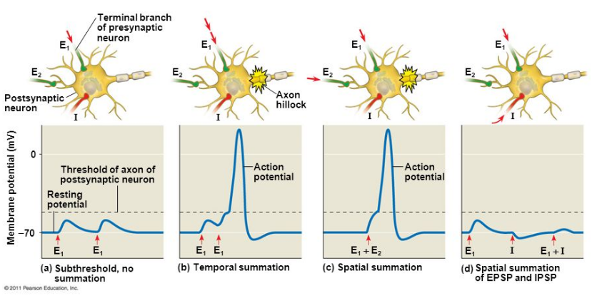

**H. What are examples of neurotransmitters that have opposing effects in the body?**

1. **Acetylcholine** and **norepinephrine** are two neurotransmitters that have opposing effects in the body (see chart below)

|  |  |  |
| --- | --- | --- |
| **Effect** | **Norepinephrine** | **Acetylcholine** |
| Which division of the nervous system does this neurotransmitter act on? | Sympathetic (active during times of stress / emergencies) | Parasympathetic (active during times of relaxation / everyday life) |
| How does it affect the digestive system? | Slows it down | Speeds it up |
| How does it affect the pupils of the eye? | Dilates them | Constricts them |
| How does it affect the heart rate? | Speeds it up | Slows it down |
| How does it affect the breathing rate? | Speeds it up | Slows it down |

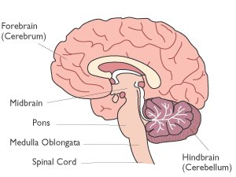

**I. Do different parts of the brain control different activities?**

1. Below are some examples of parts of the brain that have specific roles in the body.
   * The **medulla oblongata** controls heartbeat, breathing and blood pressure. It also contains the reflex centers for vomiting, coughing, sneezing, hiccuping and swallowing. It is a primitive structure responsible for basic functions.
   * The **cerebellum** is responsible for fine motor movements and balance / posture.
   * The **cerebrum / cerebral cortex** contains the two sides (**right and left hemispheres)** of the brain, which are responsible for consciousness. Different parts (lobes) of the cerebrum control different functions.
   * For example, the **frontal lobe** is responsible for judgment / reasoning, the **occipital lobe** is responsible for eyesight, etc.
   * The **corpus callosum** is a tissue that connects the two hemispheres of the cerebrum and allows them to share information. The corpus callosum is larger in women, and may account for women’s increased ability to multi-task. In patients with severe seizure disorders / epilepsy, doctors occasionally cut the corpus callosum to prevent the spread of seizures from one hemisphere of the brain to the other.

**Notes Questions**

1. Identify the functions of the following parts of a neuron: dendrites, axon, axon terminals, Schwann cells
2. Why do interneurons often have highly-branched dendrites?
3. Explain why your leg kicks forward when you get hit by a mallet just below the knee.
4. How is a reflex arc different from a normal neural signaling pathway?
5. Describe the difference between a monosynaptic reflex arc and a polysynaptic reflex arc.
6. Why is the resulting potential of a neuron negative (specifically, -70 mV)?
7. What is the threshold potential and how is it related to an action potential?
8. Why is an action potential considered an “All or None” (aka “All or Nothing”) response?
9. What happens during the depolarization phase of an action potential? How are the voltage-gated sodium channels involved in this step?
10. What occurs during hyperpolarization / undershoot? How are the voltage-gated potassium channels involved in these step?
11. How does the nerve cell get back to its resting potential?
12. List the following steps of synaptic transmission in order. Indicate whether each step occurs in the presynaptic or postsynaptic neuron.
    1. Neurotransmitter binds with receptors associated with the postsynaptic membrane.
    2. Calcium ions (Ca2+) rush into neuron's cytoplasm.
    3. An action potential depolarizes the membrane of the axon terminal.
    4. The ligand-gated ion channels open.
    5. The synaptic vesicles release neurotransmitter into the synaptic cleft.

|  |  |
| --- | --- |
| **Step (Letter)** | **Presynaptic or Postsynaptic Neuron?** |
|  |  |
|  |  |
|  |  |
|  |  |
|  |  |

1. Describe the difference between an excitatory post-synaptic potential (EPSP) and an inhibitory post-synaptic potential.
2. Describe the difference between spatial summation and temporal summation.