Name: ______________________________________ Unit 4 Topic 2
Period: ______ Page: _______
Photosynthesis Graph Analysis
A pigment is a substance that absorbs and reflects light of particular wavelengths. For example, the yellow-green color of a leaf is due to a pigment in the leaf called chlorophyll. When white light (which contains all the colors of the spectrum) shines on chlorophyll, the chlorophyll absorbs most of the red, orange, blue, and violet and reflects most of the green and yellow. That is why you see a yellow-green color. Think of a pigment as a sponge that soaks up all of the other colors of the spectrum except the one you see.
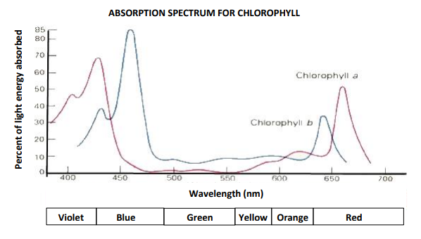
A spectrophotometer is an instrument that is used to measure the amount of light absorbed by a pigment. To the left is a graph showing the percentage of light energy reflected for the absorption spectrum for chlorophyll. The highest peaks represent the wavelengths chlorophyll absorbs the most. Therefore, those colors are least visible.

Use the graph above to answer questions 1-8.
- Which of the colors absorbed by chlorophyll a is seen least (meaning it is absorbed the most)? _________________
- What is its approximate wavelength? (Make sure your answer includes a unit.) _____________________________
- What percentage of light energy absorbed does this peak represent? ______________________________________
- What percentage of this color is being reflected? (Reflected is the opposite of absorbed.) _____________________
- What percentage of light energy absorbed by chlorophyll does the orange spectrum peak represent? ____________
- Why would you say there are no peaks in the range between 500 nm and 600 nm? (Think about the color of chlorophyll and how you see that color.) _____________________________________________________________
_______________________________________________________________________________________________
- Are you able to see the light in the yellow-green spectrum of chlorophyll? Explain why. _______________________
_______________________________________________________________________________________________
- Arrange the colors in the absorption spectrum of chlorophyll in order of their visibility. Place the most visible color first. a. __________________________ b. ____________________________ c. _________________________
d. _______________________________ e. ____________________________ f. __________________________
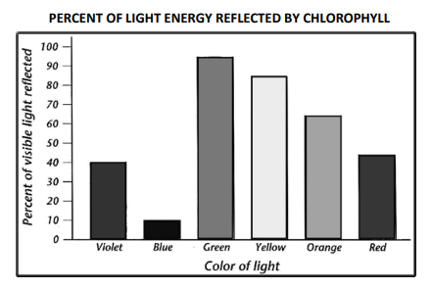
Use the bar graph to the left to answer questions 9-12.
- Which color in this spectrum is most visible? _____________
Why? ____________________________________________
_________________________________________________
- What is the % of light energy reflected for this color? _____
- What % of light energy absorbed does this represent? ____
- If everything above 50% of light energy reflected is visible to the human eye, is red light part of the mixture of colors seen in light reflected by chlorophyll? Explain your answer. _______________________________________________________________________________________________
_______________________________________________________________________________________________

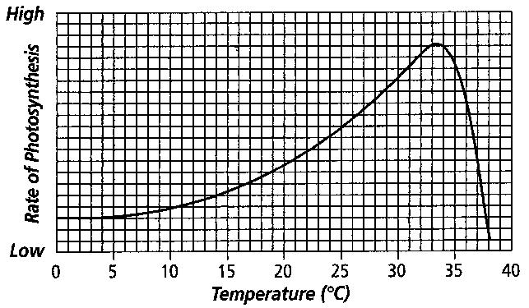
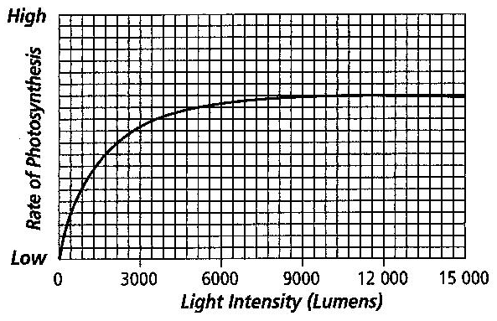
The rate at which photosynthesis occurs is not always the same. The intensity of light, temperature, supply of carbon dioxide, supply of water, and availability of minerals are important factors that affect the rate of photosynthesis in land plants. The rate also varies by species and a plant’s health and maturity. The two graphs below show the effects of light intensity and temperature on the rate of photosynthesis in land plants. These two factors affect many enzymes that control photosynthetic reactions. Study the graphs below and answer questions 13-20.

- What type of biomolecule is an enzyme? _______________________________________________
- Explain what the graph on the left tells about the effect of light intensity on the rate of photosynthesis. __________
______________________________________________________________________________________________
- What happens to the rate of photosynthesis when light intensity rises above 9000 lumens? ___________________
______________________________________________________________________________________________
- Explain what the graph on the right tells about the effect of temperature on the rate of photosynthesis. _________
_______________________________________________________________________________________________
- What happens to the rate of photosynthesis when the temperature rises above 33˚C? ________________________
- What might cause this change? (Think about your answer to #13 and what happens when heat is applied to photosynthetic enzymes.) ________________________________________________________________________
______________________________________________________________________________________________
- What light intensity and temperature levels allow the highest photosynthesis rate? __________________________
______________________________________________________________________________________________

- Critical Thinking: Tropical rainforests on the equator receive 12 hours of sunlight every day and the temperature rarely goes about 34˚C. Based on what you know about photosynthesis and the information in the graphs above, explain how this relates to the high biodiversity (lots of plants and animals) found in tropical rainforests. _______________________________________________________________________________________________
_____________________________________________________________________________________________________________________________________________________________________________________________________________________________________________________________________________________________

Scientists set up an experiment to measure the rate of photosynthesis under different colored lights. 5 elodea plants (a water plant that we have used in class in previous labs), each plant is placed into its own 100mL beaker with 80mL of distilled water. Each plant is them placed in a grow-box that completely shields them from outside light sources. Plant A has no light shined on it, Plant B has white light shined on it, Plant C has blue light shined on it, Plant D has red light shined on it, Plant E has green light shined on it. All bulbs used in the experiment are 25 watt bulbs. Each day the scientists calculate the rate of photosynthesis.
Independent Variable: _______________________________________________________________________________
Dependent Variable: ________________________________________________________________________________
Constants: _________________________________________________________________________________________
Control Group: _____________________________________________________________________________________
Experimental Group(s): _______________________________________________________________________________
Possible Hypothesis: _________________________________________________________________________________ ____________________________________________________________________________________________________________________________________________________________________________________________________
What results would you expect and why?
__________________________________________________________________________________________________________________________________________________________________________________________________________________________________________________________________________________________________________________________________________________________________________________________________________________________________________________________________________________________________________

