Unit 4, Topic 1 Project: Photosynthesis Poster
For this poster project, you may use your notes and you will have access to textbooks if you would like to use this additional resource. This poster will be hand-drawn on the construction paper provided and will not leave the classroom until it has been submitted, graded, and returned. Until then, it stays in the room.
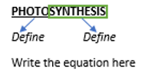
Top of Poster: In relatively large lettering, write the word PHOTOSYNTHESIS in all caps. Underline the prefix photo with a pen or marker and then beneath it, define this prefix. Put a box/rectangle around the term synthesis and beneath it, define this term.
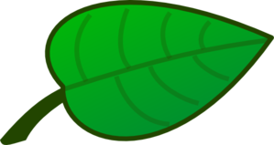
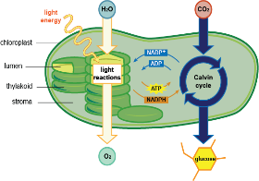
Across the poster paper, underneath and parallel to the heading PHOTOSYNTHESIS, you will write the chemical equation for this reaction. You may use words or symbols.
Beneath Equation: Draw, as best you can, a large leaf with the sun off to the side. Make this leaf take up the rest of the poster because you will draw the reactions of photosynthesis inside of the large leaf.
Inside Large Leaf: You will illustrate a single chloroplast. The following parts must be labeled: thylakoid; grana; stroma; outer membrane; inner membrane. After labeling the parts, you will draw out of the light dependent and the light independent reactions (to include: water; carbon dioxide; light energy; ADP+P; ATP; NADP+; NADPH; oxygen; glucose)

Underneath Plant: You will create a flowchart for photosynthesis using the following items (YOU need to put them in order on your poster…check them with me before you right them out!):
- Once it has electrons, NADP+ is converted to the electron carrier, NADPH
- Glucose is produced using carbon dioxide and other products from the light reactions (ATP & the electrons from NADPH)
- Oxygen is produced from the water and electrons are charged with energy in the process
- Chlorophyll, in the thylakoids, absorbs light
- Each molecule of NADP+ picks up these high-energy electrons
- The absorbed light energy is used to split water
- NADPH carries electrons to the Calvin Cycle
GRADE:
Component | Points Possible
Title with word parts defined | 3 (10%)
Equation | 2 (7%)
Leaf with Chloroplast Image (and sun) | 15 (1 point per component in correct location) (50%)
Flowchart | 3 (10%)
Neatness | 3 (10%)
Behavior (working in seat, no bathroom, using time wisely, asking questions if necessary) | 4 (13%)

_______ /30 = _______________

