Name: __________________________________________________ Date: _______________________ Period: ______

Unit 7 (Gene Regulation and Biotechnology) Review Packet
AP Biology

Topic #1: Gene Regulation and Development

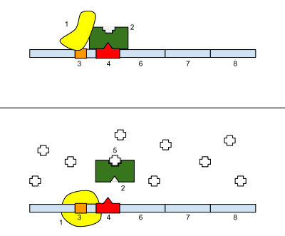
With regard to the operon pictured to the right, the image on top shows the operon in its normal state, and the image on the bottom shows the operon in the presence of molecule #5 (looks like a + sign).
1. Identify the different parts of the picture. Your options are repressor, promoter, genes of the operon, operator, RNA polymerase, and inducer.

6-8.

2. What type of operon is shown—inducible or repressible—and how do you know?

3. What is the role of molecule #5 in regulating the operon shown above?

4. Why is a catabolic operon (one that contains genes for enzymes used to break down molecules) usually an inducible operon?

5. Why is an anabolic operon (one that contaisn genes for enzymes used to build molecules) usually a repressible operon?

6. Let’s say methyl groups are added to the DNA of the gene coding for human growth hormone (or the histone proteins that interact with this DNA). How will this affect the amount of human growth hormone produced? Explain your answer.

7. Let’s say acetyl groups are added to the histone proteins that interact wth the DNA of the gene coding for human growth hormone. How will this affect the amount of human growth hormone produced? Explain your answer.

8. How is the regulation of gene expression different for prokaryotic cells vs. eukaryotic cells?

9. How can changes at the level of mRNA processing (after transcription) produce totally different proteins (ex: variations of the different antibody proteins that are targeted to attack specific bacteria or viruses?

10. Explain the role of homeotic genes in pattern formation during embryonic development.

11. Explain the role of apoptosis in morphogenesis during embryonic development.

12. Explain the role of embryonic induction in cell differentiation during embryonic development.

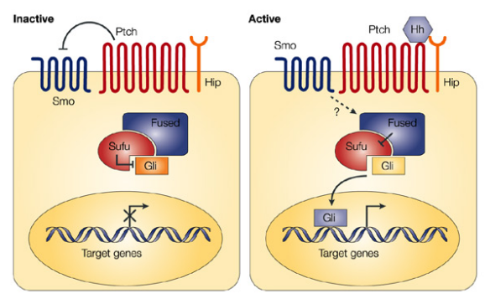
The Hedgehog protein (Hh) plays a critical role during a certain period of embryo development. As illustrated in the figure to the right, when Hedgehog is present, it binds to membrane proteins Ptch and Smo. Activated Smo interacts with a complex of proteins, which eventually results in the activation of a Gli transcription factor that stimulates the transcription of target developmental genes in the nucleus. The image on the left shows the signaling pathway when Hedgehog is not present.

13. Suppose a scientist injects a compound that prevents the activation of Smo in the presence of the hedgehog protein. How will this affect the amount of transcription of the genes in the nucleus?

Two different genes are known to be involved in the development of different body regions of Drosophila fruit flies. The diagram below shows the distributions and levels of mRNA transcribed from two different genes (bicoid and caudal) in different locations in a Drosophila egg immediately before fertilization. Note: bcd stands for bicoid mRNA and cad stands for caudal mRNA

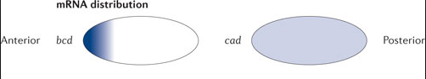

The diagram below shows the distributions and levels of the two corresponding proteins along the body after fertilization. Note: BCD stands for bicoid protein and CAD stands for caudal protein.

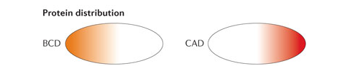

14. How will the removal of caudal mRNA affect the distribution of bicoid protein in the fertilized egg?

15. The image to the right shows the regulation of transcription of the albumin gene in liver cells vs. brain cells. Based on the diagram, why is the albumin gene transcribed at a higher level in liver cells?
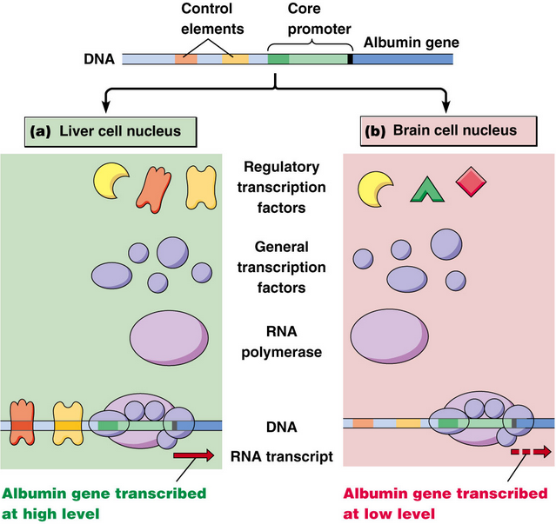

Topic #2: Biotechnology
16. Explain the purpose of each of the three factors in polymerase chain reaction (PCR).
- Heat:

- Primers:

- Taq polymerase:
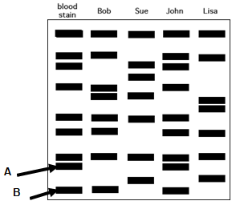
17. Which person in the DNA fingerprint shown to the right—Bob, Sue, John, or Lisa—matches the blood stain DNA? How do you know?

18. If the “wells” of the gel are located up at the top, which DNA fragment is larger—A or B? How do you know?

Below is a plasmid with restriction sites for BamHI and EcoRI. Several restriction digests were done using these two enzymes either alone or in combination. Use the figure to answer questions 19-21.
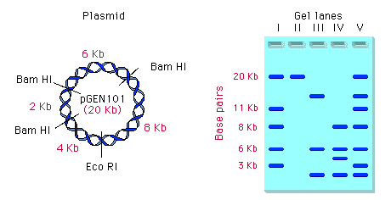
Hint: Begin by determining the number and size of the fragments produced with each enzyme. "kb" stands for kilobases, or thousands of base pairs.

19. Which lane shows a digest with BamHI only? Explain your answer.

20. Which lane shows a digest with EcoRI only? Explain your answer.

21. Which lane shows a digest with both BamHI and EcoRI? Explain your answer.

In a lab experiment that WORKED, scientists transformed E. coli bacteria with a plasmid containing the gene for ampicillin resistance (ampR) and the gene to enable the bacterium to glow (pGlo). The pGlo gene is typically turned off but can be turned on in the presence of the sugar arabinose (ara). The scientists attempted to grow cultures of this transformed bacteria in three conditions—plain LB agar (bacteria food), LB / amp, and LB / amp / ara. They then attempted to grow cultures of untransformed bacteria (lacking the plasmid) in the same three conditions. The table below summarizes all the treatment groups.
 | LB | LB / amp | LB / amp / ara
E. coli with plasmid | 1 | 2 | 3
E. coli without plasmid plasmid | 4 | 5 | 6

22. For each plate, state whether there will be bacterial growth, the type of growth (lawn or colonies), and whether the bacteria will glow. Provide an explanation for your answers.
Plate | Growth? (Y or N) | Lawn or Colonies?  (if growth) | Glow? (Y or N) | Explanation
1
2
3
4
5
6

Almost done, 2 questions on the back!
23. List the steps involved in creating human insulin protein through using recombinant DNA.

24. Golden rice is a transgenic plant, meaning it contains a gene from another organism. In this case, it has been given the gene for the creation of beta carotene (vitamin A). How can a bacterium be used as a “vector” to insert the beta carotene gene into the golden rice plant cells?

