Name: ___________________________________ Unit 7 Topic 2

Period: ______ Page: ______

**Sex-Linked Traits Practice**

**1**

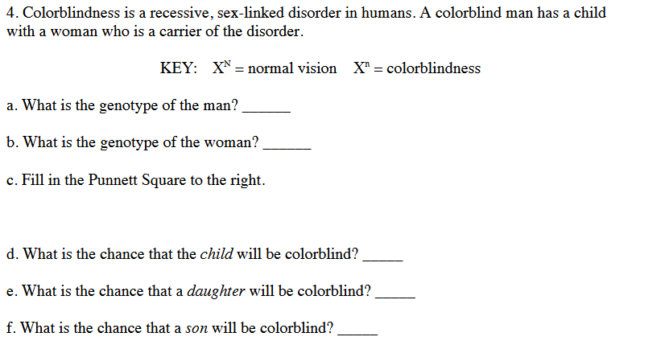

**2**

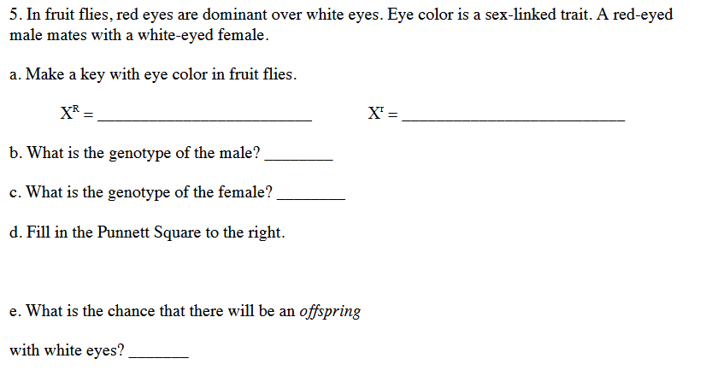

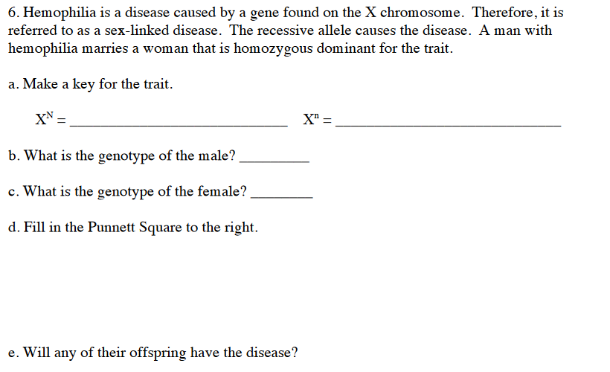

**3**

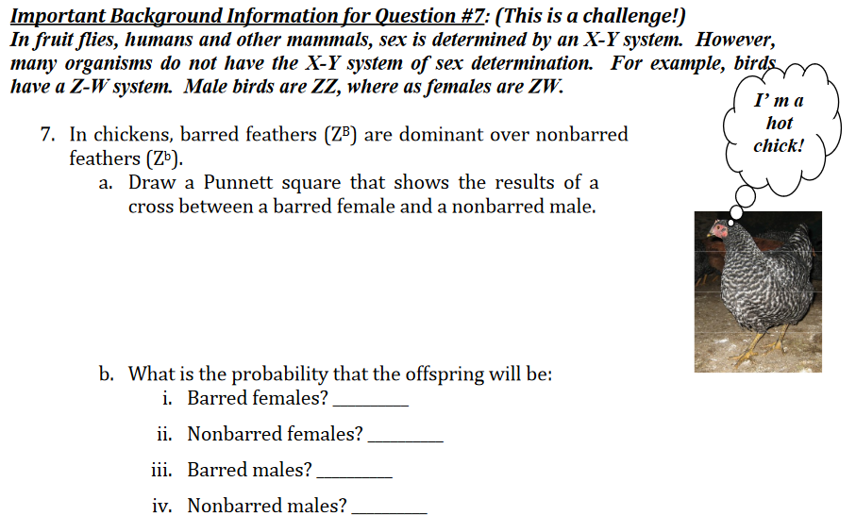

**4**

**4**