Name: _______________________________________________ Date: ___________________________ Period: _____

Unit 10, Part 1 Notes – Populations
AP Biology

- Population Density vs. Population Size:
- Population size simply refers to the number of individuals in the population
- Population density however takes into account the area in which that population lives. The density refers to the number of individuals per unit area (for organisms that live on land) or per unit volume (for organisms that live in the air or in the water).

Population Density

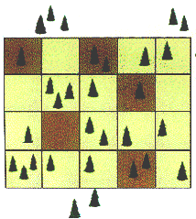
2. There are two methods to study population density--the quadrant technique and the mark and recapture technique. These methods are discussed below.

3. Quadrant Technique
- Quadrat sampling is a classic tool for the study of ecology.
- In general, a series of squares (quadrats) of a set size are placed in a habitat of interest and the species within those quadrats are identified and recorded.
- The number of organisms found at the study site can then be calculated using the number found per quadrat and the size of the quadrat area.
- Works well when working with large organisms that do not move from one area to another.
4. Mark and Recapture Technique
- A limited number of individual (e.g. 20) are captured at random and marked/tagged then released into the environment. Later a second group of animals is captured and the percentage of marked individuals determined.
- If 10% of the animals in this second group have the tag, then the original 20 represented 10% of the population and the population then is 200.
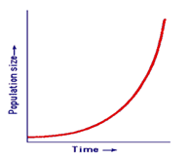

Population Growth

5. The rate at which populations grow can usually be represented by one of two general growth patterns--exponential growth or logistic growth--which are discussed below.

6. Organisms have the potential for extremely rapid growth (i.e. exponential growth). Because the graph modeling this pattern of growth looks like a J (increasing the size of the population drastically over a short period of time), it is often called a “J curve.”

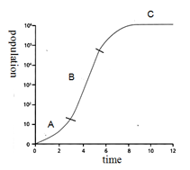
7. Exponential growth cannot continue forever due to limited resources. The exponential growth of populations levels off as the density approaches the carrying capacity. The carrying capacity of a population is the maximum density of a population that the environment can support and sustain over a time period. When a population grows exponentially at first but levels off at the carrying capacity, this is called logistic growth. Because the graph modeling this pattern of growth looks like an S, it is often called an “S curve.”

Question: For the logistic growth curve shown to the right, how does the birth rate compare to the death rate at points A, B, and C?

A:

B:

C.

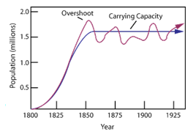
8. Most populations oscillate (move up and down) around the carrying capacity rather than staying exactly at the carrying capacity. When a population is above the carrying capacity, the environment cannot sustain it, the population decreases. If it falls below the carrying capacity, then resources are plentiful and population increases.

Demography:

9. Demography is the study of factors that affect birth and death rate. Some of these factors are discussed below.

- Generation time = the average span of time between birth of an organism and the birth of its offspring.
- There is a correlation between generation time and body size. In other words, larger organisms typically have longer generation times, and smaller organisms typically have shorter generation times.
- A shorter generation time usually results in faster population growth so long as birth rate is greater than death rate with all other factors that contribute to population growth being equal.

- Fecundity: The average number of offspring each surviving individual produces at each life stage
- For example: humans would have a higher fecundity in their mid-20s and 30s compared to their 50s.

- Survivorship: The fraction of individuals that survive from birth to different life stages (childhood, reproductive age, old age, etc.) Determining the survivorship rates and mortality rates (i.e., death rates, the opposite of survivorship rates) for the various age groups in the population gives a survivorship curve (a line graph).
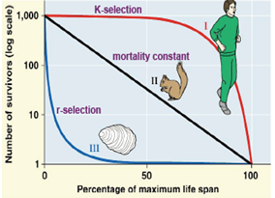
- Type I curve = This type of curve is flat in the beginning because there are low death rates for young and middle-aged organisms. It drops significantly at the end as death rates increase for older organisms.

Populations that show this type of survivorship curve include large mammals like humans that have a small number of offspring but given them high amounts of care (making them unlikely to die young).

- Type III curve = This type of curve shows a rapid decrease in the beginning, which indicates that death rates for young organisms are high. The curve flattens out after this sharp decline because the organisms that survive the initial “die-off” have lower death rates for the remainder of their lives.

Populations that show this type of survivorship curve are typically composed of organisms that have very large numbers of offspring but provide no care or very little care for said offspring (making them more likely to die young). Examples of populations that show this type of survivorship curve include many fishes, most marine invertebrates (salt-water organisms without a backbone like oysters), etc.

c. Type II curve = This type of curve shows constant death rates for organisms at all ages. Examples of organisms that show a type II curve include Belding’s ground squirrels, some other rodents, some invertebrates, some lizards, etc.
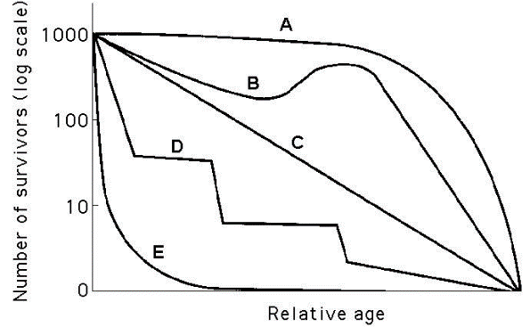
d. It should be noted that many population do not show a perfect Type I, Type II, or Type III curve. For these populations, the curve may be some sort of mix/blend of the three main types or something else entirely. For example, crabs may show a stair-step survivorship curve where mortality (death) rates increase when they are more vulnerable during molting (i.e., shedding of their hard exoskeleton). Crab mortality rates decrease when their protective exoskeleton has grown back (before the next molt). This is represented by Curve D in the graph to the right.
- Life History = An organism’s life history involves the traits that affect its schedule of reproduction and survival. There are three main factors that contribute to an organism’s life history

- When reproduction begins (the age at first reproduction or age at maturity)
- How often the organism reproduces
- How many offspring are produced per reproduction

- One example of a life history pattern is semelparity (from the Latin word semel, which means “once”). An organism that exhibits semelparity reproduces once with many offspring and typically does not provide parental care for the offspring. Pacific salmon display semelparity. They hatch in a freshwater stream, travel to the open ocean, and take 1-4 years to mature. After they reach maturity, they come back to the stream and produce thousands of eggs at once. This huge reproductive event may be called “one-shot” reproduction or “big-bang” reproduction. The parent often dies shortly after this reproductive event because she only has so much energy reserved for growth, maintenance of life processes, and reproduction, and she uses up most of this energy during the reproductive event. Because the parent dies quickly and cannot provide parental care, the offspring must be mature enough at birth to take care of themselves.

- Semelparity is more common in unpredictable environments. In these environments, offspring are unlikely to survive. Thus, the hope is that by producing many offspring, perhaps a few will encounter favorable conditions in the environment and survive until they are old enough to reproduce. Species that exhibit semelparity are often called r-selected species.

- Another example of a life history pattern is iteroparity (from the Latin word iterare, which means “to repeat”). An organism that exhibits iteroparity reproduces multiple times throughout its life. It only has a few offspring each time, but they are typically large. In addition to creating large offspring (which are more likely to survive than smaller offspring), these organisms typically provide more parental care. This also helps to ensure survival of the offspring, who are typically immature at birth and unable to take care of themselves until they learn life skills from their parents.

- Iteroparity is more common in more dependable environments. In these environments, adults are more likely to survive long enough to reproduce multiple times. If adults typically survive a long time, there may be high levels of competition for resources among adults. In this situation, larger offspring that are assisted by their parents in finding food and other resources are more likely to survive long enough to reproduce. Species that exhibit iteroparity are often called K-selected species.

- The differences between r-selected and K-selected species are highlighted in the chart given below.

r-selected species | K-selected species
Shorter lifespan | Longer lifespan
Mature earlier | Mature later
More offspring | Less offspring
Smaller offspring | Larger offspring
Less parental care | More parental care
Likely to show a Type III survivorship curve | Likely to show a Type I (and in some cases Type II) survivorship curve

- Scientists often say that there is always a life history trade-off between reproduction and survival. For example, semelparity results in many offspring (i.e., more reproduction), but they are less likely to survive because they are smaller and the parent can’t typically care for them. In contrast, iteroparity results in only a few offspring (i.e., less reproduction), but they are more likely to survive because they are larger and the parent can typically provide more care.
- Another major factor in the variation of the growth rates among populations is the variation in their age structure. Age structure refers to the percentage of a population that falls into various age ranges (ex: 0-4 years old). Age structure is important when considering population growth rates because generally, a population with a higher percentage of older, non-reproductive individuals grows more slowly than a population with a higher percentage of young, reproducing individuals.

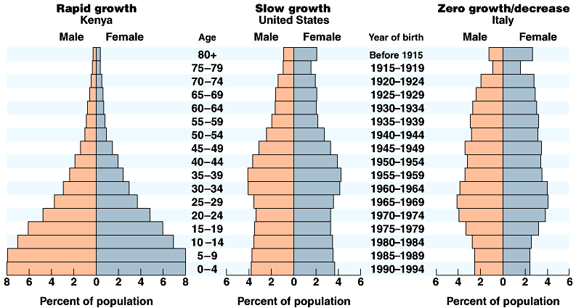
We can use a diagram called an age structure pyramid to depict the age structures of various countries. Notice that distinction is made between the percentage of males and females in each age range. Age structure pyramids for Kenya, the United States, and Italy are given in the diagram to the right.

Question: What can you conclude about the population growth rates in Kenya, the United States, and Italy from their age structure pyramids? Explain your answer thoroughly

Population Regulation

10. Recall from earlier in the notes that the carrying capacity of a population is the maximum density of a population that the environment can support over a time period without damage to the environment. The following are two types of factors that regulate the population size and therefore determine the carrying capacity for the population. These factors are called limiting factors because they limit the growth of the population.
- Density-independent limiting factors regulating population size are unrelated to population density (they affect the same number of individuals regardless of the population size). Weather, climate and natural disasters such as freezes, seasonal changes, hurricanes and fires are examples of density-independent limiting factors.

- Density-dependent limiting factors regulate population size because a population that is growing (i.e. increasing in size) has high levels of competition for limited resources, high levels of disease, etc. In other words, limiting factors like food / water / space shortages and infectious disease only “kick in” when the population is large / dense.
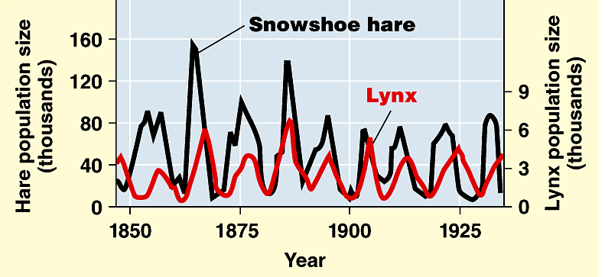

Question: What type of limiting factor is producing the population changes seen in the hare and lynx on the graph to the right? Explain your answer thoroughly.

11. A population’s ability to respond to changes in the environment is affected by genetic diversity. Species and populations with little genetic diversity are at risk for extinction (ex: cheetahs!) Cheetahs lost much of the genetic diversity of ancestral cheetah populations when they experienced a drastic reduction in population size at the end of the ice age that nearly resulted in extinction. Reduced numbers of cheetahs resulted in a lower number of reproducing individuals and high levels of inbreeding (mating between relatives). This lowered the amount of different types of genes (i.e., segments of DNA that code for particular traits) within the cheetah population. Certain types of genes determine whether individuals are vulnerable to infections diseases caused by bacteria or viruses or resistant to these diseases. Because all cheetahs have similar genes (i.e., low genetic diversity) due to inbreeding, if one cheetah is susceptible to an infectious disease, it is likely that all cheetahs will be susceptible to the disease. Therefore, if a disease is introduced into the cheetah population (i.e. a change in the environment), the cheetah population may go extinct.

12. Technology has increased Earth’s carrying capacity for humans. The human population is unique among populations of large animals. It continues to grow at a high rate. The human population has increased with every new technology advancement including food production, improved health and the rise of agriculture. There are constantly new hypotheses about how large the human population will grow. Scientists also hypothesize about when it will begin to decline and what will cause the decline. What is the carrying capacity for the human population? Only time will tell!

Behavior within Populations

13. Organisms within populations often exhibit cooperative behavior to enhance the survival and growth of the population as a whole.

- For example, certain prey species communicate with other members of their species using sounds or visual displays to indicate that a predator is nearby. Adult meerkats use alarm calls to warn the rest of the group of an approaching predator. They are more likely to make these calls when pups (meerkat babies) are present, suggesting that the behavior is intended to enhance the survival of the group not the individual adult. This is type of behavior is called altruism (aka altruistic behavior), where one organism puts himself/herself at risk for the benefit of the group.

14. Members of a population also exhibit behaviors to enhance their personal reproductive success. For example, male dogs mark their territory with urine, signaling to other males of their species to stay away from females within the territory.

15. Animals can signal in a variety of different ways (ex: visual, audible, tactile, electrical and chemical signals) for a variety of different purposes (ex: to indicate dominance, find food, establish territory and ensure reproductive success).

- For example, worker bees perform a “waggle dance” upon returning to the hive that signals to the other workers where nectar can be found outside the hive. The dance is very intricate (almost language-like) and changes depending on the location of the nectar. Below is a description of the “waggle dance,” courtesy of PBS NOVA.

- A bee performs the waggle dance when she wants to inform other bees of a nectar source she has found. The waggle occurs on a special dance floor, which is conveniently located near the entrance to facilitate quick entry and exit of foragers, and only bees with news of highly profitable sources of nectar execute the dance. Arriving back at the nest, a bee with news to share immediately proceeds to the dance floor, where other bees waiting for news gather around her. During the waggle, she dances a figure-eight pattern, with a straight "walk" in between the loops and a sporadic fluttering of her wings.

- The worker communicates several key pieces of information during the dance. The longer she waggles - typically bees make between one and 100 waggle runs per dance - the farther the flower patch lies from the hive, with every 75 milliseconds she prolongs the dance adding roughly another 330 feet to the distance. She shows how rich the source is by how long and/or how vigorously she dances. Perhaps most astonishingly, she indicates the direction of the source by the angle her waggle walk deviates from an imaginary straight line drawn from the dance floor to the sun at its current position. In other words, if the source lies in the exact direction of the sun, the bee will walk facing exactly straight up (remember that a hive hangs vertically). If it lies 20 degrees to the right of that imaginary line to the sun, the angle of the bee's walk will be 20 degrees to the right of vertical. Finally, the dancer shares the odor of the flowers in question with the other bees, who sample it with their antennae.

- Attendees will watch only one waggle dance and only for a brief period before leaving the hive. In this way, the bee works for the good of the hive rather than for the good of herself. If she stayed for the whole dance, she would know exactly how rich the source is, for instance. But if all bees waited for the entire dance to take place, and then only went to the richest sources, the colony would not be maximizing its use of available resources.

- Examples of waggle dance angles are given below.

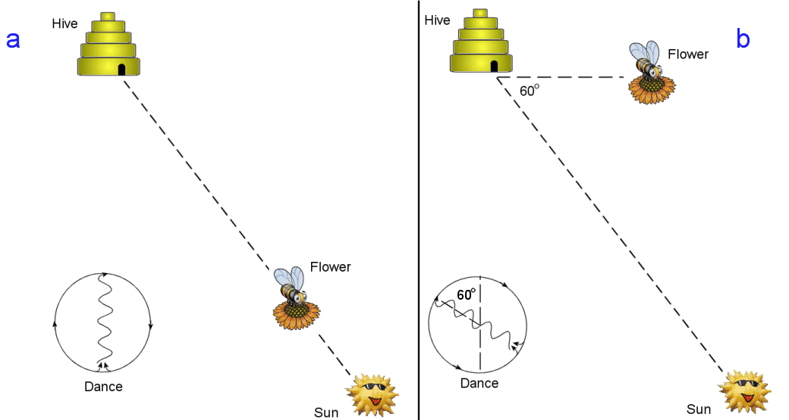

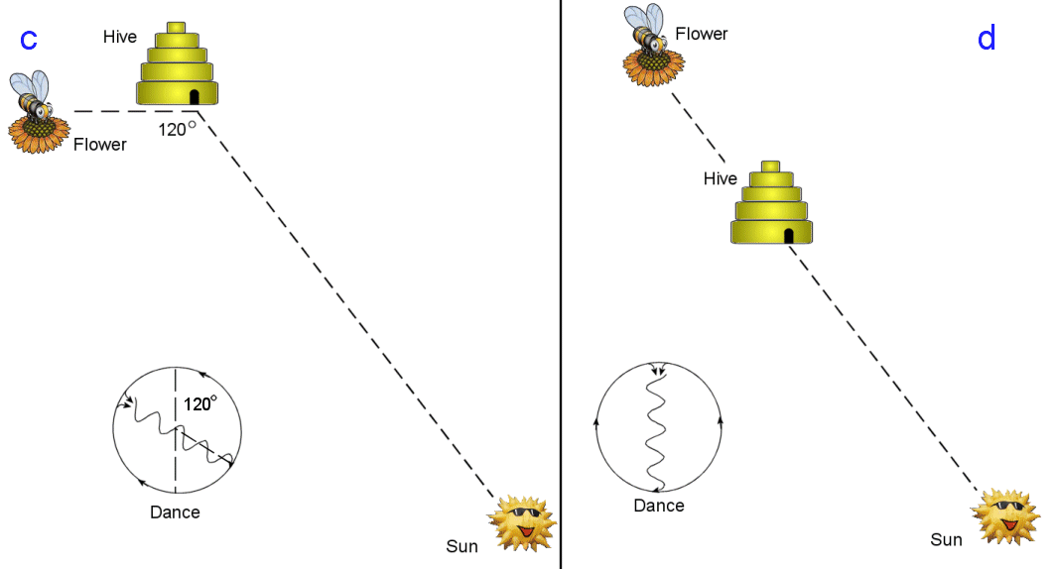

Notes Questions

- Scientists are using the mark-recapture technique to estimate the population density of a population of turtles. (Yeah, this is totally made up). Initially, 30 turtles were captured and tagged (marked) with a line of orange paint on their shells and released back into the environment. The scientists later captured 20 more turtles and found that 5 of them had tags on their back. Use the following equation to estimate the size of the whole turtle population.

R = # of recaptured turtles that had a mark
T = total # of recaptured turtles
M = # of turtles that were initially captured and marked
N = total # of turtles in the population

$\frac{M}{N}=\frac{R}{T}$

- Describe the difference between exponential and logistic growth.

- Which of the following graphs depicting logistic growth is more likely for a REAL population? Use the term carrying capacity in your response.

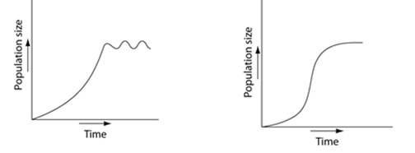
- In no more than three sentences, describe the difference between type I and type III survivorship curves.

- Why do organisms that exhibit semelparity often die shortly after reproducing?

- North Atlantic right whales first give birth around 9-10 years old after a year long gestation (pregnancy). Their calves (babies) weigh approximately 3,000 pounds at birth. There is typically a 3-6 year long interval between reproductions. Given this information, what type of species are these whales likely to be--r-selected or K-selected? Explain your answer.

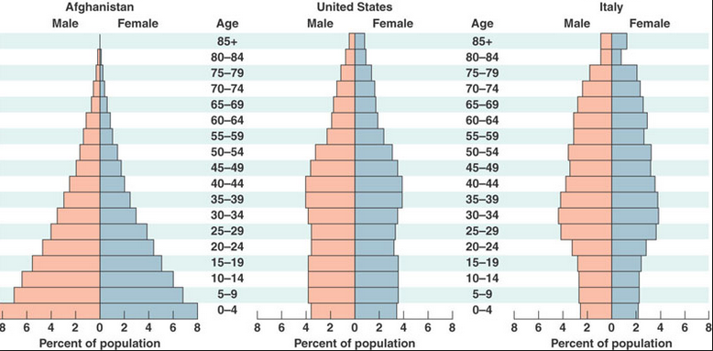
- Describe the age structure of each of the populations of each of the three countries shown to the right—Afghanistan, the United States, and Italy. Then, predict which country has the highest rate of population growth and which country has the lowest rate of population growth.

