Name: ___________________________________________ U1T1
Period: _________ Page: ________
Are Viruses Alive? Writing Prompt

Background Information: For years, scientists have debated whether or not viruses should be considered alive. Viruses include disease-causing agents in humans such as influenza, rhinovirus (the cold virus), and HIV (human immunodeficiency virus). Viruses are made of two molecules commonly found in cells—protein and genetic material. Unlike other organisms, not all viruses contain DNA as their genetic material. Instead, some viruses contain a molecule similar to DNA called RNA. The structures of the DNA and RNA molecules are shown side-by-side below and to the right.

Their protein outer coating typically surrounds and protects their genetic material (molecules which determine the traits of the virus and are used in the construction of new viruses). Though viruses are made of some molecules typically found in cells, they do not contain all the essential parts of a typical cell. For example, the contain proteins and nucleic acids (what DNA or RNA is made of), but does not have any organelles or even a cell membrane.

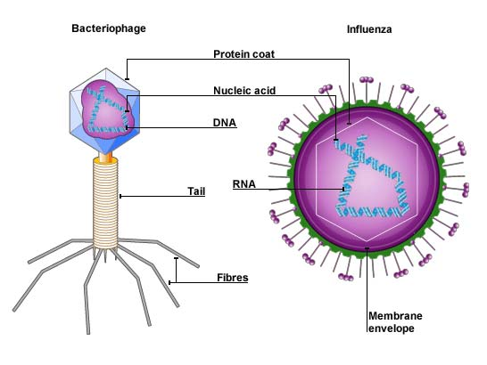
Viruses can reproduce only by infecting other organisms (ex: bacteria, plants, and animals) and using their cell parts to make more of themselves. The image to the left shows a bacteriophage—a type of virus that infects bacteria cells—and the influenza virus. Though they look different from each other, they have the same basic structure—a protein coat surrounding genetic material.

To infect the cells of other organisms, viruses use a needle-like structure that is part of their protein coat to inject their genetic material (either DNA or RNA) into the host cell. They then use the host cell’s tools (organelles) to make more viruses based on their genetic material. These new viruses then burst out of the host cell, killing it in the process. The image below shows the infection process.

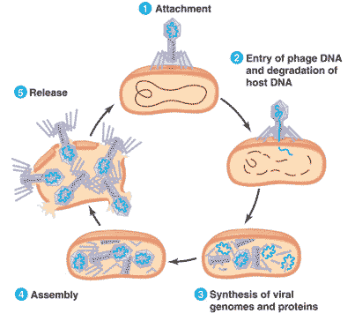
Viruses do not make or use energy molecules of their own. Instead, they use the energy molecules created by their host cell to provide energy necessary for reproduction. Additionally, because they live inside a host cell, viruses do not need to respond to the environment or maintain stable internal conditions. The host cell does this for them.

Groups of viruses change over time. This is why you need a new flu shot every year. The population of influenza viruses changes enough every year that old vaccines will be ineffective against the traits displayed by the new viruses.

Assignment Description: In the CER organizer provided, use the evidence presented in the passage and what you have learned about the characteristics of life to conclude whether or not viruses are living things. You must identify three pieces of evidence from the passage that support your claim and clearly explain HOW these pieces of evidence support your claim. You can cite specific phrases / sentences from the passage, but please explain how they support your conclusion in your own words. Your response will be evaluated using the rubric given below.

Category | You Got It!  (3 points) | You’re Almost There!  (2 points) | You Need to Make Some Changes!  (1 point) | Missing  (0 points) | Your Score
Claim | The claim is correct and clearly stated. | The claim is not correct OR is not clearly stated. | The claim is not correct AND is not clearly stated. | No claim | /3
Evidence | Three pieces of evidence relevant to the claim/conclusion are clearly identified. | Only two pieces of evidence are identified, or the three pieces of evidence are not related to the claim. | 1 pieces of evidence are identified. | No evidence provided | /3
Reasoning | There is a thorough and accurate explanation of how the pieces of evidence support the claim. Any vocabulary terms that are central to the explanation are defined. | There is an explanation but it lacks the necessary detail to fully describe the connection between the pieces of evidence and the claim. Vocabulary terms that are central to the explanation are included but not defined. | The explanation is not correct or is very lacking in detail and associated vocabulary terms. | No reasoning provided | /3

Total Points: _____/ _____

