- A mutation that occurs in the gametes of an organism will most likely be transferred to which of the following?
  - The siblings of the organism c. The other organisms living nearby
  - The offspring of the organism d. The mating partner of the organism
- Sickle-shaped red blood cells result from a mutation in the gene that codes for hemoglobin. This mutation results in sickle-cell anemia. A partial sequence of bases from a normal hemoglobin gene and a sequence that results in sickle-cell anemia are shown below. What type of mutation is depicted in this sequence? 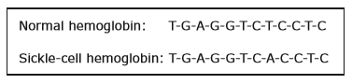
  - Substitution c. Deletion
  - Insertion d. Frameshift
- Which statement best describes the relationship that exists among proteins, DNA, and cells?
  - Proteins combine to produce cells, which produce DNA.
  - Proteins are made up of DNA, which determines the cells that are produced.
  - DNA is made up of proteins, which tell a cell how to function.
  - Cells contain DNA, which controls the production of proteins.
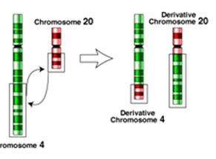
- The diagram shown pictures what type of mutation?
  - Inversion c. Duplication
  - Deletion d. Translocation
- With a normal DNA sequence of GCA-TAA, which of the following is a frame shift mutation, and what type of frame shift mutation is shown?
  - GGA-TAA; Deletion c. ACA-TAA; Substitution
  - GCT-ATA-A; Insertion d. None of the above
- Which of the following mutations will have the smallest effect on the resulting polypeptide?
  - A nonsense mutation c. An insertion
  - A missense mutation d. A silent mutation

