Name: __________________________________________ Date: ________________________ Period: ______

**Unit 1 Notes, Part 4 – Classification and Biodiversity**

AP Biology, 2018-2019

1. **How do scientists place organisms into groups (classify them)?**
2. 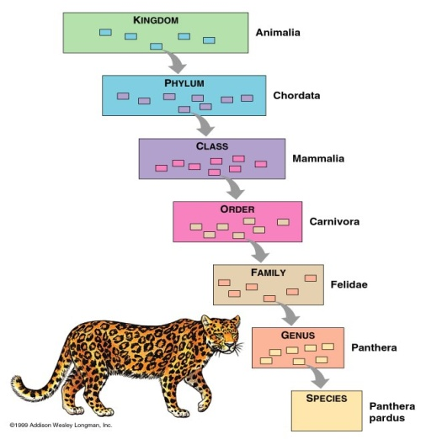Today, scientists consider phylogeny when classifying organisms. **Phylogeny** is defined as the evolutionary history of a species or a group of related species ; uses evidence from **systematics** (a scientific discipline focused on determining evolutionary relationships between organisms based on fossil, morphology/anatomy, and molecular evidence)
3. **Taxonomists** are scientists that use phylogeny to group organisms into categories

* The “father of modern taxonomy” was a scientist named Carolus Linnaeus
* Linnaeus created the system of **binomial nomenclature**, a two-part naming system that includes the “**genus**” name (group of similar species) and “**species** identifier” (ex: *Canis familiaris –* Common dog)
* **Scientific names** are written in Latin to ensure that names are the same anywhere in the world
* Ex: Common Names for Bluegill = bream, sunperch, blue sunfish, copperbelly ; Scientific Name = *Lepomis macrochirus*
* The hierarchical classification of organisms consists of the following levels, starting with the most general/inclusive level: **domain, kingdom, phylum. class, order, family, genus, and species.**

1. **What evidence do scientists use to determine phylogeny?**
2. Scientists use morphological and molecular data to infer phylogeny (evolutionary history)
3. **Morphological data**

* **Homologous structures** = similarities due to shared ancestry (having a common ancestor) ; result from divergent evolution – ex: the bones of a whale’s flipper and a tiger’s paw
* **Analogous structures** = similarities due to similar environmental requirements and similar functions ; these similarities do not indicate shared ancestry ; result from convergent evolution – ex: the wings of a butterfly and a bat

1. **Molecular data (aka molecular homologies, aka biochemical data)**

-DNA and amino acid sequences

-The more alike the DNA or amino acid sequences of two organisms, the more closely related they are evolutionarily

1. **How can we use diagrams to show evolutionary relationships between groups of organisms?**
2. Scientists use **cladograms** and **phylogenetic trees** to show evolutionary relationships between groups of organisms.
3. An example of a cladogram is given on the next page.
4. In the cladogram, the heart symbol at the bottom sits next to the **root** of the tree. This root represents the **common ancestor** of all the groups of organisms depicted in the cladogram.
5. The star symbols sit next to the **branches** of the tree. The **tips** of these branches are labeled with the names of specific groups of organisms.
6. The letters A, B, and C sit next to the **nodes** or branching points of the cladogram. These nodes represent points where groups of organisms diverged from one another. For example, Node C represents a point where the groups of organisms that eventually evolved into modern lizards and elephants diverged (branched) from one another. We can also say that Node C represents the common ancestor of lizards and elephants (but not goldfish and worms.)
7. The number 1 sits next to a mark on the main line of the cladogram. We call this mark a “**tick mark**.” This particular mark represents a trait found in all of the groups of organisms shown in the cladogram (worms, goldfish, lizards, and elephants) because it comes before they branched apart from one another. For example, the trait represented by Tick Mark 1 might be cells because worms, goldfish, lizards, and elephants all have cells. We can call this trait a “**shared ancestral trait**” because it was found in the ancestor of all the groups of organisms shown in the cladogram and is still found in all the groups of organisms today.
8. Tick marks 2 and 3 are not shared ancestral traits because they are not found in all the groups of organisms shown on the cladogram. As a general rule…

* The groups of organisms that DO display a particular trait are found ABOVE the trait’s tick mark on the main line of the cladogram.
* The groups of organisms that do NOT display a particular trait are found BELOW the trait’s tick mark on the main line of the cladogram.
* For this cladogram, the trait represented by Tick mark 2 is found in goldfish, lizards, and elephants but not in worms. An example of such a trait might be the presence of limbs.
* For this cladogram, the trait represented by Tick mark 3 is found in lizards and elephants but not in worms or goldfish. An example of such a trait might be lungs.

For this cladogram, tick marks 2 and 3 represent traits known as **shared derived traits** or just **derived traits**. These traits may also be known as **synapomorphies.** They may be shared by some groups of organisms on the cladogram and they are “derived” because they are not found in the common ancestor of all the groups of organisms in the cladogram. These traits arose by mutation later on in certain groups of organisms.

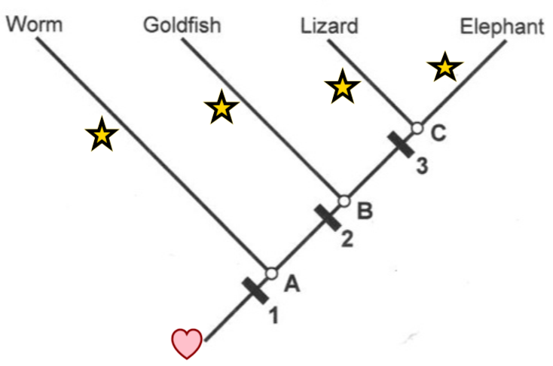

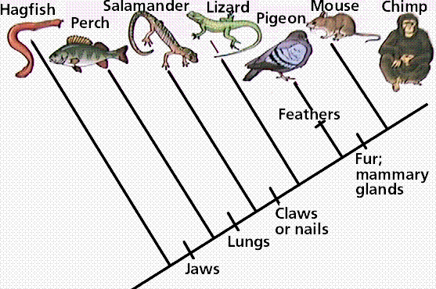

1. Another example of a cladogram is given to the right. In this cladogram, the tick mark for one of the derived traits (feathers) is placed on a branch rather than the main line of the cladogram. This means that the trait (feathers) is only found in the group of organisms found on that branch (pigeons).
2. A cladogram can also be depicted as shown in the image given below.

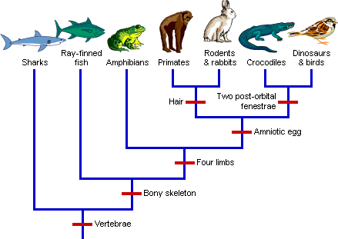

1. **Phylogenetic trees** are another type of diagram that scientists use to represent evolutionary relationships among groups of organisms. They only differ from cladograms in that the length of the branches in phylogenetic trees represents the amount of time that has passed and the amount of evolutionary change that has occurred in groups of organisms. An example of a phylogenetic tree is given below.

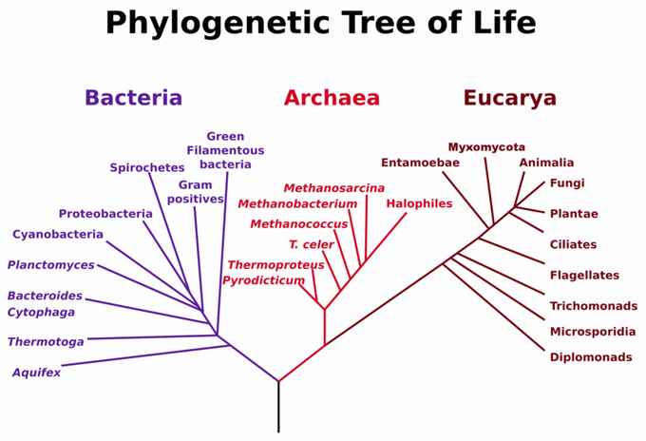

1. **How can we determine the length of time that has passed since two groups “branched apart” (i.e. diverged)?**
2. The rate of evolution/change of DNA sequences varies from one part of the genetic code to another

* DNA that codes for **ribosomal RNA** changes relatively slowly and is useful for investigating relationships between taxa that diverged (branched off) hundreds of millions of years ago. **RNA** is a nucleic acid (similar to DNA) that is found in the nucleus and a cell part called a ribosome. **Ribosomes** are found in ALL cells (no matter what type of organism) and are used to create proteins.
* DNA found in **mitochondria** evolves rapidly and can be used to explore recent evolutionary events. Mitochondria are cell parts that are used to produce energy for the cell. They are one of only a couple cell parts (other than the nucleus) where DNA is found.
* **Molecular clocks** are sequences of DNA that seem to mutate at constant rates. For example, if a sequence tends to mutate at a rate of one base change every 25 million years and there are two bases that are different between two groups of organisms, then it is likely they branched apart 50 million years ago and began to evolve separately.

A Real Example: the gene that codes for the protein alpha-globin (a component of hemoglobin, the molecule that binds to oxygen in your red blood cells) experiences base changes at a rate of .56 changes per base pair per billion year

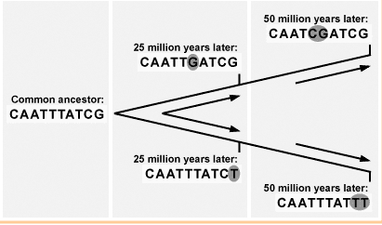

***Sequence serving as a molecular clock (one base change every 25 million years)***

**Questions to be Completed as a Class**

***Part 1: Analyzing a Cladogram***

Analyze the cladogram below by answering the associated questions.

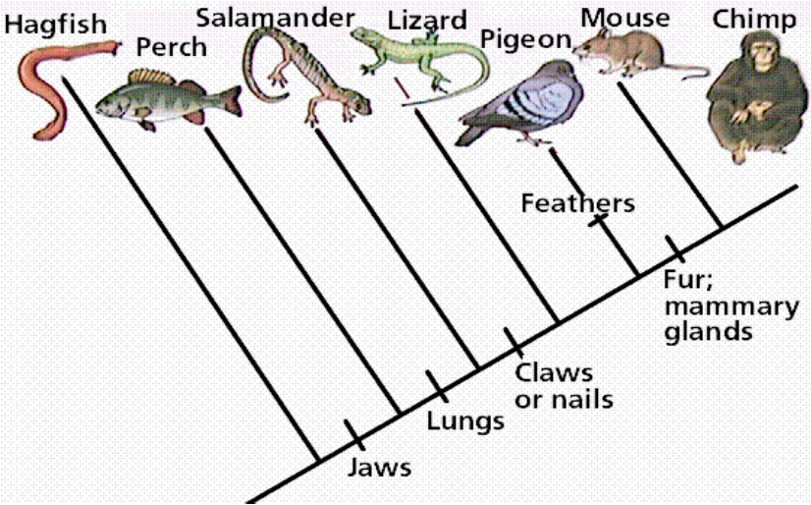

1. After which animals did mammary glands develop?______________________________________

2. What animal does not have jaws? ___________________________________________________

3. Which animals have lungs? ________________________________________________________

4. Which animals are probably predators? _______________________________________________

5. After which animal did protection from the elements arise?________________________________

***Part 2: Creating a Cladogram***

To make a cladogram, you must first look at the animals you are studying and establish characteristics that they share and ones that are unique to each group. For the animals on the table, indicate whether the characteristic is present or not by placing a checkmark in boxes for organisms that possess a given trait. Based on that chart, create a cladogram

**Step 1: Creating a Table of Shared Characteristics**

|  |  |  |  |  |  |
| --- | --- | --- | --- | --- | --- |
|  | Cells | Backbone | Legs | Hair | Opposable Thumbs |
| Slug |  |  |  |  |  |
| Catfish |  |  |  |  |  |
| Frog |  |  |  |  |  |
| Tiger |  |  |  |  |  |
| Human |  |  |  |  |  |

**Step 2: Draw Your Cladogram** (in the space below)

Note: each trait will represent a “tick mark” on the tree. Again, traits that are shared by most of the species will be shown by tick marks that are closer to the “root” of the cladogram. Traits that are more “derived” (i.e. evolved later in only some species on the cladogram) will be shown by tick marks that are farther from the “root” of the cladogram and closer to the “tip.” For example, opposable thumbs are the most derived trait on the cladogram we are creating because they are only found in one group, humans. Opposable thumbs evolved after humans and tigers split from their common ancestor. Tick marks can be found on the main line of the cladogram or on lines that branch off to certain species. Tick marks can also be used to show traits that have been lost due to evolution. For example, most mammals have hind legs, but certain sea mammals have lost hind legs due to their aquatic environment. Hind legs would therefore be an example of a trait that was “lost” for sea mammal species like whales.

1. **Do all living organisms share a common ancestor?**
2. To determine whether all organisms on Earth shared one really old ancestor, scientists decided to determine whether there were traits shared by all organisms on Earth. Below is a list of traits they found that are common to all living things and therefore provide evidence for a **universal common ancestor** (i.e. a single ancestor for all living things)

* A common genetic code based on DNA
* Common processes (replication) and molecules (enzymes) used to create a copy of DNA for new cells
* Common processes (transcription and translation) and molecules (enzymes) used to create proteins from the code in DNA using 20 different protein building blocks called “amino acids”
* A common energy storage molecule called ATP and common processes of creating this molecule (cellular respiration)
* Common cellular features (ex: a watery fluid called the cytoplasm surrounded by a membrane made of lipid / fat molecules)

1. Based on their research, scientists have also determined what the universal common ancestor might have “looked like”. They believe it was an organism similar to a modern organisms in the Domain Archaea (see part F below). It probably was small and single celled. It most likely had a cell wall and a small ring of DNA at the middle of the cell that was not enclosed by a nucleus. It most likely lived in harsh environments like deep ocean vents, used anaerobic respiration (a process of creating ATP without using oxygen), and was a heterotroph (i.e. could not create its own food, so it had to consume other organisms for sustenance). From the universal common ancestor, modern organisms have lost certain traits and gained certain traits to give them the characteristics they have today.
2. **Into what groups have scientists classified organisms based on their evolutionary history?**
3. Originally, scientists grouped organisms into five main kingdoms: **monera, protista, fungi, plantae, and animalia** based on number of cells found in the organisms, cell parts and features, method of obtaining food, habitat, and method of reproduction. Monera included all single celled organisms that lacked a nucleus (i.e., prokaryotes)
4. Upon realizing that organisms in monera were too different to be placed in one kingdom, scientists split kingdom monera into two groups, the **archaebacteria and eubacteria**. The **five kingdom system** thus became a **six kingdom system.**
5. Recently, a scientist named Carl Woese proposed that we look at **ribosomal RNA** base sequences to determine how to group organisms. Molecular sequences (i.e. DNA or RNA sequences) often provide more accurate data to determine the relationships between organisms. Based on their ribosomal RNA sequences, Woese determined that four of the kingdoms (protista, fungi, plantae, and animalia) were very closely related and thus could not be considered in separate groups, when compared to the archaebacteria and eubacteria. Therefore, he created a **three domain system** with kingdom archaebacteria falling into **domain archaea**, kingdom eubacteria falling into **domain bacteria**, and all four remaining kingdoms falling into **domain eukarya**. The characteristics distinguishing the three domains and the four kingdoms of domain eukarya are given in the chart below.
6. The organisms within domain eukarya all share certain traits. Some of these traits are listed below. Others are listed in the chart on the ***next page***.

* A network of protein fibers called the cytokeleton scattered throughout the cytoplasm of their cells to support cell structure and shape and provide tracks (like train tracks!) for other cell parts (i.e. organelles) to travel on inside/throughout the cell.
* Membrane-bound organelles (ex: mitochondria and chloroplasts), which are cell parts that are made of or enclosed by membrane
* Linear chromosomes, which are chromosomes that look like single poles or rods prior to DNA replication in preparation for cell division. Once replicated, linear chromosomes appear to have an “X” shape.
* An endomembrane system, which is an internal network of membranes that includes organelles like the nuclear membrane, endoplasmic reticulum, and Golgi apparatus. This system is used to create products like proteins, package them, and secrete (i.e. export) them from the cell.

*Chart on the next page…*

|  |  |
| --- | --- |
| **Domain or Kingdom** | **Distinguishing Features** |
| Domain Bacteria | * **Prokaryotic** cells (lack a nucleus and most cell parts / organelles) * **Unicellular** (have only one cell) * Some bacteria are heterotrophs (must eat other organisms) and some are autotrophs (can make their own food) * **Cell wall with peptidoglycan** * **Cell membrane has different lipids than Archae** * Tend to live in **less extreme environments** * *Example Organisms:* *E. coli (bacteria that live in your intestines), streptococcus (bacteria that cause strep throat), cyanobacteria (blue/green bacteria that can go through photosynthesis)* |
| Domain Archaea | * **Prokaryotic** cells * **Unicellular** * Some archaea are heterotrophs and some are autotrophs * **Cell wall** (but **does not** contain peptidoglycan**)** * **Cell membrane has different lipids than Bacteria** * Tend to live in **extreme environments** with high heat, low oxygen, and harsh chemicals (ex: deep sea vents, geysers) * *Example organisms: methanogens (archaea that create methane), thermophiles (heat loving archaea), and halophiles (salt loving archaea)* |
| Domain Eukarya | * **Eukaryotic** cells (contain a nucleus and membrane-bound organelles like mitochondria or chloroplasts) * Some are unicellular and some are multicellular * Some eukarya are heterotrophs (ex: animals, fungi), and some are autotrophs (ex: plants) |
| Kingdom Protista | * **Unicellular** * Some are heterotrophs, some are autotrophs * **No cell wall** (just membrane) * Live mostly in **aquatic environments** * Broken down into three groups based on how they compare to the other three eukaryotic kingdoms: animal-like protists, plant-like protists, and fungus-like protists * *Example Organisms: Amoeba and Paramecium (two animal-like protists), Euglena (two plant-like protists), Volvox (a colonial protists)* |
| Kingdom Fungi | * **Most are multicellular** with a basic body structure made of filaments called hyphae (used for absorbing food and reproducing), some are unicellular (i.e. the yeasts) * They are **heterotrophs** that send out enzymes to break down food and absorb it through their hyphae (because they digest their food outside their cells this is called extracellular digestion) * **Cell wall made with chitin** * Most terrestrial, some aquatic. * *Example Organisms: Yeasts, mushrooms, molds, rusts* |
| Kingdom Plantae | * All are **multicellular** * They are **autotrophs** that make their own food through a process called photosynthesis * **Cell wall made with cellulose** * Most terrestrial, some aquatic * *Example Organisms: Mosses, ferns, pine trees, flowering plants* |
| Kingdom Animalia | * All are **multicellular** * They are **heterotrophs** that digest their food using enzymes after bringing it into their bodies * No cell walls (just membranes) * Some are terrestrial and some are aquatic * *Example Organisms: Sponges, jellyfish, worms (flat, round, and segmented), arthropods, mollusks, starfish, and vertebrates (organisms with a backbone including fish, amphibians, reptiles, birds, and mammals)* |

**Notes Questions**

**Practice Questions:**

1. Based on only the information in the chart above, compare the three domains (Bacteria, Archaea, and Eukarya). Which two domains seem to be most closely related to each other and why?
2. Would you change your answer to #1 if you knew the information given below? How would you change it?

**New Information:** rRNA (ribosomal RNA) sequences between Archaea and Eukarya seem to have fewer changes than rRNA sequences between Archaea and Bacteria or Eukarya and Bacteria. Also, both Archaea and Eukarya appear to have similar DNA features that are not found in Bacteria. For example, both have their DNA wrapped around proteins called histones and possess sections of DNA called introns that are not used to code for proteins.

1. Describe the difference between shared, derived traits (aka synapomorphies) and shared, ancestral traits. Which type of trait is used in a cladogram?
2. What are molecular clock sequences, and what purpose are they used for? You can use the image to the right to help you answer this question.
3. Identify the characteristics of the universal common ancestor that are found in all living things today.
4. Describe what the universal common ancestor may have “looked like.”
5. How and why have the “grouping systems” that scientists have used to classify organisms (ex: kingdoms, domains) changed over time?
6. Identify the characteristics shared by all members of Domain Eukarya.
7. Based on the morphological data in the table below, draw a cladogram of to the right that reflects the evolutionary relationships of the organisms.

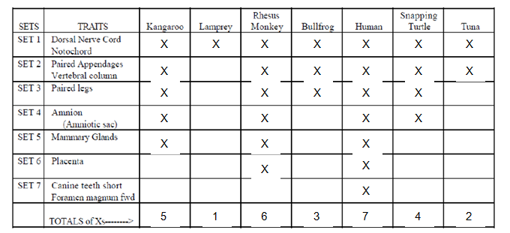

1. Based on the molecular sequence data in the table below, draw a cladogram that reflects the evolutionary relationships of the organisms based on the differences in their cytochrome c amino-acid sequences.

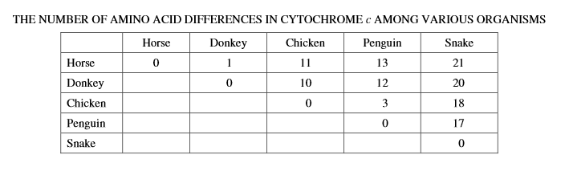

**Self-Quiz** – select questions from Campbell’s Biology. Use this resource as you see fit. Answers can be found on my website.

1. If humans and pandas belong to the same class, then they must also belong to the same
   1. order b. phylum c. family d. genus e. species
2. If you were using cladistics analysis to build a phylogenetic tree of cats, which of the following would make the best outgroup?
   1. lion b. domestic cat c. wolf d. leopard e. tiger
3. Which of the following would be most useful in constructing a phylogenetic tree for several fish species?
   1. several analogous characteristics shared by all the fishes
   2. a single homologous characteristic shared by all the fishes
   3. the total degree of morphological similarity among carious fish species
   4. several characteristics though to have evolved after different fishes diverged from one another
   5. a single characteristic that is different in all the fishes
4. Which of the following statements is *not* true?
   1. Archae and bacteria have different membrane lipids.
   2. Both archae and bacteria generally lack membrane-enclosed organelles.
   3. The cell walls of archae lack peptidoglycan.
   4. Only bacteria have double-stranded DNA.
5. *All* fungi share which of the following characteristics?
   1. symbiotic b. heterotrophic c. flagellated d. pathogenic