Name: ___________________________________________ Unit 1 All Topics

Period: _________ Page: ________

**Unit 1 Notes: Introduction to Biology**

***Topic 1: Characteristics of Life***

**Topic 1 Objectives:**

* I can tell the difference between organisms and nonliving things
* I can list and explain the characteristics all living things share
* I can explain why some things are considered nonliving, even though they meet some characteristics of life

1. **General Vocabulary**
   1. Biology: ___________________________________________________________
      1. Bio = ___________ & Life = _______________
   2. Organism: anything that has or _________________ all of the ________________________________________________.
2. 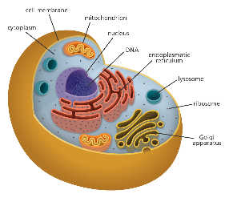**Characteristics of Living Things**
3. **Made of one or more CELLS**
   1. Cells are the ________________________________capable of all life functions
      1. *Uni*cellular organisms: composed of ___________________________(i.e. bacteria)
      2. *Multi*cellular organisms: composed of _____________________________________ (i.e. humans)
      3. List the numbers of the photos under the correct heading below:

Unicellular or Multicellular

1. **Organization**
   1. Living things are arranged in an _____________________________________.
   2. Each organized structure in an organism has a ______________________________.
      1. Example: ________________________________________________
   3. Put a ***circle*** around the levels of organization below that are found in UNIcellular organisms and then put a ***box*** around all the levels of organization found in MULTIcellular organisms.

*Atom 🡪 Molecule 🡪 Cell 🡪 Tissue 🡪 Organ 🡪 Organ System 🡪 Organism*

|  |  |  |
| --- | --- | --- |
| **Level** | **Definition** | **Example in Humans** |
| Atom | The smallest unit of matter |  |
| Molecule | Groups of atoms that are bonded together |  |
| Cell | The smallest unit of life (composed of atoms and molecules). |  |
| Tissue | Groups of cells that work together to perform a specific function. |  |
| Organ | Groups of cells and tissues that work together to perform a specific function. |  |
| Organ System | Groups of organs that work together to perform a specific function. |  |
| Organism | An individual living thing. |  |

1. 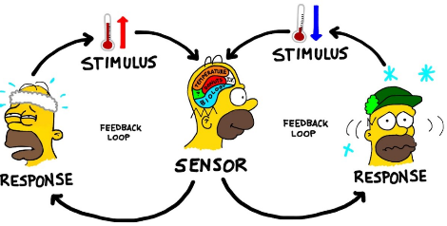**Regulation**
   1. Maintaining ____________ _________________ conditions despite changes in ________________ conditions.
   2. **Homeostasis:** when an organism’s internal conditions are _______________.
      1. Example:
2. 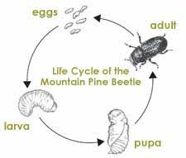**Growth and Development**
   1. DNA directs pattern of growth and development
   2. Most organisms begin as ________ ____________.
   3. ________________________**:** addition of __________ and/or new cells to an organism.
   4. _____________________________**:** changes that take place to bring an organism to ___________________.
3. **Requires and Uses Energy**
   1. All chemical reactions that happen in an organism require ______________. What is one source of energy? ______
      1. **Autotrophs**: organisms that ________ their own food (using energy from ______________ during photosynthesis)
      2. **Heterotrophs**: organism that get their energy from ____________________ other organisms.
   2. All energy originates from the ________.

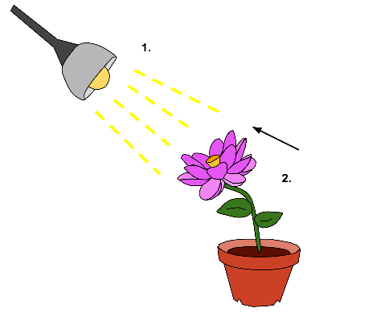

1. **Response to the Environment**
   1. *Internal Environment* = all things __________________ of an organism
   2. *External Environment* = all things ________________________ an organism
   3. ***Stimulus*** = anything that is part of either an organism’s external or internal environment that causes a __________________ from the organism.
   4. ***Response*** = an organism’s reaction to a _________________________.
2. **Reproduction**
   1. Reproduction = the production of _____________________ (can only happen within a species)
      1. No organism lives forever; so reproduction ensures their genes “live on” after they die.
   2. Two types: asexual vs. sexual
   3. *Species* = a group of organisms that can breed with one another and produce _________________ offspring
3. **Groups of Living Things EVOLVE Over Time**
   1. *Evolution =* ___________________________________________________________________________________ _____________________________________________________________________________________________
      1. *Population* = group of organisms of the **same species** that live in a particular area.
   2. New species can develop over time if enough changes occur
   3. Natural selection — “survival of the fittest”
   4. 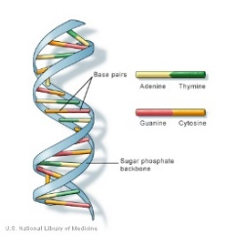_____________________________: any inherited characteristics that results from changes in a species over time.
      1. Example: _______________________________________________
4. **Has a Genetic Code (DNA)**
   1. All organisms store the complex information they need to live, ___________, and reproduce in a genetic code written in a molecule called ___________.
5. **How do I tell if something is classified as living or not?**

|  |  |  |
| --- | --- | --- |
| **Living** | **Once-Living** | **Nonliving** |
| * Must have **_______ _________** characteristics currently! * No exceptions! | * Does not currently have all 9 characteristics, but __________ ________. * “______________” * Usually still have DNA and cells. | * Does not have all 9 characteristics of life. * May have some, but not all. * Never did in the ___________. * Never will in the ________________ |

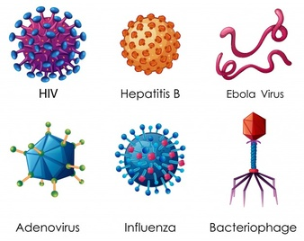

**[[*Language Target for Topic 1: I can be given information about an object and determine whether it is living, once-living, or nonliving.*]]**

*Use the prompt and information provided to determine if a virus is living, once-living, or nonliving. Support your decision with evidence from the reading.*

***Topic 2: Lab Safety***

**Topic 2 Objectives:**

* I can distinguish between safe and unsafe practices in the lab
* I can identify the location of safety equipment in the classroom
* I can explain what the appropriate lab safety steps are in various scenarios (fire, cuts/burns, broken glass, etc)
  + - * 1. **General Safety Rules:**

1. Listen to or read instructions carefully before attempting to do anything.

2. Wear proper protective gear and appropriate clothing.

3. Notify your teacher if any spills or accidents occur.

4. After handling chemicals, always wash your hands with soap and water.

5. During lab work, keep your hands away from your face and tie back your hair.

6. Know the location of lab safety equipment.

7. Keep your work area uncluttered. Take to the lab station only what is necessary.

8. Never put anything into your mouth during a lab experiment.

9. Clean up your lab area at the conclusion of the laboratory period.

10. Never “horse around” or play practical jokes in the laboratory.

1. **Science Classroom Items**

|  |  |  |  |
| --- | --- | --- | --- |
| **Behavior**:  Students should not touch equipment unless given proper instructions and permission by the teacher  Always read your lab procedure! | **Behavior cont'd:**  Food, drink, & gum: NO!  Minimize clutter | **Appropriate Clothing:**   * Complete-cover shoes * Tie _______ Back * Roll up loose sleeves * Jersey Material: will melt! | **Equipment:**   * wear glasses, not contacts * goggles (vents v. no vents) * sometimes, apron/gloves * extinguisher & fire blanket * eye wash station |

**\*\*You are responsible for replacing items broken or damaged due to negligence. What is “negligence?” __________________________________________________________________________________________________**

1. **Various Safety Requirements**

|  |  |  |  |
| --- | --- | --- | --- |
| **Glassware** | **Chemical** | **Electrical** | **Heating** |
| * Do not use chipped or _______________ glassware. Bring it to the teacher. * Broken glassware never goes in the regular trashcan. Place it in the broken glass _______. * Never pick up broken glass yourself. Tell the teacher. | * Wear goggles and an apron when pouring or heating *hazardous* chemicals * Never mix chemicals together unless it is part of the lab (and when it is, always do so in the manner specified). * Never touch/taste/smell any chemicals [___________, when necessary] * If mixing water and acid, the acid should be slowly poured into the water * Follow instructions for disposing of chemicals * Wash _____________ after working with chemicals | * Be sure to place electrical cords out of the way so that no one trips over them * Before using electrical equipment, be sure that your work space and your hands are __________ * Never poke anything into electrical outlets (you will get a referral if you put anything other than plugs into the outlets) | * Before touching hot plates or burners, make sure they have cooled down (bring the back of your hand ___________ to them to test) * Use tongs and/or protective gloves to handle hot objects * Never reach across an open flame (or burner) * Tie long hair back & refrain from wearing loose clothing * Always point the open end of test tubes ___________ from yourself and others in the lab * When heating a test tube, move it around slowly to distribute the heat evenly |

1. **Handling Biological Materials**

* With any live or preserved specimens, be RESPECTFUL!
* Exercise caution when using sharp tools
* Dispose of all biological materials as directed by the teacher

1. **First Aid**

|  |  |  |  |  |
| --- | --- | --- | --- | --- |
| **Burns** | **Cuts** | **Eyes** | **Poisoning** | **Spills on skin** |
| Immediately flush area with _________ water until burning sensation is lessened | Do not touch open wounds without safety gloves. __________ directly on minor cuts to stop bleeding within a few minutes | Flush eyes immediately with plenty of ______________ for a few minutes (at least 15 minutes) | Find out what substance was responsible and alert the teacher immediately | Flush with large quantities of water |

**[[*Language Targets for Topic 2: I can identify safe/unsafe lab procedures using an image; I can locate safety equipment in the classroom.*]]**

*1: Use the following image and identify as many unsafe procedures as you can. Suggest ways to make these unsafe procedures safe.*

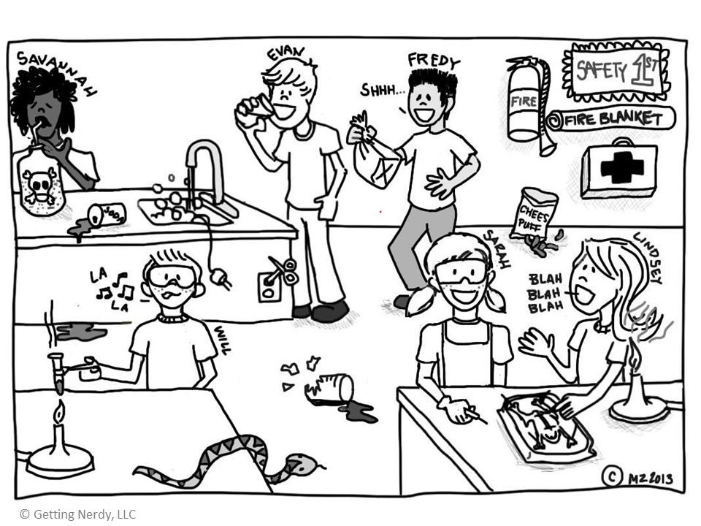

*2: Look around the room and describe the location of the following pieces of safety equipment:*

Fire extinguisher: ____________________________________ Fire blanket: _____________________________________

Eyewash station: ____________________________________ Glass box: _______________________________________

Goggles: ___________________________________________ Band aids: _______________________________________

***Unit 1 Topic 3: Scientific Method***

**Topic 3 Objectives:**

* I can collect quantitative and qualitative data
* I can distinguish between observations and inferences
* I can develop a well-written hypothesis based on observations and research
* I can identify independent and dependent variables in an experiment
* I can identify constants in an experiment
* I can differentiate between a control group and experimental groups
  + - * 1. **Nature of Science**

1. Two definitions:
   1. *Science =* an organized way of using __________________ to learn about the ______________ ____________
   2. *Science =* the body of knowledge scientists have built up over ________ using this process
2. Characteristics of science:
   1. Relies on _______________
   2. Expands scientific knowledge
   3. Challenges accepted _______________ and ____________
   4. Questions results
   5. Undergoes _________ _________________
      1. *Peer review* = a process by which the procedures used during an experiment and the results are evaluated by __________ ___________________.
   6. Uses the _________ system (meter, gram, liter, second)

*\*Because of these characteristics, science is always growing and changing as we discover more!\**

* + - * 1. **Scientists Make Observations Before Experimenting**
      1. *Observation =* a direct method of ________________________________________________ in an orderly way.
         * Recording information using the five ____________ or tools (like a ruler or scale)
      2. *Inference =* a _______________________________________ or conclusion **based on** the observations you’ve made and experiences you’ve had.
         * *Example:* You leave school and **observe** that the ground is wet. You **infer** ___________________________.
      3. Practice:

|  |  |  |
| --- | --- | --- |
| **Image #** | **Observation** | **Inference** |
| **1** |  |  |
| **2** |  |  |
| **3** |  |  |
| **4** |  |  |
| **5** |  |  |
| **6** |  |  |

* + - * 1. **Bio pre-assessment**

*Read the experiment and identify the components on the next page.*

Ten seeds were planted in five pots (two seeds per pot) that Erica found around the house. Each contained exactly 500g of Peat’s Potting Soil. The pots were given the following amounts of purified water each day for 40 days. Pot 1: 50mL, Pot 2: 100mL, Pot 3: 150mL, Pot 4: 200mL, Pot 5: 250mL. Pot 3 received the recommended amount of water. The dry mass of each pot with soil and plant was measured at the end of the experiment after being placed in a drying oven for 4 days.

1. Independent Variable: _________________________________________________________________________________
2. Dependent Variable: ___________________________________________________________________________________
3. Constants: ____________________________________________________________________________________________
4. Control Group: ________________________________________________________________________________________
5. Experimental Group(s): _________________________________________________________________________________
6. Hypothesis: ___________________________________________________________________________________________

_____________________________________________________________________________________________________

* + - * 1. **Scientific Method**

*\*Remember that all questions come because of an observation that someone has wanted to learn more about\**

1. **Ask a Question** (sometimes also called “State the Problem”)
   * A scientific question must be _____________________
   * Scientists based their questions on observations, prior knowledge, and related __________________
     + *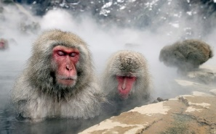Write a question you have about the Japanese Macaques behavior below:*
2. **Hypothesis:** a testable _______________________ of a situation, also based on observations
   1. Written in an “If….. then….” format
   2. “If *[insert what you’ll do to CAUSE a change],* then *[insert what measurable change you predict will happen].”*
      * *Example:* If dogs receive 3 training sessions per day, then they will recall tricks faster than dogs that receive one training session per day.

A hypothesis is not to be confused with:

* ***Theory*** = a **well-tested** **explanation** that **unifies** a broad range of observations
* ***Law =*** a statement of **fact**, deduced from observation, that a natural or scientific phenomenon **always occurs** if certain conditions are present *(ex: law of gravity*).
* *Write a hypothesis about why our Japanese Macaques exhibit this behavior below:*

1. **Design Experiment:**an investigation of a phenomenon in a controlled setting to _________ ___ ___________________

***A new experiment to study: a scientist observes that grass grows tallest in his lawn right next to the sprinkler.***

*Hypothesis:*

*Experiments have the following components:

* ***Variable*** = any factor that can ____________ or ­­­­­____________________ and affect the experiment’s outcome
* ***Independent Variable*** *(­__________________ variable) =* what is changed by the ________________________
  + *Example:* amount of water
    - Memory Trick: I change the Independent
    - Memory Trick: **CAUSE**
* ***Dependent Variable*** *(______________________ variable) =* the ______________ we’re looking to find.
  + *Example:* change in the height of grass
    - Memory Trick: Dependent Variable depends on the independent variable.
    - Memory Trick: **EFFECT**
* ***Constant =*** a factor/variable that is __________________________________ during an experiment.
  + *Examples: ________________________________________________________________*
* ***Control Group =*** a group used for ________________________ that **does not** receive “the treatment” (IV).
  + *Example:* the plot of grass that **does not** receive any ________________
* ***Experimental Group =*** the groups ____________________ to any amount of “the treatment” (IV)
  + *Example:* the plots of a grass that **were** given any amount of ________________
* ***Procedure =*** the planned list of steps to follow in order to test the hypothesis

1. **Perform Experiment and GATHER DATA:** do the experiment you designed and record the results.
   1. *Data* = information gained from observations
   2. ***Quant****itative Data =* ______________________ data (measurements of quantities like time, ______________, length and mass.
      * Example from grass experiment: ________________________________________
   3. ***Qual****itative Data* = ______________________ of what our senses detect (___________________, not numerical).
      * Example from grass experiment: ________________________________________
2. 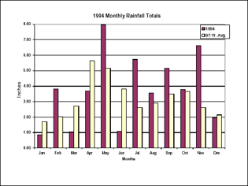**Analyze the Data:** see what the data actually means!
   1. Questions that scientists may ask:
      * Has my hypothesis been ________________________?
      * Is more data needed?
      * Are different procedures needed?
      * What are possible __________________ _____ __________________?
   2. Tables and _______________ are good tools for data analysis.
3. **Conclusion:**
   1. Your hypothesis may be supported or ______________________ by the data, OR indicate more research is needed!
   2. Conclusions should include:
      * Conclusion statement
      * Summary of _____________ with specific _________________________ values.
      * Explanation of how the data actually supports your ____________________________ statement.
4. **Communicate Results**:
   1. Scientists report their conclusions and findings in _______________________ journals that are peer-reviewed.
      * + 1. **The Culture of Science**
5. Communicate Results
   * Share results with ________________________________________________________________
6. Scientists build on what has been learned from ________________________________________________________________________________________________.
   * They pay close attention to contemporary scientists working on the same problem.
7. Both cooperation and competition characterize the __________________________________________________________.
   * Scientists check the conclusions of others by attempting to repeat experiments.

**[[*Language Targets for Topic 3: (1) I can sort examples of qualitative and quantitative observations; (2) I can discuss whether a statement is an observation or an inference with a partner]; (3) I can create an example of a hypothesis, a theory, and a law and defend why I made these choices.*]]**

1. *Identify each observation as being qualitative or quantitative. Explain why you made that choice.*
   1. *One leaf is 9cm in length. _____________________________________________________________________*
   2. *It is light green in color. ______________________________________________________________________*
   3. *It gets darker over a period of time. _____________________________________________________________*
   4. *The veins are 3mm wide. ______________________________________________________________________*
2. *Identify the following statements as an observation or an inference. Again, explain why.*
   1. *The container is filled to the 350mL mark with water. __________________________________________________*
   2. *The caterpillar did not eat the moth because it is not a carnivore. ________________________________________*
   3. *The plant on the left grew more because it received more water. _________________________________________*
   4. *Sound traveled faster through the desk than through the air. ___________________________________________*
3. *Identify each of the following as a hypothesis, theory, or law:*
   1. *Force is equal to mass multiplied by acceleration (F=ma). ________________________*
   2. *If I keep a plant in the dark, then it will fail to photosynthesize. _________________________*
   3. *All living things are made of cells, all cells come from preexisting cells, and cells are the basic unit of function in living things. __________________________*

***Unit 1 Topic 4: Data Analysis***

**Topic 4 Objectives:**

* I can record (quantitative) data in tables and charts, using units
* 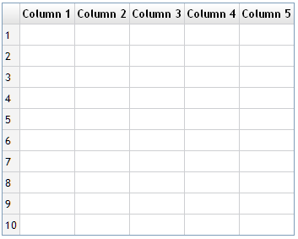I can organize data to show the relationship between variables on appropriate graphs
* I can identify and discuss trends using data

1. **Organizing data**
2. Scientists use _____________________________________ to record and organize their data.
   1. Vertical ____________________
   2. 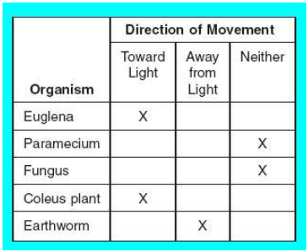Horizontal _________________
3. The labels of the chart tell us a lot. What could we title this data table?

_______________________________________________________________________ _______________________________________________________________________

1. We then use the chart to make a ___________________
   1. ______________________ the data
   2. Easily and quickly identifies ____________________ or trends in the data.
2. **Types of Graphs**
3. 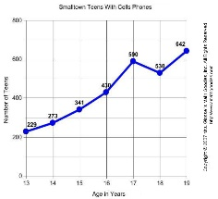Line Graph
   1. Both sets of variables (data on the x and y axis) are quantitative / ____________________.
      * Often (______________________________), the variable on the x-axis is ____________.
   2. Connected _______________ allow us to see an overall ____________ in the data.
   3. *Extrapolation* = when we _____________________ values beyond our given data points on the x-axis.
4. 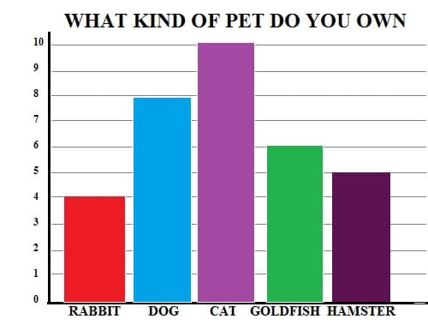Bar Graph
   1. Used to _______________ values from different ____________________
   2. X-axis variable is usually qualitative (category), and y-axis is usually quantitative.

1. Histogram
   1. Similar to bar graph but it compares numerical **_________** **____**, rather than categories.

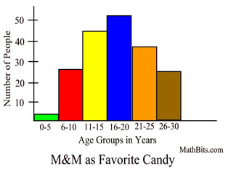

1. Pie Graph (Pie Chart)
   1. Used to compare the ________________________________________________
2. **What to Include in a Scientific Graph**
3. A descriptive title
   * “The effect of ______________ on ___________________”
   * “How ________________ effects _________________”
     + First blank is the ______________________ variable and second blank is the ____________________.
4. 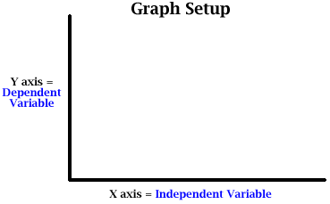Variables placed on the correct axes
   * Independent variable goes on the _______________
   * Dependent variable goes on the _______________
     + ***Memory Trick:*** *DRY MIX*

**DRY** = **D**ependent **R**esponding **Y** axis

**MIX** = **M**anipulated **I**ndependent **X** axis

1. Labeled axes with units in parentheses (if applicable)
   * *Example:* Average Height of Grass ( _____ )
2. Properly scaled axes
   * Number your axes so that the data is spread out across the _________________ _______________
   * 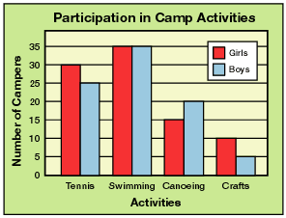Write values along the ______________ axis (even if your data doesn’t use the whole axis)
   * You **do not** need to start your axes with zero.
3. Properly plotted points or bars
4. A key/legend (if applicable)
   * Two different sets of data can be plotted on the ___________ _____________ to compare them.
   * The key helps distinguish between the ____________________ ____________.
5. **Graphing Practice Problem #1**

Let’s say scientists were attempting to determine the effect of changing pH levels (a measure of acidity) in a pond on the number of surviving tadpoles. They counted the number of tadpoles found in ponds at various pH levels. Their data is given below. Please graph the data—making sure to include all the elements of a “proper scientific graph”—and answer the questions on your notes.

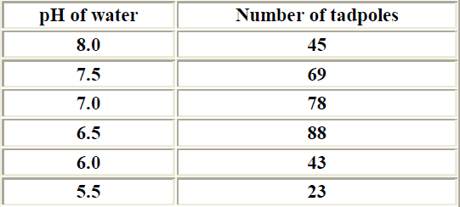



**Analysis Questions:**

1. What kind of graph did you use to plot the data and why?
2. What is the I.V.?
3. What is the D. V.?
4. What is the OPTIMUM water pH for tadpole survival?
5. **How do I analyze a graph?**
6. Read the ______________ and axes __________________ first.
7. Try to identify the independent and dependent _______________________.
8. 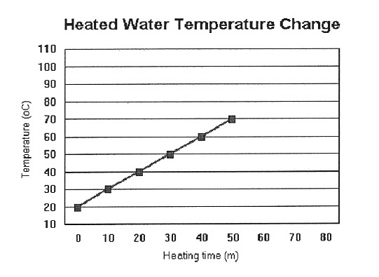Terms to know:
   1. *Maximum / Optimum* = the _________________ / ___________ value
   2. *Minimum* = the ___________________ value

**Analysis Practice Problem #1**

Based on the data in the graph, the temperature of water at 25 minutes is

a) 15˚F

b) 15˚C

c) 45˚F

d) 45˚C

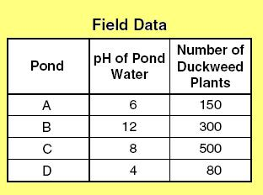 **Analysis Practice Problem #2**

The information to the right was collected in the field while studying the effect of pH on the growth of the duckweed plant. The data shows that duckweed has optimum growth at a pH of:

a) 4

b) 6

c) 8

d) 12

**[[*Language Targets for Topic 4: (1) I can draw and label a graph of given data; (2) I can identify and discuss trends in the data based on charts and graphs]]***

*Directions: Read the passage below and complete the questions to show your understanding of Jacob’s experiment.*

*Jacob, a landscaper, wondered if a particular tree would grow better in the sun or in the shade. Without collecting information or doing much research, Jacob claimed that if he could limit the amount of sunlight the tree was exposed to, then the tree would grow taller. To test this idea, Jacob planted 10 trees in a shady area and 10 trees in an area with a significant amount of sunlight. Over the next several months, Jacob watered and fertilized each tree in the exact same way. He also took measurements of the tree’s height and averaged them. The data he took is below.*

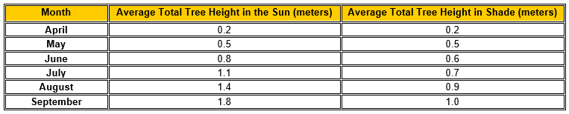

*1. What was Jacob investigating with his experiment?*

*2. What is a proper hypothesis you can write for this experiment?*

*3. What was the independent variable? 4. What was the dependent variable?*

*5. What were the constants for this experiment?*

*6. What conclusion can you draw from the data above?*

*7. Graph the data:*