Name: __________________________________________________ Date: _______________________ Period: ______

Unit 2 Biochemistry Review Packet

Topic #1: Atoms and Molecules

1. What type of bond forms between calcium (Ca) and chlorine (Cl)? Note: Ca has an electronegativity value of 1.0, and chlorine has an electronegativity of 3.0 .

2. What is electronegativity? How can we use the electronegativity values of two atoms to figure out which will become a positively charged ion and which will become a negatively charged ion within an ionic bond? How can we use electronegativity to determine what type of bond will form?

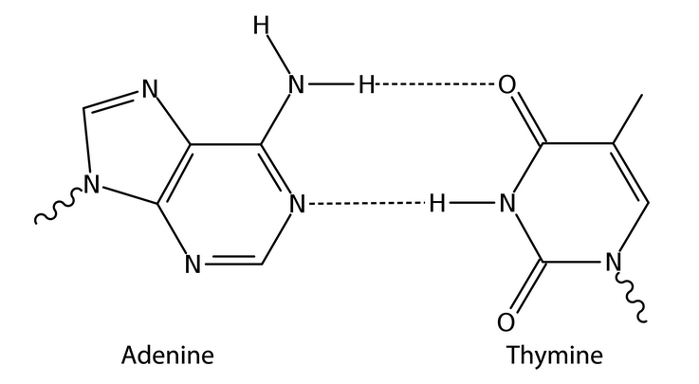

3. Label the hydrogen bonds shown between adenine and thymine in the image to the right. Write in the partial charges next to the atoms that participate in the bonds.
Note: Partial charges are denoted by the following symbols…
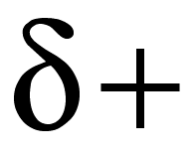 or 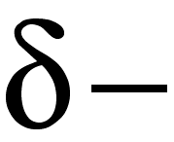

4. List the following four types of bonds in order from weakest to strongest: nonpolar covalent, ionic, hydrogen, and polar covalent.

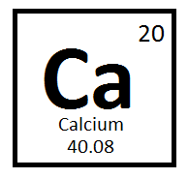
5. For the element shown to the right (calcium), list the number of each subatomic particle—protons, neutrons, and electrons—in a neutral atom of this element. Also, identify the atomic mass and atomic number of calcium.

6. Calcium forms an ion with a charge of +2. How many electrons are found in the ionized form of calcium? Explain your answer.

Topic #2: Properties of Water

7. Explain why areas near a lake tend to be cooler in the summertime than areas that have no large body of water nearby. Use the term high specific heat / heat capacity in your answer.

8. Explain why sweating helps cool humans down. Use the term high heat of vaporization in your answer.

9. The following image shows salt (NaCl) dissolving in water. Use the image to explain why water’s polarity allows it to act as such an excellent solvent (i.e.) a substance that dissolves other substances?
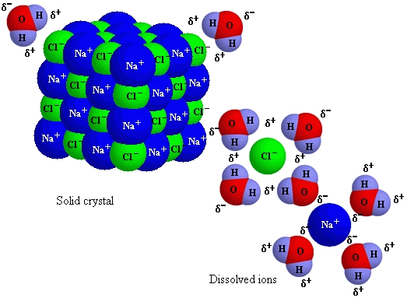

10. Why do large bodies of water tend to remain at least partially liquid during the wintertime?

11. The carbonic acid-bicarbonate buffer system maintains blood pH between 7.38 and 7.42. The system involves the use of HCO3- (bicarbonate, a weak base and H+ acceptor) and H2CO3 (carbonic acid, a weak acid and H+ donor) to minimize changes in blood pH.

H2CO3 <----> HCO3- + H+

If the pH of the blood increases, one would expect this buffer system to respond by… (In other words, the reaction would shift in which direction? How will the concentrations of carbonic acid and bicarbonate change?)

12. How does hydrogen bonding contribute to the high surface tension of water?

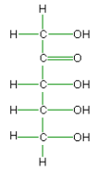
Topic #3: Macromolecules

13. Is the molecule pictured to the right polar or nonpolar based on the presence of certain function groups? Explain your answer.

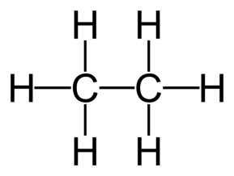
14. Is the molecule pictured to the right polar or nonpolar based on the presence of certain function groups? Explain your answer.

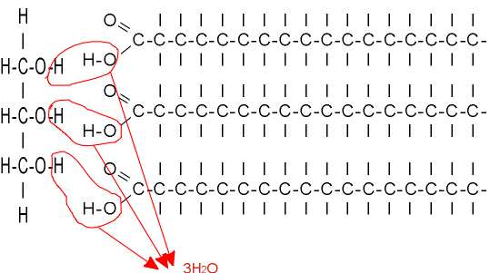
15. Does the image to the right show dehydration synthesis or hydrolysis? How do you know? What molecule is being created, and from what parts?

16. Does the image to the right show dehydration synthesis or hydrolysis? How do you know? What molecule is being broken, and into what parts?
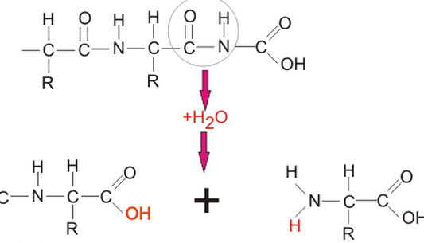

17. List names and examples of monomers and polymers for each macromolecule in the chart given below.

Macromolecule | Monomers | Polymers
Carbohydrates | Name:  Examples: | Name:  Examples:
Lipids | Names: | Examples:
Proteins | Name: | Name:
Nucleic Acids | Name: | Examples:

18. Name the type of of covalent bonds created by dehydration synthesis and broken by hydrolysis in the images given below. Identify these bonds on the image. Also, identify the type of macromolecule in which this bond type is found.

Type of Bond | Image | Type of Macromolecule
 | 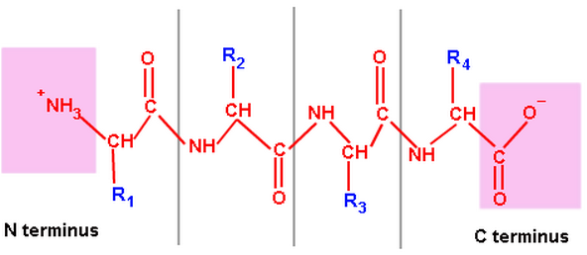
 | 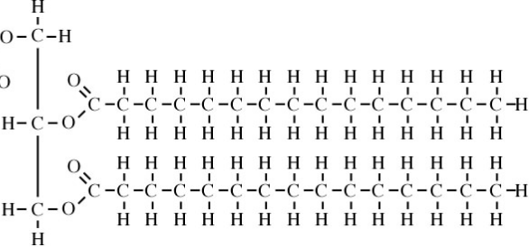
 | 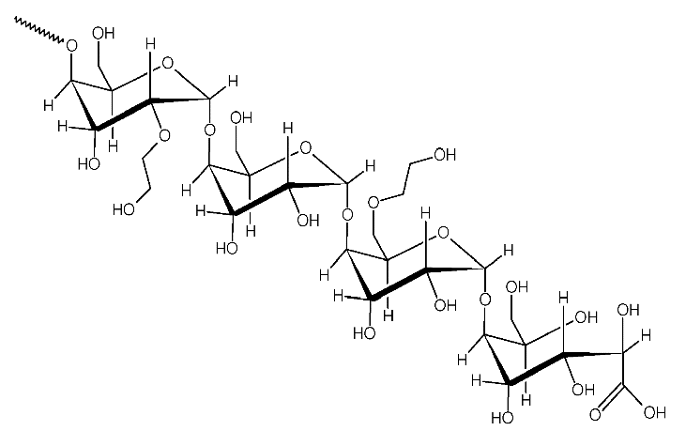
(Please also identify the hydrogen bonds in the image) | 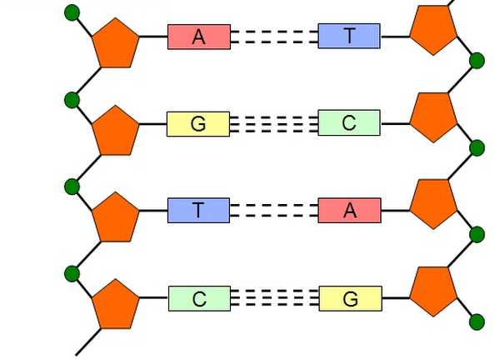

19. Explain the difference between a saturated and unsaturated fatty acid. Which is better for your health and why?

20. Explain how the structure of a macromolecule relates to its function. Use an example to help your explanation.

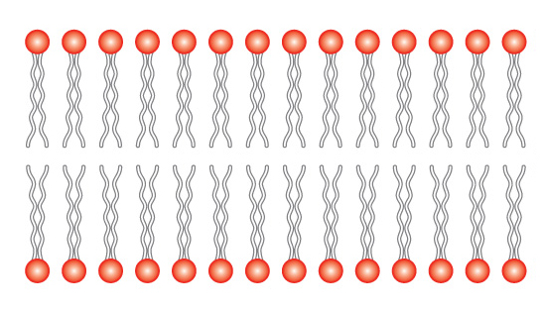
21. Label the hydrophilic heads and hydrophobic tails of the phospholipid bilayer (cell membrane) shown to the right. Why do they arrange themselves this way in the membrane, and why are the tails unsaturated?

22. Label each of the images below with the letter that corresponds to the correct name of the molecule. Also, identify whether the molecule is an example of a carbohydrate, lipid, protein, or nucleic acid using the following symbols…
A. RNA G. Polysaccharide
B. Disaccharide H. DNA
C. Phospholipid I. Polypeptide
D. Amino Acid J. Triglyceride
E. Steroid K. Monosaccharide
F. Nucleotide L. Fatty Acid

Carbohydrate: +
Lipid: $
Protein: #
Nucleic Acid @

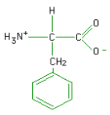 | 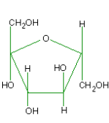 |  | 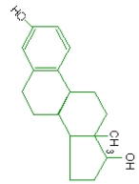 | 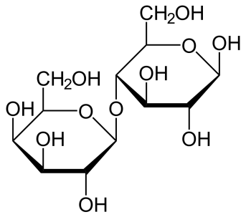
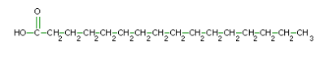 |  | 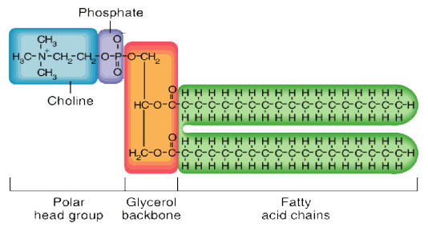
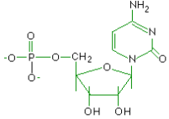 |  |  | 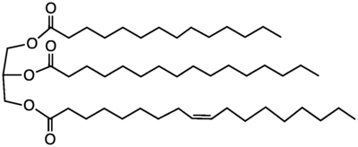
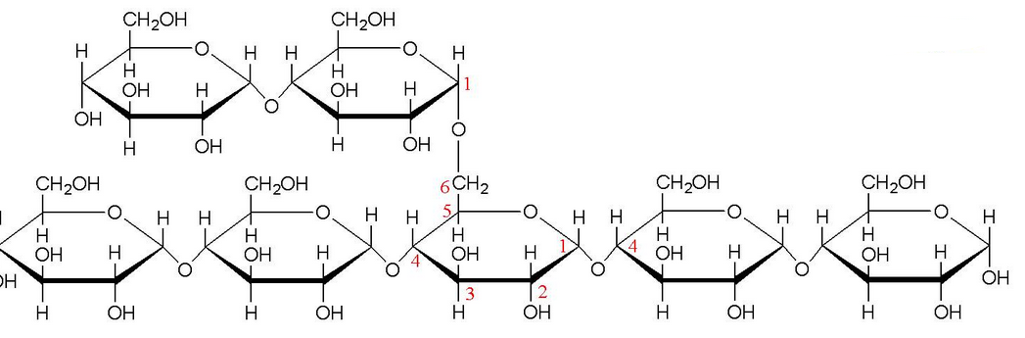 |  |  | 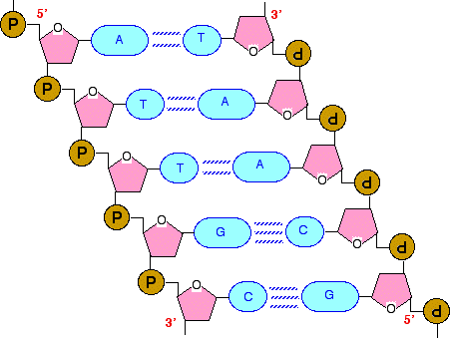
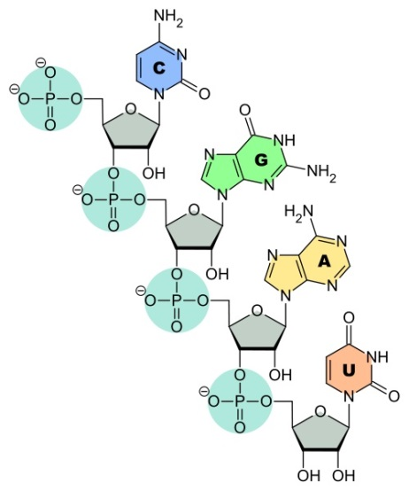 |  |  | 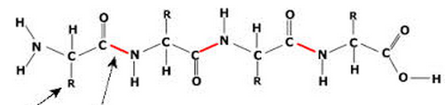

Topic #4: Enzymes

- How are competitive and noncompetitive inhibition of enzyme action different from one another? What are they both used to do?

- In negative feedback, does the end product of a multi-step reaction typically inhibit an enzyme involved in an earlier or later step of the reaction? Why

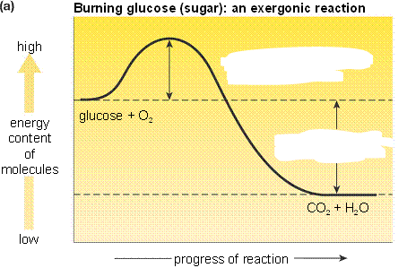
- How does an enzyme affect the activation energy of a reaction? How does an enzyme affect the ΔG (change in free energy) of a reaction (i.e. the change in energy from the reactants to the products)? Label the activation energy (E_{A}) and change in free energy (ΔG) of the reaction shown in the graph to the right.

- How does decreasing the temperature affect an enzyme’s ability to catalyze a reaction?

- Why does denaturation of an enzyme affect its ability to bind to the substrate(s)?

- Which of the following could you use to measure the rate of an enzyme-catalyzed reaction (circle all that apply)? Explain your choices!
- The amount of enzyme
- The rate of substrate destruction
- The rate of product formation

29. Why does the rate of an enzyme-catalyzed reaction stop increasing at very high substrate concentrations?

