Name: __________________________________________ Date: __________________________ Period: ______

**Unit 2, Part 4 Notes – Enzymes**

AP Biology, 2018-2019

1. **The chemistry of life is organized into metabolic pathways.** 
   * The total of all the chemical reactions occurring in an organism is called **metabolism.**
   * All metabolic pathways consist of a series of reactions which convert one molecule (the reactant) into another (the product).
     + 1. **Catabolic** pathways release energy by breaking down complex molecules to simpler compounds.
   1. A major catabolic pathway is cellular respiration, in which the sugar glucose is broken down in the presence of oxygen to carbon dioxide and water.
   2. Hydrolysis is also an example of a catabolic pathway.
2. **Anabolic** pathways consume energy to build complicated molecules from simpler compounds.
   1. 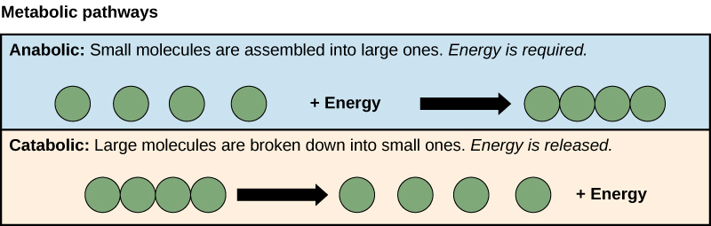The synthesis of polypeptides from amino acids (i.e. dehydration synthesis) is an example of an anabolic pathway.
3. **Organisms transform energy** 
   1. **Energy** is the capacity to do work.
   2. Energy exists in various forms, and cells transform energy from one type into another.
   3. During every transfer or transformation of energy, some energy is converted to heat and lost to the environment
   4. **Chemical reactions** can be classified as either exergonic or endergonic based on the change in energy that occurs because of the reaction.
      * An **exergonic reaction** is one that releases energy. These reactions are typically catabolic.
      * An **endergonic reaction** is one that absorbs energy. These reactions are typically anabolic.

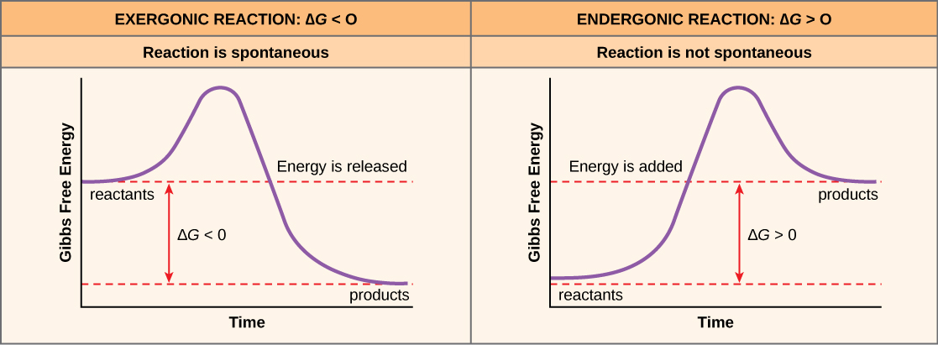

* + - 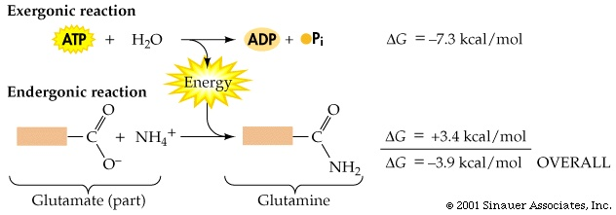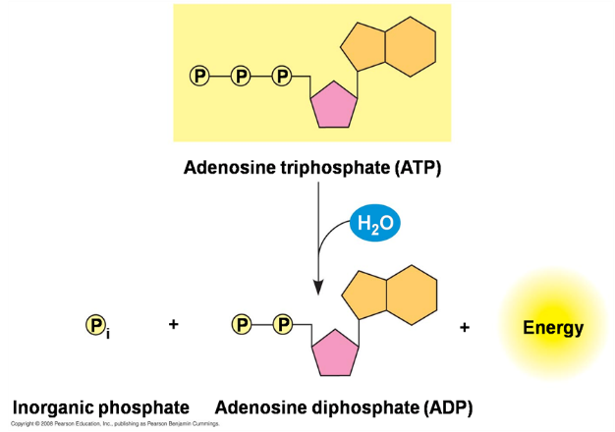The energy released by exergonic reactions can be used to “power” endergonic reactions. For example, the breakdown of ATP (adenosine triphosphate) releases energy by breaking the bond between the last two phosphate groups to create the products ADP (adenosine diphosphate) and Pi (inorganic phosphate). The energy from this catabolic reaction can be used to power an anabolic reaction like the creation of polysaccharides from monosaccharides.

**C. Enzymes speed up metabolic reactions by lowering energy barriers.**

1. Many chemical reactions occur spontaneously in cells but at very slow rates.
2. A **catalyst** is a chemical that speeds up the rate of a reaction without being consumed by the reaction. In other words, the catalyst can be reused many times. An **enzyme** is a catalytic protein.
3. The initial investment of energy for starting a reaction is the **free energy of activation or activation energy (EA).** 
   * + **Activation energy** is the amount of energy necessary to push the reactants over an energy barrier so that the bonds can be broken in the reactants and reformed to create different product molecules.
4. 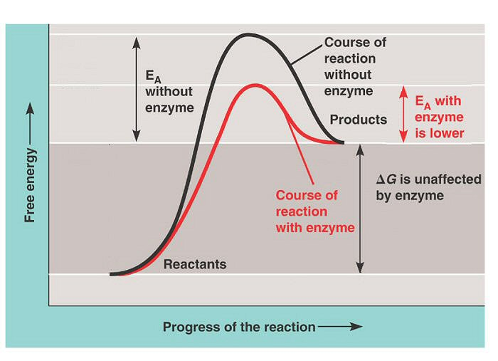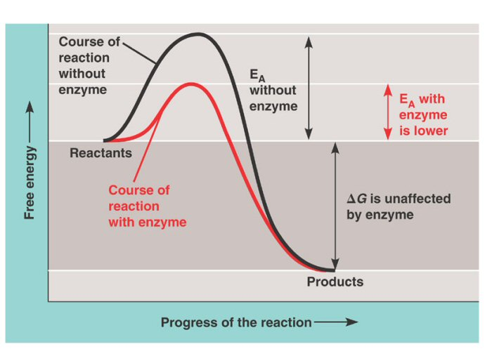There is not enough energy at the temperatures typical of the cell for most organic molecules to make it over the hump of activation energy. Heat would speed up reactions, but it would also denature proteins and kill cells. Enzymes speed reactions by lowering EA.
   * + - 1. **Enzymes are substrate specific**
   1. The reactant that an enzyme acts on is the **substrate**.
   2. The enzyme binds to the substrate and while they are bound, the enzyme either bends the substrate in such a way that it can break into multiple products or brings multiple substrates close to one another so they can form one product.
   3. Enzymes are often named for the substrate with the suffix "-ase." e.g., an enzyme which digests protein is a protease; one that digests lipids is a lipase. The reaction catalyzed by each enzyme is very specific.
   4. The **active site** is the area of the enzyme where the reaction actually occurs. The active site is like a pocket into which the substrate fits. There is specificity between the enzyme and substrate because of the shape of the active site.
      1. 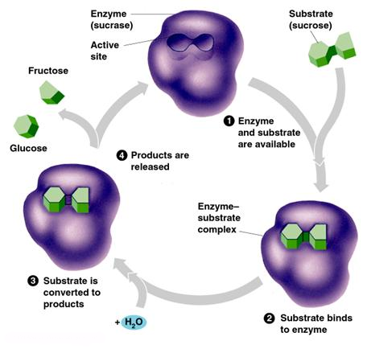As the substrate enters the active site, interactions between the substrate and the amino acids of the enzyme causes the enzyme to change shape slightly, leading to a tighter induced fit that improves the fit between the substrate and the enzyme.
      2. In most cases, substrates are held in the active site by weak interactions, such as hydrogen bonds and ionic bonds.
      3. R groups of a few amino acids on the active site catalyze the conversion of substrate to product. (Remember: the enzyme either bends the substrate in such a way that it can break into multiple products or brings multiple substrates close to one another so they can form one product.)
      4. The product then leaves the active site.
   5. Remember: Enzymes are unaffected by the reaction and are reusable.
   6. A single enzyme molecule can catalyze thousands of reactions per second.
      * + 1. **Factors affecting the rate of enzyme-catalyzed reactions:**
5. **Temperature** 
   * 1. As with non-catalyzed reactions, the reaction rate increases with increasing temperature because the kinetic energy of the molecules is greater and closer to the activation energy. Also, the increased molecular movement means more frequent collisions between molecules.
     2. For enzyme-catalyzed reactions, as temperature increases, collisions between substrates and active sites occur more frequently so reaction rate increases.
     3. This is advantageous for endothermic organisms because they can maintain body temperature close to the optimum temperature for enzymes.
     4. If temperature increases too much, the protein **denatures** (loses its shape) and the reaction slows down or stops.
6. **pH** 
   * 1. A change in pH (i.e., [H+] or [OH-]) can affect the tertiary structure of proteins (can denature it).
     2. Because there is such high specificity between the active site and the substrate, if the shape of the active site changes, it will no longer match the substrate as well.
7. **Substrate concentration** 
   * 1. At low [S] (substrate concentration), an increase in [S] speeds binding of substrate molecule to available active sites. With increasing [S], the enzyme spends less time "waiting" for substrate and more time catalyzing reactions.
     2. 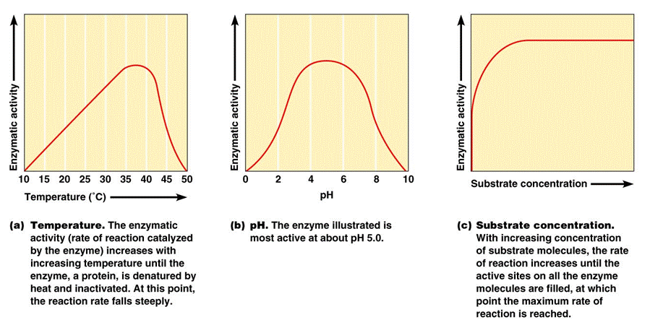At high substrate concentrations, the active sites on all enzymes are busy and we say the enzyme is saturated.
8. **Enzyme concentration** 
   * 1. When an enzyme is saturated, the only way to increase productivity is to add more enzyme molecules.
        + 1. 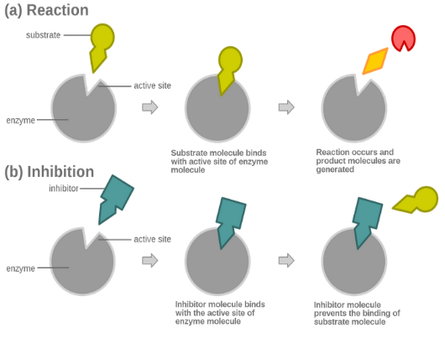**To be efficient, the cell must be able to control enzyme activity.** In many cases enzymes can be **inhibited** (to slow them down) or **activated** (to speed them up). We will look here only at inhibition; activation will be addressed in a later unit.
9. **Competitive inhibition** 
   * 1. Some inhibitors resemble the substrate and compete for binding to the active site, preventing the binding of substrate.
     2. Competitive inhibition can be partially overcome by increasing the concentration of the substrate.
10. **Non-competitive inhibition** 
    * 1. Noncompetitive inhibitors slow enzymatic reactions by binding to another part of the molecule.
      2. The inhibitor binds to a site other than the active site and causes a conformational change in the enzyme so the active site shape no longer matches that of the substrate.
      3. 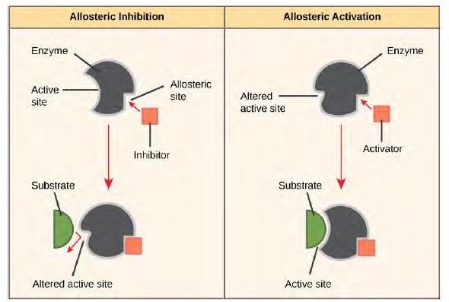Toxins and poisons are often irreversible enzyme inhibitors.
11. **Allosteric Regulation** 
    * 1. Regulatory molecules bind to an **allosteric site**, a specific site away from the active site. This can be any part of the enzyme that is not the active site.
      2. **Allosteric activators** are regulatory molecules that bind to the allosteric site and speed up the rate of enzyme action by changing the shape of the active site such that it better fits the substrate.
      3. **Allosteric inhibitors** are regulatory molecules that bind to the allosteric site and lower the rate of reaction by causing a change in the shape of the active site. (Note: Non-competitive inhibition is a type of allosteric regulation)
12. **Feedback Regulation** 
    * 1. Most reactions occur as part of a metabolic pathway.
      2. By controlling an early step in the pathway, the entire path can be controlled.
      3. In **feedback inhibition** (AKA negative feedback), an end-product from a chain of reactions is an inhibitor of an enzyme in the chain.
      4. Feedback inhibition is an especially efficient way of regulating enzyme activity.
         + It is self-regulating.
         + The cell does not waste chemical resources by synthesizing more product than is needed.
      5. **Positive feedback** occurs when a product of the pathway acts as an activator on an enzyme earlier in the pathway and increases synthesis of the product.

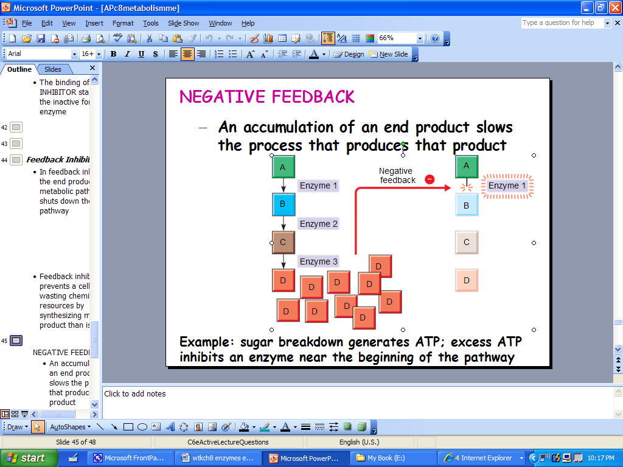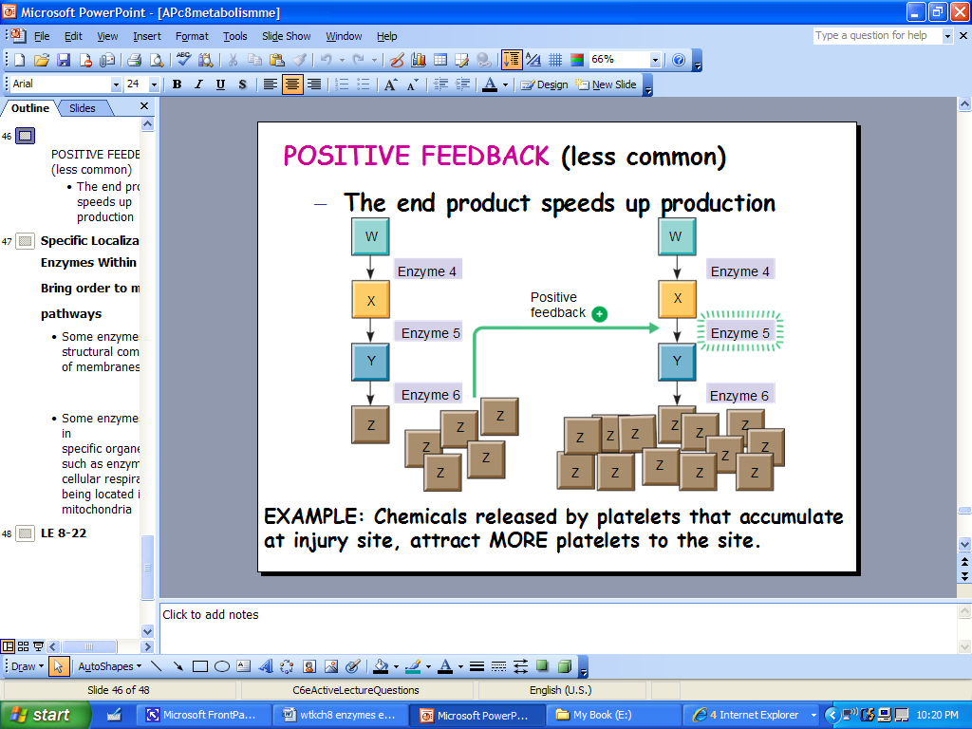 **Negative Feedback Positive Feedback**

**Notes Vocabulary and Questions**

**Vocabulary:** It is always a good idea to define all bolded/highlighted words in the reading in your own annotations.

1) How are dehydration synthesis and hydrolysis related to catabolism and anabolism?

2) What is energy coupling? How is ATP typically used in this process?

3) How do enzymes speed up the rate of a chemical reaction?

4) Why are the interactions between enzymes and substrates considered “specific?”

5) Why are fevers dangerous for the enzymes in our bodies? (Consider the effect of temperature on enzyme activity.)

6) Why can’t the rate of reaction increase by adding more substrate molecules at the point of enzyme “saturation?”

7) How are competitive and noncompetitive inhibition different from one another?

***Critical Thinking Questions***

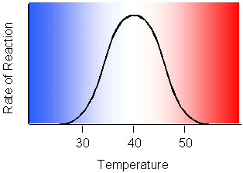

8) Which temperature is optimal for the enzyme whose reaction rate is shown in the image to the right?

9) Which of the following comparisons or contrasts between endergonic and exergonic reactions is false? (Explain your answer!)

a. Endergonic reactions have a positive ΔG (change in free energy) and exergonic reactions have a negative ΔG

b. Endergonic reactions consume energy and exergonic reactions release energy

10) Does physical exercise involve anabolic or catabolic processes? (Explain your answer!)

11) Let’s say that a series of enzymatic reactions results in the conversion of glycogen (a polysaccharide stored in the liver) to glucose monomers (used in the bloodstream for energy).

a. If negative feedback occurred in this pathway, how would enzymes in the pathway be affected, and how would the amount of glucose produced be affected?

b. If positive feedback occurred in this pathway, how would enzymes in this pathway be affected, and how would the amount of glucose produced be affected?

c. Is it more likely that the breakdown of glycogen is controlled by negative or positive feedback? Why? Relate your answer to homeostasis.

***No self-quiz for this topic.***