Name: _____________________________________ Unit 2 All Topics
Period: ______ Page: _______
Unit 2 Notes: Biochemistry
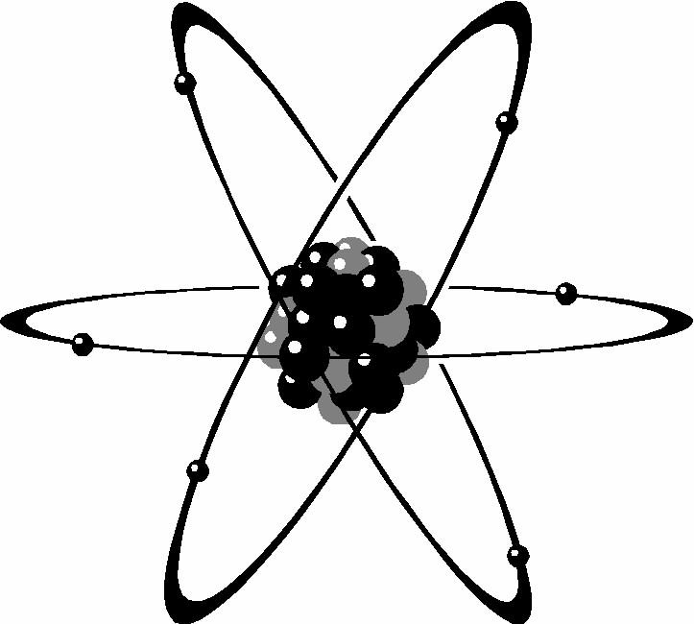
Topic 1: Atomic and Molecular Structure
Topic 1 Objectives:
By the end of this topic, you should be able to…
- I can label an atom and it’s subatomic particles (with their charge)
- I can differentiate between different types of bonds (covalent & ionic)
- I can explain the similarities and differences between: atom, ion, element, compound, molecule
- I can list the six main elements in living things

- Atoms
- What is an atom?
  - Basic unit of _______________________________
  - Smallest particle of an element that contains _______________________________________ of that element
- Atoms are made of 3 types of ___________________ ___________________ that are even smaller than an atom.
  - Proton: ________________ charge (__); located _____________________________ of an atom
  - Neutron: ________________ charge (__); located ____________________________ of an atom
  - Electron: ________________charge (__); _________________________________ of an atom

- Label the Following Atom:
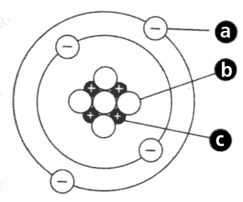
- More about each subatomic particle:
Neutrons | Protons | Electrons
- Atoms of the same element may have different numbers of neutrons  - (In this case, we are looking at ____________ of that element)  - Isotope: each of two or more forms of the same element that contain ___________________________ ________________ in their nuclei, and hence differ in atomic mass but not in chemical properties | - Atoms of the same element MUST all have the same number of protons in the nucleus of the element  - The number of protons is also equal to the ________________________  - The number of protons is balanced by the number of _______________ | - Electrons are negatively charged subatomic particles that surround the nucleus of an atom  - Little to no ________ (negligible, not included in atomic mass)  - Travel at high speeds around the nucleus  - Play a large role in chemical _________________________
Periodic Table Information:
- Atomic number = # of protons
- Atomic mass = # of _____________ plus # of ______________ (add together everything found in the ________________)
- Protons & neutrons each have a mass of 1 amu (_______________________________________)
- Mass of electrons is negligible, so we do not add that in
- Elements
- 92 natural elements (examples: ______________ (Na), _________________ (Cl), and _____________ (Pb) )
- An element is composed of ___________________________________________________________________________________________
- Six main elements in living things (in order from most abundant to least abundant):
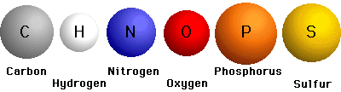
- Compounds
- Atoms are the _____________________________________________________
- Elements are made of atoms of one type
- Compounds are formed by the __________________________________________________________________ ___________________________________________________________________________________________
  - Always formed from a specific combination of ___________________________
  - Always formed in a ________________ ________________.
      - Ex: ________________________________ or ________________________________
  - Compounds are chemically joined, so they ______________ from the elements that they are made of (H₂O is very different than hydrogen and oxygen on their own)
  - Chemical formulas are used to show the ________ and _____________________________ of atoms of each element in the compound
- Molecules
- Atom – smallest unit of matter (repeat vocab! …must be important!)
- Element – made of one type of atom
- Compound – two or more elements chemically bonded together
- Molecule – ____________________________________________ joined together chemically
      - All compounds are molecules, but not all molecules are compounds!
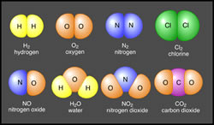
      - Draw an arrow pointing to the row that contains molecules that ARE NOT compounds.
Explain your arrow:

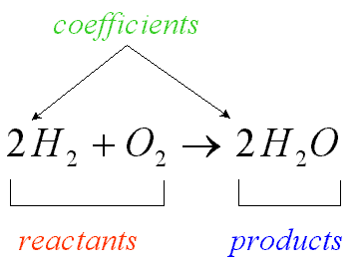

- Understanding Chemical Formulas
- Subscript ___________ a symbol tell the number of atoms of each element
- H₂O has 2 atoms of hydrogen & 1 atom of oxygen
- Coefficients _________________ a formula tell the number of molecules
      - 3O₂ represents 3 molecules of oxygen or (3x2) = 6 atoms of oxygen

- Chemical Bonds
- Atoms in a compound are held together by chemical bonds
  - The electrons in the outermost shell that are used to form these bonds are called __________________________________________________________
- There are two types of bonds:
Ionic | Covalent
-What happens to the electrons?  -What forms as a result?  Ion: _____________________________________________  -Oppositely charged ions are ______________________ to one another  -How are positively charged ions formed?  - _______________________________________________  -How are negatively charged ions formed?  - _______________________________________________ | -Two atoms combine by ____________________ electrons  -_________________________ charge  -Strength of bond depends on __________________ ______________________________________________________________________________________  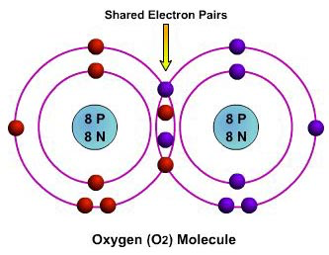
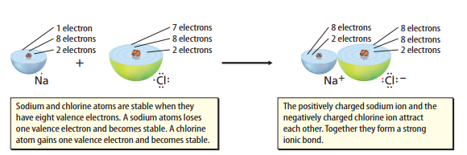

Ionic Bond

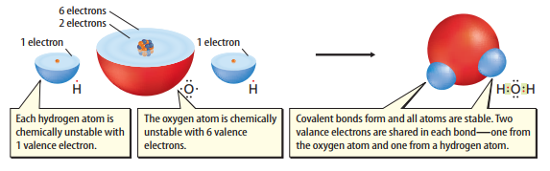

Covalent Bond

[[Language Target for Topic 1: I can draw and label an atom, identifying the key subatomic particles and their charge; I can compare and contrast covalent and ionic bonds; I can list the six main elements in living things.]]
This language target is addressed in the Unit 1 Topic 1 Practice Worksheet.
Topic 2: Properties of Water
Topic 2 Objectives:
- I can explain what “water is polar” means
- I can explain the importance of hydrogen bonds in water
- I can list the properties of water
- I can discuss the pH scale and identify substances as acids, bases, or neutral

- A Water Molecule
  - Water is not alive, but understanding water is essential
    - ~2/3 the mass of a cell is water
    - Most life-sustaining reactions take place in ____________________________________
  - 2 atoms of hydrogen linked by _______________________________ to 1 atom oxygen (H₂O)

- PROPERTIES OF WATER

- Water is Polar (and thus can make hydrogen bonds)
  - The electrons are _________________ distributed between the oxygen and the two hydrogen atoms.
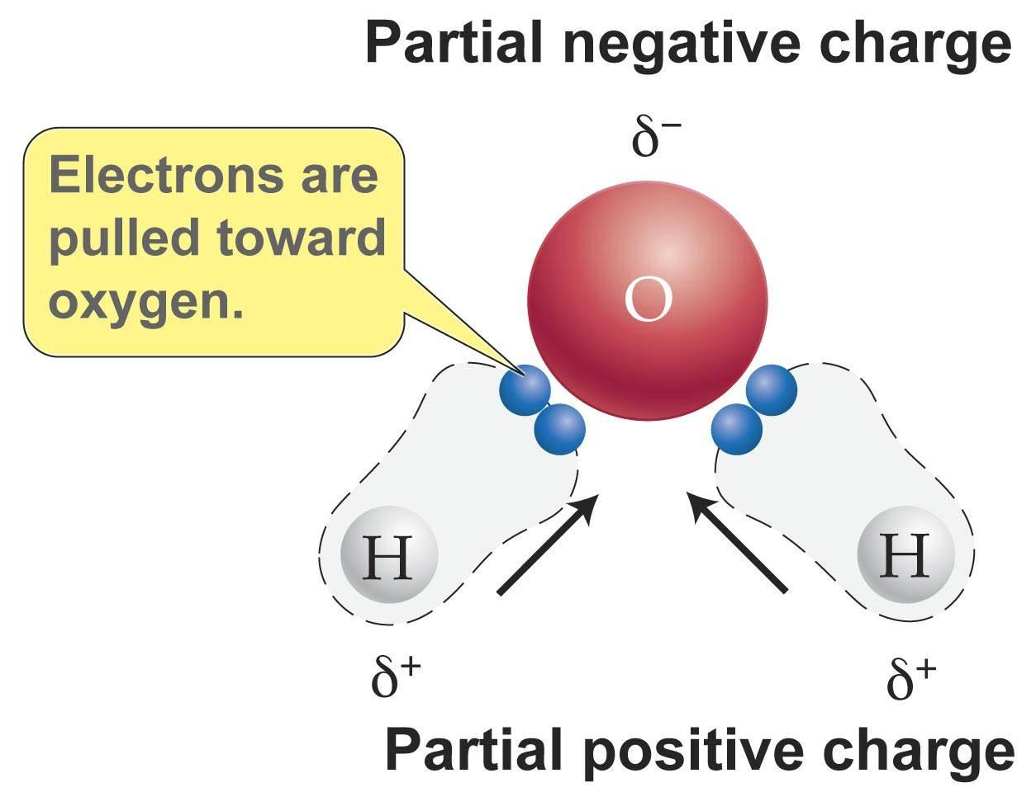
    - This leads to positive and negative ends (opposites attract!)
  - Oxygen has ___________ protons. Each hydrogen has ___________.
  - The atom with more protons, _______________ (8), pulls electrons ______________
________________________.
    - This makes oxygen slightly ___________ & hydrogen slightly __________
  - Molecules of water are attracted to one another and form __________________ ___________
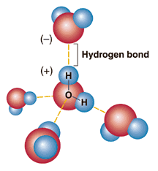
    - Opposites ____________________
    - Water can form up to ________ hydrogen bonds at once.
      - Hydrogen bonds are ___________ ___________; Much weaker than ionic or covalent bonds.
  - Draw your own diagram of what is going on in a hydrogen bond:

- Water Participates in Cohesion & Adhesion
- Cohesion: attraction between ______________________ molecules (water to ______________)
  - Results in surface tension (measure of the _________________________________________________)
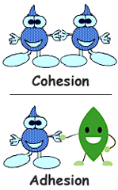
  - The surface acts like an ___________________________________
  - Explains why:
    - Water ____________________________________
    - ____________________ can walk on water
- Adhesion: attraction between _____________________ molecules (water to a __________________________________________________)
  - Ex: Measuring water in a ____________________________________
    - Water adheres (sticks) to the glass ___________________________________
    - That’s why there is a ____________________________when you read the volume.
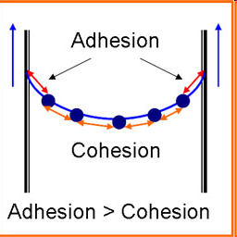
- Cohesion (water sticking to water) and adhesion (water sticking to other substances) work together to form capillary action
  - Water _________________________________________________________________
Real life example: water is absorbed by the roots of plants and travels upward!

- Water is a Universal Solvent
  - Water is often found as part of a solution which is when one substance (____________________) is dissolved into another (_________________________)
  - Universal solvent: water dissolves more substances than ___________________________________________
    - Again, because water is ____________________ and has hydrogen with _________________ ends and oxygen with ________________________________ ends, water ___________________ many other substances and is able to dissolve these substances it attracts
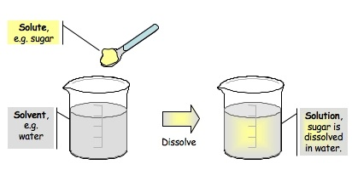
    - General rule: _________________________________________________________, so being polar, water dissolves other ________________________ substances
    - It cannot dissolve nonpolar substances, like oils!
  - Relevant Vocabulary
  - Solute: substance that is ___________________________________ (sugar)
  - Solvent: substance that _____________________________________ (H₂O)
  - Mixture: combination of substances in which individual substances retain their own properties (sand + sugar)
  - Solution: mixture of 2+ substances in which the molecules of these substances are evenly distributed (sugar water)
  - Suspension: no dissolving occurs, but one substance separates into small pieces and remains suspended

- Water has a Neutral pH (7)
- pH: measure of how ______________________________________________ a solution is
- pH scale ranges from ________________________________
    - Acids form _________________ ions (H+) in water. The pH of acids is ____________________.
      - _____________________ the pH (when under 7), the ____________________ the acid
      - Examples: _______________________________
    - Bases form _______________ ions (OH-) in water. The pH of bases is _______ than 7
    - The _______________ the pH (when above 7), the _______________ the base
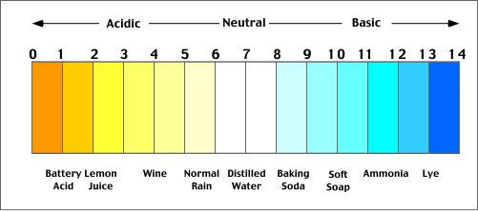
    - Examples: _______________________________
    - Neutral: pH is ___________________________
    - Water has a pH of _______

- Density of Water
  - Water is ______________________________________________ in its _______________ form (ice) than its ____________________ form
    - The orientation of hydrogen bonds pushes the molecules to push further apart, lowering the density
    - Because ice is less dense, it _____________________________ on liquid water
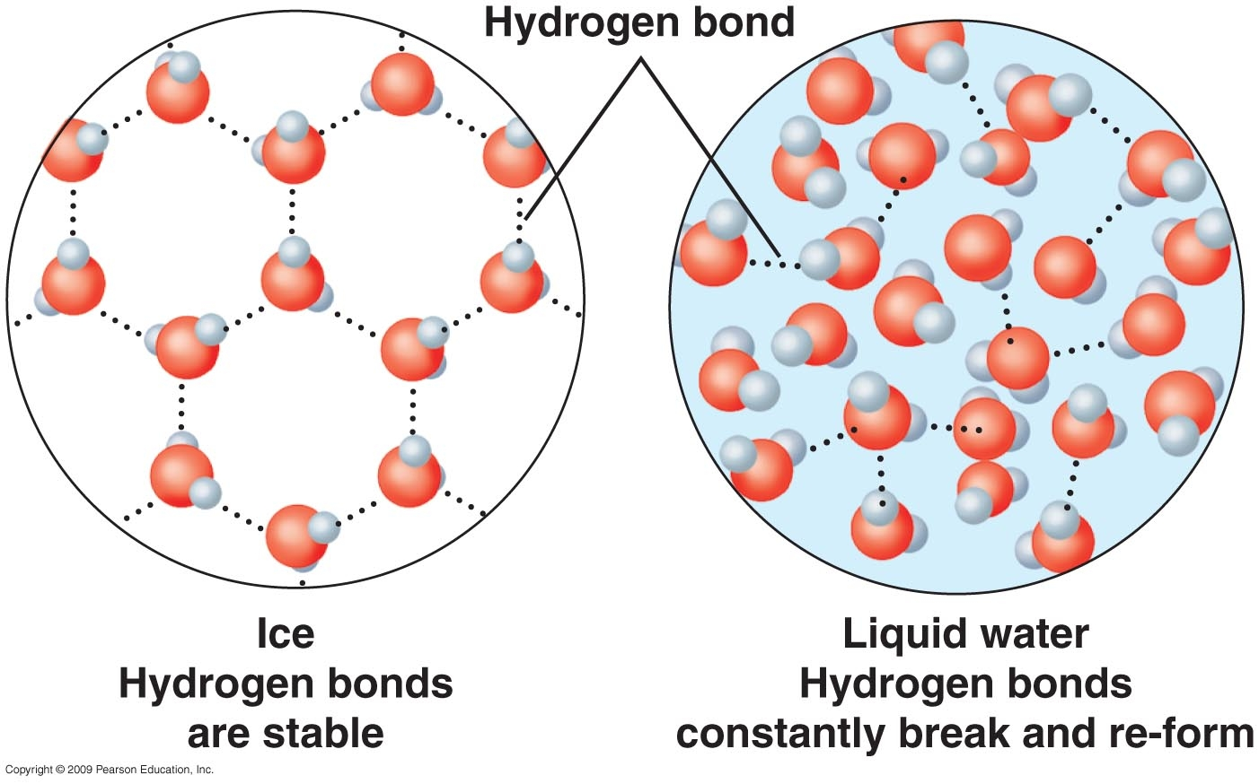
  - Why would it be a bad thing for ice to sink in a pond?

- Water Has a High Heat Capacity (specific heat)
- Water absorbs a lot of heat from the air without having a large _________________________________________
- Lakes and oceans often _________________________________________ air temperatures
- Water absorbs heat when it evaporates, which is why sweating helps __________________________________
- It takes a lot of heat to change the temperature of water because the hydrogen bonds between the water need to be broken!

[[Language Target for Topic 2: I can relate the properties of oxygen and hydrogen to the polarity of water; I can explain how water’s polarity and hydrogen bonding give it unique properties and differentiate between the listed properties of water; I can draw and label a pH scale with acid, base, and neutral.]]
Part 1:
- Draw and label a molecule of water. Explain how many atoms are in a single molecule of water and what bonds hold these atoms together, being sure to use the term polar in your response.
Drawing: Explanation:

Part 2:
- Explain how molecules of water stick together: ____________________________________________________ ______________________________________________________________________________________________________________________________________________________________________________________
- Choose three properties of water and illustrate/explain them:

Part 3:
- Draw and label a pH scale, giving at least one example of an acid/base/neutral substance.

Topic 3: Macromolecules
Topic 3 Objectives
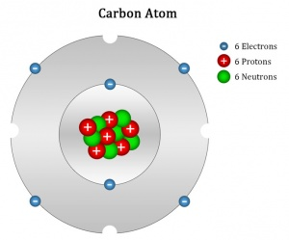
  - I can explain what the term “organic” means
  - I can define monomer and polymer and explain how polymers are made/broken
  - I can explain what happens to molecules during the processes of hydrolysis and dehydration synthesis
  - I can identify the monomer for each class of organic compounds
  - I can identify which class of organic compounds a compound falls into when given an image
  - I can explain the function of each of the four classes of organic compounds

- CARBON
- Revisit: What 6 elements are most common in our cells?

- Carbon is the backbone of __________________ compounds.
  - Organic means something contains __________________
  - _____________________________ is the study of all compounds that contain bonds between carbon atoms.
- A carbon atom contains ______ valence electrons in its outer shell, which means it can make up to _______ ___________________ _____________ with other atoms.
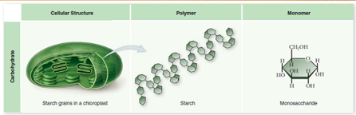
- MACROMOLECULES
- “Macro-“ means _________________.
- In the space below, provide the definition of macromolecules.

- Macromolecules are so large because they are made up of smaller units.
    - Monomer: the ______________________________________________________ of a polymer (________________________________________________________)
    - Polymer: _________________________________ of repeating units (monomers)
    - Polymerization: process of linking monomers together to produce polymers
- Polymerization: in the space below, draw a chain of monomers forming a polymer.

- Dehydration/Condensation Synthesis: monomers are joined ____________________; molecules of water are released
- Dehydrate – __________________________________________________________
  - Synthesis – to produce/make/combine
- Hydrolysis: a polymer is ___________________into monomers when water molecules are added
  - Hydro - _______________________________
  - Lysis - ___________________________________________________

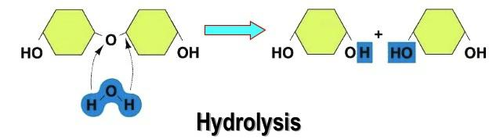
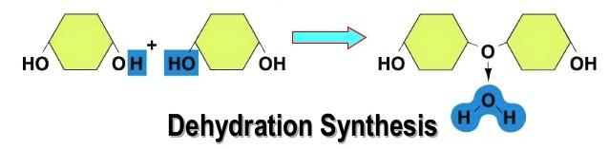

- List the four types of macromolecules found in living things.
1) 3)
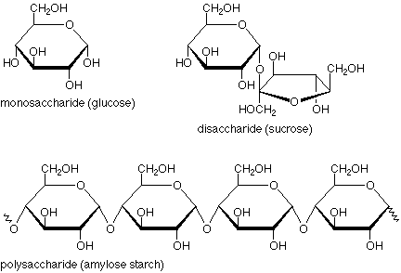
2) 4)

- Macromolecules: CARBOHYDRATES (aka ________________________)
  - Carbohydrates are __________________
    - Carbo – _____________________
    - Hydrate – __________________________
    - So, carbohydrates are made of: carbon, hydrogen, and oxygen (1:2:1 ratio)
  - Provide the function of carbohydrates (sugars), and list the elements found in carbohydrates.
Function:

Elements:

  - Explain the difference between a monosaccharide, disaccharide and polysaccharide. Provide an example of each.
Monosaccharide  (MONOMER) | Disaccharide | Polysaccharide  (POLYMER)
Definition:  Example (2): | Definition:  Example (1): | Definition:  Example (3):
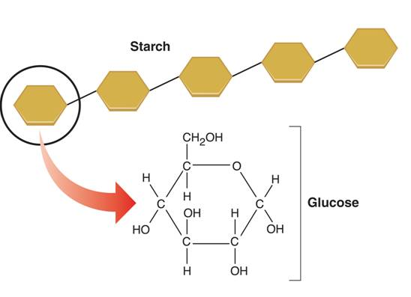
  - List the functions of the following three polysaccharides:
Starch: food storage in ______________________ (think potatoes)
Glycogen: food storage in _____________________ (us!)
Cellulose: ______________________________ in plants
Chitin: __________________________ in animals (insect exoskeleton!)

- Macromolecules: LIPIDS
- Provide the function of lipids (fats), and list the elements found in lipids.
Function:

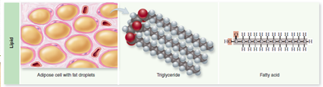
Elements:
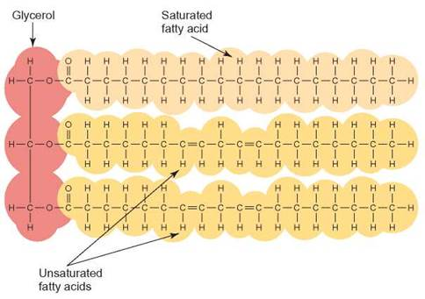
- List 4 examples of lipid molecules (polymers):

- Describe or draw the structure of a lipid monomer. (Triglyceride)
GLYCEROL AND FATTY ACIDS

- Are saturated or unsaturated fats worse for your health? Why?

- Macromolecules: NUCLEIC ACIDS
- Provide the function of nucleic acids, and list the elements found in nucleic acids.
Function:

Elements:
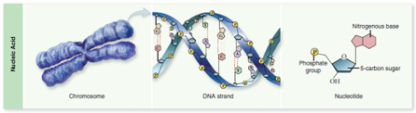
- Explain how a nucleotide relates to DNA and RNA.

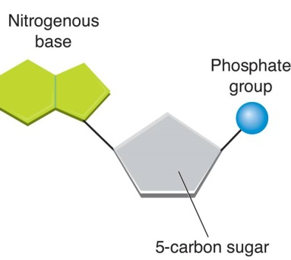
- Nucleotides are the building blocks, or monomers, of nucleic acids. Label the parts of a nucleotide on the diagram below.

4. List the functions of the polymers DNA and RNA.
DNA
- __________________________________________ acid
- __________________________________________________ of an organism’s genetic code

RNA
- ______________________________________________________________ acid
- Copy of DNA (able to leave nucleus)
- Plays major role in ______________________________________________________

- Look at the DNA and RNA molecules below. List two differences between these two molecules.
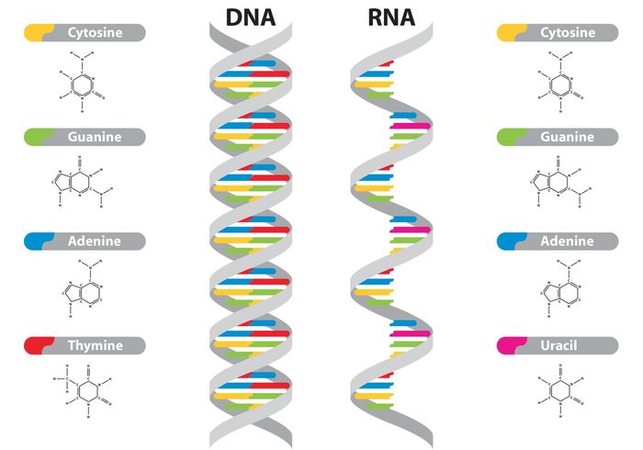

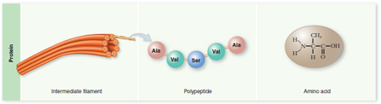
- Macromolecules: PROTEINS
  - List the elements founds in proteins:

  - Functions of proteins:
- ________________________________________ (hail, nails)
- _______________________________________ (hemoglobin)
- ______________________________________ (muscle fiber)
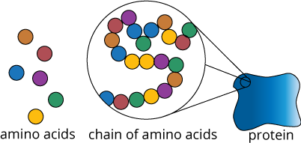
- ________________________________________ (antibodies)
- ________________________________________ (hormones and enzymes)

  - What is the monomer of proteins and what is its general structure?

  - There are ____________________ different amino acids that can be bonded together in many different ways to make all of our proteins!

  - Label the diagram to the right with the 4 parts of an amino acid that are bonded to a central carbon atom
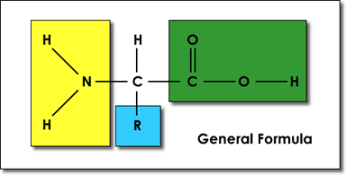
1) Carboxyl Group
2) Amino Group
3) Hydrogen Atom
4) R-Group (changes!)

- What is the polymer of proteins?

- Polypeptide: a chain of amino acids linked together (polymer)
- Amino acids are connected through ____________________________ bonds
- Proteins are made of two or more polypeptides folded around each other into complex structures

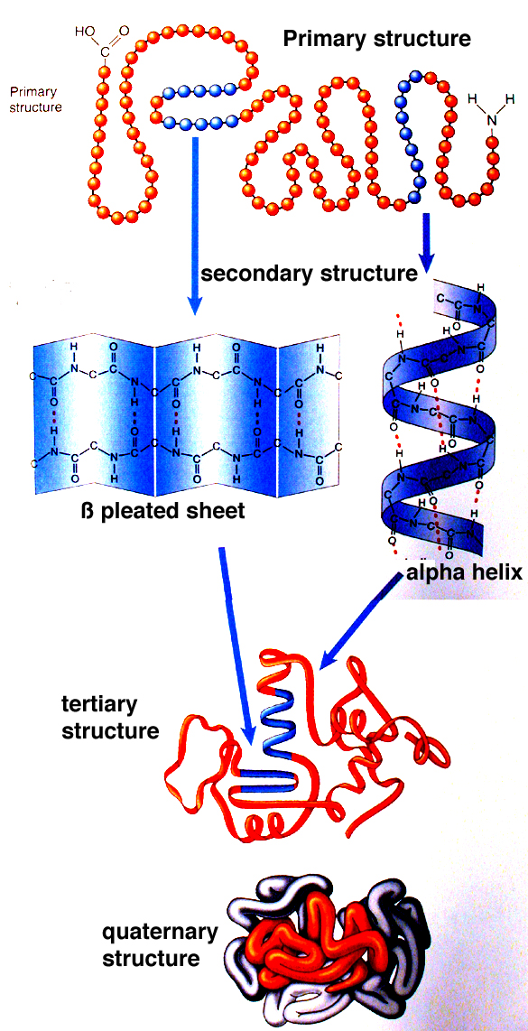
- Four levels of protein structure (draw a line to match each one with the picture)
- Primary
- Secondary
- Tertiary
- Quaternary

[[Language Target for Topic 3: I can identify an organic compound as one containing carbon; I can create a table identifying the function, structure, polymers, and monomers for each of the four classes of macromolecules.]]
Part 1:
- Define the term “organic,” and provide examples of organic compounds: Organic means containing ________________________. The four classes of organic compounds are _________________________________, _____________________, ____________________________________________, and __________________________________________.

Part 2: The chart for part two will be completed on a separate worksheet.

Topic 4: Enzymes
Topic 4 Objectives
  - I can identify the components of a chemical reaction (products and reactants/substrates)
  - I can construct a graph detailing enzyme reaction data
  - I can describe the function of an enzyme
  - I can explain the importance of shapes in active sites on an enzyme
  - I can explain how enzymes speed up chemical reactions (act as biological catalysts)

- Why Study Chemistry in Biology?
- In order to understand how an organism functions, we need to understand the reactions that take place in that organism.
  - Growth, response to stimuli, sensing, taking medicine to control regulation… all of this is chemistry!

- Chemical Reactions
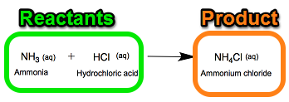
  - A______________________ is a process that changes one set of chemicals (the ____________________) into another set of chemicals (the ________________________)
    - Reactants: what you _________________________________
    - Products: what you __________________________________
  - Chemical reactions always involve the ________________ and ______________________ of bonds in the reactants and products.
*Note: In chemical reactions, you can either put reactants together or break them apart. Your product can be one final product or many individual pieces.

- Energy in Reactions
- Some chemical reactions ________________ energy and others __________________ energy.
    - Exothermic: energy is ________________________ (digestion)
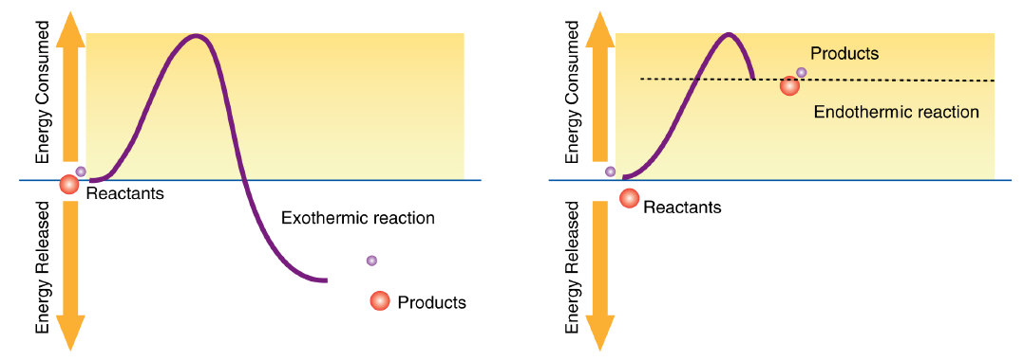
    - Endothermic: energy is ________________________ (synthesis)

- Most reactions will require a certain amount of energy to get started. This energy is called the ____________________________________.
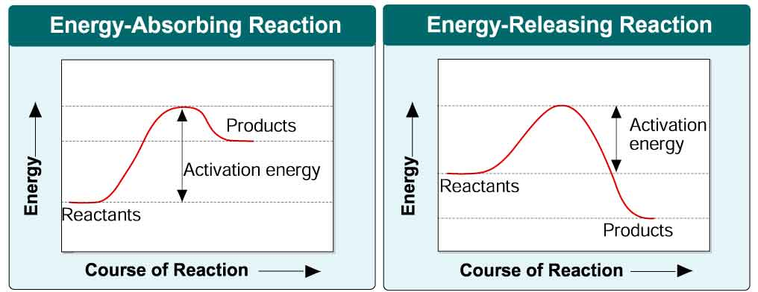
- Highlight the activation energy on the energy diagrams below:

- Role of Enzymes
- Some chemical reactions that make life possible are too __________ or have _____________________________ that are too high to make them practical for living tissue.
- The role of enzymes (a.k.a. ___________________) in our cells is to ______________________________ ____________________________________!
    - Remember, activation energy: the amount of energy required to _________________ a reaction
    - Enzymes names often end in --___________
- In biology, we like to say “___________________________________________________________.”
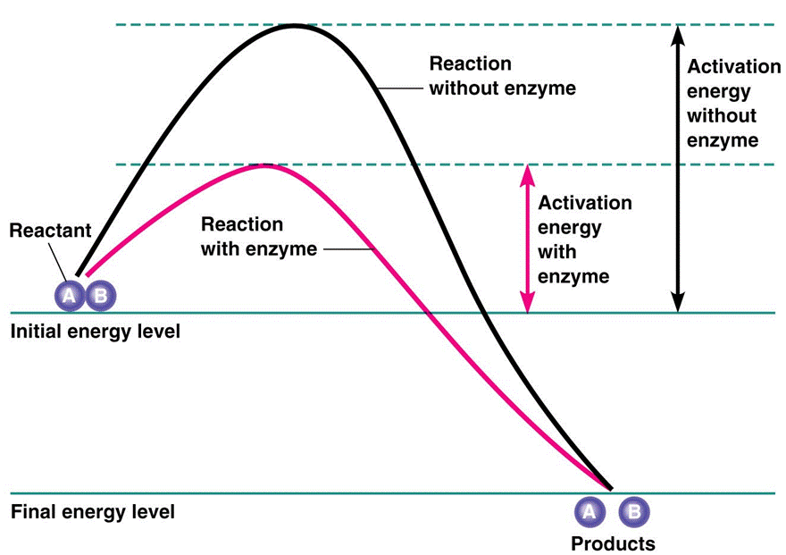
    - So, the form (shape) of an enzyme impacts its role. This is important for the next section.
- The diagram to the right shows the effect of enzymes on activation energy in a reaction. The higher line represents the reaction without an enzyme present, which requires more activation energy. The lower line represents the reaction with an enzyme, showing a lower activation energy which means the reaction can happen faster.

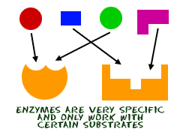
- Enzyme Action
- Enzymes provide a site where the ______________ can be brought together to react. This site reduces the energy needed for reaction.
- In an enzyme-catalyzed reaction, the reactants are called _______________.
- Each enzyme has a specific shape and a specific portion called the _________________, where substrates bind.
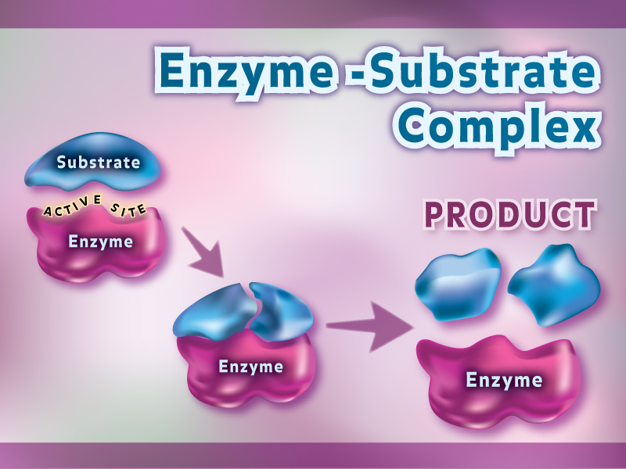
- The substrates must fit exactly into the active site. This is called the _________________________ model.
- When the substrates are fitted into the active site of the enzyme, the whole thing is called the ___________________________________________.
- Once the reaction (breaking or forming bonds) is complete, the enzyme releases the ______________ of the reaction.
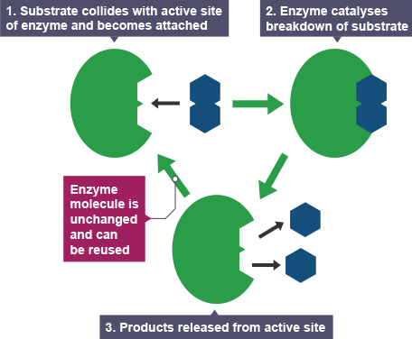
    - The enzyme is not “used up.” When the reaction is complete, the products are released and the enzyme is available to bind with another substrate again.
- Enzymes can __________ or ___________ substrates into products.
- List 4 Roles of Enzymes:

- In the space below, draw an enzyme-catalyzed reaction. Make sure to label the enzyme, substrate, enzyme-substrate complex, active site, and products.

- What happens if an enzyme changes shape?
- We call this a “________________________________________________________” enzyme/protein.
- When the shape changes, the substrate(s) will ______________________________________________ in the active site, so the enzyme will no longer function.
- Enzymes work best in certain _________________________________________________________ ranges. The best pH or temperature is said to be “_______________________________________.”
- Changing this optimum environment too much leads to enzyme __________________________.
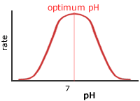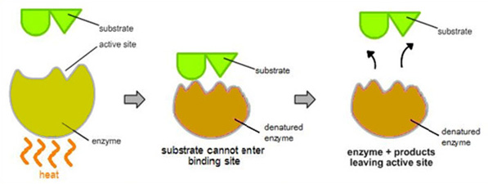

- Factors that affect Reaction Speed
- _______________________ – compete for space in the active site
    - Slow down reaction
- _______________________ – higher temp = faster reaction speed (to a point)
    - Can get too hot and _____________________ protein structure
- ______________________ – enzymes work best at a particular pH
- ______________________ – higher substrate = faster reaction speed (to a point)
    - There is a point where it levels off because all the enzymes are already working as fast as they can!

[[Language Target for Topic 4: I can construct an appropriate graph for enzyme reaction data and explain the role of enzymes on the reaction rates; I can explain the importance of enzymes and their role in reactions to a peer.]]
Part 1:
- On the graph below, identify the products, reactants, activation energy, and amount of energy released/absorbed. Calculate the Activation Energy of each and identify it as endo- or exo- thermic. Then on each graph, sketch what the curve would look like if an enzyme was used.

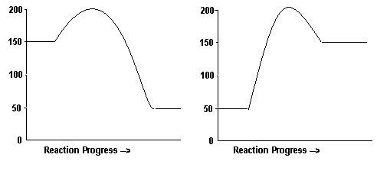

Activation Energy: Activation Energy:

Endothermic or Exothermic? Endothermic or Exothermic?

Draw the line for what an enzyme would do. Draw the line for what an enzyme would do.

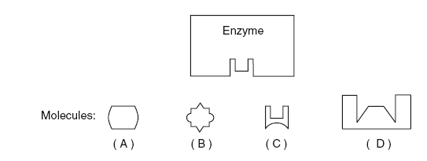
Part 2:
- The enzyme would most likely affect reactions involving which of the molecules pictured?

- How does an enzyme work?

- What is the optimal pH for both enzymes?
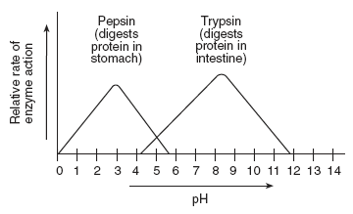
Pepsin:

Trypsin:

Definition of optimal:

- Using the pepsin and trypsin graph above, compare the rate of the pepsin-catalyzed reaction at pH of 3 with the rate of the trypsin-catalyzed reaction at pH of 3.

