Name: ______________________________________________ Unit 2 Topics 1-4
Period: ______ Page: _______
Unit 2 Topic Reviews
Biochemistry
Topic 1: Atomic & Molecular Structure
- In the space provided, draw an atom with 3 protons, 3 neutrons, and 3 electrons (label the subatomic particles and their charges):

- Use a periodic table to identify what atom you drew above: __________________________________
- How do you calculate the atomic mass? _________________________________________________________
  - Which subatomic particle is NOT used for this calculation (and why)? _____________________________ _____________________________________________________________________________________
- Hydrogen can have an atomic mass of 1, 2, or 3 amu. What subatomic particle is changing in number? ________
  - What are atoms of elements with the same atomic number but different mass numbers called? _______________________
- Which leads to charged atoms – an ionic bond or a covalent bond? _____________________________________
  - Why? ________________________________________________________________________________ _____________________________________________________________________________________
- List the six main elements in living organisms: ______________________________________________________ ___________________________________________________________________________________________

Topic 2: Properties of Water
- Draw a single molecule of water, labeling the atoms that make it up:

- What is the overall charge on a molecule of water? ______________________________________________
- Water is attracted to other molecules of water (cohesion). Why? ______________________________________ ___________________________________________________________________________________________
- Using the image you drew above, explain what polarity is: ____________________________________________ ___________________________________________________________________________________________
  - What are some of the properties of water? _________________________________________________ __________________________________________________________________________________________________________________________________________________________________________
- What type of bond holds oxygen and hydrogen together in a single water molecule? _______________________
- What type of bond holds two molecules of water together? ___________________________________________
- Draw a pH scale, labeling the pH numbers, acids, bases, and neutral. Provide at least one example of each:

Topic 3: Macromolecules
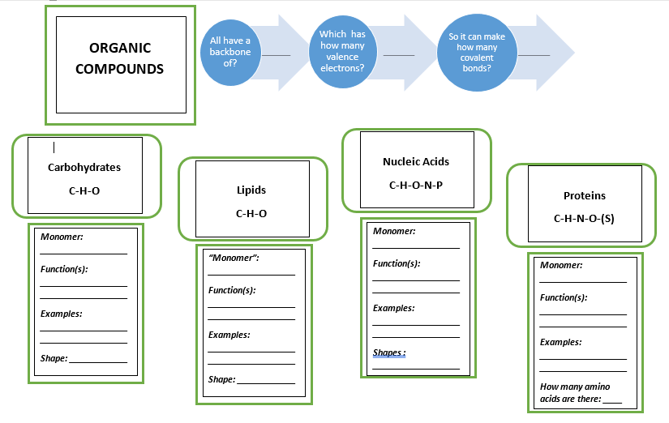
- How are polymers built? _______________________________________________________________________
- How are polymers broken down? ________________________________________________________________

Topic 4: Enzymes
- Which class of organic compounds contains enzymes? _______________________________________________
- An enzyme is a biological catalyst. What does this mean? _____________________________________________ ___________________________________________________________________________________________
- What is activation energy? _____________________________________________________________________
- Label the following image and circle the enzyme-substrate complex: 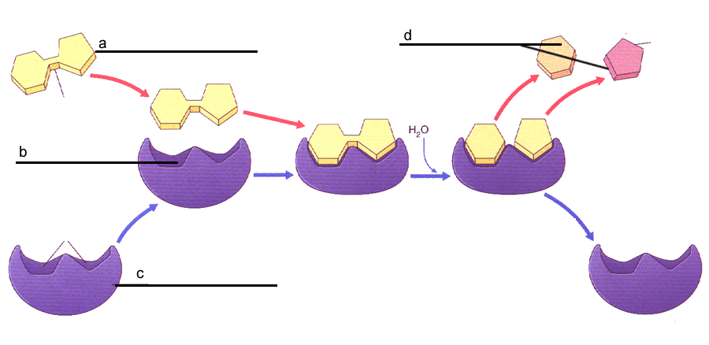
- Explain what “denaturing” of an enzyme is and what can cause it: ______________________________________ ______________________________________________________________________________________________________________________________________________________________________________________
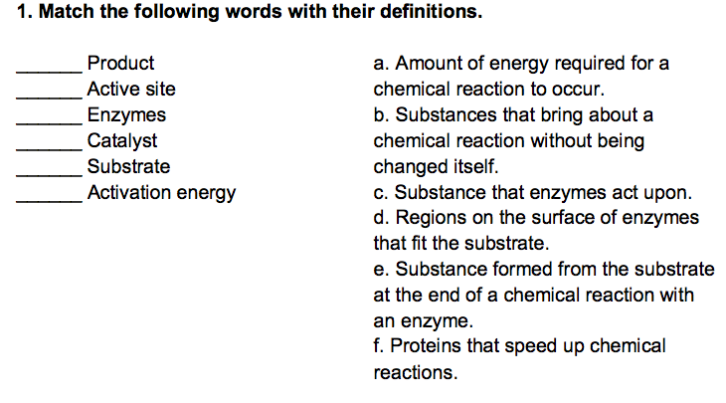

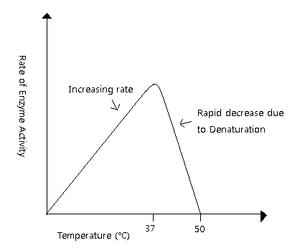
- Be able to analyze enzyme graphs!

- What is the optimum temperature for the enzyme in the graph to the right?

