Name: _______________________________________________ Date: __________________________ Period: ______

Unit 3, Part 1 Notes –Cellular Respiration (Aerobic and Anaerobic)

AP Biology, 2018-2019

- Why do cells need energy?

  - To perform cell work, cells require energy. A cell does three main kinds of work.
    - Mechanical work, such as the beating of cilia, contraction of muscle cells, and movement of chromosomes during cellular reproduction.
    - Transport work, the pumping of substances across membranes against the direction of spontaneous movement.
    - Chemical work, driving endergonic reactions such as the synthesis of polymers from monomers.

  - Cells manage their energy resources to do this work by energy coupling, using an exergonic reaction (one that releases energy) to drive an endergonic one (one that absorbs energy).

  - Basically, enzymes catalyze the breakdown of high energy organic molecules to simpler, low energy products. Some of the released energy is used to do work; the rest is lost as heat. Specifically, 40% is converted to ATP while 60% of the energy from glucose is lost as heat. Some of that heat is used to maintain our high body temperature (37°C).

  - Cells harvest the chemical energy stored in these organic molecules and use it to make ATP, the molecule that is the energy source for most cell work. This process is called cellular respiration.
    - Although carbohydrates, fats, and proteins can all be used as the fuel, most cells prefer to use glucose. The chemical formula for aerobic cellular respiration (the breakdown of glucose to fuel the creation of ATP in the presence of oxygen gas) is given below.

C₆H₁₂O₆ + 6O₂ 6CO₂ + 6H₂O + Energy (ATP + heat)

    - ATP (adenosine triphosphate) is a modified adenine nucleotide consisting of the nitrogenous base adenine, the sugar ribose, and a chain of three phosphate groups.
    - The bonds between phosphate groups can be broken by hydrolysis. Hydrolysis of the end phosphate group (i.e. breaking off the last phosphate group by adding water) forms adenosine diphosphate (ADP) and a single inorganic phosphate (P_{i}). Because the phosphate bonds of ATP are high-energy bonds, they are unstable, and their hydrolysis yields energy because the products (ADP and P_{i}) are more stable.
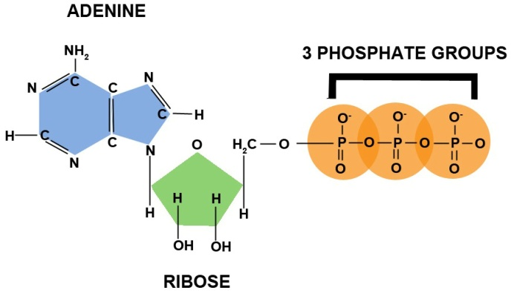
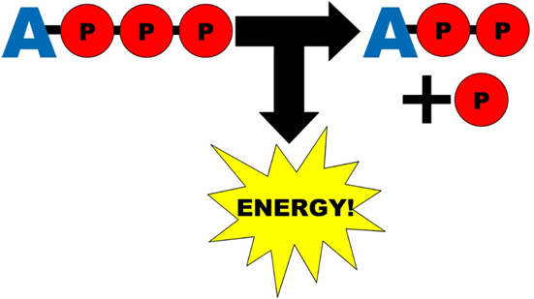

  - In the cell, the energy from the hydrolysis of ATP is directly coupled to endergonic processes by the transfer of the phosphate group to another molecule.
    - This recipient molecule is now said to be phosphorylated and is now has more energy (is less stable) than the original unphosphorylated molecule.
    - To perform work, a phosphate group is transferred from ATP to another molecule and the phosphorylated molecule undergoes a change that performs work.

  - ATP is a renewable resource that can be regenerated by the addition of a phosphate group to ADP.
    - The energy to phosphorylate ADP comes from catabolic reactions in the cell.
    - A working muscle cell recycles its entire pool of ATP once each minute. More than 10 million ATP molecules are consumed and regenerated per second per cell.

- Where does cellular respiration occur in the cell?

  - In a prokaryotic cell, cellular respiration occurs in the cytoplasm an across the cell membrane.
  - In a eukaryotic cell, cellular respiration occurs in the mitochondria (singular, mitochondrion)
    - A mitochondrion has two membranes, called the outer and inner membrane. The inner membrane is folded and the folds are called cristae.
    - The space between the outer and inner mitochondrial membranes is called the intermembrane space.
    - The space inside the inner membrane is called the mitochondrial matrix (or just matrix).
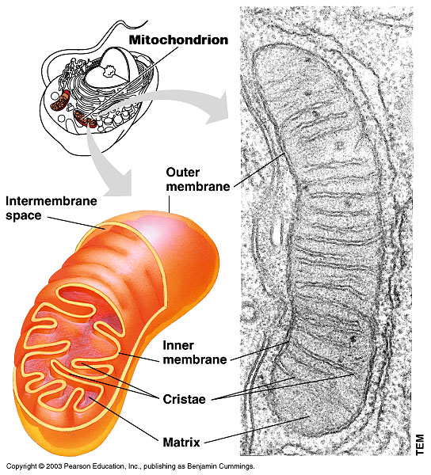
    - The three different steps of aerobic cellular respiration (i.e. glycolysis, the Krebs cycle, and the electron transport chain) occur in different parts of the cell / mitochondrion.

- How are electrons and energy transferred during cellular respiration?

  - The breakdown of glucose is exergonic (releases energy stored in the bonds found in the glucose molecule) and the synthesis of ATP from ADP and P_{i} is endergonic (absorbs energy to form the bond between the last two phosphate groups). Because the energy released by the exergonic process is used to “power” the endergonic process, this is an example of energy coupling.

  - Cellular respiration is considered an oxidation-reduction reaction (aka a “Redox” reaction) because electrons are transferred from one molecule to another at many points throughout the process. The molecule that has lost the electron(s) is oxidized, and the molecule that has received the electron(s) is reduced. Usually, an H+ ion is lost or gained with the electrons, so the molecule that is oxidized will lose an H+, and the molecule that is reduced will gain an H+.

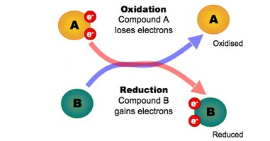
  - You can remember how electrons are lost or gained during oxidation reduction reactions with the memory trick OIL RIG… in other words Oxidation Is Loss (of electrons and H+) and Reduction is Gain (of electrons and H+).

- What happens during glycolysis (i.e. the first step of aerobic cellular respiration)?
  - Glycolysis occurs in the cytoplasm of the cell (not in the mitochondrion at all!)
  - During glycolysis, one glucose molecule (C₆H₁₂O₆) is broken down into two smaller pyruvate molecules (C₃H₄O₃), each of which have three carbons.
  - In the process, two ATP molecules are created, and two molecules of NAD+ are converted to NADH by receiving an electron and H+. Technically two ATP molecules are used during glycolysis and four are created, so there is a net output of two ATP molecules.
  - Glucose is oxidized when it is broken down into two pyruvate molecules. (Notice that four hydrogen atoms are lost from glucose when it is broken down!)
  - NAD+ is reduced when it is converted to NADH by receiving an electron and hydrogen atom from the oxidation of glucose. Because it receives electrons, NAD+ / NADH is often called an “electron carrier.”
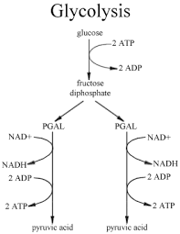
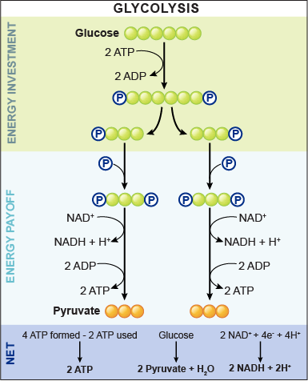
  - NADH will be used later in the electron transport chain!

- What happens between glycolysis and the Krebs cycle (intermediate step)?

  - Once they are created during glycolysis, pyruvate molecules diffuse from the cytoplasm through both the outer and inner mitochondrial membrane into the mitochondrial matrix.

  - Once the pyruvate molecules are in the mitochondrial matrix, pyruvate dehydrogenase (a group of three enzymes) helps to assist the breakdown of one molecule pyruvate (C₃H₄O₃) to an acetyl group (COCH₃) and a single carbon dioxide molecule CO₂) with joins with a molecule called Coenzyme A to create acetyl CoA.

  - In the process, two molecules of NAD+ are converted to NADH by receiving an electron and H+.

  - Pyruvate is oxidized when it is broken down into acetyl CoA and CO₂. (Notice that one hydrogen atom is lost from pyruvate when it is broken down!)

  - NAD+ is reduced when it is converted to NADH by receiving an electron and hydrogen atom from the oxidation of pyruvate.

  - NADH will be used later in the electron transport chain!
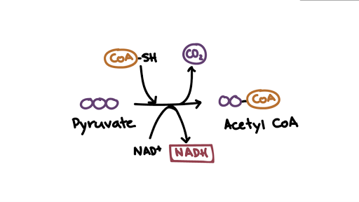
    - Note: the process shown in the image below would happen twice for one glucose molecule, because one glucose molecule makes two pyruvates.

- What happens during the Krebs cycle (also known as the Citric Acid Cycle)?

  - The Krebs cycle occurs in the mitochondrial matrix

  - During the Krebs cycle, acetyl CoA is broken down to CO₂.

  - In the process, two ATP molecules are created and six molecules of NAD+ are converted to NADH by receiving an electron and H+. Two molecules of FAD are also converted to FADH₂ by receiving electrons and hydrogen atoms. FAD / FADH₂ is another electron carrier, and will be used later (along with NADH) in the electron transport chain!

  - Acetyl CoA is oxidized when it is broken down into CO₂.

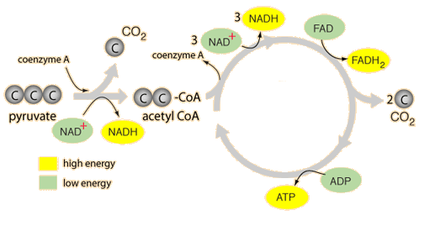
  - NAD+ and FAD are reduced when they receive electrons and hydrogen atoms from the oxidation of acetyl CoA.

Note: The image above shows both the intermediate step mentioned above and the Krebs cycle itself, while the image below shows only the Krebs cycle.

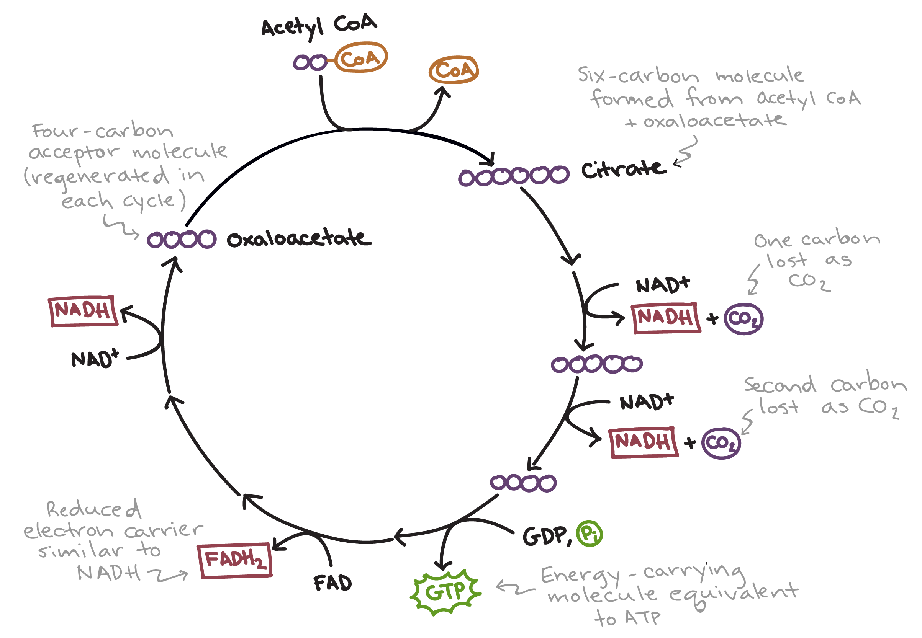

- What happens during the electron transport chain (i.e. the third step of aerobic cellular respiration)?

  - The electron transport chain occurs in the folds of the inner mitochondrial membrane. Folding the membrane creates more membrane surface area to fit more electron transport chain protein complexes and therefore make the process more efficient (i.e. create more ATP).

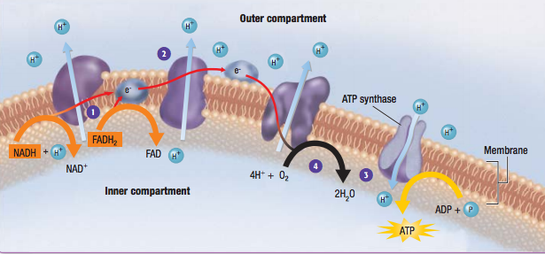
  - During the electron transport chain, high energy electrons are harvested from the electron carriers NADH and FADH₂. The energy from these electrons is used to fuel the creation of ATP from ADP and P_{i}. The steps involved in this process are given below.

    - NADH and FADH₂ release high-energy electrons at the beginning of an electron transport chain complex. In the process, NADH and FADH₂ are converted back into NAD+ and FAD.

    - High-energy electrons are passed between proteins stuck in the inner mitochondrial membrane, alternately reducing and oxidizing these proteins. An example of one of these proteins is Cytochrome C, which is found in ALL organisms.

    - Energy from the electrons is used by the proteins to pump H+ ions from the matrix across the inner membrane into the intermembrane space.

    - The last molecule to receive the electrons is oxygen gas (O₂). Oxygen gas combines with the electrons and H+ to form H₂O, one of the products of aerobic cellular respiration.

    - H+ builds up in the intermembrane space and wants to flow back down its concentration gradient across the inner membrane into the matrix. This gradient that has been created is called the H+ or proton gradient. We call the “desire” of H+ to move back down its gradient the “proton motive force.”

    - The only way that H+ can diffuse across the membrane is through ATP synthase, another membrane protein. As H+ ions flow through ATP synthase, the protein turns, and this turning motion causes ADP and P_{i} to “squish” together and create ATP. 32-34 ATP molecules can be created during this process (per original glucose molecule). The process of H+ flowing through ATP synthase and driving the production of ATP is called chemiosmosis. ATP created using this method is said to be created using oxidative phosphorylation whereas the ATP created during glycolysis and the Krebs cycle is created using substrate-level phosphorylation.

  - NADH and FADH₂ are oxidized when they release electrons and hydrogen atoms at the beginning of the electron transport chain.

  - Oxygen gas (O₂) is reduced when it gains electrons and hydrogen atoms to become H₂O at the end of the electron transport chain. Oxygen gas is often described as the “final electron acceptor” at the end of the electron transport chain.
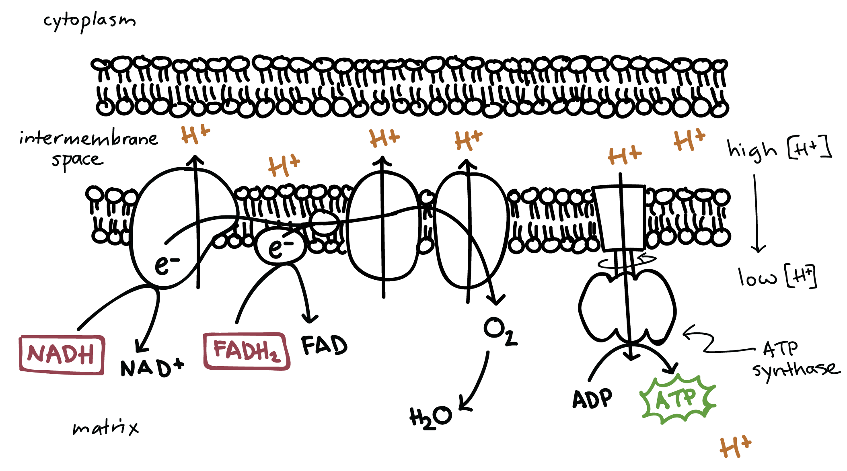

- Glycolysis can accept a wide range of carbohydrates as fuel

  - Polysaccharides like starch or glycogen can be hydrolyzed to glucose monomers that enter glycolysis.
  - Other monosaccharides, such as galactose and fructose, can also be modified to undergo glycolysis.
  - The other two major fuels, proteins and fats, can also be used during cell respiration.
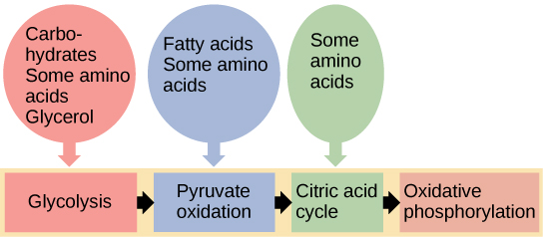
    - Proteins must first be digested to individual amino acids which then have their amino groups removed.
    - The carbon skeletons of the amino acids are modified by enzymes and enter into glycolysis or the Krebs cycle, depending on their structure.
  - Fats must be digested to glycerol and fatty acids.
    - Glycerol can enter glycolysis.
    - The rich energy of fatty acids is accessed as fatty acids are split into two-carbon molecules that enter the Krebs cycle.
  - Intermediates in glycolysis and the Krebs cycle can be diverted from the final steps of cellular respiration and used to fuel anabolic / endergonic processes in the cell (i.e. processes that build larger molecules and require energy)
    - For example, a human cell can synthesize about half the 20 different amino acids by modifying compounds from the Krebs cycle.
    - Glucose can be synthesized from pyruvate; fatty acids can be synthesized from acetyl CoA.
    - Excess carbohydrates and proteins can be converted to fats through intermediate molecules of glycolysis and the citric acid cycle.

- Anaerobic respiration (aka fermentation) enables some cells to produce ATP in the absence of oxygen.
  - Without oxygen to accept electrons in the electron transport chain, most of cellular respiration stops, but fermentation provides a mechanism by which some cells can continue to oxidize (break down) organic molecules like glucose and generate ATP.
  - In glycolysis, glucose is oxidized to two pyruvate molecules with NAD+ being reduced to NADH. Fermentation can generate ATP from glucose by substrate-level phosphorylation during glycolysis as long as there is a supply of NAD+ to accept electrons from glucose. If the NAD+ pool is exhausted, glycolysis shuts down. (Remember: Substrate-level phosphorylation is the type of ATP synthesis where a phosphate from one molecule gets directly transferred to another, unlike in oxidative phosphorylation.)
  - Under aerobic conditions (i.e. oxygen is present), NADH transfers its electrons to the electron transfer chain, recycling NAD+. Under anaerobic conditions (i.e. oxygen is NOT present), pyruvate then accepts electrons from NADH, oxidizing it back to NAD+. The NAD+ is then available to oxidize more glucose
  - Because the pyruvate does not enter the citric acid cycle (aka Krebs cycle), there is still a lot of energy which is not removed from the fuel.
  - Under aerobic respiration, a molecule of glucose yields 36-38 ATP, but the same molecule of glucose yields only 2 ATP under anaerobic respiration (comparatively inefficient).

- There are two types of fermentation—alcoholic fermentation and lactic acid fermentation.
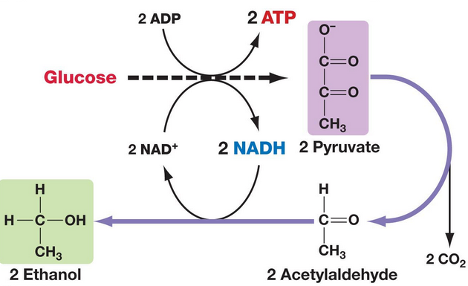
- During alcoholic fermentation (which happens in yeast and certain species of bacteria), the end products are ethanol (aka ethyl alcohol) and carbon dioxide. Pyruvate first breaks down into acetaldehyde and carbon dioxide. Then acetaldehyde accepts electrons from NADH and accepts hydrogen atoms to become ethanol. Because this process produces alcohol, it is used in the process of making beer and wine. Alcoholic fermentation is also used to help bread rise because carbon dioxide is produced, which creates bubbles in the dough.

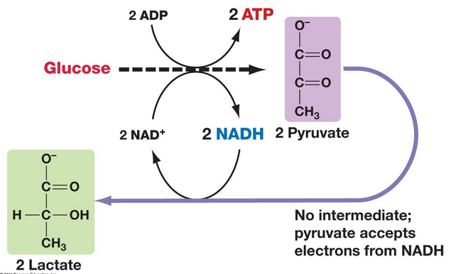
- Human muscle cells switch from aerobic respiration to lactic acid fermentation to generate ATP when O2 is scarce (ex: during extreme exercise). When O2 is absent, the electron transport chain stops; therefore pyruvate accepts electrons from NADH and accepts hydrogen atoms, forming lactic acid. This waste product causes muscle fatigue and cramping, but it is eventually converted back to pyruvate in the liver. Lactic acid fermentation is also used by certain species of bacteria. Lactic acid fermentation in bacteria can be used to make yogurt.

Notes Vocabulary and Questions

Vocabulary: In your annotations define in your own words the bolded/highlighted words you don’t already know.

Questions: ***Don’t be lazy! Do this chart!! All information necessary is straight out of the text!***
Process | Overall Description | Location in Cell or Mitochondrion | Amount and Type of ATP Production | Electron Carriers Produced or Used | What is Oxidized? | What is Reduced?
Glycolysis
Creation of Acetyl CoA

Kreb’s Cycle / Citric Acid Cycle

Electron Transport Chain / Chemiosmosis

- Where does cellular respiration take place in a prokaryotic vs. eukaryotic cell?

- Why are the phosphate bonds of ATP considered to be “high energy bonds”?

- Label the following parts of the mitochondrion pictured below: outer membrane, inner membrane / cristae, matrix, and intermembrane space.
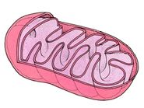
- How does cellular respiration relate to energy coupling?

- What is an oxidation reduction reaction?

- If the membrane protein pumps of the electron transport chain are defective and cannot pump H+ into the intermembrane space, how will this affect the amount of ATP created during the electron transport chain? Explain your answer.

- Is glucose the only molecule that can be broken down during cellular respiration to create ATP? Explain your answer.

- What are two ways in which aerobic fermentation differs from anaerobic fermentation?

- Why is it impossible for the electron transport chain to take place if oxygen is not present?

- Why is it important to regenerate NAD+ during anaerobic respiration? Use the terms glucose and pyruvate in your answer.

- What types of organisms use alcoholic fermentation vs. the ones that use lactic acid fermentation?

- How does the amount of ATP produced during anaerobic respiration compare to the amount of ATP produced during aerobic respiration?

Self-Quiz – questions from Campbell’s Biology. This is optional, use as you see fit.

      - The immediate energy source that drives ATP synthesis by ATP synthase during oxidative phosphorylation is
        - The oxidation of glucose and other organic compounds.
        - The flow of electrons down the electron transport chain.
        - The affinity of oxygen for electrons.
        - The H+ concentration gradient across the inner mitochondrial membrane.
        - The transfer of phosphate to ADP

      - Which metabolic pathway is common to both fermentation and cellular respiration?
        - The citric acid cycle
        - The electron transport chain
        - Glycolysis
        - Synthesis of acetyl CoA from pyruvate
        - Reduction of pyruvate to lactate

      - In mitochondria, exergonic redox reactions
        - Are the source of energy driving prokaryotic ATP synthesis
        - Are directly couple to substrate-level phosphorylation
        - Provide the energy to establish the proton gradient
        - Reduce carbon atoms to carbon dioxide
        - Are coupled via phosphorylated intermediates to endergonic processes

      - The final electron acceptor of the electron transport chain that functions in oxidative phosphorylation is
        - Oxygen
        - Water
        - NAD+
        - Pyruvate
        - ADP

      - When electrons flow along the electron transport chains of mitochondria, which of the following changes occurs?
        - The pH of the matrix increases.
        - ATP synthase pumps protons by active transport.
        - The electrons gain free energy.
        - The cytochromes phosphorylate ADP to form ATP
        - NAD+ is oxidized.

      - In the presence of a metabolic poison that specifically and completely inhibits all function of mitochondrial ATP synthase, which would you expect?
        - A decrease in the pH difference across the inner mitochondrial membrane
        - An increase in the pH difference across the inner mitochondrial membrane.
        - Increased synthesis of ATP
        - Increased oxygen consumption
        - An accumulation of NAD+

      - Which of the following is a true distinction between fermentation and cellular respiration?
        - Only respiration oxidizes glucose.
        - NADH is oxidized by the electron transport chain in respiration only.
        - Fermentation, but not respiration, is an example of a catabolic pathway.
        - Substrate-level phosphorylation is unique to fermentation.
        - NAD+ functions as an oxidizing agent only in respiration.

      - Most CO₂ from cellular respiration is released during
        - Glycolysis
        - The citric acid cycle
        - Lactate fermentation
        - Electron transport
        - Oxidative phosphorylation

