Name: __________________________________ Unit 3 Topics 1-3 Period: _______ Page: _______
Unit 3 Topic Reviews
Topic 1: The Cell Theory
- What are the three main tenets of the cell theory?
  - ________________________________________________________________________________
  - ________________________________________________________________________________
  - ________________________________________________________________________________
- Can you identify the role each scientist/individual played in developing the cell theory?
  - Virchow: ____________________________________________________________________________
  - Schleiden: ____________________________________________________________________________
  - Schwann: ____________________________________________________________________________
  - Pasteur: ____________________________________________________________________________
  - Leeuwenhoek: _________________________________________________________________________
  - Hooke: ____________________________________________________________________________
- What tool was necessary for developing the cell theory? _____________________________________________
Topic 1 Extension: The Microscope
- Who is believed to be the inventor(s) of the microscope? _____________________________________________
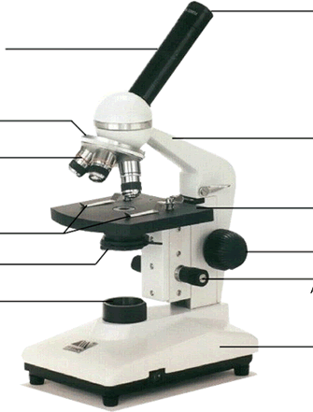
- Be able to label a microscope and/or identify the function of each part:

- Know rules for using the microscope. Jot some down in the space below:

Topic 2: Cell Types and Structures
- There are two main types of cells: _______________________________ and __________________________
  - Which type contains a nucleus (and other membrane bound organelles)? ______________________
  - Which type is larger and more complex? __________________________________
  - What do ALL cells have in common? _______________________________________________________
- Be able to match up organelles with their function! Match the following:
_____1. Nucleus A. This is the protein making site in the cell.

_____2. Cytoplasm B. This part is the outer part of a plant cell.

_____3. Ribosome C. This is the power house of the cell.

_____4. Endoplasmic reticulum D. This is the control center of a cell.

_____5. Nucleolus E. This determines what goes in and out of a
cell.

_____6. Mitochondria F. This is a jelly-like substance that fills the cell.

_____7. Vacuole G. This is the site of ribosome production.

_____8. Lysosome H. This is a tubular passageway.

_____9. Cell membrane I. This stores food and water

_____10. Chloroplasts J. This contains chlorophyll; food making site.

_____11. Cell wall K. This digests food and old cell parts.

- Use the following images to answer the following questions:
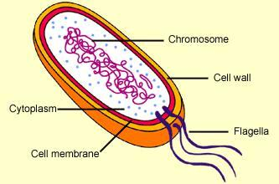 | 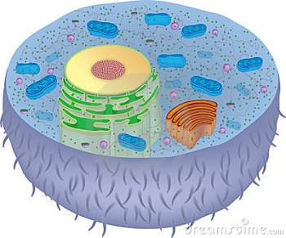 | 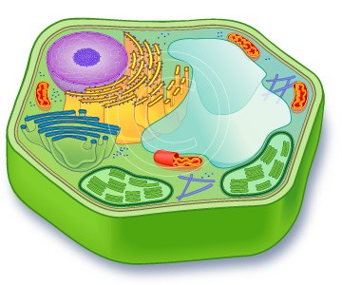
I | II | III

  - Which cell(s) is (are) most likely found in a mouse? ________________________________
  - Which cell(s) is (are) most likely found in an Oak tree? ________________________________
  - Which cell(s) is (are) prokaryotic? ________________________________
  - Which cell(s) is (are) eukaryotic? ________________________________

Topic 3: Cell Transport
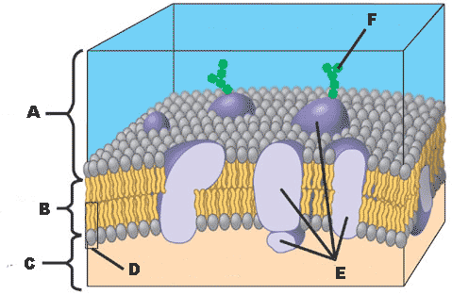
1. Label A-F in the diagram to the right with the following terms: proteins, outside the cell, inside the cell, phospholipid tails, single phospholipid, carbohydrate chains

A. _______________________________________

B. _______________________________________

C. _______________________________________

D. _______________________________________

E. _______________________________________

F. _______________________________________

2. What is a function of membrane proteins?

3. What is the function of carbohydrate chains on the surface of cell membranes?

4. Why do we use the phrase “Fluid Mosaic Model” to describe the cell membrane?

5. If a cell membrane lets any substance in or out of the cell in any amount, will this membrane be effective at maintaining homeostasis? Why or why not?

6. What does it mean to say that a substance is moving “down its concentration gradient?” Is this a passive or active process? Explain your answer.

7. Identify the type of cell transport—diffusion, facilitated diffusion, osmosis, or active transport—shown in each of the images and explain your answer. This chart continues on to the next page.

Image | Type of Cell Transport | Explanation
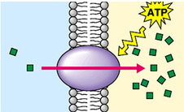
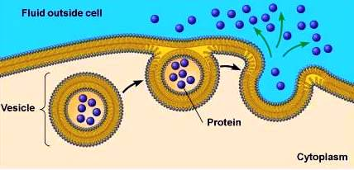
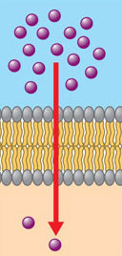
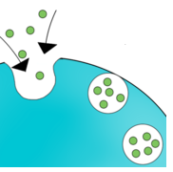
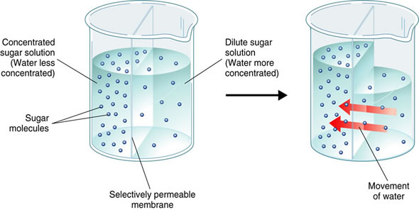

8. For each of the following, state which direction water will move and what will happen to the cell as a result:
a. Hypertonic solution: _________________________________________________________________
b. Hypotonic solution: _________________________________________________________________
c. Isotonic solution: _________________________________________________________________

