Name: __________________________________________ Unit 4 Review
Period: ________ Page: _______

Unit 4 Review Packet: Cell Energy

- Describe the structure of ATP (adenosine triphosphate) or draw and label it. Why do living organisms use ATP as the main energy storage molecule in the cell?

- What is the difference between a heterotroph and an autotroph?

- Why are photosynthesis and respiration often thought of as a cycle?

- In what cell parts (i.e. organelles) of eukaryotic cells do photosynthesis and cellular respiration take place?

- What is the equation for cellular respiration?

- What is the main goal of cellular respiration?

- What are the three steps of cellular respiration, what is the goal of each step, and where does each step occur within the cell or mitochondrion?

Step Name | Goal | Location
 | `

- In what step of cellular respiration is the most ATP created?

- Describe the sequence of energy transformation, beginning with photosynthesis and ending with the products of cellular respiration.

- Compare / contrast aerobic and anaerobic respiration (aka fermentation). Which type of respiration makes more ATP?

- Explain the difference between the two types of anaerobic respiration and identify the organisms that use these types of anaerobic respiration.

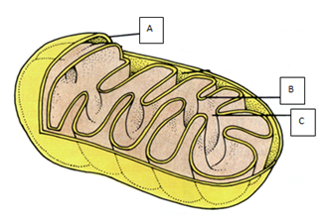
- Identify the parts labeled on the mitochondrion pictured to the right.

- What is the equation for photosynthesis?

- What is the main goal of photosynthesis?

- What are the two steps of photosynthesis, what is the goal of each step, and where does each step occur within the chloroplast?

Step Name | Goal | Location
 | `

- Describe how chlorophyll is used during the light reactions of photosynthesis.

- Describe how water is used during the light reactions of photosynthesis.

- How / when is oxygen gas produced during photosynthesis?

- How / when is carbon dioxide gas used during photosynthesis?

- How is NADPH created during the light reactions and used during the dark reactions of photosynthesis?

- How could you measure the rate (amount over time) of photosynthesis in a plant? (Hint: There are several correct answers to this question!)

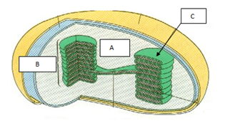

- Identify the parts labeled on the chloroplast pictured to the right.

- How did mitochondria and chloroplasts become part of eukaryotic cells through endosymbiosis? Provide two pieces of evidence to support the idea that mitochondria and chloroplasts were once free-living organisms.

- How do plants take in water and transport water throughout their bodies (be sure to include specific plant part names)? Why is water important in photosynthesis?

- How do plants take in carbon dioxide and release oxygen (what part of the leaf does this occur in)?

- Identify several factors that might INCREASE the rate of photosynthesis in plants.

