Name: __________________________________ Unit 4 All Topics Period: _______ Page: _______
Unit 4 (Cell Energy) Topic Reviews
Topic 1: Photosynthesis & ATP
- What molecule is used as energy currency in cells? ______________
- Label it’s components: 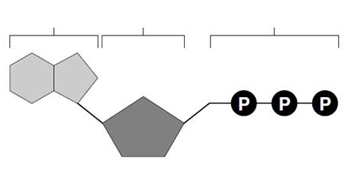
- How is energy released from this molecule? ________________________________________________
- After breaking off the last phosphate group, what remains? ___________________________________
- Organisms capable of producing their own food are called what? _______________________________
Provide some examples: ________________________________________________________________
- Organisms NOT capable of producing their own food are called what? ___________________________
Provide some examples: ________________________________________________________________
- What is the main goal of photosynthesis? __________________________________________________
  - What is released as a waste product? _______________________________________________
  - What organelle does this process occur in? __________________________________________
  - What is the pigment that captures sunlight? ________________________________________
  - Why do leaves appear green? _____________________________________________________
- What are the two primary process for photosynthesis AND where does each take place?
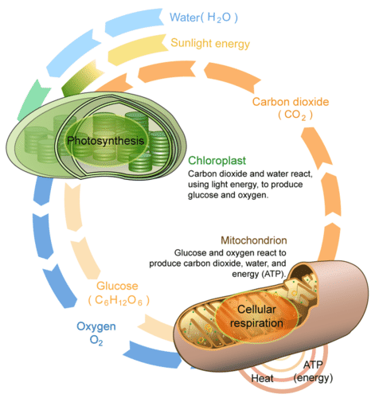
  - ________________________________________________
  - ________________________________________________
- In photosynthesis, what type of energy is trapped and what type of energy is released (what is the energy transformation)? ____________________________________________________________
- Why are the processes of photosynthesis and cellular respiration often referred to as a cycle in nature? ___________________________________________________________ ___________________________________________________________
- Identify the location/purpose for each of the following:
  - Stroma: ______________________________________________
  - Stomata: _____________________________________________
  - Thylakoid/Grana: _______________________________________
  - Chlorophyll: ___________________________________________
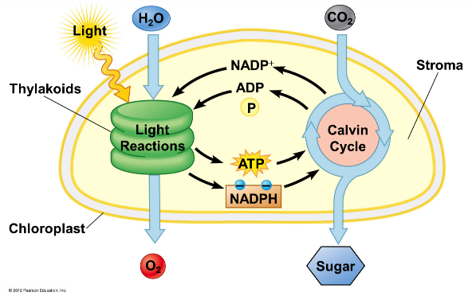
  - Chloroplast: ___________________________________________

Topic 2: Cellular Respiration
- What is the primary goal of cellular respiration? __________________________________________________
- What organisms undergo cellular respiration? _________________________
  - Do they all do it the same way? _____________
- Sometimes, an organism carries out cellular respiration without oxygen. What is this process called? ___________________________________________________
- Complete the concept map!
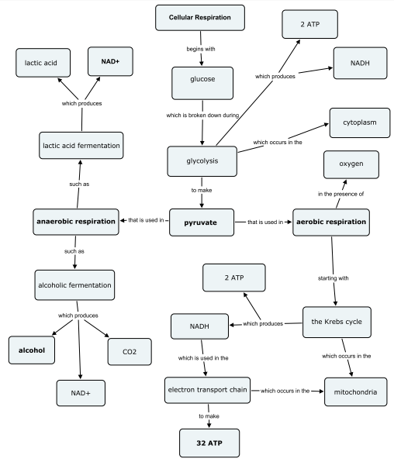
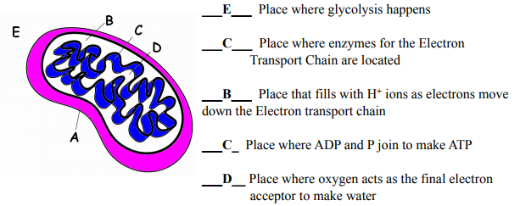
- Matching:

