Name: __________________________________________ Unit 5
Period: ______ Page: ______

Unit 5 Review Packet: Cell Division
**Remember: This packet must be completed and turned in BEFORE you take the test in order to be eligible for a retake.

- Topic 1: Draw a chromosome. Label the sister chromatids and centromere.

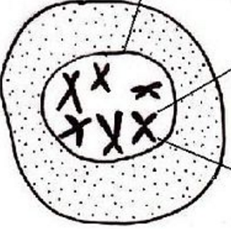
- Topic 1: How many chromosomes are shown in the cell pictured to the right? How many chromatids?

- Topic 1: Label the following parts of the image shown below: chromatin, DNA, chromatid, chromosome.
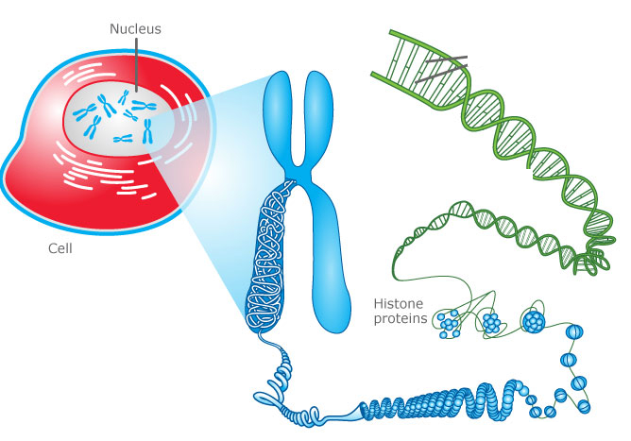

- Topic 1: Why does chromatin coil up into chromosomes in preparation for mitosis?

- Topic 1 & 2: Why does DNA replication have to occur before cell division?

- Topic 2: What happens during the three stages of interphase—G1, S, and G2?

G1:

S:
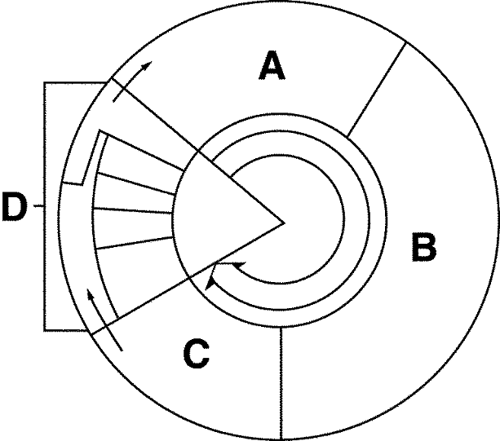
G2:

- Topic 2: Label the image of the cell cycle to the right with the following terms: cell division, interphase, cytokinesis, S, metaphase, G2, prophase, mitosis, telophase, G1, anaphase

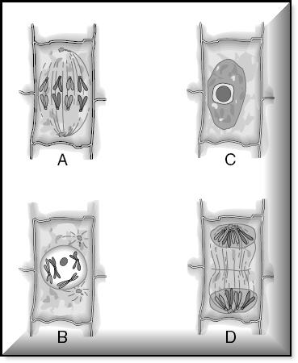
- Topic 2: Explain what is occurring in each image shown to the right. Make sure to include the NAME of each stage of the cell cycle/mitosis (hint: not all of them are stages of mitosis).

A:

B:

C:

D:

- Topic 2: What is the correct order of the images shown to the right? Which stage of mitosis appears to be missing?

- Topic 2: Explain what is occurring in each image shown below. Make sure to include the NAME of each stage of the cell cycle/mitosis. I know you did this for number 8, but practice makes you less likely to forget on the test!
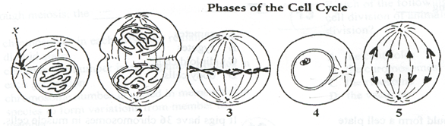
1:

2:

3:

4:

5:

- Topic 2: What is the correct order of the images shown above?

- Topic 2: Why could you say that telophase is like “reverse prophase?”

- Topic 2: What is the main purpose of mitosis in eukaryotic single-celled organisms (ex: protists like amoebas)? ALSO, how is this process different from binary fission in prokaryotic cells (ex: bacteria)?

- Topic 2: What are the [3 main] purposes of mitosis in eukaryotic multicellular organisms (ex: plants and animals)?
- Topic 3: What is the purpose of meiosis?

- Topic 3: A blood cell (somatic cell/”body” cell) in a chicken contains 78 chromosomes. How many chromosomes will a chicken sperm cell contain?

- Topic 3: An egg cell in a cow contains 30 chromosomes. How many chromosomes will a cow nerve cell contain?

- Topic 3: In what organ does meiosis (aka oogenesis) in human females occur?

- Topic 3: In what organ does meiosis (aka spermatogenesis) in human males occur?

- Topic 3: How are oogenesis and spermatogenesis different?

- Topic 3: When (what phase) during meiosis does crossing over occur? ALSO, what happens during crossing over?

- Topic 3: What is the purpose of crossing over?

- Topic 3: What is a karyotype?

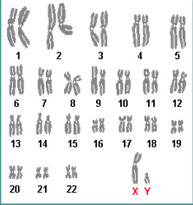
- Topic 2 and 3: What do we call the first 22 pairs of chromosomes? What do we call the last (23rd) pair of chromosomes? What can we tell about this person based on the last pair of chromosomes?

- Topic 3: What is nondisjunction? How is nondisjunction related to Down syndrome (aka trisomy 21)?

- Topic 3: How is metaphase I of meiosis different from metaphase II? Draw a picture as part of your answer!

- Topic 3: How is anaphase I of meiosis different from anaphase II? Draw a picture as part of your answer!

- Topic 3: Which process—meiosis I or meiosis II—is most similar to mitosis? Provide several reasons for your answer.

- Topic 2: Fill in the image of mitosis below with the correct number of chromosomes in the daughter cells and the type of cell (diploid or haploid) for the parent and daughter cells.
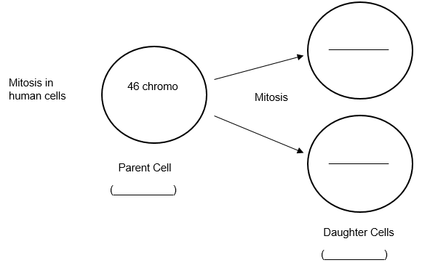
- Topic 3: Fill in the image of meiosis below with the correct number of chromosomes in the daughter cells of meiosis I and meiosis II and the type of cell (diploid or haploid) for the parent and daughter cells.

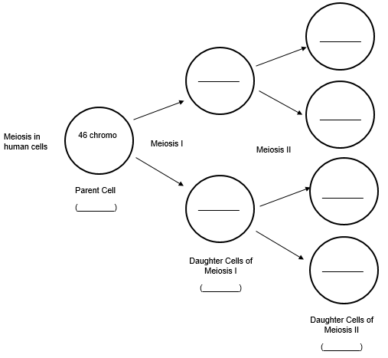

- Topic 3: Why do eggs and sperm need to be haploid cells? Use the terms meiosis and fertilization in your answer.

- Topic 2 and 3: Fill in the information in the columns below to compare characteristics of mitosis and meiosis.
Characteristic | Mitosis | Meiosis
# of Divisions?
# of Daughter Cells?
Creation of Haploid or Diploid Cells?
# of Chromosomes in Human Daughter Cells?
Creation of Somatic Cells or Gametes?
Type of Reproduction: Asexual, Sexual, or Both?
Used for Growth / Tissue Repair? (yes or no)

- Topic 2: How is cytokinesis different in plant vs. animal cells?

- Topic 2 (you can use the internet for this one): What types of cells normally divide very quickly in the human body? Why do they divide quickly?

- Topic 2: What types of cells normally divide very slowly or not at all in the human body? Make sure to mention the G0 state.

- Topic 4: How does the rate of cell division in cancer cells compare to the rate of cell division in healthy cells?

- Topic 4: When in the cell cycle do the three checkpoints occur? Why are they important in preventing cancer?

- Topic 4: What are oncogenes?

Some Quick Reminders…
- The metaphase plate can also be called the equatorial plate or cell’s equator
- Pairs of homologous chromosomes can also be called tetrads. “Tetra” means “four,” and pairs of homologous chromosomes have four chromatids.
- Homologous chromosomes are referred to as “matching” chromosomes because they have codes for the same genes in the same spots.

