Name:___________________________________________ Unit 5 Cell Division
Period:______ Page: ______
Unit 5 Notes – Cell Division
Unit 5, Topic 1: DNA Organization
By the end of this topic, you should be able to…
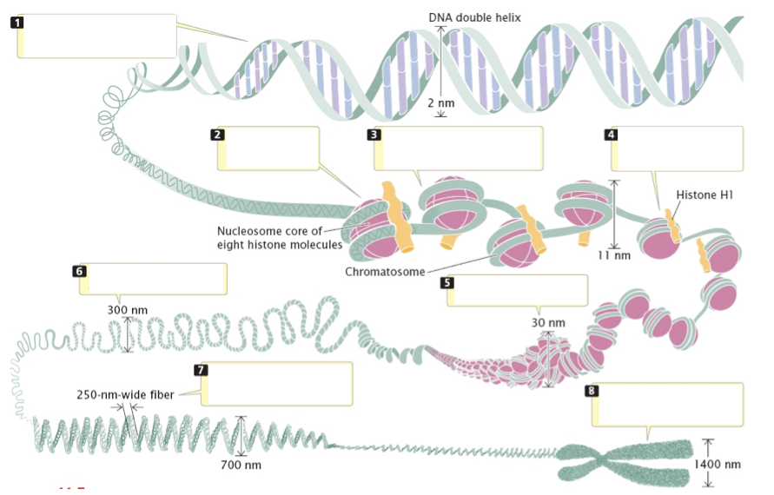
- Identify parts of a chromosome ----- 2. Explain why DNA must copy & coil before cell division ----- 3. Explain why cells can’t grow forever
- Organization of Genetic Material
  - All the DNA in a cell constitutes the cell’s ______________________________
  - A genome can consist of a number of DNA molecules
  - DNA molecules in a cell are packaged into ________________________________
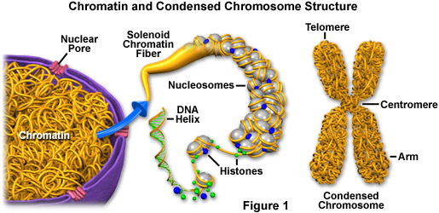
  - Eukaryotic chromosomes consist of _________________________, a complex of DNA and protein that ________________________________________
  - Every eukaryotic species has a characteristic number of chromosomes in each cell nucleus
How many chromosomes are in human cells?______
  - Non-reproductive cells have _______________________ of chromosomes
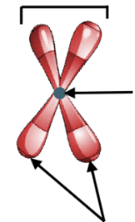
- DNA terms (LABEL THE IMAGE TO THE RIGHT)
  - In preparation for cell division, DNA is replicated and the chromosomes __________________
  - Each duplicated chromosome has two _____________________________
which separate during cell division
  - The__________________________________- is where the two
chromatids are most closely attached
- Growth vs. Division
  - When an animal or plant grows, what happens to its cells? Does an animal get larger because each cell increases in size (grows) or because it produces more of them?
__________________________________________________________________________________________________________________________________________________________________________
- Why can’t cells grow forever?
  - REASON 1: _______________________________.As the cell increases in size, it keeps the same amount of DNA. Eventually the cell will grow too much for the DNA to control all its activities
    - What is “DNA Overload?” _________________________________________________________ ______________________________________________________________________________
    - Why do we age? ________________________________________________________________ ______________________________________________________________________________

  - REASON #2: ____________________ of membrane doesn’t increase as quickly as cell _____________________
    - Too little membrane not enough exchange of materials in and out of the cell

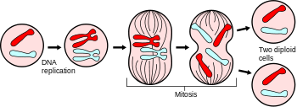
- The Solution
  - Before a cell becomes too large, it divides to form 2 _________________________
  - This process is called _________________________
  - Cell division can only happen once a cell has made a _____________________________ so that each daughter cell can have a full genetic library

- Why Divide?
  - Multicellular organisms depend on cell division for
    - ______________________________________, ______________________ and ______________________
  - Cell division is an integral part of the ____________________________, the life of a cell from formation to its own division
Complete the Language Target for Unit 5 Topic 1

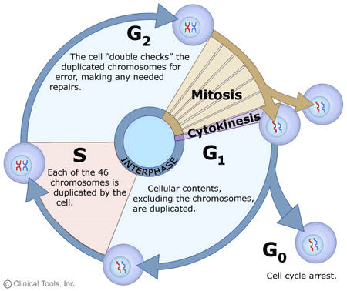
Unit 5, Topic 2: Mitosis
By the end of this topic, you should be able to…
- Explain why cells must divide
- Draw and label the stages of mitosis
- Compare and contrast animal cell division and plant cell division (cytokinesis)
- Compare and contrast prokaryotic and eukaryotic cell division

- Purpose of Mitosis
  - To create two _______________________________ from one parent cell
  - Cells begin ____________________ (2 sets of chromosomes) and end ___________________

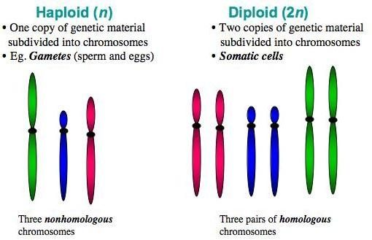
- Vocabulary to know
  - Diploid (2n): ________ sets of ______________________ (one from each parent)
    - Example: _____________________________________
    - What kinds of cells are diploid? ______________
  - Haploid (n): _____ set of chromosomes (example: sex cells)
    - Example: _____________________________________
    - What kinds of cells are haploid? ______________
  - Sex Chromosomes: determine the _____ of an organism; either ____ or ____ (Male = _____; Female = ____)
  - Autosomes: all the other ________________ in an organism
  - Cell cycle: the series of events that cells go through as they _______ and ________
    - A cell __________, preps for __________________, and divides to form TWO ____________________

- Stages of the Cell Cycle
  - G1, S and G2 ___________________________
  - Mitosis
  - Cytokinesis

- The Steps prior to Cell Division
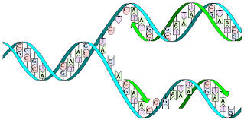
  - the cell doubles in size (____________________)
  - chromosomes replicate (__________________)
  - the number of organelles doubles
    - most doubling is directed by the _____________________

- What is DNA Replication?
  - A chromosome is unzipped and thus starts as one strand of DNA
  - Each daughter cell ____________________________ of the DNA strand.
  - The DNA strand is duplicated and the two parts are “tied” together

- Important Details
  - DNA replication occurs during the ___________________.
  - Mitosis and ____________________ overlap.
  - Cells may also enter a __________________ phase where they no longer divide.
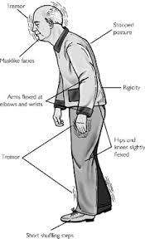
  - Cells move onto the next stage of the cycle when enough __________________ builds up.
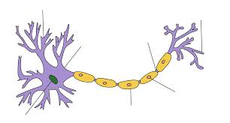
  - Cells of the ____________________________ and spinal cord do not divide.
  - _____________________ is a disease where brain cells die, and because nervous system cells ________________ replicate the body is unable to replace the dead cells.
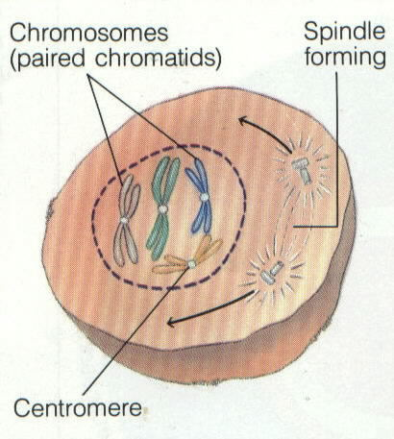
  - Mitosis is the process of dividing just the __________________, not the _______________ cell.
- STEPS OF MITOSIS (PMAT)
- PROPHASE:
  - _______________________________________ is broken down.
  - ________________________ appear for the first time.
  - Centrioles migrate - (___________________ don’t have centrioles).
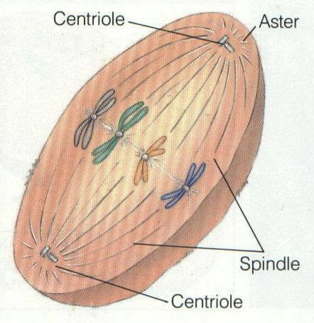
- METAPHASE:
  - Chromosomes align on the _____________________ ______________________.
  - Spindle fibers attach to the ____________________________.
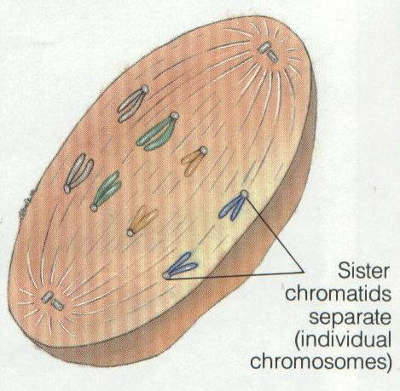
- ANAPHASE:
  - Chromatids move to ______________________ ends of the cell
(with the help of ___________________________).
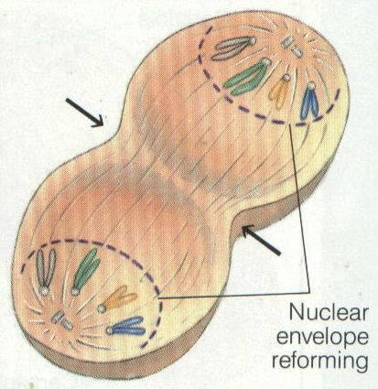
- TELOPHASE:
  - Chromosomes ______________________ moving.
  - ____________________ ______________________ reforms.

CYTOKENESIS is the _______________ of the entire cell after the nucleus divides.
- Differs for plants and animals because plants cells have ____________________
(see next page for details)
Animal Cells | Plant Cells
The _______ ______________ constricts to make a groove and divide. | Vesicle produced by _________ ____________ form a ____________ in the cell.
The groove is referred to as the ____________________ | Vesicles fuse to make a ______________ ____________ which attached to the cell wall

- How does the beginning cell differ from the ending cells in mitosis?
- Two Types of Reproduction in Prokaryotes
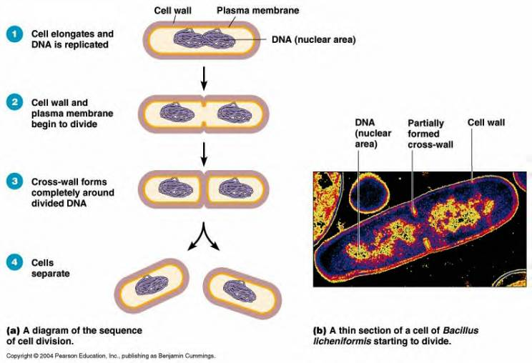
- Binary Fission (____________________________): cell parts reproduce and cell divides in half
    - The most ______________________ of reproduction for eubacteria and archaebacteria (bacteria)
    - In binary fission, the DNA replicates, and the two daughter chromosomes actively move apart
    - The __________________________________ pinches inward, dividing the cell into two
    - Produces ___________________________________ daughter cells.

- Conjugation (SEXUAL): ______________________of genetic material (plasmid) between two bacterium
- One bacterium transfers the ____________________ to the other bacterium through the conjugation bridge.
- This produces genetic diversity in bacteria that may ______________________________
***Bacteria can pick up resistance to antibiotics this way!
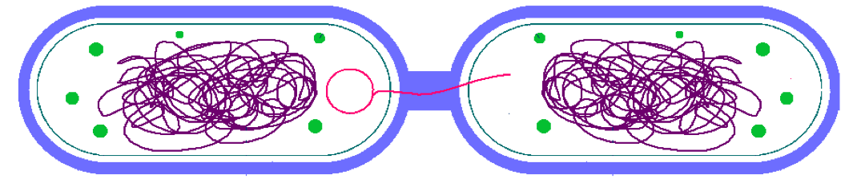

Complete the Language Target for Unit 5 Topic 2

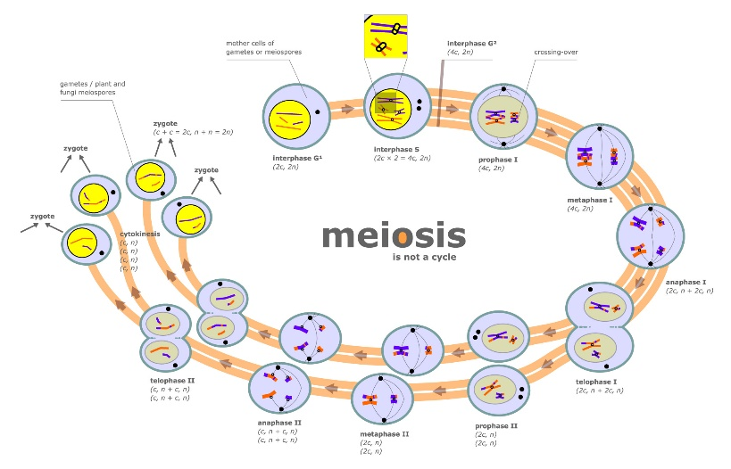
Unit 5, Topic 3: Meiosis

By the end of this topic, you should be able to…
- Compare and contrast sexual and asexual reproduction
- Illustrate meiosis I and meiosis II
- Explain fertilization of eukaryotic cells
- Explain production of egg and sperm cells
- Explain nondisjunction and read a karyotype

- Review of Topic 2
  - A cell with the full amount of genetic material (somatic body cells) would be referred to as being _______________. A cell with half of the genetic material (gametes…egg/sperm) would be referred to as being __________________.

- Meiosis Does Two Things
  - Meiosis takes a cell with two copies of every chromosome (___________________) and makes cells with a single copy of every chromosome (_______________________).
  - In meiosis, one diploid cells produces _________________________________________.
- Meiosis scrambles the specific forms of each gene that each sex cell (egg or sperm) receives.
  - This makes for a lot of genetic diversity. This trick is accomplished through ____________________________________________ and ________________________________.
Genetic diversity is important for the evolution of populations and species.

- Why do we need Meiosis?
  - Meiosis is necessary __________________ the number of chromosomes going into the sex cells
  - Why halve the chromosomes in gametes?
    - At fertilization the male and female sex cells will provide ½ of the chromosomes each – ______________________________________________________________________________

- Meiosis I : ____________________________________________________________________________

- ___________________________ (THIS ONLY HAPPENS BEFORE MEIOSIS I, NOT IN BETWEEN I AND II)
    - DNA is replicated
    - The result is two genetically identical sister chromatids which remain attached at their centromeres

- ___________________________________
Meiosis I continued….
    - During this phase each pair of chromatids don’t move to the equator alone, they match up with their homologous pair and fasten together (synapsis) in a group of four called a _____________
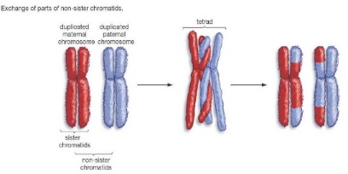
    - Extremely IMPORTANT!!! _______________________________________________
    - Crossing Over is the exchange of segments during synapsis.

- ___________________________________________
    - The chromosomes line up at the equator attached by their centromeres to spindle fibers from centrioles.
    - Still in homologous pairs

- _____________________________________________
    - The spindle fibers guide the movement of the chromosomes toward the poles
    - _____________________________________ remain attached
    - Move as a unit towards the same pole
    - The homologous chromosome moves toward the opposite pole

- __________________________________________________________
- This is the end of the first meiotic cell division.
- The cytoplasm divides, forming _________________________________.
- Each of the newly formed cells has ______________________________ of the parent cell’s chromosomes, but each chromosome is already replicated ready for the second meiotic cell division
- ______________________________________
- Occurs simultaneously with ________________________
      - Forms 2 daughter cells
- Plant cells: ___________________________
- Animal cells: _________________________
- NO FURTHER REPLICATION OF GENETIC MATERIAL PRIOR TO THE SECOND DIVISION OF MEIOSIS

- Meiosis II : __________________________________________________________________________
There is no Interphase II !!!
- ___________________________________
- Each of the daughter cells forms a spindle, and the double stranded chromosomes move toward the equator

- __________________________________
- The chromosomes are positioned on the metaphase plate in a mitosis-like fashion

- __________________________________
Meiosis II continued….
- The centromeres of sister chromatids finally separate
- The sister chromatids of each pair move toward opposite poles
- Now individual chromosomes

- ____________________________________________
- Nuclei form at opposite poles of the cell and cytokinesis occurs
- After completion of cytokinesis there are four daughter cells
- All are haploid (n)

- One Way Meiosis Makes Lots of Different Sex Cells (Gametes) – ________________________________
  - Independent assortment produces 2^{n} distinct gametes, where n = the number of unique chromosomes.
  - In humans, n = 23 and 2²³ = 6,000,0000.
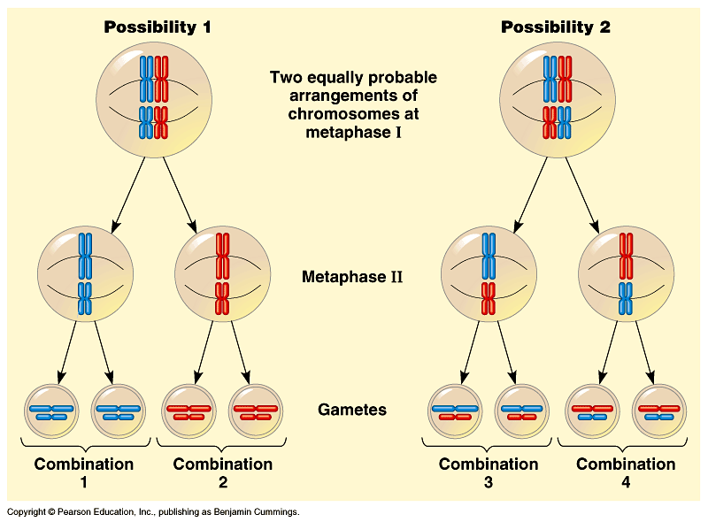

- Another Way Meiosis Makes Many Different Sex Cells: ________________________________________
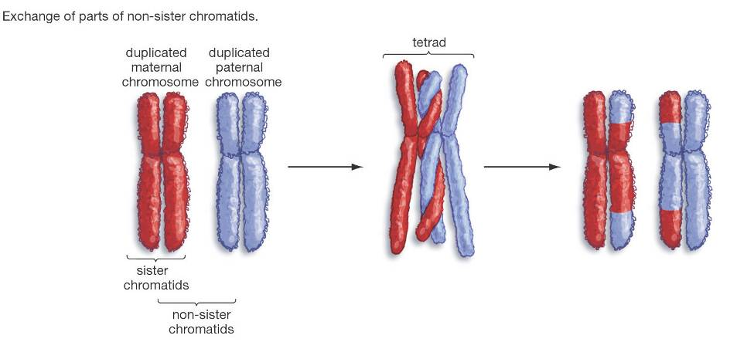
  - Crossing-over multiplies the already huge number of different gamete types produced by independent assortment.
  - Swapping genes is known as a ________________________________
  - Crossovers occur while the homologous chromosomes are paired in _______________________

- Meiosis Summary
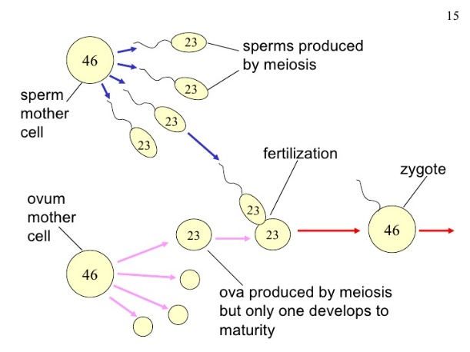
  - Sex cells divide to produce __________________________ (sperm or egg).
  - Gametes have _______________________ the # of chromosomes.
  - Occurs only in gonads (testes or ovaries).
    - Male: ________________________________
    - Female: ______________________________
  - Meiosis is similar to mitosis with some chromosomal differences
- Fertilization
  - The fusion of a sperm and egg to form a ___________________________.
  - A zygote is a fertilized egg
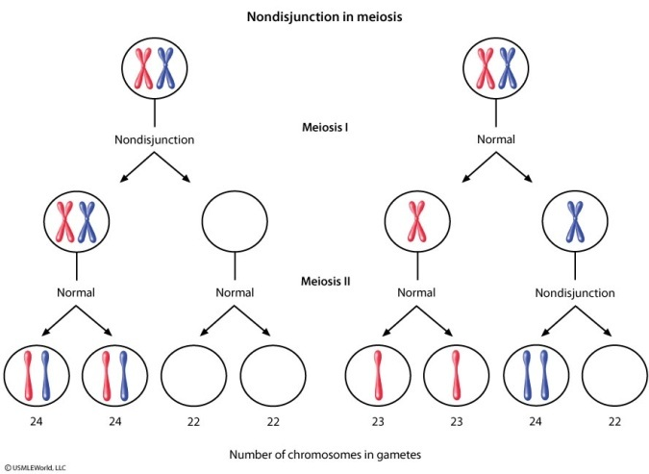
- Nondisjunction
  - Occurs when chromosomes ____________________________.
  - Can occur during ______________________ or ___________________ of Meiosis
  - Result: eggs or sperm with _____________________________ number of chromosomes
  - If the mutated egg or sperm is fertilized, the child will have abnormalities.
Note: It may also occur in anaphase of _________________, but usually the abnormal cells die and the whole organism is not affected.

  - ______________________________:Each cell has an extra chromosome
  - ______________________________:Each cell has one less chromosome

- _________________________________________: can detect chromosomal abnormalities
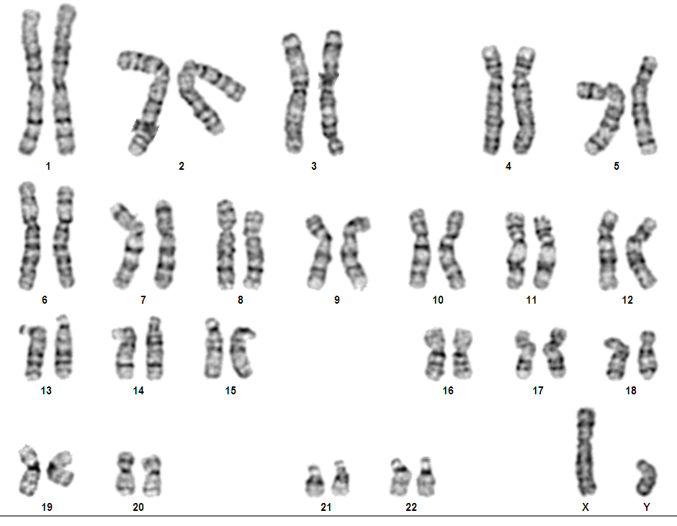
Chromosomes are photographed, cut, and matched based on size

- Examples of Nondisjunction
  - Trisomy _______ Down Syndrome
  - Trisomy ________ Patau Syndrome
  - Turner Syndrome only has an X in pair 23 (missing another sex chromosome)
  - Klinefelter Syndrome has XXY (an extra sex chromosome)
Complete the Language Target for Unit 5 Topic 3

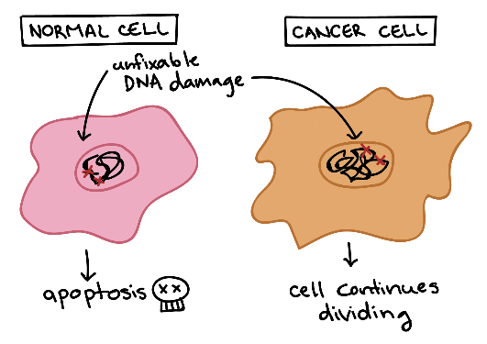
Unit 5, Topic 4: Cell Cycle Regulation
By the end of this topic, you should be able to…
- Explain the role of cell regulation checkpoint
- Explain what happens when the cell cycle controls fail

- Cell Regulation Checkpoints
- _________________________________
- _________________________________
- Tumor suppressor genes can control these checkpoints
    - Tumor suppressor genes turn ______________________ rate of cell division
- For many cells, the_____________________ checkpoint seems to be the most important
    - If a cell receives a go-ahead signal at the G₁ checkpoint, it will usually divide
    - If the cell does not receive the go-ahead signal, it will exit the cycle, switching into a non-dividing state called the ________________________________
- Neighboring cells ________________________ with dividing cells to regulate their growth also.

- Proto-Oncogenes
- Proto-oncogenes encode proteins that function to __________________________ cell division
- Important for normal human development and for the ________________ of tissues and organs.
- Sometimes a proto-oncogene undergoes a _________________ and becomes an____________
    - When mutated into an oncogene it may produce a large amount of these growth proteins, resulting in ____________________________________________
    - When a cell can no longer regulate its rate of cell division it becomes a ___________________.
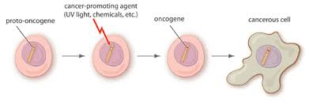

- Because there are several genes that act as proto-oncogenes it may take _____________________________ to cause harm.
    - Anything that can damage genes can cause these harmful mutations.
    - These are called ______________________________________
- Cancer
- Cancer is a disease of the __________________________. Some of the body cells divide ____________________________ and tumors form.
- Mutations may be caused by: ______________________________________________________
- Due to DNA mutations, cancer cells ignore the chemical signals that start and stop the cell cycle.
- Due to DNA mutations, cancer cells cannot communicate with neighboring cells. Cells continue to grow and form tumors.
Normal Cell | Cancer Cell
_________________________ start & stop the cell cycle | Chemical signals that start & stop the cycle are _______________________
Cells __________________________ with each other to avoid becoming ________________________ | Cells DO NOT ______________________________ with each other and ______________ form

- Cancer Vocabulary
- = loss of cell cycle control = abnormal growth of cells
- = non-spreading
- = spreading
- = spread rate of a malignant cancer to locations other than their origin
    - tumor cells enter blood vessels and travel to other parts of the body

Complete the Language Target for Unit 5 Topic 4 below

[[I can identify the cell cycle checkpoints on a diagram; I can explain in writing how cancer relates to the cell cycle.]]
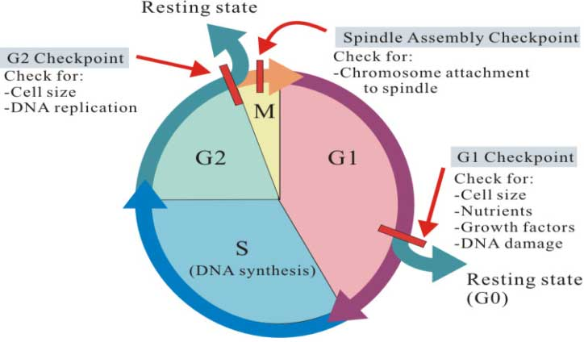
1. Explain the following image in the space to the right:
_________________________________________
_________________________________________ _________________________________________
_________________________________________
_________________________________________
_________________________________________
_________________________________________
_________________________________________
_________________________________________
2. What stage of the cell cycle do normal cells spend the majority of their time in? _______________________________
3. Comparing cancer cells to normal cells, how does your answer for number 2 change for cancerous cells? ____________________ ___________________________________________________________________________________________________________
4. What can cause cancer? _____________________________________________________________________________________
5. Why don’t all cells with mutated DNA cause cancer? _______________________________________________________________ (think of what happens at certain points in the cell cycle for normal cells- see #1).

