Name: _____________________________________________ Date: __________________________ Period: ________

Unit 5 Notes, Part 3: The Endocrine System
AP Biology

Note: You do NOT need annotations for these notes!

What is the overall function of the endocrine system?

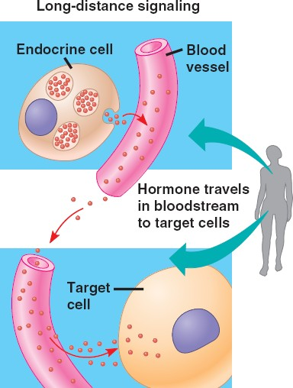
- Sending signals (via hormones) through the bloodstream to induce a response in target organs, tissues, and cells
- Hormones are chemicals that are secreted into the bloodstream by a tissue called a gland. These chemicals have multiple target cells, tissues, or organs in which they trigger a response.
- For example, human growth hormone is secreted by the pituitary gland in the brain when a person is going through puberty. This hormone travels through the blood stream and causes muscle, bone, and internal organ growth.
- Effects of hormone molecules include:
- Successful growth and development
- Successful reproduction
- Regulation of metabolism
- Proper responses to environmental changes (ex: temperature, dehydration)

What are glands and how are they related to the endocrine system?
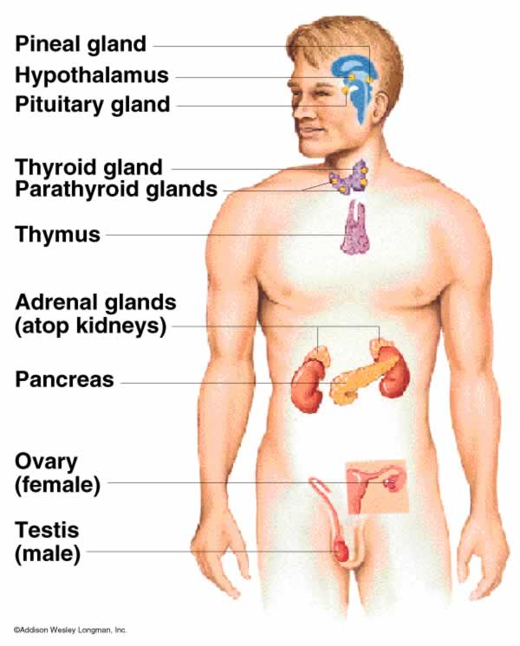
- Glands are tissues that secrete substances into a particular location in the body
- Exocrine glands (not part of the endocrine system): secrete products into ducts which open into cavities in organs (ex: sweat and oil glands, digestive glands)
- Endocrine glands secrete hormones into the bloodstream. Endocrine glands include the hypothalamus (in brain), pituitary (in brain), thyroid (in neck), adrenal (on top of kidney).
- Organs that can secrete hormones but are not considered glands (because making hormones is not their main job) include the pancreas, ovaries, testes, kidney, stomach, and small intestine.

How are feedback loops used in the endocrine system?
- Negative feedback loops within the endocrine system prevent too strong of a response or the overproduction of products. In a negative feedback loop, a particular product (ex: a hormone) inhibits the original stimulus.
- Analogy of negative feedback and the thermostat in your home: If the room is too cold, the thermostat detects this and turns on the heating. The room then warms up. The temperature is prevented from rising too high because the thermostat detects when the optimum temperature has been exceeded and turns of the heating. This is negative feedback, and keeps the temperature constant in the house.
- Endocrine example: An example of negative feedback is the regulation of the blood calcium level. In response to low blood calcium levels, the parathyroid gland (located in the neck), releases parathyroid hormone, which causes bone cells to release calcium into the blood. This is negative feedback because the response (i.e. the release of parathyroid hormone) inhibits the stimulus (i.e. low blood calcium) by raising the blood calcium levels. In contrast, if the blood calcium levels get too high, the thyroid gland releases a hormone called calcitonin, which causes bone cells to take in and store calcium from the blood. This is also negative feedback because the response (i.e. the release of calcitonin) inhibits the stimulus (i.e. high blood calcium) by lowering blood calcium levels.
- Negative feedback loops in the endocrine system often help humans to maintain homeostasis, or stable internal conditions (ex: stable blood glucose levels, stable water levels in blood, etc.)
- Positive feedback loops within the endocrine system increase the strength of a response by increasing the original stimulus.
- Endocrine example: The hormone oxytocin stimulates and enhances labor contractions during human childbirth. As the baby moves toward the birth canal, pressure receptors within the cervix send messages to the brain to produce oxytocin. Oxytocin travels to the uterus and stimulates the muscles in the uterine wall to contract more strongly. This pushes the baby further down the birth canal and activates more pressure receptor, which causes the release of more oxytocin from the brain. This continues until the baby has been pushed out of the birth canal. Once the stimulus on the pressure receptors ends (i.e. with the baby being born), oxytocin production stops and labor contractions cease. This is positive feedback because the response (i.e. the release of oxytocin) strengthens the original stimulus (i.e. the pressure of the baby on the pressure receptors in the cervix and birth canal).
- There are very few examples of positive feedback loops in organisms. Typically, organisms constantly try to maintain homeostasis (this is one of the defining characteristics of living things!), and positive feedback does not assist with this goal.
Notes Questions
There are several different types of hormone molecules—steroids, amines, single polypeptides, and full proteins (i.e., multiple polypeptides folded around each other).
- Steroids (ex: testosterone and estrogen): have a similar structure to a cholesterol molecule; they are fat-soluble (aka non-polar) so they CAN pass through the cell membrane.
- Why would being non-polar allow steroid hormones to move through the cell membrane?

- What type of receptors would steroid hormones bind to (options = plasma membrane receptors or intracellular receptors)? Why?

- Amines (ex: epinephrine): modified from the amino acid tyrosine ; they are water-soluble (aka polar) so they CANNOT pass through the cell membrane

- Why would being polar prevent amine hormones from moving through the cell membrane?

- What type of receptors would amine hormones bind to (options = plasma membrane receptors or intracellular receptors)? Why?

- Full Proteins or Single Polypeptides (ex: oxytocin… used to induce labor): vary in size ; they are water-soluble so they CANNOT pass through the cell membrane.

- Why would being water soluble (i.e. being attracted to water) prevent protein hormones from moving through the cell membrane?

- What type of receptors would protein hormones bind to (options = plasma membrane receptors or intracellular receptors)?
Note: Hormones that bind to plasma membrane receptors typically activate chemical signals called second messengers (ex: cyclic AMP) and phosphorylation cascades to produce a particular cell response. This is a signal transduction pathway, which consists of three parts: reception, transduction, and response!

- For each of the images shown in the chart below, answer the associated questions.

Image | Questions
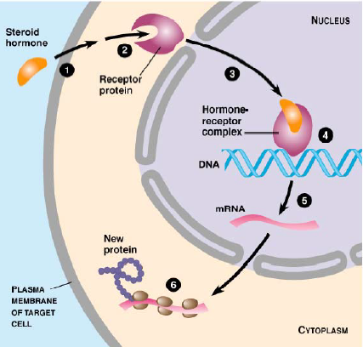 | Describe what is occurring in each of the six steps shown in the image to the left.  What type of hormone is being used? How do you know?  Which parts of the pathway shown in the image to the left represent reception, transduction and response?
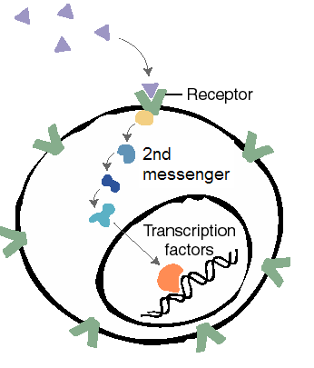  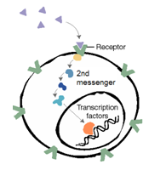 | Describe how this image is different from the previous image.  What type of hormone is being used? How do you know?  Which parts of the pathway shown in the image to the left represent reception, transduction and response?
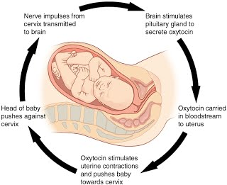 | Is the hormone oxytocin (involved in human labor) part of a negative or positive feedback loop? How do you know? (Use information from the image and from your notes to help answer this question).
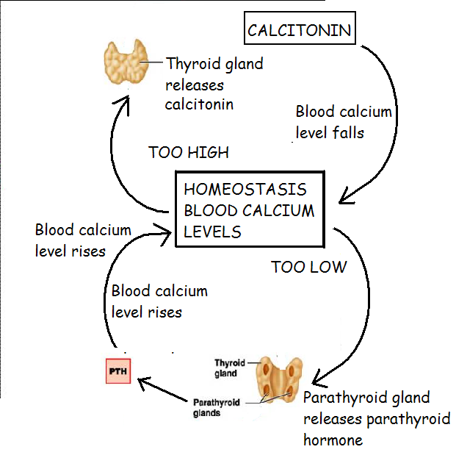 | Are the hormones calcitonin and parathyroid hormone part of a negative or positive feedback loop? How do you know? (Use information from the image and from your notes to help answer this question).  Where does calcitonin store the excess calcium moved from the blood? In other words, what tissue in your body is primarily made of calcium?

- In response to high blood glucose levels (ex: after a meal), your pancreas releases the hormone insulin into the bloodstream. Insulin causes liver cells to take in glycogen. In the liver cells, glucose molecules join together to form glycogen, a large energy-storage polysaccharide (i.e. big carbohydrate). Bringing glucose molecules into the liver cell to be stored causes blood glucose levels to drop.

In response to low blood glucose levels (ex: if you haven’t eaten a meal in a while), your pancreas releases glucagon into the bloodstream. Glucagon causes glycogen in liver cells to be broken down into individual glucose molecules. These glucose molecules are released into the blood, thereby raising blood glucose levels.

Is this system an example of positive or negative feedback? Explain your answer.

- Diabetes is a disease in which there is an error in the blood glucose control system. There are two forms of diabetes—Type 1 diabetes and Type 2 diabetes
- With Type 1 diabetes, the pancreas cannot produce insulin. How will this affect blood glucose levels?

- With Type 2 diabetes, the pancreas can produce insulin, but the receptors on the liver cells that cause the liver cells to respond to insulin are dysfunctional. How will this affect blood glucose levels?

- A ripening apple releases the hormone ethylene. Nearby apples come in contact with the ethylene hormone and ripen in response. As they ripen, they release more ethylene. Is this system an example of positive or negative feedback? Explain your answer.

- What are the pros and cons of using the endocrine system as a method of cell signaling? (Hint: Look back to your Part 1 Notes on the Basics of Cell Signaling.)

