Name: __________________________________________________ Date: _______________________ Period: ______

Unit 5 Review Packet: Cell Signaling
AP Biology

Topic #1: The Basics of Cell Signaling

- A small, nonpolar signal molecule is sent to a target cell. What type of receptor is used (intracellular vs. plasma membrane) and what type of response occurs (cytoplasmic vs. nuclear)? Explain your answers.

- A large, polar signal molecule is sent to a target cell. What type of receptor is used (intracellular vs. plasma membrane) and what type of response occurs (cytoplasmic vs. nuclear)? Explain your answers.

- Provide an example of cell signaling by direct contact in either animals or plants. What are the pros and cons of using this method of signaling?

- The endocrine system is used for signaling across long distances. What are the pros and cons of using this method of cell signaling?

- In class, we learned about the epinephrine signaling pathway involved in the fight or flight response. What type of plasma membrane receptor (i.e., G-protein coupled receptor or receptor tyrosine kinase) is used in this signaling pathway? How does this receptor initiate the transduction step of signaling?

- If the second messenger molecule cyclic AMP (cAMP) cannot be created during the transduction step of the epinephrine signaling pathway, what will be the final effect on the signaling pathway?

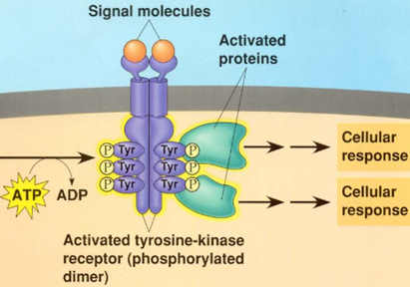
- If ATP is not present in the cell pictured to the right, what would be the most immediate effect on the receptor tyrosine kinase pathway?

- Explain how insulin is used in the pathway pictured below to lower blood glucose (you can also reference your notes and our class lecture notes).

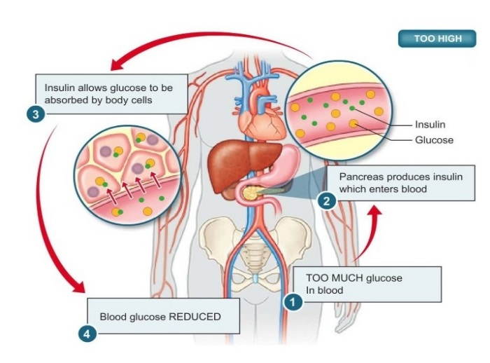

Topic #2: The Nervous System
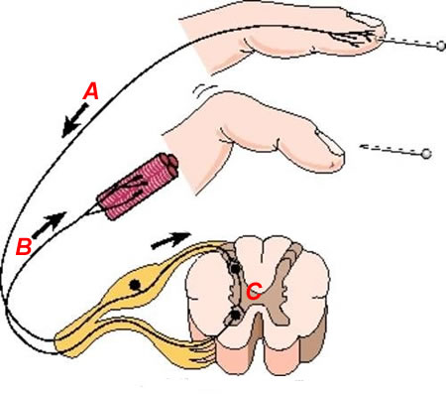
- Identify the neurons (A, B, C) involved in the polysynaptic reflex arc pictured to the right and explain how they interact to produce a response to the stimulus.

- How is an excitatory neurotransmitter (that creates EPSPs) different from an inhibitory neurotransmitter (IPSPs)?

- What is the role of Schwann cells in nerve signaling?

- Which ion channels are involved in the depolarization phase of the action potential? How does the opening of these channels affect the membrane potential inside the neuron?

- Which ion channels are involved in the repolarization phase of the action potential? How does the opening of these channels affect the membrane potential inside the neuron?

- How do nerve cells reach threshold potential (-55 mV)? What happens when a nerve cell reaches threshold?

- List the steps involved in the transmission of a signal across a synapse. Start from the wave of depolarization (the action potential) reaching the presynaptic neuron’s axon terminal. End with the postsynaptic neuron reaching threshold potential.

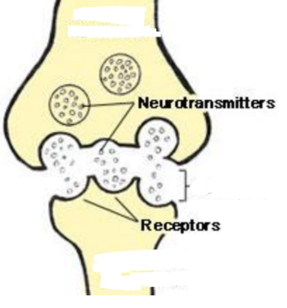
- In the image to the right, which structure (the one on the top or the one on the bottom) represents the axon terminal / tip of the presynaptic neuron? How do you know?

- In the image to the right, which structure (the one on the top or the one on the bottom) represents the dendrite membrane of the postsynaptic neuron? How do you know?

- In the image to the right, where is the synapse located?

- Are neurotransmitters constantly released from the cell on the top? If not, when are they released (i.e. in response to what signal)?

Topic #3: The Endocrine System

- When the concentration of solutes in the blood (blood osmolarity) is high, the pituitary gland releases antidiuretic hormone (ADH). ADH stimulates the kidneys to reabsorb water in order to increase blood volume and decrease blood osmolarity. When the kidneys reabsorb water, this causes the urine to be extremely concentrated (i.e. have a low water content). Mrs. Jensen overhydrates in preparation for a big race (haha, maybe in another life!). How will her body respond to this massive intake of water, which results in a high blood volume?

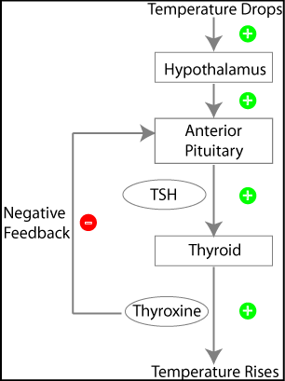

- The hypothalamus and pituitary release hormones to stimulate the thyroid gland to create thyroxine, a hormone that speeds up metabolism. How does the production of thyroxine affect the hypothalamus and pituitary? Is this an example of positive or negative feedback? Why?

- Let’s say the hormone oxytocin causes uterine contractions during mammalian labor. The uterine contractions, in turn, cause the release of more oxytocin, which causes even stronger contractions. Is this an example of positive or negative feedback? Why?

- When your blood calcium levels are too high, the hormone calcitonin causes the absorption of excess calcium into the bones, lowering the level of calcium in the blood. Is this an example of positive or negative feedback? Why?

Topic #4: The Immune System

24. Explain the difference between the nonspecific and specific immune responses in humans.

25. Explain how macrophages destroy antigens (full bacteria / viruses or parts of bacteria / viruses) that they determine to be “non-self” (foreign / not part of the human body).

26. Explain how the secondary immune response is initiated. Is this response smaller or larger than the initial (primary) immune response?

27. How are macrophages (aka Antigen-Presenting Cells) and Helper T lymphocytes used to initiate the specific immune response?

28. Explain the difference between the humoral and cell-mediated immune responses.

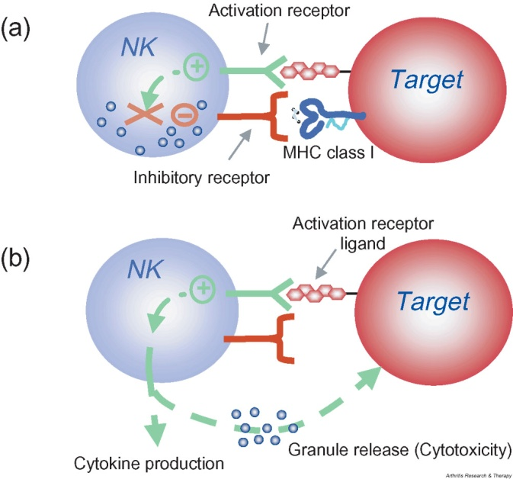
29. All normal, healthy body cells have MHC-1 proteins on their cell surfaces. A natural killer (NK) cell (another name for cytotoxic T cells) is produced by the immune system and has inhibitory receptors that bind to MHC-1 proteins. When an NK cell binds to a normal body cell, it recognizes the MHC-1 protein, “turns off,” and does not destroy the cell. If, however, the NK cell binds to a cell lacking the correct MHC-1 protein, the NK cell is “turned on” and releases cytotoxic substances that destroy the cell.

Suppose a normal body cell cannot produce normal MHC-1 proteins. How will this affect the process shown to the right?

30. How does HIV (Human Immunodeficiency Virus) affect the human immune system?

