Name: __________________________________________________ Date: _______________________ Period: ______

Unit 5 Review Packet: Cell Signaling - KEY
AP Biology

Topic #1: The Basics of Cell Signaling

- A small, nonpolar signal molecule is sent to a target cell. What type of receptor is used (intracellular vs. plasma membrane) and what type of response occurs (cytoplasmic vs. nuclear)? Explain your answers.

- Intracellular Receptor (because small, non-polar signal molecules typically CAN pass through the membrane on their own)
- Nuclear Response (because once intracellular receptors are activated by a signal molecule, they can act as transcription factors to “turn on genes”)

- A large, polar signal molecule is sent to a target cell. What type of receptor is used (intracellular vs. plasma membrane) and what type of response occurs (cytoplasmic vs. nuclear)? Explain your answers.

- Plasma membrane (because large, polar signal molecules typical CANNOT pass through membrane on their own)
- Usually associated with a cytoplasmic response (a transduction pathway following reception typically results in the activation of an enzyme used in the cytoplasm… like with our epinephrine fight or flight pathway when the cytoplasmic enzyme phosphorylase was activated)

- Provide an example of cell signaling by direct contact in either animals or plants. What are the pros and cons of using this method of signaling?

Plants: use of plasmodesmata (see Part 1 Notes, front of second page at the bottom)
Animals (specifically in the human immune system): when a type of macrophage called an antigen-presenting cell communicates with a helper T cell

Pros: Fast Cons: Can only have one target/responding cell

- The endocrine system is used for signaling across long distances. What are the pros and cons of using this method of cell signaling?

Pros: Can have more than one target/responding cell because signal molecules can travel to different parts of the body through the bloodstream.
Cons: Slow

- In class, we learned about the epinephrine signaling pathway involved in the fight or flight response. What type of plasma membrane receptor (i.e., G-protein coupled receptor or receptor tyrosine kinase) is used in this signaling pathway? How does this receptor initiate the transduction step of signaling?

A G-protein coupled receptor is used. A shape change in this receptor (in response to the signal molecule binding to the receptor) causes the associated G protein to exchange GDP with GTP. This activates the G protein’s alpha subunit. The alpha subunit detaches from the rest of the G protein and activates adenylyl cyclase, another protein on the cell membrane. Adenylyl cyclase creates cyclic AMP (cAMP) from ATP. Cyclic AMP is a second messenger molecule.

Note: There are other steps of transduction after this that ultimately result in a response. The first step of transduction occurs when the G-protein coupled receptor changes shape.

- If the second messenger molecule cyclic AMP (cAMP) cannot be created during the transduction step of the epinephrine signaling pathway, what will be the final effect on the signaling pathway?

If there is no cyclic AMP (i.e. a vital part of the transduction pathway), the cell will not be able to response. Glycogen will not be chopped up by the enzyme phosphorylase into glucose, and glucose will not be released into the blood.

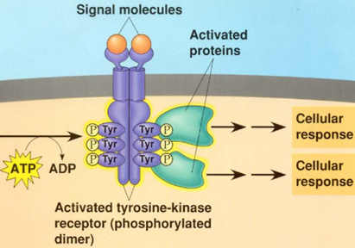
- If ATP is not present in the cell pictured to the right, what would be the most immediate effect on the receptor tyrosine kinase pathway?

The receptor will not be able to activate relay proteins by giving them a phosphate group that was originally stolen from an ATP molecule.

- Explain how insulin is used in the pathway pictured below to lower blood glucose.

In response to high blood sugar, insulin is released from the pancreas into the bloodstream. Insulin causes body cells (including liver cells) to take in glucose so that blood glucose levels are lowered (even though cells now have a higher amount).
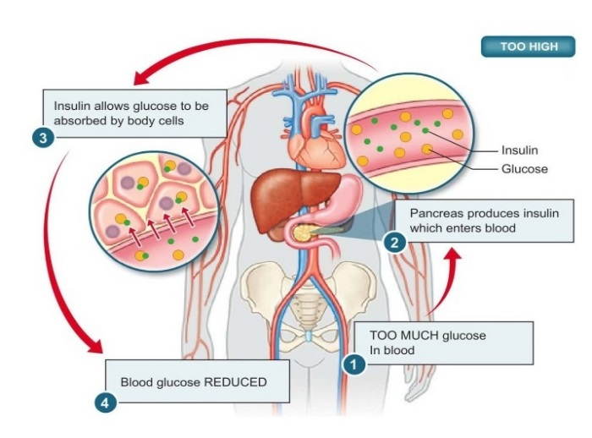

Topic #2: The Nervous System
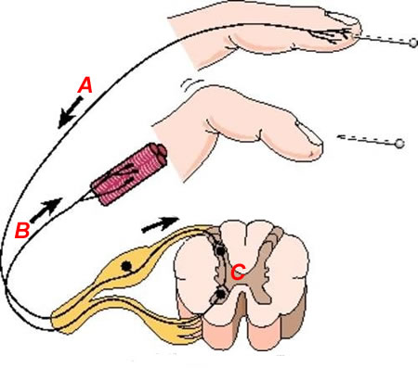
- Identify the neurons involved in the polysynaptic reflex arc pictured to the right and explain how they interact to produce a response to the stimulus.

A – Sensory neuron
B – Motor neuron
C – Interneuron in the spinal cord

A sensory neuron responds to the finger pinprick and communicates to an interneuron in the spinal cord. The interneuron signals to a motor neuron, which signals to a muscle in the finger to contract and pull away from the pin.

- How is an excitatory neurotransmitter different from an inhibitory neurotransmitter?

Excitatory neurotransmitters cause depolarization / action potentials in the post-synaptic neuron, and inhibitory neurotransmitters cause hyperpolarization (no action potentials) in the post-synaptic neuron. For example, the neurotransmitter glutamate is often considered an excitatory neurotransmitter because it typically binds to ligand-gated ion channels that open to allow Na+ to enter the postsynaptic cell (thus depolarizing the postsynaptic cell by bringing positive charge in). The neurotransmitter GABA is often considered an inhibitory neurotransmitter because it typically binds to ligand-gated ion channels that open to allow Cl- to enter the postsynaptic cell (thus hyperpolarizing the postsynaptic cell by bringing negative charge in.

- What is the role of Schwann cells in nerve signaling?

The Schwann cells increase the speed of the nerve signal because the signal jumps from one Node of Ranvier to the next in a process called saltatory conduction. Nodes of Ranvier are the spaces between Schwann cells on the axon.

- Which ion channels are involved in the depolarization phase of the action potential? How does the opening of these channels affect the membrane potential inside the neuron?

The voltage-gated sodium (Na+) channels are involved in the depolarization phase. When they open, they let Na+ into the neuron. This makes the membrane potential more positive (i.e. brings it closer to 0 mV and eventually up to approximately +30 mV from a resting potential of -70 mV.)

- Which ion channels are involved in the repolarization phase of the action potential? How does the opening of these channels affect the membrane potential inside the neuron?

The voltage-gated potassium (K+) channels are involved in the repolarization phase. When they open, they let K+ out of the neuron. This makes the membrane potential more negative (i.e. brings into back down past the resting potential of -70 mV to about -80 mV from the peak membrane potential of approximately +30 mV at the end of the depolarization phase.)

- How do nerve cells reach threshold potential (-55 mV)? What happens when a nerve cell reaches threshold?

Typically, a chemical signal molecule called a neurotransmitter binds to ligand-gated Na+ channels on the dendrite membrane. This ligand-gated Na+ channels open and allow Na+ to enter the nerve cell. If enough Na+ enters the nerve cell to bring the membrane potential up to -55 mV from the resting potential of -70 mV, then the voltage-gated Na+ channels open to start the depolarization phase of the action potential.

- List the steps involved in the transmission of a signal across a synapse. Start from the wave of depolarization (the action potential) reaching the presynaptic neuron’s axon terminal. End with the postsynaptic neuron reaching threshold potential.

- The axon terminal of the pre-synaptic neuron receives an action potential signal. The depolarization in the axon terminal causes voltage-gated calcium (Ca²⁺) channels to open and allow calcium ions to enter the axon terminal.
- The influx of calcium causes synaptic vesicles carrying signal molecules called neurotransmitters to fuse with the axon terminal membrane and release neurotransmitters in the synaptic cleft.
- Neurotransmitter molecules diffuse across the synaptic cleft and bind to ligand-gated ion channels on the post-synaptic (dendrite) membrane. (Note: Ligand-gated ion channels open in response to the binding of a signal molecule / ligand.)
- The ligand-gated ion channels open and allow Na+ to enter the cell to get the cell to threshold potential (-55 mV), triggering depolarization / action potential in the post-synaptic neuron.
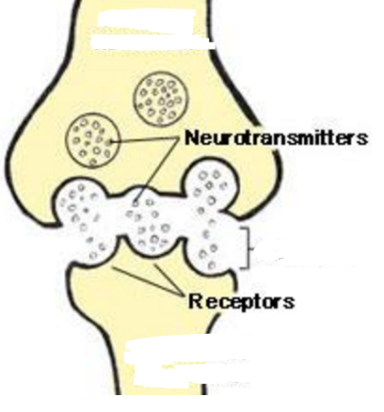
- In the image to the right, which structure (the one on the top or the one on the bottom) represents the axon terminal / tip of the presynaptic neuron? How do you know?

The one on top because it is releasing neurotransmitters into the synapse.

- In the image to the right, which structure (the one on the top or the one on the bottom) represents the dendrite membrane of the postsynaptic neuron? How do you know?

The one on the bottom because neurotransmitters are diffusing across the synapse and binding to its receptors.

- In the image to the right, where is the synapse located?

The synapse is the space between the presynaptic neuron on the top and the postsynaptic neuron on the bottom.

- Are neurotransmitters constantly released from the cell on the top? If not, when are they released (i.e. in response to what signal)?

No, they are only released when the axon tip of the presynaptic neuron receives an action potential signal that has traveled down the length of the presynaptic neuron. The wave of depolarization that reaches the axon tip causes voltage-gated calcium channels to open and allow calcium ions (Ca²⁺) to enter the axon tip. Calcium ions cause vesicles containing neurotransmitters to fuse with the axon tip membrane and release their neurotransmitters into the synapse.
Topic #3: The Endocrine System

- When the concentration of solutes in the blood (blood osmolarity) is high, the pituitary gland releases antidiuretic hormone (ADH). ADH stimulates the kidneys to reabsorb water in order to increase blood volume and decrease blood osmolarity. When the kidneys reabsorb water, this causes the urine to be extremely concentrated (i.e. have a low water content). Mrs. Jensen overhydrates in preparation for a big race (haha, maybe in another life!). How will her body respond to this massive intake of water, which results in a high blood volume?

Summary of 1st Paragraph:

High solutes in blood = low water in blood = low blood volume ADH released kidneys reabsorb water into bloodstream higher blood volume and concentrated urine (high solutes, low water)
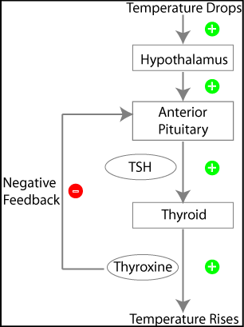
Answering the Question:

Overhydrating low solutes in blood = high water in blood = high blood volume no release of ADH kidneys do not reabsorb water into bloodstream lower blood volume and dilute urine (low solutes, high water)

- The hypothalamus and pituitary release hormones to stimulate the thyroid gland to create thyroxine, a hormone that speeds up metabolism. How does the production of thyroxine affect the hypothalamus and pituitary? Is this an example of positive or negative feedback? Why?

We can’t actually see the effect of thyroxine on the hypothalamus in the picture. The picture does show, however, that thyroxine negatively affects the anterior pituitary. This is an example of negative feedback because the response (i.e. the secretion of thyroxine from the thyroid) inhibits the stimulus (i.e. the secretion of TSH from the anterior pituitary.)

- Let’s say the hormone oxytocin causes uterine contractions during mammalian labor. The uterine contractions, in turn, cause the release of more oxytocin, which causes even stronger contractions. Is this an example of positive or negative feedback? Why?

This is an example of positive feedback because the response (i.e. the uterine contractions) increases the stimulus (i.e. the release of oxytocin).

We could also say that the release of oxytocin is the response, and the uterine contractions are the stimulus… WHATEVER!

- When your blood calcium levels are too high, the hormone calcitonin causes the absorption of excess calcium into the bones, lowering the level of calcium in the blood. Is this an example of positive or negative feedback? Why?

This is an example of negative feedback because the response (i.e. the release of calcitonin) inhibits the stimulus (i.e. high blood calcium levels).

Topic #4: Immune System

24. Explain the difference between the nonspecific and specific immune responses in humans.

The nonspecific (ex: innate) immune response is inherited and targets anything foreign (non-self) in the body. An example of a nonspecific immune cell is a macrophage, which swallows and digests any foreign particle. The specific immune response develops after exposure to a particular pathogen and targets that specific pathogen. An example of a specific immune cell is a B cell (which creates antibodies against a particular pathogen) and a cytotoxic (AKA killer) T cell (kills off any body cells infected by a particular pathogen.

25. Explain how macrophages destroy antigens (full bacteria / viruses or parts of bacteria / viruses) that they determine to be “non-self” (foreign / not part of the human body).

Macrophages swallow / engulf a foreign particle using phagocytosis. The foreign particle is encased in an ingrowth of the cell membrane called a vesicle or vacuole. The vesicle / vacuole fuses with a lysosome, which contains digestive enzymes to break apart the foreign particle.

26. Explain how the secondary immune response is initiated. Is this response smaller or larger than the initial (primary) immune response?

Memory B cells and memory cytotoxic T cells from the primary immune response become plasma B cells (which can make antibodies) and active cytotoxic T cells that can target the particular pathogen. This response is typically larger (i.e. more antibodies and active cytotoxic T cells are made) and quicker than the primary immune response.

27. How are macrophages (aka Antigen-Presenting Cells) and Helper T lymphocytes used to initiate the specific immune response?

Step | Analogy
Macrophages swallow a pathogen, chop it up, and present a portion of the particle on their cell membrane. | A scout (the macrophage) kills an intruder and presents his head on a pike.
The macrophage presents the portion of the pathogen to a helper T cell. | The scout presents the head to the military commander (the helper T cell)
The helper T cell directs the creation of B cells and cytotoxic T cells that specifically target the particular pathogen. | The military commander tells his troops (the B and cytotoxic T cells) to “Kill anyone that looks like this guy.”

28. Explain the difference between the humoral and cell-mediated immune responses.

In the humoral response, antibodies created by B cells target pathogens that are free-floating in the body fluids and mark them for destruction. These pathogens have not yet infected a body cell.
In the cell-mediated response, cytotoxic T cells recognize body cells that have been infected by the pathogen and destroy them.

29. All normal, healthy body cells have MHC-1 proteins on their cell surfaces. A natural killer (NK) cell (another name for cytotoxic T cells) is produced by the immune system and has inhibitory receptors that bind to MHC-1 proteins. When an NK cell binds to a normal body cell, it recognizes the MHC-1 protein, “turns off,” and does not destroy the cell. If, however, the NK cell binds to a cell lacking the correct MHC-1 protein, the NK cell is “turned on.” Different receptors on the NK cell then search for other proteins that indicate that the cell is in distress or damaged. If these other proteins are detected, the NK cell will release cytotoxic substances that destroy the distressed or damaged cell. The diagrams to the right show how an NK cell interacts with a normal body cell and with a cancer cell (damaged body cell).
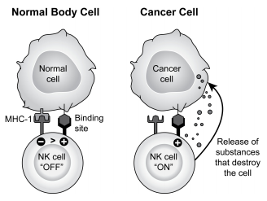
Suppose a normal body cell cannot produce normal MHC-1 proteins. How will this affect the process shown to the right?

If the NK cell cannot bind to the MHC-1 proteins because they are abnormal, this will turn the NK cell on, and it will release substances that destroy the body cell.

30. How does HIV (Human Immunodeficiency Virus) affect the human immune system?

HIV destroys the helper T cells, so the body cannot create B cells and cytotoxic T cells to target particular pathogens. Therefore, HIV inhibits the initiation of a specific immune response. Therefore, people with HIV are more vulnerable to infection by other pathogens (ex: the bacteria that causes pneumonia).

